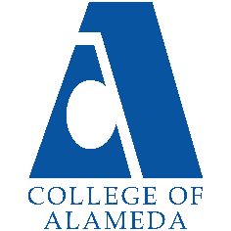
College of Alameda
2022-23 Program Review Template – EOPS/CARE/CalWORKs/Next Up

Lead Author:
Shalamon Duke, Dean and Louie Martirez y McFarland, Project Manager

Program Overview
Provide your service area’s mission statement. If your service area does not have a mission statement, what is your timeline for creating a mission statement?
This is a three-year program review of the EOPS/CARE/CalWORKs/Next UP Programs.

The EOPS/CARE/CalWORKs/Next UP Programs provides above and beyond academic and career counseling that serves the vulnerable and underrepresented students at College of Alameda.

Faculty and staff strive to provide culturally relevant and transformative experiences that support students’ goals and learning outcomes. We lean of the values of equity and social justice that is in direct correlation with the civil rights movement.

List your program faculty and/or staff
- Dean Shalamon Duke, Director of EOPS
- Louie Martirez y McFarland, Project Manager for EOPS/CARE/CalWORKs/Next Up
- Hourly Staff Assistant, Bolortuya Baasanjav (Academic Year 2023, August 1, 2022 through June 30, 2023)
- Counselor Mary Shaughnessy for EOPS/CARE
- Counselor Marissa Nakano for EOPS/CARE and CalWORKs
- Adjunct Counselor Fathia Mohamed for EOPS/CARE
- Adjunct Counselor Hector Corrales for EOPS/CARE
- Counselor Vacancy for EOPS/CARE and Next Up
- Adjunct Counselor Daynelle Parker as of September 2022 for Next Up

List the essential functions of your department, program or unit and provide a description of how the unit aligns with the college mission.
Essential Functions that will be developed by EOPS/CARE/CAL WORKS & NEXT UP Programs is to provide a uniform process that allows comprehensive and flexible programming and resources:

- Develop Common Application for all EOPS/CARE/CAL WORKS & NEXT UP Programs which will be implemented in Fall 2022. Use thereafter for the future program form.
- Develop Common Mutual Responsibility Contract EOPS/CARE/CAL WORKS & NEXT UP form which will be implemented in Fall 2022. Use thereafter for the future program form.
- Develop comprehensive semester orientation for continuing and new EOPS/CARE/CAL WORKS & NEXT UP program participants, starting in the Spring 2022. Use thereafter for the future programming of orientation and on-boarding of new students by cohort format.
- Develop Summer Bridge program for EOPS/CARE/CAL WORKS & NEXT UP participants starting in the Summer 2023.
- Established a College Visitation programs (HBCU, Sacramento Region and Southern California Region UCs and CSUs) for EOPS/CARE/CAL WORKS & NEXT UP participants starting in the Spring 2022. This will be ongoing programming for EOPS/CARE/CAL WORKS & NEXT UP.
- Establish Life Skills Workshops EOPS/CARE/CAL WORKS & NEXT UP and related program starting in Fall 2022. This will be ongoing programming for EOPS/CARE/CAL WORKS & NEXT UP.
- Re-establish Academic Review of EOPS/CARE/CAL WORKS & NEXT UP Scholars starting in Fall 2023.
- Assess the EOPS/CARE/CAL WORKS & NEXT UP Data for program eligibility, duplicity, “age” clients who already has Associate Degree or CTE starting in Spring and Summer 2022
- Establish partnership with other programs to reduce barriers of participation and provide “Guide Pathway” for students involved with EOPS/CARE/CAL WORKS & NEXT UP and other programs such as Puente, Adult Education, Umoja, Undocumented Students, Basic Need, Promise Students, etc.
- Establish a SALAAM Learning community that is sub-set of the EOPS/CARE/CAL WORKS & NEXT UP case load to focus on Southwest Asian and North African in Spring 2022.

List your program goals from your most recent Program Review or APU. Then, provide an update on the status of the goal. Has your program achieved the goal? Have any of your goals been revised or any still in progress? Lastly, make sure to discuss which College or District goal your program goal aligns to: Alignment of Goals
If no program goals exist or if this is your first program review, create 2-3 goals and align them with a College or District goal.
Program Goal | Serving more Effectively EOPS/CARE/CAL WORKS & NEXT Up by providing them access and reducing the narrow use of “vouchers” via traditional gift cards to students by Fall 2022
Status: In-Progress or Complete? | Completed: We moved away from “gift cards” to financial aid mobile bank services that allow direct deposit and wider flexibility to use the different types of vouchers. Such as, the Book Vouchers were distributed via the Book Store which students were limited to purchasing books and/or supplies at one vendor, Follett. Now, the use of Bank Mobile via Financial Aid, will allow students to purchase supplies via Amazon, Barnes and Noble, Office Depot, etc at a competitive price and use their entire allotment. All 200 students are now using in Fall 2022 terms.
Which college or district goal is aligned with your program goal? | Guided Pathways

Program Goal | Serving more effectively Cal Works students by coordinating County Welfare Department with COA - Career Technical Education Programs (CTE) and Career Center by Fall 2022
Status: In-Progress or Complete? | Completed. Contracted with a County Job Developer to work directly with our Cal Works clients directly, enrolled all EOPS/CARE/CAL WORKS & NEXT Up in the Career Academy (i.e., producing a resume, LinkedIn Profile, etc.) in the Spring 2023
Which college or district goal is aligned with your program goal?

Program Goal | Increase presence of Chicano/Latinos/Hispanics, Pacific Islander and African American Males by 3% , in the Fall 2023
Status: In-Progress or Complete? | In – Progress, working with ACESSO/Puente and UMJOA to share students’ records, counseling and workshop to support and augment supplement aid provided by the above programs with EOPS/CARE funds. Also, recruited Black and Brown male Peer Mentors to the EOPS/CARE Peer Mentor to support and encourage Chicano/Latinos/Hispanics, Pacific Islander and African American Males to join our programs, provide mentoring and peer support
Which college or district goal is aligned with your program goal?

Program Goal | 80% of EOPS/CARE/Cal WORKs/ Next Up students have signed the Mutual Agreement Contract and attended their first counseling meeting by Zoom and/or in-person by the end in Fall 2022
Status: In-Progress or Complete? | Completed.
Which college or district goal is aligned with your program goal?

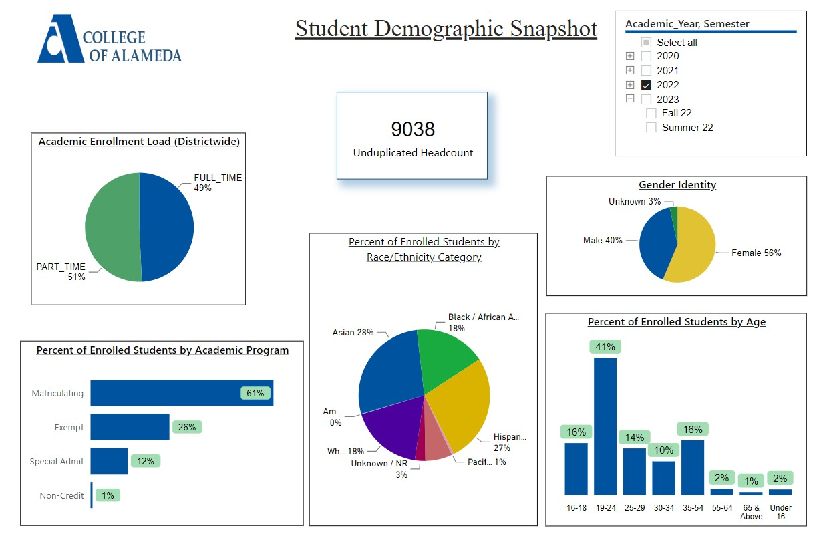
Demographics dashboard link
Do the students served by your service area differ from the College's overall student population? If so, elaborate on how the service area is identifying and addressing the needs of the student population
The students served by the service are the same from the College’s overall student population but does not distinguish Southwest Asian and North African and Southeast Asian and Pacific Islander Students. These students data are not able to be distinguishable in the data percent enrolled by students. This aggregation of students based on traditional aggregation by race and ethnicity prevents us to learn how to better serve the after mentioned students. As such, we must rely on empirical data from counselors and peer mentors to say this is a Pacific Island – Tonga, SWANA - Yeman American, etc. In short, CCC Applications data for ethnicity and race needs to be improved at the Statewide level. As such, we do not understand our population because we do not capture the right data at the CCC Application level. As noted, the API people and SWANA are the fast growing population in America but specific API population from Southeast, Pacific Islander and SWANA population are not highlighted even though immigration patterns show otherwise.

The data noted above average success for EOPS/CARE/CAL WORKS & NEXT Up students. Recently, Spring 2022, we had to review and assess the data better because we had students that completed their first associate degree or CTE program but continues to be a part of EOPS/CARE/CAL WORKS & NEXT Up. The numbers of EOPS/CARE/CAL WORKS & NEXT Up data decreased due to Covid 19 in 2020, 2021 and 2022 but we scaled back further to focus on the intent of the EOPS/CARE/CAL WORKS & NEXT Up legislative mandates and served students who need help to matriculate and persist to finish their first Associate degree or certificate, CTE, Academic Pathway, etc. and help them transfer to a four year college or promote career internships via CTE/Alameda County Career Center.

Which groups of students are underrepresented among those who received services, particularly by race/ethnicity and gender?
SWANA, Southeast Asians and Pacific Islanders are underrepresented within our CCC data. Men of color who are black and brown are not being served actively because those students may not be aware of our services or decided not to apply. Also, Black Americans not African American or Black Americans from Africa or East Caribbean needs to be distinguish from Black Americans who are descendants of 400 years of American slavery are not being served. As such, we will need counselors of color especially Black, Brown and API Counselors who are men to help attract and retain this vulnerable population. Also, we will need Peer Mentors who are men of color to support the non-traditional network in the BIPOC communities.

Describe how external factors such as advisory board recommendations, federal or state mandates, changing demographics, and/or COVID-19 has impacted the support services your program or administrative unit provides.
How has your program addressed these changes or challenges to ensure students are supported and can continue to work towards meeting their educational goals?
We have restarted our advisory board in EOPS/CARE in Spring 2022 which is still in progress due to the barriers created by Covid 19 and changes to Public Health requirements for masking. We have included faculty, students, counselors, and community (AUSD). We have identified that disbursement of funds such books, transportation, grocery, etc., was limited because they were in a form of a “gift card” through the bookstore. We shifted the “gift cards” model to direct bank to bank transfer where students are not restricted based on the gift cards such as Safeway to purchase their grocery. Now students have been giving grocery vouchers through Bank Mobile via Financial Aid that allows them to purchase groceries at their local grocery store instead of gift cards for Safeway. Also, the Program Measures for tracking the use of vouchers has improved because all the data is collected in Campus Solutions which supports better auditing practices.

Changes in Next Up – age eligibility from 16 to 13 increase our eligibility pool. The changes in CARE funds to be used with CalWORKs improves our ability to service additional students by providing larger supplemental aid. However, we are not able to use Campus Solutions to pull data via query for all CAFYES students that applied - - lack of staffing and knowledge at the District and Campus Level.

Carryover funds EOPS/CARE/CAL WORKS & NEXT Up has allowed us to create a “Common” Application that allows algorithm review of “approved”, “conditional approved”, and denied application via ConexED. The transition in Spring 2023 to ConexED Case Management will help greater control and transparency of Student Education Plan across non- EOPS/CARE/CAL WORKS & NEXT Up Programs where students are members of Puente, Umoja, Adult Education, Veterans, etc.

New PeopleSoft implementation has negatively impacted EOPS/CARE/CAL WORKS & NEXT Up by not able to do contracts effectively to secure vendors to do Workshops, College Tours, etc. The changes in procurement process hampered our ability to do any college tours in Fall 2022. We hope changes in the procurement/contract process will allow us to engage in the college tours in Spring 2023.

The lateness of payments to our vendors due to the requisition/procurement has jeopardize our relationships with our vendors and community partners. Requisitions systems items are not transition to Dispatch POs to pay invoices effectively. Payments are not more then 30 days to 9 months delays in payments.

In short, internal IT Systems – PeopleSoft has been negative impact to support and deliver services under the Guided Pathway model. Lastly, the lost of staff due to retirement and better pay does not help with support our current systems.

Data Analysis
Consider your program’s course completion rates over the past three to five years (% of student who earned a grade of "C" or better).
Academic Year | Cohort | Headcount | Total Graded | Course Completion | Course Completion Rate
2022 | EOPS Alameda | 261 | 1205 | 899 | 75%
2021 | EOPS Alameda | 368 | 2237 | 1849 | 83%
2020 | EOPS Alameda | 584 | 3408 | 2781 | 82%
2019 | EOPS Alameda | 655 | 4239 | 3283 | 77%
2018 | EOPS Alameda | 608 | 3911 | 2948 | 75%

Academic Year | Cohort | IPEDS Ethnicity (SB29) | Course Completion Rate | Retention Rate
2022 | EOPS Alameda | American Indian | 40% | 60%
2021 | EOPS Alameda | American Indian | 60% | 91%
2020 | EOPS Alameda | American Indian | 69% | 80%
2022 | EOPS Alameda | Asian | 85% | 84%
2021 | EOPS Alameda | Asian | 91% | 86%
2020 | EOPS Alameda | Asian | 89% | 90%
2022 | EOPS Alameda | Black / African American | 64% | 81%
2021 | EOPS Alameda | Black / African American | 65% | 82%
2020 | EOPS Alameda | Black / African American | 73% | 84%
2022 | EOPS Alameda | Hispanic / Latino | 62% | 92%
2021 | EOPS Alameda | Hispanic / Latino | 76% | 75%
2020 | EOPS Alameda | Hispanic / Latino | 75% | 94%
2022 | EOPS Alameda | Pacific Islander | 67% | 61%
2021 | EOPS Alameda | Pacific Islander | 69% | 82%
2020 | EOPS Alameda | Pacific Islander | 56% | 87%
2022 | EOPS Alameda | Two or More | 55% | 94%
2021 | EOPS Alameda | Two or More | 76% | 81%
2020 | EOPS Alameda | Two or More | 72% | 87%
2022 | EOPS Alameda | Unknown / NR | 88% | 93%
2021 | EOPS Alameda | Unknown / NR | 93% | 96%
2020 | EOPS Alameda | Unknown / NR | 81% | 80%
2022 | EOPS Alameda | White | 86% | 82%
2021 | EOPS Alameda | White | 91% | 67%
2020 | EOPS Alameda | White | 85% | 65%

How do the course completion rates for your program or discipline compare to your college's College-Set Standard for course completion of 67%?
Our course completion rates are higher due to direct and consistent counseling and the establishment of Peer Mentoring in Spring 2022. As noted in the above tables, our rates are in 80%.

Also, changes and removing students from our rooster that have already completed their Associate Degree and CTE in Spring 2022 has skewed our numbers for many years. The current count 175 reflects a change and building up to 600 goal of students in the EOPS/CARE/CAL WORKS & NEXT Up as our community return to some degree of normalcy after Covid-19.

Academic Year | Cohort | Headcount | Total Graded | Retained | Retention Rate
2022 | EOPS Alameda | 261 | 1205 | 1054 | 87%
2021 | EOPS Alameda | 368 | 2237 | 2014 | 90%
2020 | EOPS Alameda | 584 | 3408 | 3064 | 90%
2019 | EOPS Alameda | 655 | 4239 | 3692 | 87%
2018 | EOPS Alameda | 608 | 3911 | 3376 | 86%

On average the course retention rate (number of students are retained in the course) for College of Alameda has been 85% for the past three years. Examine the course retention rates for your program over the last three years. How does your program or discipline course retention rates compare to the college?
As noted, our retention rates remain higher than the college, 87% because we have wrap around services by providing counseling, EOPS community and starting in the Spring 2022 the Peer Mentoring Program, Face to Face Orientation/Onboarding, improving our voucher programs plus adding Life Workshops and College Visits in Spring 2022.

Equity
College of Alameda continues to focus on access, equity, and success. The goal is to create an inclusive environment where all students can thrive and meet their education and career goals. In 2019 the Student Service Equity team analyzed data to identify groups that were disproportionately impacted in access, persistence, transfer rate, completion of transfer level English and Math, and goal completion.
- Access: Black/African American male students enroll at disproportionate rates. Additionally, female Black/ African American, disabled and LGBTQIA students enroll at disproportionate rates.
- Persistence: Female Black or African American, Latinx, foster youth, LGBTQIA and veteran students are persisting at disproportionate rates. Male Black or African American, foster youth and LGBTQIA students are also persisting at disproportionate rates. The most significant retention equity gap was with male foster youth students.
- Transfer to a Four-Year Institution: Female American Indian or Alaska Native, Native Hawaiian or other Pacific Islander and disabled students transferred at disproportionate rates. American Indian or Alaska Native, Black or African American, Filipino, Latinx, disabled, first generation and foster youth males also transferred at disproportionate rates.
- Complete both Transfer-level Math and English within the first year: Female foster youth complete both transfer level math and English at disproportionate rates. Additionally, Black/African American, Latinx, disabled, economically disadvantaged, foster youth and LGBTQIA males transfer at disproportionate rates.
- Vision 2022 Goal Completion: Asian, Black/African American, Latinx, foster youth, LGBTQIA, and veteran female students complete at disproportionate rates. American Indian or Alaska Native and LGBTQIA male students are also completing at disproportionate rates.
Discuss how your program has worked to address these equity gaps. Incorporate examples of your program data where applicable.

We have a Peer Mentoring Program started in Spring 2022 to reflect our diverse population and representative of the students we served both in the program and outside. We see students in the beginning of each term to help them oriented them to college or support general counseling.

Student Learning Outcomes Assessment
List your Service Area Outcomes (SAOs) and/or Student Learning Outcomes (SLOs)
100% of EOPS/CARE/Cal WORKs/ Next Up students have signed the Mutual Agreement Contract and attended their first counseling meeting by Zoom and/or in-person by the end in Fall 2022

Please provide a high-level summary and your program’s interpretation of your SAO/SLO findings over the past year.
100% of EOPS/CARE/Cal WORKs/ Next Up students have signed the Mutual Agreement Contract and attended their first counseling meeting by Zoom and/or in-person by the end in Fall 2022. We will using, Spring 2023 ConexED Case Management to manage the process, improve cross reference to partner programs like Puente and Umoja, etc.

What were the most important things your department learned from assessment? Did implementation of your action plans result in better student learning?

Degrees & Certificates Conferred
Increasing the number of students who complete a certificate or degree is a shared goal across CoA’s Ed Master Plan Goals, PCCD Goals, the Chancellor’s Office Vision for Success, the Student-Centered Funding Formula, and Guided Pathways.
How can your program contribute to increasing the number of certificates and degrees awarded over the next three years? For more information on awards click on the Degrees & Certificates Dashboard link
We can increase the certificates and degrees award by moving towards a cohort base structure, with strong Peer Mentoring with required Life Workshops and established college visits. Further, we are reviewing existing program structures to reduce barriers by working with established learning community such as UMOJA, PUENTE and SALAAM by coordinating wrap around complimentary services between EOPS/CARE/CalWORKs and Next with UMOJA, Puente and SALAAM.

Engagement
How has your department has participated in college wide efforts such as committees, presentations, and departmental activities?
We have engaged at a college wide level by teaming up with Career Center, MESA Connect, ACESSO/Puente, Adult Education and SAS in shared conference development and workshops. We have worked with enrollment management team through Rock N Roll events and Alameda Promise by doing in reaching and outreach using our call center and Peer Mentors Centers. Lastly, many of the students leaders in the Associate Students of Alameda College are EOPS/CARE/Cal WORKs/ Next Up scholars which supports to a wider college community engagement.

How has your department has engaged in community activities, partnerships and/or collaborations?
We have established direct ties with the Alameda Unified School District to sponsor a Black Youth Conference in the Winter of 2022, we are establishing formal ties to local churches, temples and mosque through our outreach and working to establish an EOPS/CARE/CalWORKs and Next UP MOU with AUSD and OASD to have workshops and outreach to make COA as the first choice school in the Spring 2023. We are in-progress to develop targeted Memorandum of Understanding with Alameda Unified School District and opening discussions with Oakland Unified School District Counselors to do joint programming to help vulnerable communities in Oakland that could be eligibility for EOPS/CARE/Cal WORKs/ Next Up.

Prioritized Resource Requests Summary
In the boxes below, please add resource requests for your program. If there are no resource requested, leave the boxes blank.
Resource Category | Description/Justification | Total Estimated Cost
Personnel: Classified Staff | EOPS Staff Services Specialist and/or EOPS Staff Assistant | $95,000 with benefits
Personnel: Student Worker
Personnel: Part Time Faculty
Personnel: Full Time Faculty | EOPS/CARE - Counselor | $200,000 with benefits

Resource Category | Description/Justification | Total Estimated Cost
Professional Development: Department wide PD needed | Microsoft 365 and Professional Office | $1,000
Professional Development: Personal/Individual PD needed
Supplies: Software
Supplies: Books, Magazines, and/or Periodicals
Supplies: Instructional
Supplies: Non-Instructional
Supplies: Library Collections
Technology & Equipment
Library materials/collections
Facilities: Classrooms/Labs | Develop Lending Computer and Hardware Center in A105
Facilities: Offices
Other

