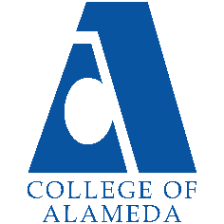

**College of Alameda**

2022-23 Program Review Template – **Transfer Center**

**Lead Author:**

|  |
| --- |
| **Vivian Virkkila** |

**Program Overview**

Provide your service area’s mission statement. If your service area does not have a mission statement, what is your timeline for creating a mission statement?

|  |
| --- |
| The mission of College of Alameda’s Transfer Program is to continually increase the student transfer rates from COA to four-year colleges/universities. In order to accomplish this goal, it is the Transfer Program’s primary function to ensure that all students have access to necessary transfer information and provide programs and services needed for successful transition to the receiving institutions. An area of responsibility for the Transfer Program is to assist underrepresented, low-income, disabled, and first-generation college students through outreach programs and services to increase their awareness of the opportunities and resources available to achieve student success and transfer. |

List your program faculty and/or staff

|  |
| --- |
| Vivian Virkkila .5 |

List the essential functions of your department, program or unit and provide a description of how the unit aligns with the college mission.

|  |
| --- |
| Following the Transfer Center Guidelines set by the California Community College Transfer Center Directors and the California Community Colleges Chancellor's Office the Transfer Counselor works to engage with the college community in the following areas:  1. Serving as the primary contact person for inquiries from community college administrators, faculty, staff, students and the community concerning the college's transfer programs and services.  2. Serving as a liaison between the community college and baccalaureate-level universities in regards to admission policies and transfer requirements.  3. Working with campus faculty and administration to ensure that the transfer function i s clearly identified as a primary mission of the college  4. Working with college administrators to coordinate the activities of the Transfer Center with other instructional and student services programs on campus and to encourage cooperative working relationships.  5. Chairing the Transfer Center Advisory Committee developed to assist in supporting and strengthening transfer activities on campus.  6. Working with the campus articulation officer to monitor and encourage the development of articulation agreements and campus participation in articulation efforts.  7. Providing ongoing information and training to counselors regarding new transfer options, changing requirements, university selection criteria, ASSIST and university application procedures to ensure that accurate and up-to-date information is being conveyed to students.  8. In conjunction with the Counseling Department, provide transfer counseling that includes handling complex transfer cases referred to the Transfer Center by counselors, administrators or instructional faculty; the evaluation of independent and out-of-state transcripts for transfer to UC, CSU or other baccalaureate-level colleges or universities; research regarding transfer requirements to independent or out-of-state universities; or advocacy for students who believe their denial of admission from a baccalaureate-level university is unfair or incorrect.  9. Receiving daily California Community College and university updates through the statewide Transfer Center Director’ s distribution list |

List your program goals from your most recent Program Review or APU. Then, provide an update on the status of the goal. Has your program achieved the goal? Have any of your goals been revised or any still in progress? Lastly, make sure to discuss which College or District goal your program goal aligns to: [Alignment of Goals](https://alameda.edu/wp-content/uploads/2021/12/Alignment-of-Goals-2022-Vision-for-Success-Peralta-Community-College-District-CoAs-Educational-Master-Plan.pdf)

If no program goals exist or if this is your first program review, create 2-3 goals and align them with a College or District goal.

|  |  |
| --- | --- |
| **Program Goal** | Launch STARS Student Transfer and Reaching Success |
| Status: In-Progress or Complete? | In-Progress |
| Which college or district goal is aligned with your program goal? | A. Advance Student Access, Equity, and Success  C. Build Programs of Distinction |

|  |  |
| --- | --- |
| **Program Goal** | Provide students with accurate transfer information and transition services |
| Status: In-Progress or Complete? | In-progress |
| Which college or district goal is aligned with your program goal? | A. Advance Student Access, Equity, and Success |

|  |  |
| --- | --- |
| **Program Goal** | Monitor the progress of transfer students to the point of transfer. |
| Status: In-Progress or Complete? | In-progress |
| Which college or district goal is aligned with your program goal? | A. Advance Student Access, Equity, and Success |

|  |  |
| --- | --- |
| **Program Goal** | Assess students that utilize the resources offered at the Transfer Center for transfer related activities, guidance, and support |
| Status: In-Progress or Complete? | In-progress |
| Which college or district goal is aligned with your program goal? | A. Advance Student Access, Equity, and Success  E. Develop and Manage Resources to Advance Our Mission |

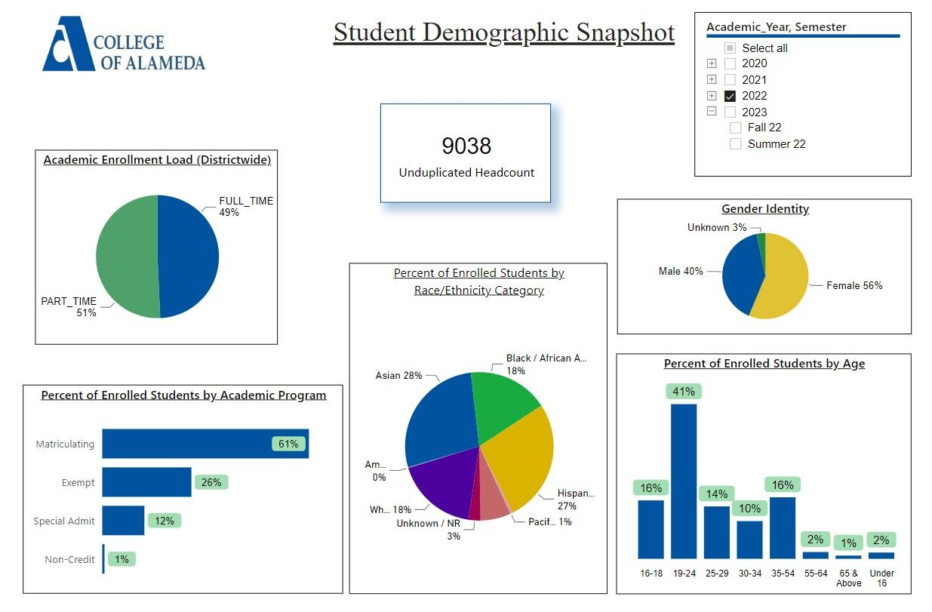

[**Demographics dashboard link**](https://app.powerbi.com/view?r=eyJrIjoiMzVhNGU3YzAtNTIyNy00ZDZmLWIyYzMtYWIzMzllMGViZDQ5IiwidCI6ImVlYTE2YTE2LTQ4YWYtNDc3Yi05MTEzLTA1YjFjMDExMjNmZiIsImMiOjZ9&pageName=ReportSectionb4e116c96a753400a00c)

Do the students served by your service area differ from the College's overall student population? If so, elaborate on how the service area is identifying and addressing the needs of the student population

|  |
| --- |
|  |

Which groups of students are underrepresented among those who received services, particularly by race/ethnicity and gender?

Describe how external factors such as advisory board recommendations, federal or state mandates, changing demographics, and/or COVID-19 has impacted the support services your program or administrative unit provides.

How has your program addressed these changes or challenges to ensure students are supported and can continue to work towards meeting their educational goals?

|  |
| --- |
| Guided Pathways and Student Centered Funding support the mission of the Transfer Center to increase student transfer rates. Challenges to bringing services to students increases in March 2020 with the onset of Covid-19. Beginning fall 2020 services were offered remotely. |

**Data Analysis**

Consider your program’s course completion rates over the past three to five years (% of student who earned a grade of "C" or better).

How do the course completion rates for your program or discipline compare to your college's College-Set Standard for course completion of **67%**?

|  |
| --- |
| The course completion rates and discipline for the Counseling Department is historically above the 67% College-Set Standard with the exception of the 2022 Academic Year when it was at the set standard of 67% |

On average the course retention rate (number of students are retained in the course) for College of Alameda has been **85%** for the past three years. Examine the course retention rates for your program over the last three years. How does your program or discipline course retention rates compare to the college?

|  |
| --- |
| The course completion rates between face to face and Distance Education/hybrid courses are consistent. There are no substantial differences in course completion rates between face to face and Distance Education/hybrid courses, except for the 2020 Academic Year. In 2020 In Person completion rates were lower than online, most likely due to the mid-semester switch for in person courses to online. |

**Equity**

College of Alameda continues to focus on access, equity, and success. The goal is to create an inclusive environment where all students can thrive and meet their education and career goals. In 2019 the Student Service Equity team [analyzed data](https://alameda.peralta.edu/wp-content/uploads/2019/06/CoA-equity-exec-summary-6.2019.docx) to identify groups that were disproportionately impacted in access, persistence, transfer rate, completion of transfer level English and Math, and goal completion.

* **Access:** Black/African American male students enroll at disproportionate rates. Additionally, female Black/ African American, disabled and LGBTQIA students enroll at disproportionate rates.
* **Persistence:** Female Black or African American, Latinx, foster youth, LGBTQIA and veteran students are persisting at disproportionate rates. Male Black or African American, foster youth and LGBTQIA students are also persisting at disproportionate rates. The most significant retention equity gap was with male foster youth students.
* **Transfer to a Four-Year Institution:** Female American Indian or Alaska Native, Native Hawaiian or other Pacific Islander and disabled students transferred at disproportionate rates. American Indian or Alaska Native, Black or African American, Filipino, Latinx, disabled, first generation and foster youth males also transferred at disproportionate rates.
* **Complete both Transfer-level Math and English within the first year:** Female foster youth complete both transfer level math and English at disproportionate rates. Additionally, Black/African American, Latinx, disabled, economically disadvantaged, foster youth and LGBTQIA males transfer at disproportionate rates.
* **Vision 2022 Goal Completion:** Asian, Black/African American, Latinx, foster youth, LGBTQIA, and veteran female students complete at disproportionate rates. American Indian or Alaska Native and LGBTQIA male students are also completing at disproportionate rates.

Discuss how your program has worked to address these equity gaps. Incorporate examples of your program data where applicable.

|  |
| --- |
| The Transfer Center partners with CSU and UC programs that support the college's efforts to increase the number of students prepared to transfer, specifically in underrepresented populations. |

**Student Learning Outcomes Assessment**

List your Student Learning Outcomes

|  |
| --- |
| 1. Students who utilize the Transfer Center’s services, events, and programs will demonstrate the ability to access, utilize, and integrate new transfer information learned into their transfer planning. (ILO 1 Problem Solving & Decision Making; ILO 2 Technology & Communication)  2. Students who utilize the Transfer Center’s services and resources, and participate in the center’s events, will demonstrate an increased level of confidence in their transfer knowledge.(ILO 1 Problem Solving & Decision Making; ILO 2 Technology & Communication) |

Please provide a high-level summary and your program’s interpretation of your SLO findings over the past year.

|  |
| --- |
| Data was collected from UC transfer admission guarantee applicants. Students who met criteria for UC transfer admission guarantee and successfully completed the application were forwarded for approval by the UC.  According to the data collected, 80% of students who applied for a TAG would have their TAG approved. While the percent of students who successfully completed their TAG application was close to 90%, the focus should be directed towards increasing the number of students who take advantage of TAGs. |

What were the most important things your department learned from assessment? Did implementation of your action plans result in better student learning?

|  |
| --- |
| After reflecting on SLO assessments, strategies to increase student participation in transfer services and activities need to be explored. Low participation may be due to student schedules and outreach strategies. The action plan to improve student awareness of transfer resources and information will include an increase in classroom visits; essentially bringing workshops to the students. |

**Degrees & Certificates Conferred**

Increasing the number of students who complete a certificate or degree is a shared goal across CoA’s Ed Master Plan Goals, PCCD Goals, the Chancellor’s Office Vision for Success, the Student-Centered Funding Formula, and Guided Pathways.

How can your program contribute to increasing the number of certificates and degrees awarded over the next three years? For more information on awards click on the [**Degrees & Certificates Dashboard link**](https://app.powerbi.com/view?r=eyJrIjoiZjU2M2M5MzItOTcwZi00Y2U1LWJmODUtYTc0YjlhZGI2ZDhjIiwidCI6ImVlYTE2YTE2LTQ4YWYtNDc3Yi05MTEzLTA1YjFjMDExMjNmZiIsImMiOjZ9&pageName=ReportSectionde32556e136b0a8caccd)

|  |
| --- |
| As part of student transfer plans, students are encouraged to explore receiving an associate degree that furthers their educational goals. Students are educated on the Associate Degrees for Transfer and value of receiving a certificate for completing IGETC and CSU GE. |

**Engagement**

How has your department has participated in college wide efforts such as committees, presentations, and departmental activities?

|  |
| --- |
| The Transfer Center promotes transfer through the annual College Transfer Fair and end of year transfer celebration. The Transfer Center acts as a liaison between college and university undergraduate admissions representatives. |

How has your department has engaged in community activities, partnerships and/or collaborations?

|  |
| --- |
| The Transfer Center works with college and university undergraduate admission representatives; inviting representatives to counseling meetings, scheduling one on one student appointments, and promoting transfer programs. |

**Prioritized Resource Requests Summary**

In the boxes below, please add resource requests for your program. If there are no resource requested, leave the boxes blank.

|  |  |  |
| --- | --- | --- |
| **Resource Category** | **Description/Justification** | **Total Estimated Cost** |
| Personnel: Classified Staff | 1 Staff Assistant (Transfer Support) to provide needed support for the growing needs of the Transfer Center |  |
| Personnel: Student Worker |  |  |
| Personnel: Part Time Faculty |  |  |
| Personnel: Full Time Faculty |  |  |

|  |  |  |
| --- | --- | --- |
| **Resource Category** | **Description/Justification** | **Total Estimated Cost** |
| Professional Development: Department wide PD needed | Attendance at CCC Transfer Summit, Ensuring Transfer Success, and other counselor conferences | 500 |
| Professional Development: Personal/Individual PD needed |  |  |
| Supplies: Software |  |  |
| Supplies: Books, Magazines, and/or Periodicals |  |  |
| Supplies: Instructional |  |  |
| Supplies: Non-Instructional | Various operational expenses like pens, paper, folders and swag to support outreach efforts throughout the year | 4000 |
| Supplies: Library Collections |  |  |
| Technology & Equipment |  |  |
| Library materials/collections |  |  |
| Facilities: Classrooms/Labs |  |  |
| Facilities: Offices |  |  |
| Other | UC Davis TOP - Transfer Opportunity Program  Transfer Opportunity Program at UC Davis provides comprehensive support to students year round if applying to UC Davis. The overall numbers of students applying to Davis has increased  Transfer Day/Year End Transfer  Celebration Marketing and Meal support for the Annual Transfer Fair and the year end transfer celebration 5000  Book Cards Incentives and support for students participating in STARS | 7000  5000  3000 |