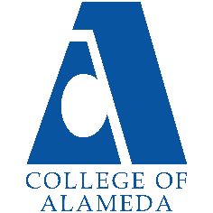
College of Alameda
2022-23 Program Review Template – Veteran’s Services

Lead Author:
LA SHAWN BRUMFIELD , JAMAR MEARS

Program Overview
Provide your service area’s mission statement. If your service area does not have a mission statement, what is your timeline for creating a mission statement?
The Veterans Resource Center Program provides Resources, supportive services & assistance to veterans and their eligible Family members in their pursuit towards a degree or certificate. Services provided to veterans and eligible family members in: Academic / career counseling, tutorial assistance, referral services on/off campus with job search, housing, Mental health and Wellness services and food.

List your program faculty and/or staff
La Shawn Brumfield – Coordinator / Certifying Official
Jamar Mears – Counselor
1 Student Worker

List the essential functions of your department, program or unit and provide a description of how the unit aligns with the college mission.
Function - Alignment w/ College Mission
Counseling - Counseling provides healthy dialogue between student and counselor, which produces an education plan that will guide the student to accomplishing their educational goal. Certify - By certifying veterans & dependents enrollment, this action provides monies to student that cover the bare and educational necessities for students to complete their program/degree. Resources & Referrals - The services provided by the VRC empowers student by providing educational necessities and assist in the students maintaining their mental & physical well-being

List your program goals from your most recent Program Review or APU. Then, provide an update on the status of the goal. Has your program achieved the goal? Have any of your goals been revised or any still in progress? Lastly, make sure to discuss which College or District goal your program goal aligns to: Alignment of Goals
If no program goals exist or if this is your first program review, create 2-3 goals and align them with a College or District goal.
Program Goal | Students will have a defined educational goal by the second semester of their enrollment.
Status: In-Progress or Complete? | complete
Which college or district goal is aligned with your program goal? | ILO Civic Responsibility

Program Goal | Students will understand how to access their educational Benefits
Status: In-Progress or Complete? | complete
Which college or district goal is aligned with your program goal? | ILO: Problem Solving and Decision Making

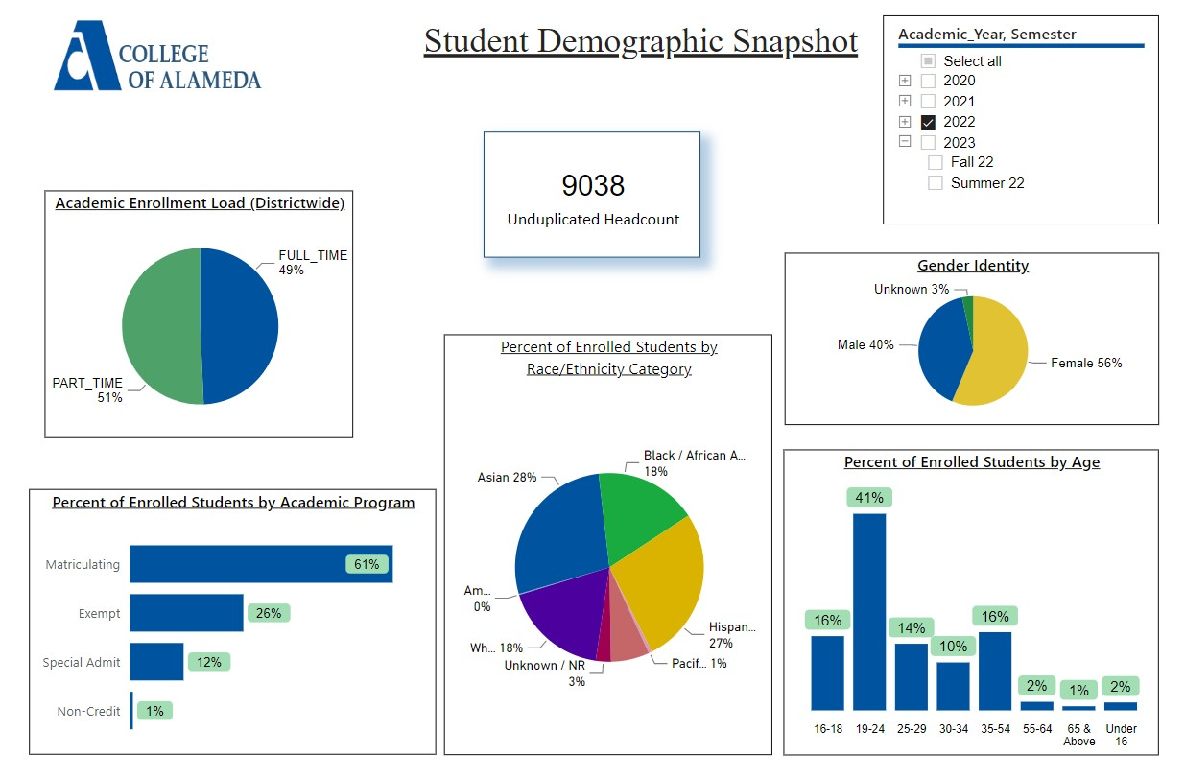
Demographics dashboard link

Do the students served by your service area differ from the College's overall student population? If so, elaborate on how the service area is identifying and addressing the needs of the student population
The Veteran population need all the basic needs (with a greater need for Mental Health Services) as the overall population at CoA, the difference outside of financial aid for those you draw from the Pell Grant is that they also are eligible for Veterans benefits (financial) and we connect them to those services by partnering with the Veterans Administration.

Which groups of students are underrepresented among those who received services, particularly by race/ethnicity and gender?
Pacific Islander, Female

Describe how external factors such as advisory board recommendations, federal or state mandates, changing demographics, and/or COVID-19 has impacted the support services your program or administrative unit provides.
How has your program addressed these changes or challenges to ensure students are supported and can continue to work towards meeting their educational goals? Consider implications for outreach, marketing, and/or communication, for example.
Covid – 19 has impacted the VRC services greatly and this is how the VRC Staff supported students:

Impact: The “orientation process, counseling, intake process (new students) & supportive supplies. The utilization of, zoom, phone, email & tabling (supplies) to connect students with services, goods and support.

As a result, More academic supplies (i.e.… Supplies packs to include, calculators, pencils, pens, paper, highlighters, etc...) and laptops were purchased to support veterans who had online courses.

Data Analysis
Consider your program’s course completion rates over the past three to five years (% of student who earned a grade of "C" or better).
How do the course completion rates for your program or discipline compare to your college's College-Set Standard for course completion of 67%?

College | Academic Year | Cohort | Headcount | Total Graded | Course Completion | Course Completion Rate
Alameda | 2022 | AVET Student Group | 46 | 207 | 128 | 62%
Alameda | 2021 | AVET Student Group | 54 | 245 | 155 | 63%
Alameda | 2020 | AVET Student Group | 75 | 358 | 255 | 71%
Alameda | 2019 | AVET Student Group | 79 | 461 | 327 | 71%
Alameda | 2018 | AVET Student Group | 86 | 492 | 354 | 72%

Before Covid-19 epidemic 2018 up to 2020, the course completion rate exceeded the college’s College set Standard at 71%. from Covid – 19 (March 2020) to present day, there’s was a drop by overall 4-5%.

On average the course retention rate (number of students are retained in the course) for College of Alameda has been 85% for the past three years. Examine the course retention rates for your program over the last three years. How does your program or discipline course retention rates compare to the college?
College | Academic Year | Cohort | Headcount | Total Graded | Retained | Retention Rate
Alameda | 2022 | AVET Student Group | 46 | 207 | 170 | 82%
Alameda | 2021 | AVET Student Group | 54 | 245 | 193 | 79%
Alameda | 2020 | AVET Student Group | 75 | 358 | 314 | 88%
Alameda | 2019 | AVET Student Group | 79 | 461 | 410 | 89%
Alameda | 2018 | AVET Student Group | 86 | 492 | 416 | 85%

During the 2019 -2020 years, the course retention rate has exceeded College of Alameda course retention rate at its highest of 89%. During the 2021 year, the course retention rate dropped to 79%.

Equity
College of Alameda continues to focus on access, equity, and success. The goal is to create an inclusive environment where all students can thrive and meet their education and career goals. In 2019 the Student Service Equity team analyzed data to identify groups that were disproportionately impacted in access, persistence, transfer rate, completion of transfer level English and Math, and goal completion.
- Access: Black/African American male students enroll at disproportionate rates. Additionally, female Black/ African American, disabled and LGBTQIA students enroll at disproportionate rates.
- Persistence: Female Black or African American, Latinx, foster youth, LGBTQIA and veteran students are persisting at disproportionate rates. Male Black or African American, foster youth and LGBTQIA students are also persisting at disproportionate rates. The most significant retention equity gap was with male foster youth students.
- Transfer to a Four-Year Institution: Female American Indian or Alaska Native, Native Hawaiian or other Pacific Islander and disabled students transferred at disproportionate rates. American Indian or Alaska Native, Black or African American, Filipino, Latinx, disabled, first generation and foster youth males also transferred at disproportionate rates.
- Complete both Transfer-level Math and English within the first year: Female foster youth complete both transfer level math and English at disproportionate rates. Additionally, Black/African American, Latinx, disabled, economically disadvantaged, foster youth and LGBTQIA males transfer at disproportionate rates.
- Vision 2022 Goal Completion: Asian, Black/African American, Latinx, foster youth, LGBTQIA, and veteran female students complete at disproportionate rates. American Indian or Alaska Native and LGBTQIA male students are also completing at disproportionate rates.
Discuss how your program has worked to address these equity gaps. Incorporate examples of your program data where applicable.

The VRC Counselor provide support to students by using a number of tools and resources, including, but not limited to the following: - Course Planning/Advising - Student Education Plans (SEP) - Transcript Review/Initial Evaluation - ASSIST (Major prep) - General Education Patterns - COA GE/CSU GE/IGETC - LRC (Learning Resource Center/Tutoring) - Health Services - Financial Aid - Program Referrals - EOPS/Puente/Umoja/MESA (Math Engineering Science Achievement) - Transfer Center - Veterans Resources - Alameda/Oakland Promise - SAS (formerly Services for Student with Disabilities) - College Application assistance - Excess Units/Probations/Dismissal/Prerequisite Clearance - Academic Renewal/CSU GE/IGETC Certification - Associate Degree/Certificate Petition

Student Learning Outcomes Assessment
List your Service Area Outcomes (SAOs) and/or Student Learning Outcomes (SLOs)
- Students will have a defined educational goal by the second semester of their enrollment measured by the number of updated Ed Plans
- Students will be knowledgeable about campus resources as measured by student survey
- measured by the number of students who are certified by the 4th week of school

Please provide a high-level summary and your program’s interpretation of your SLO findings over the past year.
More students are attending orientation. We are having a higher success rate because we are offering more orientation times and reaching out to students to remind them. Students are taking courses needed towards their academic goal. This fosters higher success rates among students achieving their academic goal faster and maximinning their VA benefits.

What were the most important things your department learned from assessment? Did implementation of your action plans result in better student learning?
increased awareness among faculty and staff, increased knowledge or skill in a particular area related to the program, and student satisfaction with VRC program.
We are reaching program level success rate. We will continue being persistent and supporting students.

Degrees & Certificates Conferred
For more information on awards: Degrees & Certificates Dashboard link
Increasing the number of students who complete a certificate or degree is a shared goal across CoA’s Ed Master Plan Goals, PCCD Goals, the Chancellor’s Office Vision for Success, the Student-Centered Funding Formula, and Guided Pathways.
How can your program contribute to increasing the number of certificates and degrees awarded over the next three years?
The VRC assist with increasing the number of certificates and degrees awarded by mandating that veteran students meeting with the counselor twice a semester and attend one orientation.

Engagement
How your department has has participated in college wide efforts such as committees, presentations, and departmental activities?
By joining Committees (SEA & Professional Development) , participated in Rock Enroll Activities, EOPS Bundle Enrollment Activity.

How has your department engaged in community activities, partnerships and/or collaborations?
The VRC has partner or collaborated with outside organization such as : Oakland Veterans Center, Swords to Plowshares, Disable American Veteran’s Department (DAV).

Prioritized Resource Requests Summary
In the boxes below, please add resource requests for your program. If there are no resource requested, leave the boxes blank.
Resource Category | Description/Justification | Total Estimated Cost
Personnel: Classified Staff | 1 classified staff (part or full time) we need “consistency” at the front desk to greet, assist w/ application (VA, school, etc..) schedule appts. work study has not been able to provide that resource on a consistent basis. | $4358.43
Personnel: Student Worker
Personnel: Part Time Faculty
Personnel: Full Time Faculty

Resource Category | Description/Justification | Total Estimated Cost
Professional Development: Department wide PD needed
Professional Development: Personal/Individual PD needed | Credit for Prior Learning (CPL): Veterans Transcripts
Supplies: Software | Microsoft Enterprise10 software | $3,000.00
Supplies: Books, Magazines, and/or Periodicals | Books: for Books Loan Program | $ 1500.00
Supplies: Instructional
Supplies: Non-Instructional
Supplies: Library Collections
Technology & Equipment | Computer refresh (6) computer lab & front desk | $7,000.00
Library materials/collections
Facilities: Classrooms/Labs
Facilities: Offices
Other

