**College of Alameda**

2022-23 Program Review Template – **Student Services**

**Lead Author:**

|  |
| --- |
| Ramaundo Vaughn-Director of Athletics |

**Program Overview**

Provide your service area’s mission statement. If your service area does not have a mission statement, what is your timeline for creating a mission statement?

|  |
| --- |
| The Athletic programs at the College of Alameda are committed to excellence in academics and athletics. We believe that competition, conducted according to the rules, good sportsmanship and honor, both on and off the site of competition, can bring out the best in the student-athlete. We strive to win, to achieve and to excel, but we believe that each individual student-athlete striving to do their best is the heart, spirit and purpose of competition. College of Alameda will provide the environment, facilities, support and opportunities for academic and athletic excellence |

List your program faculty and/or staff.

|  |
| --- |
| Ramaundo Vaughn-Director of Athletics (year 3)  Lauren Nieraeth- Head Women’s Volleyball Coach (year 1)  Ravi Bhambhra- Head Men’s Basketball Coach (year 3) |

List the essential functions of your department, program or unit and provide a description of how the unit aligns with the college mission.

|  |
| --- |
| The essential functions of the COA Department of Athletics are to provide opportunities for COA student athletes to participate in an intercollegiate environment that fosters learning, competition, good sportsmanship, coupled with teaching positive work ethics, teamwork and community building. We believe that this aligns with the mission of the college in that the college mission is to serve the educational needs of its diverse community by providing comprehensive and flexible programs and resources that empower students to achieve their goals. It is the belief of the Director of Athletics that our Athletics program is in proper alignment. |

List your program goals from your most recent Program Review or APU (Annual Program Update). Then, provide an update on the status of the goal. Has your program achieved the goal? Have any of your goals been revised or are any still in progress? Lastly, make sure to discuss which College or District goal your program goal aligns to.

If no program goals exist or if this is your first program review, create 2-3 goals and align them with a College or District goal.

|  |  |
| --- | --- |
| **Program Goal** | Assist student athletes to identify and achieve their personal, educational and athletic goals. |
| Status: In-Progress or Complete? | In progress. |
| Which college or district goal is aligned with your program goal? | Aligns to District Goal: Advance Student Access, Equity, and Success  Aligns to College Goal: Strengthen Data-driven / informed decision making |

|  |  |
| --- | --- |
| **Program Goal** | Provide counseling and other supportive services to enable students to select appropriate goals and to receive assistance in realizing those goals. |
| Status: In-Progress or Complete? | In progress. Dr. Robinson has been hired within the past year, and he can specifically assist our student athletes with understanding the proper courses to take in order to be eligible to compete and earn athletic and academic scholarships at the various levels of 4 year university/college athletics. Dr. Robinson is well versed in NCAA, NAIA, and NCCAA rules and regulations, which vary greatly from the normal student athlete transfer protocols. Just this past year, we had two mens basketball players receive athletic/academic basketball scholarships, with Dr. Robinson’s academic guidance playing a big part in those two young men being eligible to move on. |
| Which college or district goal is aligned with your program goal? | Aligns to District Goal: Advance Student Access, Equity, and Success  Aligns to College Goal: Increase access to college programs/coursework through collaboration with other PCCD colleges in redesigning college schedules & offerings |

|  |  |
| --- | --- |
| **Program Goal** |  |
| Status: In-Progress or Complete? |  |
| Which college or district goal is aligned with your program goal? |  |

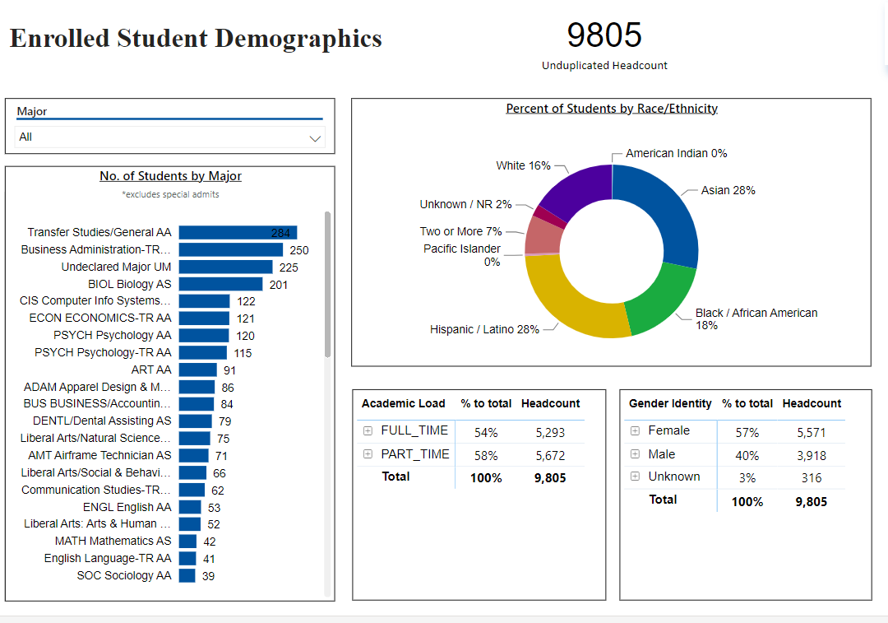

*Snapshot for Academic Year 2022-23*

[**Demographics dashboard link**](https://app.powerbi.com/view?r=eyJrIjoiMzVhNGU3YzAtNTIyNy00ZDZmLWIyYzMtYWIzMzllMGViZDQ5IiwidCI6ImVlYTE2YTE2LTQ4YWYtNDc3Yi05MTEzLTA1YjFjMDExMjNmZiIsImMiOjZ9&pageName=ReportSectionb4e116c96a753400a00c)

Do the students served by your service area differ from the College's overall student population? If so, elaborate on how the service area is identifying and addressing the needs of the student population.

|  |
| --- |
| The students served by our service area are in line with the College’s overall student population. |

Which groups of students are underrepresented among those who received services, particularly by race/ethnicity and gender?

|  |
| --- |
| The mens basketball team are underrepresented by race/ethnicity, and gender. |

Describe how external factors such as advisory board recommendations, federal or state mandates, changing demographics, and/or COVID-19 has impacted the support services your program or administrative unit provides.

How has your program addressed these changes or challenges to ensure students are supported and can continue to work towards meeting their educational goals?

|  |
| --- |
| Covid 19 played a significant role in our inability to recruit and maintain student athletes, especially players interested in intercollegiate womens volleyball.  As athletic recruiting varies greatly from the recruitment of the general student body population, I do not feel that any of the above factors have negatively impacted the support services that our programs offer.  What I would add is that COVID 19 seems to have affected the mental health of student athletes, and while we have not officially addressed it as a department, I would like, with the Deans blessing to be able to implement a policy that allows for student athletes to be able to take a specified number of “mental health days” where they can be excused from practice/participation without penalty. This is something that has been instituted at many 4 year institutions, and I would like to bring this to COA as well.  . |

**Data Analysis**

[**Course Success & Retention Rates – Student Services**](https://app.powerbi.com/view?r=eyJrIjoiNjk3NDJjOTItNzI5MS00MDhjLWJhN2EtZjcxNzU4OTBiZDBjIiwidCI6ImVlYTE2YTE2LTQ4YWYtNDc3Yi05MTEzLTA1YjFjMDExMjNmZiIsImMiOjZ9&pageName=ReportSection86d6f65e2fb41a73da4d)

Consider your program’s course completion rates over the past three to five years (% of students who earned a grade of "C" or better).

How does the course completion rate for your program compare to your college's College-Set Standard for course completion of 72% and the stretch goal of 78%?

|  |
| --- |
| The department of Athletics course completion rate is currently below the colleges set standard of 72%. It is my belief that this is due to the COVID 19 pandemic, and to a lesser extent, there not being a committed effort by the previous coaching staffs on academic excellence, as well as the dropping of the women’s volleyball program. Several athletes play sports at the community college level to try to attain athletic scholarships, and to add to their academic achievements. When COVID struck, not only did it shut down programs, but when those programs were brought back, student athletes had to go through extreme measures to participate. Having to wear masks, being separated from teammates, needing to do activities via zoom only greatly impacted these students mental health, as well as put limits on how much they could participate in their sport. Covid truly devastated community college student athletes and their academics. Also, what tends to happen in community college settings where an emphasis has not been placed on academic achievement, once the season of sport ends for some athletes, male basketball players in particular, if they are not anticipating receiving an athletics based scholarship, the interest in attending courses and achieving academic success wanes greatly. |

On average the course retention rate (number of students are retained in the course) for College of Alameda has been **85%** for the past three years. Examine the course retention rates for your program over the last three years. How does your program course retention rate compare to the college?

|  |
| --- |
| Over the course of the last 3 years, the course retention rate has been above the 85% threshold once, and in the last two years, it has dropped below that 85% mark. In the last two years, the retention rate has been 75% and 81%. I believe that last years 75% was partially due to the severe dysfunction within the mens basketball program, while the above explained COVID 19 issues also played a large part. |

**Equity**

College of Alameda continues to focus on access, equity, and success. The goal is to create an inclusive environment where all students can thrive and meet their education and career goals. In Spring 2023, the Student Equity and Achievement Expanded Committee analyzed data to identify groups that were disproportionately impacted in completion of transfer level English and Math, persistence, transfer rate, and goal completion.

* **Complete both Transfer-level Math and English within the first year:** 19% of all first-time students completed both transfer-level math and English. Black/African American & Latinx first-time students completed both transfer level math and English at disproportionate rates at 9% and 7% respectively.
* **Persistence:** 52% of first-time students persisted to the next primary term. Black or African American students persisted at a rate of 14% from first primary term to subsequent primary term.
* **Transfer to a Four-Year Institution:** Using 2016-17 data and excluding high school students, the proportion of first-time cohort students who earned 12 units or more and exited in the subsequent year and enrolled in any four-year postsecondary institution. 20% of first-time cohort students transferred to a four-year institution. Zero foster youth students (N=10) in the first-time cohort transferred.
* **Goal Completion:** 8% of first-time students (2017-18 cohort) attained one of the following earned an AA, AS, AAT, and or AST; earned a CCCCO approved credit certificate, earned a noncredit certificate, attained apprenticeship journey status, or transferred to four-year postsecondary institution. Male students completed at disproportionate rate of 3%.

Discuss how your program has worked to address these equity gaps. Incorporate examples of your program data where applicable.

|  |
| --- |
| While this information is both shocking and sad, it was unknown to the Director that these disparities existed in such low numbers.  With this being the Directors 2 review, we have not had the opportunity to address these gaps. It is my thought that we will again request a tutor for our student athletes, particularly those who are strong in the areas of Mathematics and English. We will have said tutor, as well as other academic support pay special attention to these particular courses taken by our student athletes and flag us when they see a drop off.  We will also gently suggest that our student athletes take these courses in the Fall semester, as success in the fall semester for athletes is a must in order to guarantee spring semester participation.  Please note that I also had the same request in my first review. |

**Student Learning Outcomes Assessment**

List your Service Area Outcomes (SAOs) and/or Student Learning Outcomes (SLOs)

|  |
| --- |
| This department has not been given access to SLO’s and SAO’s. If this information is provided, we can and will respond to these questions. |
|  |

Please provide a high-level summary and your program’s interpretation of your SAO/SLO findings over the past year.

|  |
| --- |
| SAME AS ABOVE |

What were the most important things your department learned from assessment? Did implementation of your action plans result in better student learning?

|  |
| --- |
| SAME AS ABOVE |

**Degrees & Certificates Conferred**

Increasing the number of students who complete a certificate or degree is a shared goal across CoA’s Ed Master Plan Goals, PCCD (Peralta Community College District) Goals, the Chancellor’s Office Vision for Success, the Student-Centered Funding Formula, and Guided Pathways.

How can your program contribute to increasing the number of certificates and degrees awarded over the next three years? For more information on awards click on the [**Degrees & Certificates Dashboard link**](https://app.powerbi.com/view?r=eyJrIjoiZjU2M2M5MzItOTcwZi00Y2U1LWJmODUtYTc0YjlhZGI2ZDhjIiwidCI6ImVlYTE2YTE2LTQ4YWYtNDc3Yi05MTEzLTA1YjFjMDExMjNmZiIsImMiOjZ9&pageName=ReportSectionde32556e136b0a8caccd)

|  |
| --- |
| Our department can continue to stress to our student athletes the value of earning their AA degrees, and the importance of matriculation to the four year level.  Our women’s volleyball program has just restarted after a year hiatus, and prior to that, we were ravaged by COVID, where there was no competition.  Mens basketball recruits several student athletes whose main goal is to move on with their athletic and academic careers at the four year level.  As the director, I will continue to stress to our head coaches to continue to recruit students whose goals are to matriculate to the 4 year level, while understanding that attaining their AA degrees is crucial in doing so. |

**Engagement**

How has your department participated in college wide efforts such as committees, presentations, and departmental activities?

|  |
| --- |
| As each worker in our department is a part time employee and not on campus as much as we would like to be, we have had difficulty in being able to put together schedules/time frames to properly give these issues the full attention that they deserve. |

How has your department engaged in community activities, partnerships and/or collaborations?

|  |
| --- |
| Having recently come off Covid, our department is still processing how best to engage in community activities.  We have shared the idea with our previous Dean that we believe that a great way to engage in the future with the community would be to hold a COA Poker tournament. This poker tournament will be a fundraising event, that will feature cash prizes, raffles and auctions. We believe that this will give the community an opportunity to visit our campus, meet our student athletes and engage in a way that they have not previously been accustomed to. The tournament would be run by Blue Dog, which is a company who frequently puts these types of events on. Having been a part of this type of event at a previous college, I am of the belief that it can not only raise a great deal of funds to allow for athletics to become more self-sufficient, but again, it will increase engagement and visibility for the college. |

**Prioritized Resource Requests Summary**

In the boxes below, please add resource requests for your program. If there are no resources requested, leave the boxes blank.

|  |  |  |
| --- | --- | --- |
| **Resource Category** | **Description/Justification** | **Total Estimated Cost** |
| Personnel: Classified Staff | Part time athletic trainer: A part time athletic trainer is an absolute necessity if we are going to have inter collegiate athletic programs. Trainers help student athletes with athletic preparation, injury prevention, injury diagnosis, in game maintenance and a host of other things. Trainers are mandated by the CCCAA for game participation. Trainers should also be available to athletic teams during their official season of sport for practice sessions.  Part time athletics tutor. Student athletes have rigorous schedules which not only include their class schedules, but also practice times which take up a great deal of their times throughout the day. It is requested that a part time tutor be made available to our student athletes during their seasons of sport for a minimum of 10 hours per week. The tutors should be proficient in math and english. | $20-25,000 |
| Personnel: Student Worker | Each program should be allowed a minimum of 1 student worker, with 2 being ideal, to help with issues such as laundry, keeping statistics during practice, and managerial type duties that teams need to properly run a collegiate athletics team. | WORK STUDY COST |
| Personnel: Part Time Faculty |  |  |
| Personnel: Full Time Faculty |  |  |

|  |  |  |
| --- | --- | --- |
| **Resource Category** | **Description/Justification** | **Total Estimated Cost** |
| Professional Development: Department wide PD (Professional Development) needed | Request that each head coach and the Director of Athletics be permitted to attend a minimum of one coaching clinic or professional development seminar for their respective position. We would like our department members to be able to continue to learn and grow professionally in their fields and stay current with the most up to date best practices and procedures. This would allow our department members to better serve our student athletes. | $3,000 |
| Professional Development: Personal/Individual PD needed | SAME AS ABOVE |  |
| Supplies: Software | Hudl software/camera. As the 3C2A requires the purchase of the Hudl software for women’s volleyball and mens basketball, the purchase of the camera will allow for all home athletic contests to be filmed and recorded, which is also required by the 3C2A. It will allow for livestreaming our contests as well. As an added security measure/protection for the college, the camera also records all activity in the gymnasium 24 hrs per day. This will also allow for added security and protect our interests against any fraudulent claims from outside groups using our facility. As we are starting to allow outside interests to utilize our facility more, we can see exactly what goes on. It is my belief that this is an extremely beneficial tool, as it protects our interests.  Synergy sports software, which is a required software tool by the 3C2A mens and womens’ basketball associations. | $5,000 |
| Supplies: Books, Magazines, and/or Periodicals | Championship Productions coaching videos. We would like our coaches to have access to the various training materials and videos. This will allow our coaches to best serve our student athletes by increasing and expanding their knowledge base with materials that they can come back to time and again. Coaches should be allowed to purchase a minimum of 3 videos per year. | $500 |
| Supplies: Instructional |  |  |
| Supplies: Non-Instructional | As the PA system in the gymnasium is currently non functioning, a new speaker/microphone combination need to be purchased. This will allow for proper announcing at our athletics contests, and will also allow for speakers to be heard during other events that will be held in our gymnasium. | $1,000-2,000 |
| Supplies: Library Collections |  |  |
| Technology & Equipment | Subscriptions to 3C2A mandated items such as synergy for Mens Basketball, Hudl for Women’s Volleyball. We also need video cameras with live streaming capabilities to move our programs forward and to be in line with the other 3C2A athletics programs. | $2,000 |
| Library materials/collections |  |  |
| Facilities: Classrooms/Labs |  |  |
| Facilities: Offices | A separate office for each athletic coach and the Director. Each coach should have their own space to meet with student athletes, recruits, parents,etc. The space should allow for privacy for private conversations, academic meetings, phone calls and coaches meetings. Offices should be of equal size as to prevent Title IX issues and each should be equipped equally. | UNKNOWN |
| Other |  |  |