**College of Alameda**

2022-23 Program Review Template – **Student Services**

**Lead Author:**

|  |
| --- |
| Jackie Vo |

**Program Overview**

Provide your service area’s mission statement. If your service area does not have a mission statement, what is your timeline for creating a mission statement?

|  |
| --- |
| The purpose of College of Alameda Financial Aid department is to provide equitable assistance to all students who apply for financial aid (grants, loans, scholarships, work-study) that will enable them to attain a certificate, a degree or to transfer to a four-year college. Our primary purpose is to ensure that all students have the opportunity to access and achieve their educational goals at College of Alameda.  The Financial Aid department recognizes and believes in equity through removing financial barriers for those farthest from opportunity. Therefore, we do not believe that students should be denied the opportunity to pursue a college education due to limited family resource contributions.    It is essential that the Financial Aid department provide assistance to address disparate educational needs through providing financial aid to assist those in greatest need to overcome financial barriers and achieve their goals. |

List your program faculty and/or staff.

|  |
| --- |
| Jackie Vo – Financial Aid Officer  Miriam Fernandez – Financial Aid Specialist  Jiayu He – Financial Aid Specialist  Laura Aguilar – Financial Aid Placement Assistant  Alexandra (Alex) Peto – Financial Aid Clerical Assistant (Hourly)  Qiman (Emma) Zheng – Financial Aid Placement Assistant (Hourly)  Alvin Ng– Work-study student  Kelsay Ramirez – Work-study student |

List the essential functions of your department, program or unit and provide a description of how the unit aligns with the college mission.

|  |
| --- |
| College of Alameda’s Financial Aid department’s goal is to provide streamlined and efficient services that are responsive to student needs. Most of the Financial Aid department’s decisions that relate to the administration of financial aid programs are made by the Financial Aid Officer beginning with the 2023-2024 academic year. Decisions before that time were made by the Director of Financial Aid. Many of these decisions require consultation with the Dean of Enrollment Services, Finance department, Business department, and other appropriate student support services. The Financial Aid Officer works closely with all the important stakeholders to ensure that students receive outstanding service and receive their money in an expeditious manner. |

List your program goals from your most recent Program Review or APU (Annual Program Update). Then, provide an update on the status of the goal. Has your program achieved the goal? Have any of your goals been revised or are any still in progress? Lastly, make sure to discuss which College or District goal your program goal aligns to.

If no program goals exist or if this is your first program review, create 2-3 goals and align them with a College or District goal.

|  |  |
| --- | --- |
| **Program Goal** | Work towards increasing Financial Aid applicants by 3% |
| Status: In-Progress or Complete? | Complete |
| Which college or district goal is aligned with your program goal? | Increase access to college programs  Advance Student Access, Equity, and Success  Increase retention and persistence rate  SCFF Student Centered Funding Formula |

|  |  |
| --- | --- |
| **Program Goal** | Increase the number of Pell recipients by 3% |
| Status: In-Progress or Complete? | Complete |
| Which college or district goal is aligned with your program goal? | SCFF Student Centered Funding Formula  Advance Student Access, Equity, and Success  Increase retention and persistence rate |

|  |  |
| --- | --- |
| **Program Goal** | Closing equity gaps for disproportionate groups through more financial aid activities twice a month |
| Status: In-Progress or Complete? | In-progress |
| Which college or district goal is aligned with your program goal? | SCFF Student Centered Funding Formula  Advance student success  Persistence rate |

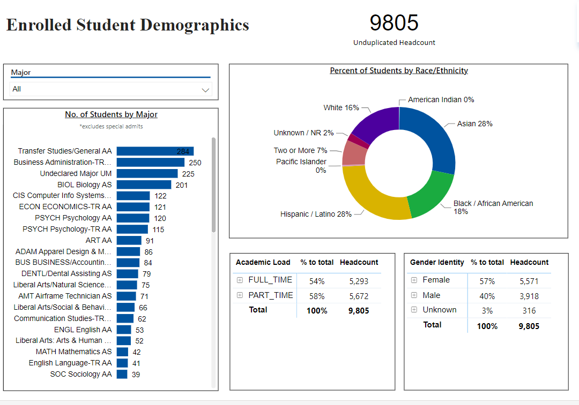

*Snapshot for Academic Year 2022-23*

[**Demographics dashboard link**](https://app.powerbi.com/view?r=eyJrIjoiMzVhNGU3YzAtNTIyNy00ZDZmLWIyYzMtYWIzMzllMGViZDQ5IiwidCI6ImVlYTE2YTE2LTQ4YWYtNDc3Yi05MTEzLTA1YjFjMDExMjNmZiIsImMiOjZ9&pageName=ReportSectionb4e116c96a753400a00c)

Do the students served by your service area differ from the College's overall student population? If so, elaborate on how the service area is identifying and addressing the needs of the student population.

|  |
| --- |
| Yes, the students served by our service area are the same from the College’s overall student population. |

Which groups of students are underrepresented among those who received services, particularly by race/ethnicity and gender?

|  |
| --- |
| Black/African American and Hispanic/Latino men are groups of students who received services from the Financial Aid department. |

Describe how external factors such as advisory board recommendations, federal or state mandates, changing demographics, and/or COVID-19 has impacted the support services your program or administrative unit provides.

How has your program addressed these changes or challenges to ensure students are supported and can continue to work towards meeting their educational goals?

|  |
| --- |
| The Student-Centered Funding Formula (SCFF) has expanded how we conduct outreach to students at the College of Alameda. We ensure that we are targeting populations that have experienced a decrease in enrollment. Federal Pell Grant eligible students have continued to decline over the years, especially during the COVID-19 pandemic. We have implemented outreach efforts that focus on encouraging them to complete their FAFSAs and submit documents to complete their financial aid files.  The Financial Aid department now has an Outreach and In-reach Committee that meets biweekly to plan the outreach efforts using the Ocelot texting service. The populations that they focus on are: (1) students that are enrolled, but didn’t submit a FAFSA; and (2) students that may be eligible for financial aid but didn’t complete their financial aid file, etc. |

**Data Analysis**

[**Course Success & Retention Rates – Student Services**](https://app.powerbi.com/view?r=eyJrIjoiNjk3NDJjOTItNzI5MS00MDhjLWJhN2EtZjcxNzU4OTBiZDBjIiwidCI6ImVlYTE2YTE2LTQ4YWYtNDc3Yi05MTEzLTA1YjFjMDExMjNmZiIsImMiOjZ9&pageName=ReportSection86d6f65e2fb41a73da4d)

Consider your program’s course completion rates over the past three to five years (% of students who earned a grade of "C" or better).

How does the course completion rate for your program compare to your college's College-Set Standard for course completion of 72% and the stretch goal of 78%?

|  |
| --- |
| N/A |

On average the course retention rate (number of students are retained in the course) for College of Alameda has been **85%** for the past three years. Examine the course retention rates for your program over the last three years. How does your program course retention rate compare to the college?

|  |
| --- |
| N/A |

**Equity**

College of Alameda continues to focus on access, equity, and success. The goal is to create an inclusive environment where all students can thrive and meet their education and career goals. In Spring 2023, the Student Equity and Achievement Expanded Committee analyzed data to identify groups that were disproportionately impacted in completion of transfer level English and Math, persistence, transfer rate, and goal completion.

* **Complete both Transfer-level Math and English within the first year:** 19% of all first-time students completed both transfer-level math and English. Black/African American & Latinx first-time students completed both transfer level math and English at disproportionate rates at 9% and 7% respectively.
* **Persistence:** 52% of first-time students persisted to the next primary term. Black or African American students persisted at a rate of 14% from first primary term to subsequent primary term.
* **Transfer to a Four-Year Institution:** Using 2016-17 data and excluding high school students, the proportion of first-time cohort students who earned 12 units or more and exited in the subsequent year and enrolled in any four-year postsecondary institution. 20% of first-time cohort students transferred to a four-year institution. Zero foster youth students (N=10) in the first-time cohort transferred.
* **Goal Completion:** 8% of first-time students (2017-18 cohort) attained one of the following earned an AA, AS, AAT, and or AST; earned a CCCCO approved credit certificate, earned a noncredit certificate, attained apprenticeship journey status, or transferred to four-year postsecondary institution. Male students completed at disproportionate rate of 3%.

Discuss how your program has worked to address these equity gaps. Incorporate examples of your program data where applicable.

|  |
| --- |
| The Financial Aid Office has partnered with other departments on campus to ensure intentional delivery of financial aid information to populations that have been disproportionately impacted in access, persistence, and transfer to a four-year institution. The activities include the following:   * Worked with EOPS/CARE/NextUp/CalWorks department to disburse categorical funds as soon as possible. * Expediated financial aid review for foster youth students. * Met with SAS students and their counselors upon request. * Partnered with faculty to conduct class presentations on financial aid * Partnered with PUENTE to conduct class presentations on financial aid |

**Student Learning Outcomes Assessment**

List your Service Area Outcomes (SAOs) and/or Student Learning Outcomes (SLOs)

|  |
| --- |
| Our SLOs are:   * Process all financial aid files within 3-4 weeks   The Financial Aid Office worked together on the Student/Service Area Learning Outcomes by collaborating on the survey for the front counter. As a team, we also made sure that the survey was accessibility friendly and clear and easy for students to understand.  We have been successful in meeting the goal of processing files within 3-4 weeks.   * Improving services to 85% for “satisfied” or “very satisfied”   Based on our surveys, we achieved 87%. We plan to continue improving our service to students. |

Please provide a high-level summary and your program’s interpretation of your SAO/SLO findings over the past year.

|  |
| --- |
| During the past year, the financial aid staff processed the files below the 3-4 weeks mark because the Department of Education waived the household and income verification. For that reason, students’ files were being processed within 1-2 weeks. |

What were the most important things your department learned from assessment? Did implementation of your action plans result in better student learning?

|  |
| --- |
| The Financial Aid department learned that the Department of Education's flexibility helped achieve our goal.  However, we know that with the FAFSA Simplification Act, processing students' financial aid files will take less time. |

**Degrees & Certificates Conferred**

Increasing the number of students who complete a certificate or degree is a shared goal across CoA’s Ed Master Plan Goals, PCCD (Peralta Community College District) Goals, the Chancellor’s Office Vision for Success, the Student-Centered Funding Formula, and Guided Pathways.

How can your program contribute to increasing the number of certificates and degrees awarded over the next three years? For more information on awards click on the [**Degrees & Certificates Dashboard link**](https://app.powerbi.com/view?r=eyJrIjoiZjU2M2M5MzItOTcwZi00Y2U1LWJmODUtYTc0YjlhZGI2ZDhjIiwidCI6ImVlYTE2YTE2LTQ4YWYtNDc3Yi05MTEzLTA1YjFjMDExMjNmZiIsImMiOjZ9&pageName=ReportSectionde32556e136b0a8caccd)

|  |
| --- |
| The Financial Aid Office is a partner in making sure that student success is achievable without the barrier of affordability. Student success includes ensuring that students are making Satisfactory Academic Progress (SAP) for financial aid eligibility. We partner with academic advising counselors for the SAP committee. This partnership contributes to a fair and balanced evaluation of SAP appeals and helps financial aid team members understand the academic challenges for student, and enhances ways that we can support their progress. This partnership also supports efforts to show the students that we are all engaged in their academic success.  We will continue to contribute to increasing the number of certificates and degrees awarded over the next three years by doing the following:   * Increasing FAFSA and Dream Act numbers * Increasing CCPG numbers * Increasing SSCG numbers * Partnering with faculty to include financial aid education for classroom presentations * SAP counseling for students on warning status * Promoting financial aid using social media for in-reach and outreach activities * Ensure that students receive their financial aid in a timely manner so they can have the funds for their educational goals. * Connect students to additional resources to support their basic needs, such as housing, food, mental health, etc. |

**Engagement**

How has your department participated in college wide efforts such as committees, presentations, and departmental activities?

|  |
| --- |
| The Financial Aid Office sees the importance of being visible in other capacities that impact the success of the college. We have participated in college wide efforts in the following ways:   * Collaborated with Puente program to outreach to students * Classroom presentation with English, Math, Puente Cohorts * Collaboration with Umoja, EOPS, NextUp programs * Served on hiring committees |

How has your department engaged in community activities, partnerships and/or collaborations?

|  |
| --- |
| The Financial Aid Office (FAO) sees the importance of being visible in the community to educate about the financial aid process. We are also vital in the recruitment process for prospective students. We understand that outreach efforts are particularly crucial since the number of financial aid recipients has been on the decline for the past few years. As a result, the FAO has adopted a multi-pronged approach to target specific populations for our outreach efforts.  Our current students and the community at large receive targeted outreach through specialized campus events as well as financial aid workshops offered twice-per-week in-person and virtually. Additionally, we partner with the East Bay Cash for College Coalition to plan and strategize ways to strengthen collaborative relationships with high schools throughout the bay area. |

**Prioritized Resource Requests Summary**

In the boxes below, please add resource requests for your program. If there are no resources requested, leave the boxes blank.

|  |  |  |
| --- | --- | --- |
| **Resource Category** | **Description/Justification** | **Total Estimated Cost** |
| Personnel: Classified Staff | Financial Aid & Placement Assistant----  The Financial Aid Department used to have the Sr. Clerical Assistant. With the help of the Financial Aid & Placement Assistant, the Financial Aid Specialists can focus on their duties and ensure the students are getting their financial aid funds promptly to purchase books and supplies. | $70,000 |
| Personnel: Student Worker |  |  |
| Personnel: Part Time Faculty |  |  |
| Personnel: Full Time Faculty |  |  |

|  |  |  |
| --- | --- | --- |
| **Resource Category** | **Description/Justification** | **Total Estimated Cost** |
| Professional Development: Department wide PD (Professional Development) needed | CCCSFAAA 2024 Conference | $5,000 |
| Professional Development: Personal/Individual PD needed | NASFAA Leadership conference | $4,000 |
| Supplies: Software |  |  |
| Supplies: Books, Magazines, and/or Periodicals |  |  |
| Supplies: Instructional | KAHOOT subscription | $300 |
| Supplies: Non-Instructional | Canva subscription | $180 |
| Supplies: Library Collections |  |  |
| Technology & Equipment |  |  |
| Library materials/collections |  |  |
| Facilities: Classrooms/Labs |  |  |
| Facilities: Offices |  |  |
| Other |  |  |