**College of Alameda**

**2022-23 Program Review Health & Wellness Center – Student Services**

**Lead Author:**

|  |
| --- |
| Lisa Sawadogo, Health Services Coordinator |

**Program Overview**

Provide your service area’s mission statement. If your service area does not have a mission statement, what is your timeline for creating a mission statement?

|  |
| --- |
| College of Alameda is committed to furthering the equality of educational opportunity and success for all students by providing access to health services which promote the physical, emotional, social, and spiritual well-being of its students. This well-being contributes to the educational aim of our community colleges by promoting student retention and academic success. |

List your program faculty and/or staff.

|  |
| --- |
| Lisa Sawadogo, Health Services Coordinator – Full-Time Faculty  Erica Gibbons, Associate Marriage & Family Therapist – Part-Time Faculty (FDIP)  Jasmine Sharma, MFT Trainee – Part -Time Volunteer  Jay Conui, MFT Trainee – Part-Time Volunteer  Reynaldo Vargas, MFT Trainee – Part-Time Volunteer  Community partner: Roots Clinic  Nurse Practitioner/Registered Nurse  Patient Health Navigator  The district made the decision to centralize all medical services to Laney College and call it the Peralta Wellness Center. The Roots Clinic is currently providing medical services for all currently enrolled Peralta students from all four colleges Monday – Friday from 9:00a.m. – 5:00p.m. on Laney’s campus.  College of Alameda mental health services are provided remotely and in-person Monday-Friday 8:30a.m. – 4:30p.m.  *In previous years, medical services and acupuncture/massage were offered on a part-time basis across all the Peralta Colleges. Due to the pandemic, the district re-evaluated services and delivery. |

List the essential functions of your department, program or unit and provide a description of how the unit aligns with the college mission.

|  |
| --- |
| The essential functions of wellness services are to provide students with access to services which promote physical, emotional, social, and spiritual well-being. Our department provides mental health wellness support for students by providing individual counseling sessions, support groups, crisis intervention, consultation, referrals, and campus wide workshops and training.  The medical services provided through our community clinic partner Roots include, but are not limited to first aid, pregnancy testing, health education, smoking cessation, health and wellness counseling, triage, flu shots, COVID-19 testing, health insurance counseling, and referrals to off-site facilities.  A part-time faculty through the Faculty Diversity Internship Program was hired to support mental health services, as well as 3 MFT Trainee volunteer graduate students. During the 2022-2023 academic year, 610 counseling appointments were utilized. A total of 96 unduplicated students were supported by the individualized mental health counseling services. These numbers increase every year. Please note that the Health Services Coordinator is the only full-time faculty overseeing the above mental health services' essential functions; there is currently no part-time faculty or classified staff assigned to support the department.  Health Services aligns with the greater college mission statement as it provides services that address barriers to equal access and ability to complete courses. |

List your program goals from your most recent Program Review or APU (Annual Program Update). Then, provide an update on the status of the goal. Has your program achieved the goal? Have any of your goals been revised or are any still in progress? Lastly, make sure to discuss which College or District goal your program goal aligns to.

If no program goals exist or if this is your first program review, create 2-3 goals and align them with a College or District goal.

|  |  |
| --- | --- |
| **Program Goal** | Update or maintain service area outcomes annually and meet or exceed all service area outcome measures for health services. |
| Status: In-Progress or Complete? | Complete |
| Which college or district goal is aligned with your program goal? | College: Strengthen data driven/informed decision-making District: Develop and manage resources to advance our mission |

|  |  |
| --- | --- |
| **Program Goal** | Increase offering of student success workshops related to wellness and health education from 2 to 4 annually. |
| Status: In-Progress or Complete? | Complete |
| Which college or district goal is aligned with your program goal? | College: Increase retention and persistence rates District: Advance student access, equity, and success |

|  |  |
| --- | --- |
| **Program Goal** | Assess success at providing culturally sensitive services for students by surveying students about their experience with wellness services. |
| Status: In-Progress or Complete? | In-Progress |
| Which college or district goal is aligned with your program goal? | College: Increase retention and persistence rates District: Advance student access, equity, and success |

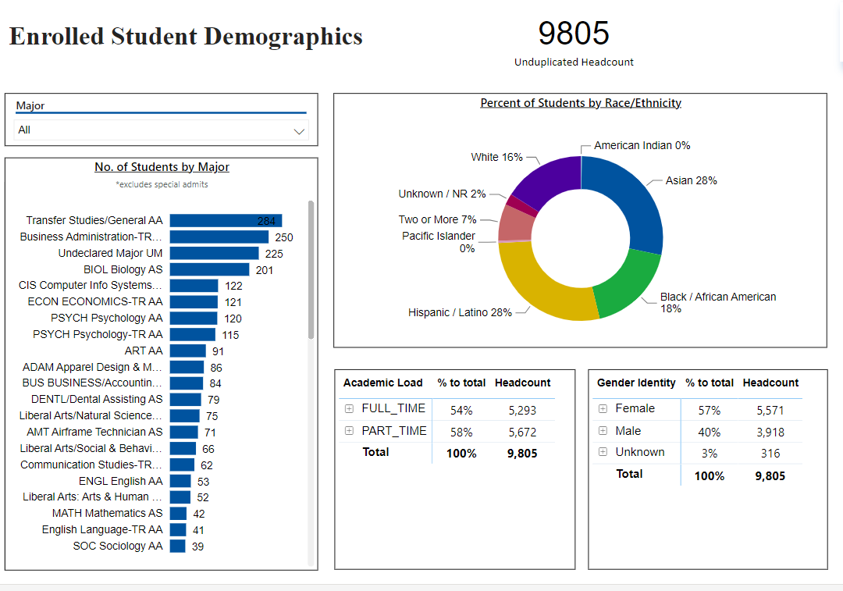

*Snapshot for Academic Year 2022-23*

[**Demographics dashboard link**](https://app.powerbi.com/view?r=eyJrIjoiMzVhNGU3YzAtNTIyNy00ZDZmLWIyYzMtYWIzMzllMGViZDQ5IiwidCI6ImVlYTE2YTE2LTQ4YWYtNDc3Yi05MTEzLTA1YjFjMDExMjNmZiIsImMiOjZ9&pageName=ReportSectionb4e116c96a753400a00c)

Do the students served by your service area differ from the College's overall student population? If so, elaborate on how the service area is identifying and addressing the needs of the student population.

|  |
| --- |
| African American/Black:  20 students  Asian: 23 students  Hispanic/Latinx:  31 students  White:  13 students  More than one race:  5 students  Declined to state:  4 students  In terms of ethnicity, the largest group of students served by Health Services are Hispanic/Latinx students, followed by the Asian student population, African American/Black population, and the students who identify as multi-ethnic. The students served by the Health & Wellness Cener are representative of the overall College of Alameda demographic data. |

Which groups of students are underrepresented among those who received services, particularly by race/ethnicity and gender?

|  |
| --- |
| Even though the race/ethnicity demographic data mirrors the overall campus data, there is always ongoing work to be done to ensure that College of Alameda students feel comfortable reaching out for services. The data focused on gender highlights that 69% of students identify as female, 20% identify as male, and 11% identify as gender-fluid, non-binary, and transgender. |

Describe how external factors such as advisory board recommendations, federal or state mandates, changing demographics, and/or COVID-19 has impacted the support services your program or administrative unit provides.

How has your program addressed these changes or challenges to ensure students are supported and can continue to work towards meeting their educational goals?

|  |
| --- |
| Every year there has been a significant increase in the number of students reaching out for support, and the acuity of mental health challenges are extreme. This year the staff was increased to 3 MFT Trainees and 1 – Part-time FDIP Mental Health Counselor Faculty.  The Part-Time Faculty hired through FDIP was able to lead a therapy support group for LGBTQ+ students both fall 2022 and spring 2023 semesters.  COVID-19 allowed students to request remote appointments and allowed for more access/flexibility to mental health services. The Wellness Center was able to pivot and implement/pilot a new electronic health record system called Advanced MD successfully. |

**Data Analysis**

[**Course Success & Retention Rates – Student Services**](https://app.powerbi.com/view?r=eyJrIjoiNjk3NDJjOTItNzI5MS00MDhjLWJhN2EtZjcxNzU4OTBiZDBjIiwidCI6ImVlYTE2YTE2LTQ4YWYtNDc3Yi05MTEzLTA1YjFjMDExMjNmZiIsImMiOjZ9&pageName=ReportSection86d6f65e2fb41a73da4d)

Consider your program’s course completion rates over the past three to five years (% of students who earned a grade of "C" or better).

How does the course completion rate for your program compare to your college's College-Set Standard for course completion of 72% and the stretch goal of 78%?

|  |
| --- |
| Unable to obtain the data at this time due to no current College Researcher. |

On average the course retention rate (number of students are retained in the course) for College of Alameda has been **85%** for the past three years. Examine the course retention rates for your program over the last three years. How does your program course retention rate compare to the college?

|  |
| --- |
| Unable to obtain the data at this time due to no current College Researcher. |

**Equity**

College of Alameda continues to focus on access, equity, and success. The goal is to create an inclusive environment where all students can thrive and meet their education and career goals. In Spring 2023, the Student Equity and Achievement Expanded Committee analyzed data to identify groups that were disproportionately impacted in completion of transfer level English and Math, persistence, transfer rate, and goal completion.

* **Complete both Transfer-level Math and English within the first year:** 19% of all first-time students completed both transfer-level math and English. Black/African American & Latinx first-time students completed both transfer level math and English at disproportionate rates at 9% and 7% respectively.
* **Persistence:** 52% of first-time students persisted to the next primary term. Black or African American students persisted at a rate of 14% from first primary term to subsequent primary term.
* **Transfer to a Four-Year Institution:** Using 2016-17 data and excluding high school students, the proportion of first-time cohort students who earned 12 units or more and exited in the subsequent year and enrolled in any four-year postsecondary institution. 20% of first-time cohort students transferred to a four-year institution. Zero foster youth students (N=10) in the first-time cohort transferred.
* **Goal Completion:** 8% of first-time students (2017-18 cohort) attained one of the following earned an AA, AS, AAT, and or AST; earned a CCCCO approved credit certificate, earned a noncredit certificate, attained apprenticeship journey status, or transferred to four-year postsecondary institution. Male students completed at disproportionate rate of 3%.

Discuss how your program has worked to address these equity gaps. Incorporate examples of your program data where applicable.

|  |
| --- |
| Health & Wellness Services is committed to recruiting and supporting MFT Trainees and FDIP’s that represent College of Alameda’s diverse campus community. We currently have MOU’s with St. Mary’s, the Wright Institute, University of San Francisco, Cal State East Bay, SF State University, and UMass Global to ensure that there is a wide range of applicants to provide mental health services. We prioritize recruiting BIPOC and LGBTQ+ candidates.  Health & Wellness Services partners with on-campus and community organizations in order to best connect our students to resources. There is a collaboration with all the learning communities and support services for ease of referrals and support for students (Veteran’s Resource Center, PUENTE/ACCESSO, C2C, and the Undocumented Student Success Program, etc.)  Our community partner, the Roots Clinic, aligns with our access, equity and success roles in providing medical services for our students. Their vision and mission are the following: “Founded in Oakland, California, the mission of Roots Community Health Center is to uplift those impacted by systemic inequities and poverty. We accomplish this through medical and behavioral health care, health navigation, workforce enterprises, housing, outreach, and advocacy. We envision a United States where all communities of African descent are resilient, healthy, self-sufficient, and self-determined. We are proudly serving the greater Bay Area and are expanding to other CA regions.” Please see their website for more information: <https://rootsclinic.org/> |

**Student Learning Outcomes Assessment**

List your Service Area Outcomes (SAOs) and/or Student Learning Outcomes (SLOs)

|  |
| --- |
| 1. Students will be able to utilize the necessary information, resources, and options available for them to make sound educational, emotional, and health-related lifelong decisions. 2. Health & Wellness Services will provide individual mental health counseling services that will increase healthy coping strategies to manage stress and address personal concerns. |

Please provide a high-level summary and your program’s interpretation of your SAO/SLO findings over the past year.

|  |
| --- |
| An online survey was distributed at the end of fall 2022 and spring 2023 to evaluate students’ experience with mental health counseling services.  When asked the question: Do you feel that you are better able to cope with problems after participating in counseling? 69% of students stated “Yes” and 31% said “Maybe”    When asked: Do you feel that you are better able to make healthier educational, emotional, or health related decisions after participating in counseling? 88% of students reported “yes” and 12% reported “maybe.”      When asked the question: Did accessing mental health services help you to stay enrolled in classes? 75% of students responded, “very likely” and 25% responded “likely” |

What were the most important things your department learned from assessment? Did implementation of your action plans result in better student learning?

|  |
| --- |
| Students who have accessed mental health counseling services overwhelmingly reported positively benefiting from their experience. Students reported feeling like the mental health support increased their ability to make healthy decisions and improved implementing coping strategies. Students also gave valuable feedback around mental health related topics they would appreciate learning more about.  Moving forward, the Health & Wellness Center will work to improve student evaluation responses. Only 20% of students responded to the surveys. |

**Degrees & Certificates Conferred**

Increasing the number of students who complete a certificate or degree is a shared goal across CoA’s Ed Master Plan Goals, PCCD (Peralta Community College District) Goals, the Chancellor’s Office Vision for Success, the Student-Centered Funding Formula, and Guided Pathways.

How can your program contribute to increasing the number of certificates and degrees awarded over the next three years? For more information on awards click on the [**Degrees & Certificates Dashboard link**](https://app.powerbi.com/view?r=eyJrIjoiZjU2M2M5MzItOTcwZi00Y2U1LWJmODUtYTc0YjlhZGI2ZDhjIiwidCI6ImVlYTE2YTE2LTQ4YWYtNDc3Yi05MTEzLTA1YjFjMDExMjNmZiIsImMiOjZ9&pageName=ReportSectionde32556e136b0a8caccd)

|  |
| --- |
| Health Services provides a lifeline for students in pursuing their educational goals. We’re committed to supporting students and strategizing how to best capture data to display our department’s contribution moving forward. |

**Engagement**

How has your department participated in college wide efforts such as committees, presentations, and departmental activities?

|  |
| --- |
| There is participation and attendance at the following:  -District Health & Wellness monthly meetings  -Weekly licensed clinician consultation meetings and discussing best practices  -Monthly Student Services meetings  -Flex Day events  -Offering campus wide workshops for both students and faculty/staff on important mental health related topics.  Note that it can be difficult for a one-person team to manage daily operations of the department, as well as make time to connect with larger college wide efforts and collaboration. |

How has your department engaged in community activities, partnerships and/or collaborations?

|  |
| --- |
| As mentioned above, our partnership with Roots Clinic has been invaluable in providing our students with medical services. It has also been critical to stay connected with community referrals and up-to-date resources. Some of the agencies we work with consistently: Alameda County ACCESS line, Crisis Support Services, Sausal Creek Outpatient Stabilization, Family Violence Law Center, Freedom Community Clinic, Korean Community Center of the East Bay, and Summit Bereavement Services.  We also have significant partnerships with multiple graduate schools to ensure that we have a consistent diverse pool of MFT Trainee applicants to provide direct mental health services for our students. We currently have MOU’s with St. Mary’s, USF, San Francisco State University, The Wright Institute, and Cal State East Bay.  In order to provide relevant and culturally sensitive training for the MFT Trainee’s, the Health Service Coordinator brings in a variety of community agencies and experts. A few training examples include Crisis Support Services, EMDR, Early Psychosis, and Trauma Informed Care. |

**Prioritized Resource Requests Summary**

In the boxes below, please add resource requests for your program. If there are no resources requested, leave the boxes blank.

|  |  |  |
| --- | --- | --- |
| **Resource Category** | **Description/Justification** | **Total Estimated Cost** |
| Personnel: Classified Staff |  |  |
| Personnel: Student Worker | 2 Student Navigators – There’s a need for consistent student presence to do outreach, classroom presentations, and create a social media presence for the Wellness Center | $7,500 |
| Personnel: Part Time Faculty | 1 Part-Time Mental Health Counselor Faculty  3 Part-Time FDIP (Faculty Diversity Internship Program) Consistent increase in severe mental health needs of students and need for experienced, licensed therapist to assist with crisis assessments and on-going support for students. There is also a need for licensed mental health counselors to cover summer hours and supervision of interns.  2 – MFT Trainees  Need for BIPOC and LGBTQ+ counselors to support diverse campus community and provide individual and group counseling support. | $78,000  $81,000  $12,000 |
| Personnel: Full Time Faculty | There is a need for an 11- month contract and extra service. The Health Services Coordinator position is a big job with multiple essential functions. The demand for mental health and wellness services will continue to grow. The job is impossible to do in a 10-month, 30 hour per week contract.  1 – Full-Time Mental Health Specialist | 11-month contract $10,000  Extra Service - $6,100  $145,000 |

|  |  |  |
| --- | --- | --- |
| **Resource Category** | **Description/Justification** | **Total Estimated Cost** |
| Professional Development: Department wide PD (Professional Development) needed | Graduate level MFT Trainees and FDIP’s provide the majority of direct individual counseling sessions for students and need up-to-date information on best practices in the field including, but not limited to: law & ethics, trauma informed care, and cultural diversity related topics | $1400 |
| Professional Development: Personal/Individual PD needed | Licensed Professional Clinical Counselors are required to obtain 36 hours of continuing education every two years in order to maintain the license and continue the ability to supervise MFT Trainees/Interns. | $750 |
| Supplies: Software |  |  |
| Supplies: Books, Magazines, and/or Periodicals |  |  |
| Supplies: Instructional |  |  |
| Supplies: Non-Instructional |  |  |
| Supplies: Library Collections |  |  |
| Technology & Equipment | Smart Classroom – In our new space there is a need to have the ability to present workshops and provide trainings for the campus community. | $15,000 |
| Library materials/collections |  |  |
| Facilities: Classrooms/Labs |  |  |
| Facilities: Offices |  |  |
| Other |  |  |