**College of Alameda**

2022-23 Program Review Template – **Student Services**

**Lead Author:**

|  |
| --- |
| Nickey Heredia |

**Program Overview**

Provide your service area’s mission statement. If your service area does not have a mission statement, what is your timeline for creating a mission statement?

|  |
| --- |
| Outreach serves as the first point of contact, engages students and potential students, provides resources, options, and aids students, regardless of their circumstances and/or background in completing a successful enrollment process |

List your program faculty and/or staff.

|  |
| --- |
| There has been a vacancy in the Outreach department. Hourly Outreach Specialist, Crystal Baasanjav, supported outreach from the months of Feb – June in 22-23.  The department usually consists of 1.0 FTE Outreach Specialist and 3-5 student workers hired through FWS or with other funds if available. |

List the essential functions of your department, program or unit and provide a description of how the unit aligns with the college mission.

|  |
| --- |
| Outreach to prospective students regarding College of Alameda’s programs and Degree/Certificate/ Transfer opportunities. Provide prospective students with application support and connect them to resources that can support their enrollment process.  Represent College of Alameda at community events. |

List your program goals from your most recent Program Review or APU (Annual Program Update). Then, provide an update on the status of the goal. Has your program achieved the goal? Have any of your goals been revised or are any still in progress? Lastly, make sure to discuss which College or District goal your program goal aligns to.

If no program goals exist or if this is your first program review, create 2-3 goals and align them with a College or District goal.

|  |  |
| --- | --- |
| **Program Goal** | Provide targeted support and information to the public regarding the application process, orientation, and counseling (ensure information is consistently updated, platforms consistently re-evaluated). |
| Status: In-Progress or Complete? | CoA was able to provide Mobile CoA to high schools/community again in 22-23 after a hiatus due to Covid-19. |
| Which college or district goal is aligned with your program goal? | Providing quality educational and student support services that result in equitable student access to educational opportunities. |

|  |  |
| --- | --- |
| **Program Goal** |  |
| Status: In-Progress or Complete? |  |
| Which college or district goal is aligned with your program goal? |  |

|  |  |
| --- | --- |
| **Program Goal** |  |
| Status: In-Progress or Complete? |  |
| Which college or district goal is aligned with your program goal? |  |

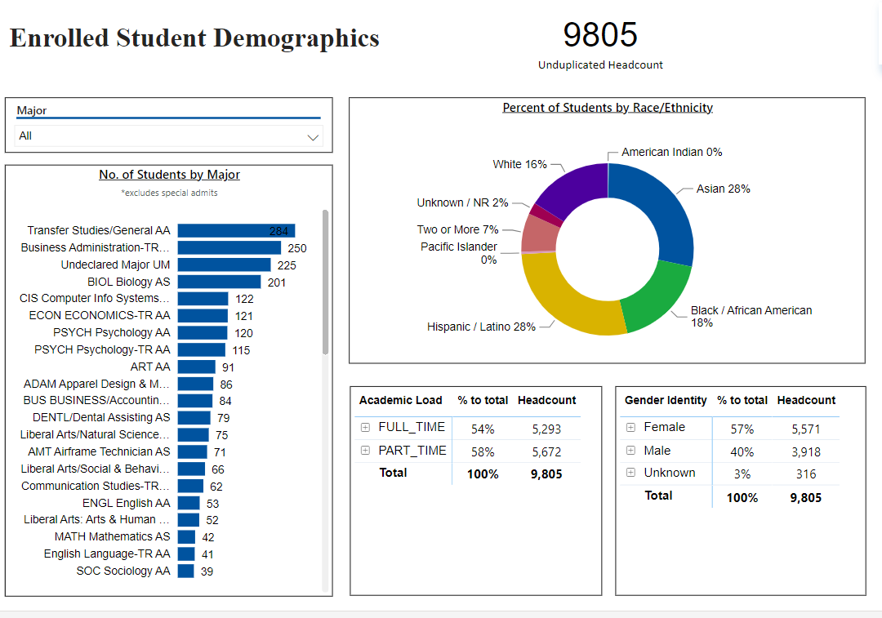

*Snapshot for Academic Year 2022-23*

[**Demographics dashboard link**](https://app.powerbi.com/view?r=eyJrIjoiMzVhNGU3YzAtNTIyNy00ZDZmLWIyYzMtYWIzMzllMGViZDQ5IiwidCI6ImVlYTE2YTE2LTQ4YWYtNDc3Yi05MTEzLTA1YjFjMDExMjNmZiIsImMiOjZ9&pageName=ReportSectionb4e116c96a753400a00c)

Do the students served by your service area differ from the College's overall student population? If so, elaborate on how the service area is identifying and addressing the needs of the student population.

|  |
| --- |
| No |

Which groups of students are underrepresented among those who received services, particularly by race/ethnicity and gender?

|  |
| --- |
| N/A |

Describe how external factors such as advisory board recommendations, federal or state mandates, changing demographics, and/or COVID-19 has impacted the support services your program or administrative unit provides.

How has your program addressed these changes or challenges to ensure students are supported and can continue to work towards meeting their educational goals?

|  |
| --- |
| With such a small number of individuals looking for work/jobs after COVID-19, it was difficult trying to find/hire student workers to specifically help support the efforts of outreach. Crystal was brought on board as an hourly with Mobile CoA, and she was able to find support from student workers/staff from other departments/areas to help with the student enrollment process of prospective students from various high schools. |

**Data Analysis**

[**Course Success & Retention Rates – Student Services**](https://app.powerbi.com/view?r=eyJrIjoiNjk3NDJjOTItNzI5MS00MDhjLWJhN2EtZjcxNzU4OTBiZDBjIiwidCI6ImVlYTE2YTE2LTQ4YWYtNDc3Yi05MTEzLTA1YjFjMDExMjNmZiIsImMiOjZ9&pageName=ReportSection86d6f65e2fb41a73da4d)

Consider your program’s course completion rates over the past three to five years (% of students who earned a grade of "C" or better).

How does the course completion rate for your program compare to your college's College-Set Standard for course completion of 72% and the stretch goal of 78%?

|  |
| --- |
| For 19-20 completion rate for Mobile CoA participants was at 81% (note that there was a vacancy in the Outreach Specialist position at this time, which only partial data may have been used). For 20-21 due to Covid-19 and vacancy in the department, there was no mobile CoA. For 21-22, though we began mobile CoA again, due to transitions of administration and staff, we do not have the data to answer this question. |

On average the course retention rate (number of students are retained in the course) for College of Alameda has been **85%** for the past three years. Examine the course retention rates for your program over the last three years. How does your program course retention rate compare to the college?

|  |
| --- |
| Unable to provide an answer to this question due to vacancy in department during this time and lack of data (data is lost due administration/staff transitioning out) |

**Equity**

College of Alameda continues to focus on access, equity, and success. The goal is to create an inclusive environment where all students can thrive and meet their education and career goals. In Spring 2023, the Student Equity and Achievement Expanded Committee analyzed data to identify groups that were disproportionately impacted in completion of transfer level English and Math, persistence, transfer rate, and goal completion.

* **Complete both Transfer-level Math and English within the first year:** 19% of all first-time students completed both transfer-level math and English. Black/African American & Latinx first-time students completed both transfer level math and English at disproportionate rates at 9% and 7% respectively.
* **Persistence:** 52% of first-time students persisted to the next primary term. Black or African American students persisted at a rate of 14% from first primary term to subsequent primary term.
* **Transfer to a Four-Year Institution:** Using 2016-17 data and excluding high school students, the proportion of first-time cohort students who earned 12 units or more and exited in the subsequent year and enrolled in any four-year postsecondary institution. 20% of first-time cohort students transferred to a four-year institution. Zero foster youth students (N=10) in the first-time cohort transferred.
* **Goal Completion:** 8% of first-time students (2017-18 cohort) attained one of the following earned an AA, AS, AAT, and or AST; earned a CCCCO approved credit certificate, earned a noncredit certificate, attained apprenticeship journey status, or transferred to four-year postsecondary institution. Male students completed at disproportionate rate of 3%.

Discuss how your program has worked to address these equity gaps. Incorporate examples of your program data where applicable.

|  |
| --- |
| N/A |

**Student Learning Outcomes Assessment**

List your Service Area Outcomes (SAOs) and/or Student Learning Outcomes (SLOs)

|  |
| --- |
| N/A due to vacancy |

Please provide a high-level summary and your program’s interpretation of your SAO/SLO findings over the past year.

|  |
| --- |
| N/A due to vacancy |

What were the most important things your department learned from assessment? Did implementation of your action plans result in better student learning?

|  |
| --- |
| N/A due to vacancy |

**Degrees & Certificates Conferred**

Increasing the number of students who complete a certificate or degree is a shared goal across CoA’s Ed Master Plan Goals, PCCD (Peralta Community College District) Goals, the Chancellor’s Office Vision for Success, the Student-Centered Funding Formula, and Guided Pathways.

How can your program contribute to increasing the number of certificates and degrees awarded over the next three years? For more information on awards click on the [**Degrees & Certificates Dashboard link**](https://app.powerbi.com/view?r=eyJrIjoiZjU2M2M5MzItOTcwZi00Y2U1LWJmODUtYTc0YjlhZGI2ZDhjIiwidCI6ImVlYTE2YTE2LTQ4YWYtNDc3Yi05MTEzLTA1YjFjMDExMjNmZiIsImMiOjZ9&pageName=ReportSectionde32556e136b0a8caccd)

|  |
| --- |
| The Outreach department can contribute to increasing the number of certificates/degrees awarded by increasing enrollment numbers for potential students through outreaching efforts. |

**Engagement**

How has your department participated in college wide efforts such as committees, presentations, and departmental activities?

|  |
| --- |
| Provide support during Enrollment events and other campus events. Phone calls to students |

How has your department engaged in community activities, partnerships and/or collaborations?

|  |
| --- |
| Tabling at local High schools and other community events. Host an annual Community College Partner Breakfast. Collaborate with AUSD and St. Joes with City Wide College Night. |

**Prioritized Resource Requests Summary**

In the boxes below, please add resource requests for your program. If there are no resources requested, leave the boxes blank.

|  |  |  |
| --- | --- | --- |
| **Resource Category** | **Description/Justification** | **Total Estimated Cost** |
| Personnel: Classified Staff | Hourly support to help with outreaching events | 20,000 |
| Personnel: Student Worker | 3 Student workers | 30,000 |
| Personnel: Part Time Faculty |  |  |
| Personnel: Full Time Faculty |  |  |

|  |  |  |
| --- | --- | --- |
| **Resource Category** | **Description/Justification** | **Total Estimated Cost** |
| Professional Development: Department wide PD (Professional Development) needed |  |  |
| Professional Development: Personal/Individual PD needed |  |  |
| Supplies: Software |  |  |
| Supplies: Books, Magazines, and/or Periodicals |  |  |
| Supplies: Instructional |  |  |
| Supplies: Non-Instructional |  |  |
| Supplies: Library Collections |  |  |
| Technology & Equipment | Hotspots for Wifi off campus | $1000 |
| Library materials/collections |  |  |
| Facilities: Classrooms/Labs |  |  |
| Facilities: Offices |  |  |
| Other | Outreaching swag, brochures/flyers | $10,000 |