**College of Alameda**

**L Building Second Floor Map**

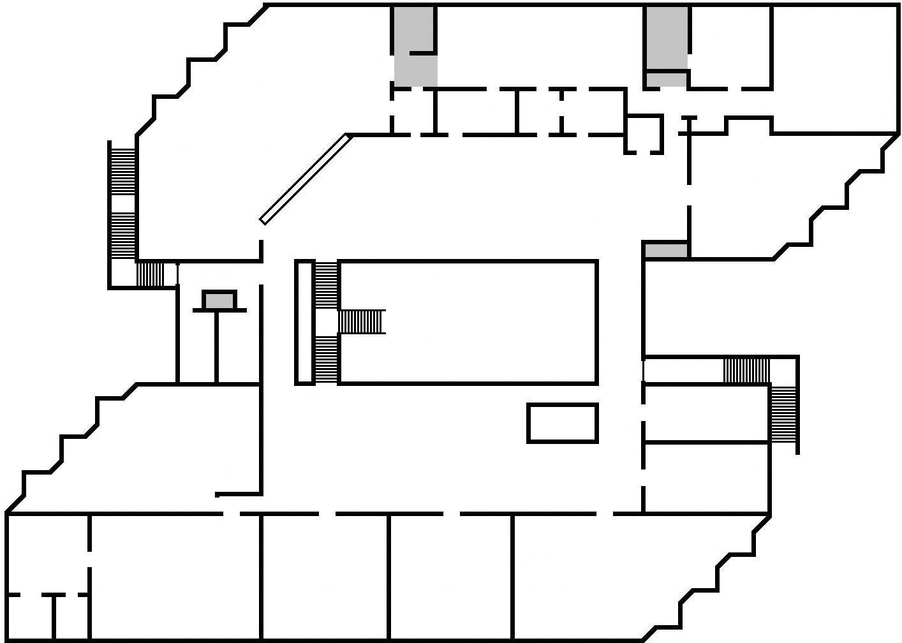

**Faculty/Staff Offices:**

**L204**

**L226**

**L227**

**L229**

**L230**

**L235**

**L236**



**L**

**2**

**3**

**6**

**Adult Education**

**L223**

**LRC Classroom**

**L234**

**L235**

**L226**

**LRC Front Desk**

**Stryker Chair**

**Math Lab**

**L202-D**

**Computer/ Open Lab**

**L202-E**

**Writing Lab**

**L207**

**UMOJA**

**L215**

**L202-C**

**L204**

**L227**

**Emergency Exit**

**OPEN AREA**

**Learning Skills**

**L210**

**Community Room**

**L237**

**L231**

**Accounting Lab**

**L230**

**L229**

**L228**

**Emergency Exit**

**IT**

**L224**