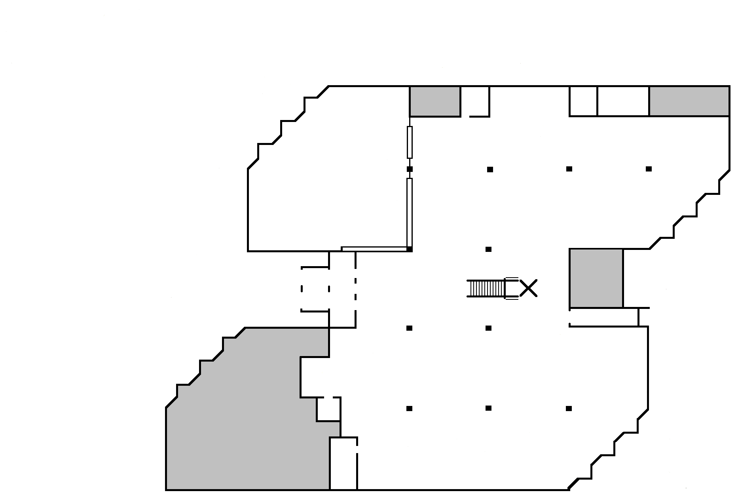

EZ

Readers

New

Books

Latinx

Circulation Desk

Young

Adult

Graphic

Novels

Staff Picks

Stacks 1 - 17

**17 16 15 14 13 12 11 10 9 8**

**1 2 3 4 5 6 7**

Best

Sellers

Reference

Monthly Book

Display

Study Room

110

} Tables

} &

} Furniture

Reserve

Desk

Fashion

**Emergency**

**Exit**

Library

Instruction

 



Study

Room

108

Periodicals stored

(Older Magazines, Journals & Newspapers)

-------------------

Quiet

Study

Room

**Defibrillator& First Aid Kit**

**Entrance**

Study

Room

109

Study Carrels

Computers

Reserve Textbooks

Reference Desk

Lib. Office 106

Li

Study

Room

107

**Library**

**Offices**

**College of Alameda**

**Library Map**

**(Downstairs)**

Study

Room

108