[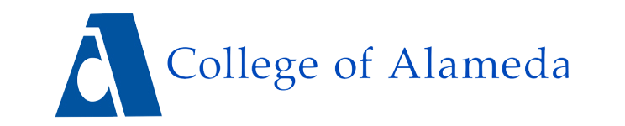](https://alameda.edu/)

**AGENDA**

**Zero Textbook Cost (ZTC) Taskforce**

Tuesday, March 18, 2025

12:00pm – 1:00pm

Location: Zoom

<https://peralta-edu.zoom.us/my/fowler>

**Action Items**

1. Approval of Agenda (5 minutes)
2. Approval of 3/4/25 Meeting Minutes (5 minutes)

**Discussion Items**

1. April 1st Spring Break meeting: Cancel or reschedule? (5 Minutes)
2. Taskforce Logistics (15 Minutes)
   * Voting procedures, meeting frequency, taskforce duration, and membership
3. Compensation & Support (15 Minutes)
   * Interim ZTC Grant Coordinator hiring process update
   * Permanent ZTC Grant Coordinator release and announcement for AY 25-26
   * ZTC Lead Faculty stipend(s)/reassigned time for Spring 25 and AY 25-26
   * Update on approval of compensation for faculty working to convert/modify courses
4. Strategic Planning & Next Steps (15 Minutes)
   * Timeline for current ZTC pathways
   * New funding for two additional pathways

**Next Meeting:** TBD Based on Discussion Item 1