[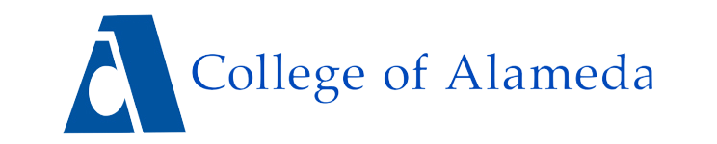](https://alameda.edu/)

**MINUTES**

**Zero Textbook Cost (ZTC) Taskforce**

Tuesday, March 4, 2025

12:00pm – 1:00pm

Location: Zoom

<https://peralta-edu.zoom.us/my/fowler>

Attendance: Diana Bajrami, Olga Fish, Jennifer Fowler, Hoi Ko, Carla Pegues, Nicole Porter, and Jayne Smithson.

**Approval of Agenda**

* Moved, seconded, and unanimously carried.

**Approval of 2/18/25 Meeting Minutes**

* Moved, seconded, and unanimously carried.

**ZTC Coordinator Update**

* The ZTC Coordinator job description was sent to faculty. The deadline to apply is March 12th at 5:00pm. Position can be split between more than one faculty if desired.

**Faculty Stipends for ZTC Course Updates or Conversions**

* Berkeley City College provided a copy of the stipend structure and job announcement used for their ZTC Grant, which our taskforce reviewed for the first time last fall semester. The taskforce agreed to adopt the stipend structure. Jennifer and Carla will email it to VPI Porter as our recommendation. The goal is to have it distributed to faculty before the end of spring semester so work can begin work in summer and/or fall as deemed appropriate.

**Chancellor’s Office Update**

* Reallocation of funding is possible and may require a new application for approval. Grant funds can be used for POCR or to buy classroom textbook sets in unique cases where OER or library licensed materials are not possible. The Chancellor’s Office requests that ZTC Collaboration Cohort resources be utilized to build on the work submitted. Data was shared on Degree/Certificates awards at the college to begin dialogue on creating new/additional pathways.

**Next Meeting:** Tuesday 3/18/25 from 12:00pm – 1:00pm on Zoom: <https://peralta-edu.zoom.us/my/fowler>