COA Academic Senate
Meeting Minutes
Thursday, February 20, 2025
Meeting Called To Order at College of Alameda, H 280 & Zoom at 12:20 pm
Note: For Virtual attendance, senators indicate their votes in the Zoom Chat
Quorum: 50% + 1
In person Quorum: 7 or more senators (15 seats, 2 vacant)
Senators in Attendance: George Cruz, Jenn Fowler, Andrew Park (note-taker), Rich Kaeser, Bruce Pettyjohn, Sue Altenbach, Carla Pegues, Kwesi Wilson, Jacinda Marshall, Andrew Fittingoff, Cady Carmichael, Jody Campbell, Cynthia Haro,
Guests in attendance: Iolani Sodhy-Gereben, Linda Dewrance, Jane McKenna, Jayne Smithson, Leslie Reiman
Agenda Item | Summary | Motion
Agenda Review & Approval for February 20, 2025 | No changes. | Motion to approve Agenda February 20, 2025  First: G. Cruz  Second: C. Pegues  M.S.U.
Review of minutes  February 6, 2025 | Any grammatical changes can be sent directly to A. Park or J. Fowler. | Motion to approve minutes from February 6, 2025  First: J. Marshall  Second: C. Pegues  M.S.U.
Action Items:  - Committee Appointments | Summary of #1  Jenn Fowler started the agenda item with the reminder of CoA AS constitution requiring senate confirmation of committee appointments.  Pending appointments are:  - Facilities & Tech appointee: Jayne Smithson  - DAS representative: Jayne Smithson | Motion to approve the appointment as described.  For Facilities & Tech:  First: J. Marshall  Second: S. Altenbach  M.S.U.  For DAS rep:  First: C. Pegues  Second: J. Campbell  M.S.U.
Discussion Items:  - Reschedule or Cancel April 3 Meeting: Spring Break  - 2025-2026 FTEF Allocation Check-In | Summary of #1  There was a brief discussion on whether to cancel or re-schedule the next regularly scheduled meeting falling within the spring break.  General consensus: meeting will be cancelled and if something time-sensitive comes up, we can schedule a special meeting.  Summary of #2  J. Fowler introduced the item with a reminder where CoA is at in the Fall 2025 scheduling process.  - Department chairs have submitted the Discipline Plans  - No draft schedules have been submitted yet (rollover schedules not yet available from the college admin).  - Some faculty have expressed concern over FTEF allocation not being received yet.  - There are other layoffs outside of faculty ranks (classifieds and admin) that will come up to Peralta board soon.  - There are talks of district-wide cuts; there may be reduction in FTEF allocation in AY25-26 compared to this year (AY24-25).  There was a robust discussion on the matter.  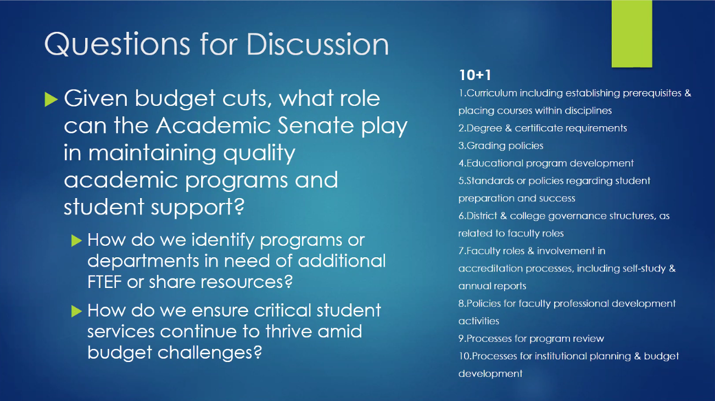  Some points include:  - Let’s add more courses as we see demands from students (overfilled classes and full waitlists)  - Large class size load factor (e.g. DVC)  - Sharing FTEF budget between departments  - Concerns for departments where classes fill but fill late  - Full time faculty are encouraged to consider declining extra-service assignments  - More dual enrollment is also something to consider  - Really need to see the FTEF budget to consider any concrete solutions  - SLO assessments  - ZTC task force  Participated in discussion: J. Fowler, C. Pegues, J. Campbell, C. Carmichael, Jane McKenna, Jayne Smithson, S. Altenbach, K. Wilson, Linda Dewrance,
Officer Reports | President: Including the items previously sent to the senators and available in senate SharePoint site:  - ASCCC scholarship available for conference (APAHE meeting in Oakland in April; March 12 deadline for scholarship application)  - ZTC Task Force website available: https://alameda.edu/our-college/college-leadership/ztc/  - ASCCC Spring Plenary is happening in April. C. Haro (voting delegate), C. Pegues, and Iolani Sodhy-Gereben are attending from CoA.  - Reminder of ASCCC solidarity statement.  - One (1) sabbatical will be available for CoA (pending board approval in March).  Vice President: Starting to prepare for emeritus luncheon. Discussions still in progress for a joint event that includes honoring/celebrating classified professionals and admins alongside the retiring faculty.  Treasurer: Nothing to report.  Secretary: Nothing to report.
Announcements | Iolani Sodhy-Gereben: reminder that the final list of Phase 3 CCN courses (listed by C-ID) were released this morning. Please look for additional information from CoA curriculum co-chairs (nothing requiring immediate action).  J. Campbell and C. Pegues: Please participate in Black History Month activities; movie showing today and more activities announced and coming up.
DAS Updates/Actions | Highlights from this week’s DAS meeting:  - Q&A with District COO Greg Nelson was postponed to the next meeting (esp. to answer questions about bookstore closing)  - Discussion on equivalency processes and min quals (CE committee memo shared; available on BoardDocs)  - Discussion on administrative procedure on program discontinuance (possibly updating the AP 4021).
Public Comment | None.
Proposed agenda items for next meeting  Thursday, March 6, 2025 | Call for additional proposed agenda items was made.  Please email J. Fowler for any other agenda items.
Adjournment at 1:21 pm | Meeting adjourned at 1:21 p.m. with all agenda items having been addressed.

