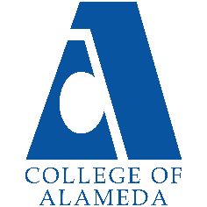
2024-25 Annual Program Update -
Apparel Design And Merchandising

Program Overview
Please verify your program’s mission statement and program’s learning outcomes below, and make any corrections necessary.
Mission Statement
The Apparel Design and Merchandising Program (ADAM) provides educational training that prepares students with the knowledge and skills needed to successfully secure a career in the vast fields of apparel design and manufacturing. The ADAM Program fosters a well-balanced educational environment which promotes professionalism, diversity, integrity, and a high standard of performance as they relate to the everyday operations in the apparel industry.

Apparel Design And Merchandising – A.A. Degree Program Learning Outcomes
- Design, sketch, cost and select appropriate fabric and trims for several apparel outfits in various garment and price categories.
- Articulate in a clear written or oral dissertation the steps involved in the production pattern and size grading process.
- Analyze critically the rationale used in applying basic drafting principles, methods and techniques learned in class to the solving of new concepts / ideas
- Develop a portfolio for an original clothing collection.

Apparel Design And Merchandising – Certificate of Achievement Program Learning Outcomes
- Design, sketch, cost and select appropriate fabric and trims for several apparel outfits in various garment and price categories.
- Articulate in a clear written or oral dissertation the steps involved in the production pattern and size grading process.
- Analyze critically the rationale used in applying basic drafting principles, methods and techniques learned in class to the solving of new concepts / ideas.
- Develop a portfolio for an original clothing collection.

List your program faculty and/or staff, and indicate whether they are full-time or part-time.
Derek Piazza –Contract Faculty/Department Chair
OJ Roundtree –Contract Faculty
Chris Perata – Teacher’s Assistant
Vincent Ogden – Teacher’s Assistant
Dennis Tuazon – Teacher’s Assistant

Describe your current utilization of facilities, including labs and other space.
As of Fall 2022, the ADAM program continues to occupy approximately 70% of the third floor in the Center for Liberal Arts building (building H). Pattern and sewing studios occupy workrooms 302, 305, and 308 while our computer lab occupies workroom 322. Lockers for student designers adjoin each room as well as inside workroom 305. Two (2) faculty storage areas are located inside workroom 305 (rooms 306 and 307). A window display to present student work and showcase the ADAM program, is located in the hallway in front of the ADAM office (room 303).

The Program Goals below are from your most recent Program Review or APU. If none are listed, please add your most recent program goals. Then, indicate the status of this goal, and which College and District goal your program goal aligns to. If your goal has been completed, please answer the follow up question regarding how you measured the achievement of this goal.
Program Goal | Evaluate ADAM Program Schedule/Course Curriculum.  Revise ADAM courses for Fall 2023 with 4 units to 3 units to better align for credit/unit transfer (many four-year universities, two-year colleges and/or private educational institutions typically base curriculum on no more than three units; thus, it may be difficult to convert/transfer four-unit courses equally and successfully).
Status: In-Progress or Complete?  If complete, give a brief description of how you measured the goal completion. | Completed Spring 2024 with the assistance of Patricia Nelson, Curriculum Committee Co-Chair. This was approved by the then Dean Eva Jennings and Min Wu, Senior Academic Support Services Specialist.
Which college or district goal is aligned with your program goal? | CoA: Mission Statement  CoA: Academic Excellence  District: Advance Student Access, Equity, and Success  District: Build Programs of Distinction

Program Goal | Continue high standards of instruction and integrity within classroom. Decrease withdrawal rates and increase retention rates, particularly during fall semesters.  SAS  Continuing to partner with SAS regarding note takers and student accommodations (tables, chairs, seating arrangements, computers, etc.).  ADAM Audio/Visual Instructional Support  Continue to use a microphone and amplifier.  Continue to use a video camera & 50” flat-screen television (onsite).  Continue to use an overhead video camera for demonstrations (online).  Continue to use a short throw projector for a 100” diagonal visual image.  Continue to display student work in our hallway display cabinet in addition to spotlighting the work of ADAM graduates and the Bay Area companies they work for.
Status: In-Progress or Complete?  If complete, give a brief description of how you measured the goal completion. | Complete (on-going). The ADAM program continues to use supplied microphones in the classroom. Each semester, we partner with SAS to accommodate students visually (large screen tv’s and projectors), audibly (microphones with speakers), and logistically (specific tables, chairs, seating students to have a clear view) so they can receive the best in-class experience which makes learning comfortable, fun, and engaging.
Which college or district goal is aligned with your program goal? | CoA: Academic Excellence  District: Advance Student Access, Equity, and Success  District: Build Programs of Distinction

Program Goal | Form partnerships with local businesses (global brands and small business owners) associated with the design, merchandising, and manufacturing sectors of the fashion industry to increase student opportunities for internships, industry exposure and access, field trips, ADAM Industry Talks (lectures & demonstrations), and workshops. Local businesses include Stella Carakasi, Levi Strauss & Co. in San Francisco (internships, ADAM Industry Talks, fabric donations), Title Nine in San Francisco (internships), SF Design Center, Fibershed in Point Reyes (workshops & tours), and KOSA Arts in Oakland (internships, tour of work studio & store).
Status: In-Progress or Complete?  If complete, give a brief description of how you measured the goal completion. | Complete (on-going). ADAM Industry Talks Zoe Gerstman (Levi Strauss & Co), Jana Hunt (The North Face), Hien Lee (Dare & Dazzle Bridal), field trip to SF Design Center
Which college or district goal is aligned with your program goal? | CoA: Community engagement.  District: Engage and Leverage Partners  District: Strengthen Accountability, Innovation, and Collaboration

Program Update – Enrollment Trends, Success Rates, and Degrees & Certificates
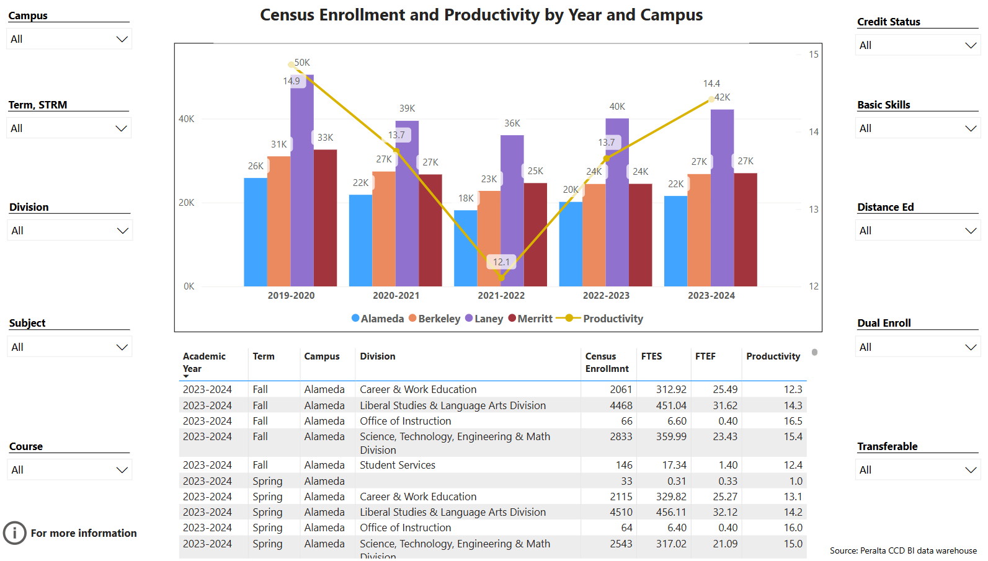
Enrollment Trends Power BI dashboard
Note: Please consider the most recent years when answering the questions below. Data with default filter is provided below. Use the link above to explore the data further.
Discuss recent enrollment trends. District-wide enrollment trends are shown above for comparison.
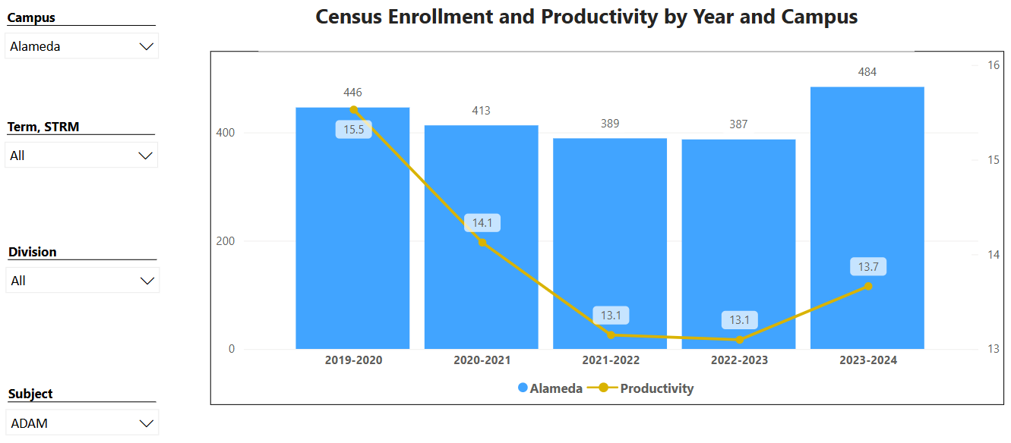

The ADAM Program has a high retention rate when compared to the College of Alameda’s average.

“The ADAM program at the College of Alameda (COA) was a wonderful experience during a unique time in our history. I felt lucky that the program was available during the shutdown. COA and the instructors made the ADAM program accessible and stimulating. Our instructors Mr. Piazza and Mr. Roundtree were personable and always available when the students needed them. The courses were concise and easy to understand with lots of information presented in an organized manner. I strengthened old skills and learned new ones. Pattern making was something I wanted to learn for a longtime and as a returning student I was so happy with COA’s affordability and the overall experience I had with the ADAM program.
I highly recommend any one either wanting to break in to the fashion industry or just wanting to take up a new hobby, to give the ADAM program at COA a try.
Dennis Tuazon . 2022 ADAM graduate . AA degree

“I received my AA this year, 2022, from the A.D.A.M. program. The program is challenging and informative. The instructors, Mr. Piazza and Mr. Roundtree, are very knowledgeable and skilled in their profession while being dedicated to the students learning and increasing their skill levels. Both instructors are approachable, open to questions while being clear on their focus and expectations of students. They wanted us to be successful. I felt guided to do my best. In Apparel History class Mr. Piazza included historical African Americans clothing designers who in the past may not been given recognition. That demonstrates inclusivity.
I appreciated learning new skills. In particular, I enjoyed the Portfolio class in learning how to utilize research to come up with different ideas for designing, use of fabrics, elements and colors. I call that learning the magic of design in an instructive way.
Verlie Carmack . 2022 ADAM graduate . VALEDICTORIAN . AA degree

Course Completion Power BI Dashboard #1
Course Completion Power BI Dashboard #2
Institutional Set Standards
Consider your course completion rates in recent years (% of student who earned a grade of "C" or better). Data with default filter is provided below. Use the link above to explore the data further.
How does the course completion rate for your program or discipline compare to your college’s Institutional Set Standard for course completion (70% with stretch goal of 77%)? Also discuss the retention rate for your program or discipline, compared to the college average shown in data below, as well as what the discipline, department, or program has done to improve course completion and retention rates.
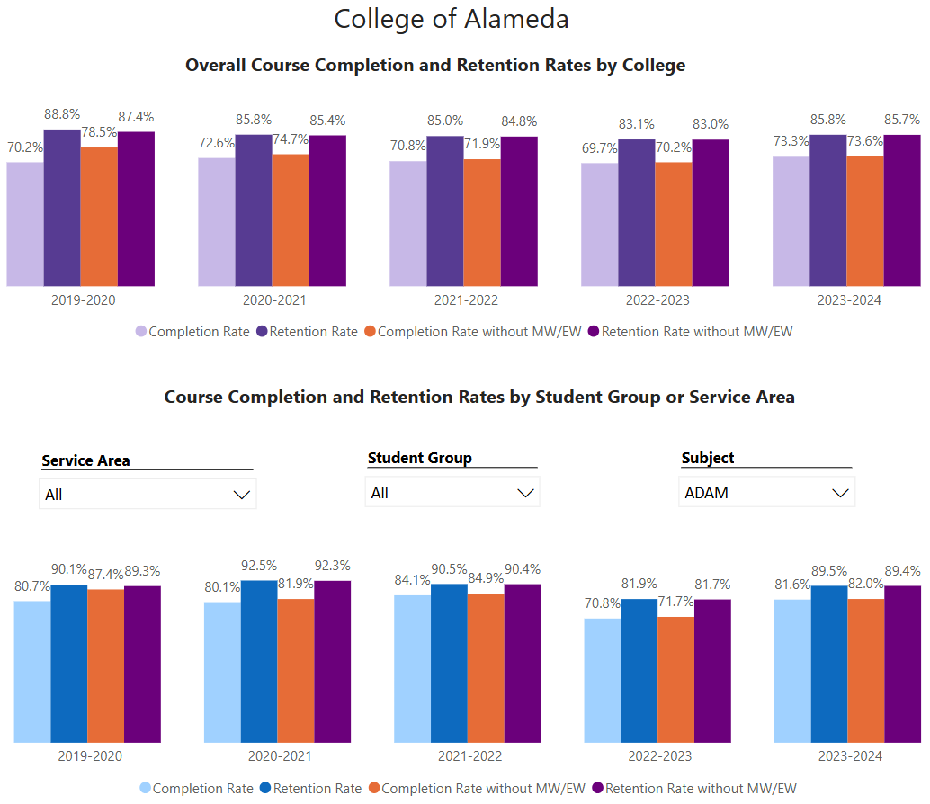

2020-2022
COVID lockdown / Online classes only
ADAM faculty discovered that fashion students stayed enrolled, motived and had great success in Apparel History, Textiles, and Design & Sketching classes. Student feedback continually mentioned that they liked the flexibility of not only being onsite but also a day or two online, with classes that do not require an onsite presence. Because of this, those classes have successfully remained online post-lockdown beginning Fall 2022.
2022-2024
ADAM retention rate and completion rate fluctuated slightly when transitioning back to mostly onsite classes when compared with previous onsite years and COVID lockdown.

Degrees & Certificates Power BI dashboard
Please provide an update on the degrees and certificates offered by the discipline, department, or program. Below data shows the number of degrees and certificates awarded by year, for the past three years. Use the link above to explore the data further.
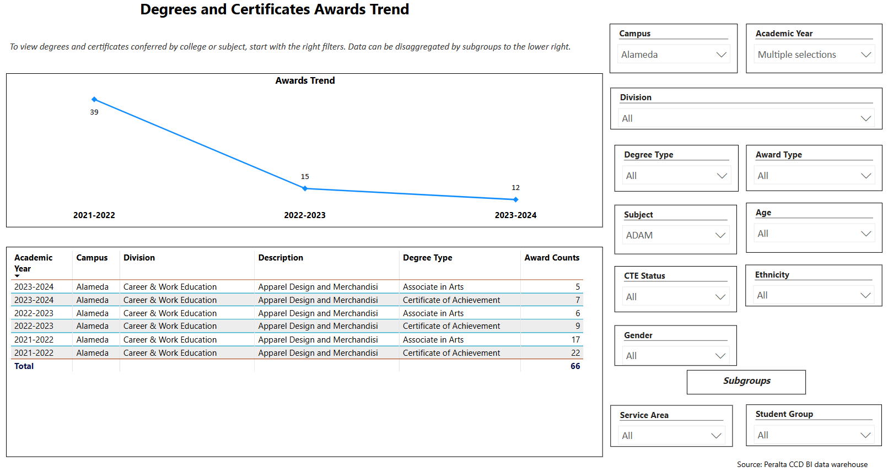

COVID lockdown 2020-2022
ADAM staff now offers:
Onsite and online office hours. This allows more options for students to connect with instructors which improves student success rates.
ADAM Certificate or AA Degree Announcements
ADAM faculty created a QR code which directs students to the ADAM website which discusses Certificate and AA degree options upon completion.
In our public hallway display tv monitor and on classroom walls, ADAM faculty celebrates recent and former graduates, the year graduated, where they are working, and the Certificate or AA degree earned. Also, a QR code displayed allows passing students to learn more about the ADAM program.
ADAM Program Schedule & Expenses lists the options for graduation, ADAM counselor Maha Elaidy’s contact information along with a QR code.

Describe any significant changes in the recent years and discuss what the changes mean to your program.
Fall 2023 – present
Hiring of Part Time ADAM Dual Enrollment instructors Janice Paredes and Stephanie Verrieres.
Total four (4) Dual Enrollment agreements with local high schools Oakland Tech, Oakland High, Skyline, and OSA (Oakland School for the Arts beginning Spring 2025).
This means the opportunity for high school students to become aware and experience the ADAM program with the opportunity to take college level classes not only for ADAM program at College of Alameda but also transfer-level to CSU.
Began high school tours specifically with Dual Enrollment high schools including OSA which then became a dual enrollment high school affiliate within the year.
Continued to participate in College of Alameda Career Discovery Day which gave ADAM tours and demonstrations to over 300 high school students. All received a copy of the ADAM Program Schedule and Expenses.

Describe the department's progress on Student Learning Outcomes (SLOs) and/or Service Area Outcomes (SAOs) since the last Program Review/APU.
The action plan for most SLO’s assessed was:
- Continue to consult with ADAM Advisory Board members in regards to current business and manufacturing trends for best practices.
- Continue to update and revise the content of assignments/handouts/activities as advised by ADAM Advisory Board members.
- Continue to use classroom technology for all lectures and demonstrations.
- Continue to present industry speakers for ADAM Industry Talks.

Describe the outcomes and accomplishments from previous year’s funded resource allocation request. If your program did not receive any allocations, leave the boxes blank.
Brief description of funded request | Source (any additional award outside your base allocation) | Total Award Amount | Outcome/Accomplishment

Prioritized Resource Requests Summary
In the boxes below, please add resource requests for your program. If there are no resource requested, leave the boxes blank.
Resource Category | Description/Justification | Full-Time Equivalent Percentage | Salary Grade (if applicable)
Personnel: Classified Staff

Personnel: Student Worker | Ongoing semester need for Student Workers/Instructional. Assistants/Teaching Assistants
Personnel: Part Time Faculty | Request: ONE Part Time Faculty  We cannot have a successful program without hiring ONE part time faculty. Hiring ONE part time faculty would not only help with outreach, student growth, retention, and success, but also to assist them in reaching the mission and vision of College of Alameda including:  - …(creating a) diverse, supportive, empowering learning community for seekers of knowledge.  - …committed to providing a creative, ethical, and inclusive environment in which students develop their abilities as thinkers, workers, and citizens of the world.  Hiring ONE Part Time faculty would also assist students in reaching all ADAM PLO’s including:  - Developing a portfolio for an original clothing collection.  - Analyze critically the rationale used in applying basic drafting principles, methods and techniques learned in class to solving of new concepts/ideas. | $45,000 annual
Personnel: Full Time Faculty

Personnel: Full Time Faculty, future anticipated need | Request: ONE Full Time Faculty  Faculty position in near future to-be-filled for retiring faculty position. | n/a

Resource Category | Description/Justification | Total Estimated Cost
Professional Development: Department wide PD needed

Professional Development: Personal/Individual PD needed

Prioritized Resource Requests Summary - Continued

Resource Category | Description/Justification | Total Estimated Cost
Supplies: Software

Supplies: Books, Magazines, and/or Periodicals

Supplies: Instructional Supplies

Supplies: Non-Instructional Supplies

Supplies: Library Collections

Resource Category | Description/Justification | Total Estimated Cost
Technology & Equipment: New

Technology & Equipment: Replacement

Prioritized Resource Requests Summary - Continued

Resource Category | Description/Justification | Total Estimated Cost
Facilities: Classrooms

Facilities: Offices

Facilities: Labs

Facilities: Other

Resource Category | Description/Justification | Total Estimated Cost
Library: Library materials

Library: Library collections

Resource Category | Description/Justification | Total Estimated Cost
OTHER

