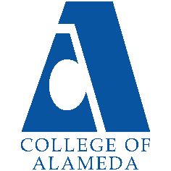
2024-25 Annual Program Update -
African American Studies

Program Overview
Please verify your program’s mission statement and program’s learning outcomes below, and make any corrections necessary.
Mission Statement
The discipline of African American Studies at the College of Alameda will give you a deep appreciation and understanding of the impact that people of African descent have had on the ancient and modern worlds. You will draw from multiple academic disciplines, including history, sociology, communication, literature, art, dance, anthropology, and political science. Through these academic lenses you will gain a broader understanding of the African diasporic experience in the U.S. and beyond as you will critically analyze the struggles, triumphs, and rich traditions both past and present. You will learn from instructors who are active in the community and their areas of academic specialization. Students in African American Studies at the College of Alameda can elect to study in Africa during the summer session through our study abroad program to Accra Ghana. Future study abroad opportunities within the African diaspora will include Mexico, Cuba, Haiti, Trinidad and Tobago, Jamaica, and Brazil.
African American Studies. Program Learning Outcomes:
- Students will learn about the rich history and vast contributions that African Americans have made to the U.S. and beyond.
- Students will study the multi dimensions of the African diaspora throughout the world by analyzing the various arts, sciences, literatures, political movements, and national identities.
- Students will be exposed to the African/African American struggle for social justice and equality throughout the diaspora.

We have currently updated our local AFRAM AA degree.

List your program faculty and/or staff, and indicate whether they are full-time or part-time.
Jody Campbell
Hillary Walker
Lawrence Vanhook

Describe your current utilization of facilities, including labs and other space.
Since the COVID-19 pandemic (campus closure), the department utilizes the
technological/virtual facilities available at COA and the PCCD. All our course offerings have been
distance education courses for the past academic year. Prior to this (and now) virtually the
department and students enrolled in courses utilized the campus computer labs (now software
available through the Peralta Portal), the college library, classrooms, and common space on
campus for observations, discussion, and study. Our program currently utilizes a considerable amount of web space like the CANVAS LMS, range of LTIs like Padlet, Flip Grid, Pronto, Voice
Thread, Confer Zoom, Turn-it-In, Honor Lock, Name Coach, and Ally to name a few. Beginning in Spring 2025, the Ethnic Studies/AFRAM Program plans to offer more of our courses face-to-face, and will once again utilize the campus space of classrooms, library, and computer labs, as well as common space for observations and discussion.

The Program Goals below are from your most recent Program Review or APU. If none are listed, please add your most recent program goals. Then, indicate the status of this goal, and which College and District goal your program goal aligns to. If your goal has been completed, please answer the follow up question regarding how you measured the achievement of this goal.
Program Goal | Solve problems and make decisions in life and work using critical thinking, quantitative reasoning, community resources, and civil engagement.
Status: In-Progress or Complete?  If complete, give a brief description of how you measured the goal completion. | In progress.
Which college or district goal is aligned with your program goal? | Institutional Goal# 1, 3, and 4.

Program Goal | Engage in respectful interpersonal communications, acknowledging ideas and values of diverse individuals that represent different ethnic, racial, cultural, and gender expressions.
Status: In-Progress or Complete?  If complete, give a brief description of how you measured the goal completion. | In progress.
Which college or district goal is aligned with your program goal? | Institutional Goal# 1, 3, and 4.

Program Goal | Use technology and written and oral communication to discover, develop, and relate critical ideas in multiple learning environments.
Status: In-Progress or Complete?  If complete, give a brief description of how you measured the goal completion. | In progress.
Which college or district goal is aligned with your program goal? | Institutional Goal# 1, 3, and 4.

Program Update – Enrollment Trends, Success Rates, and Degrees & Certificates
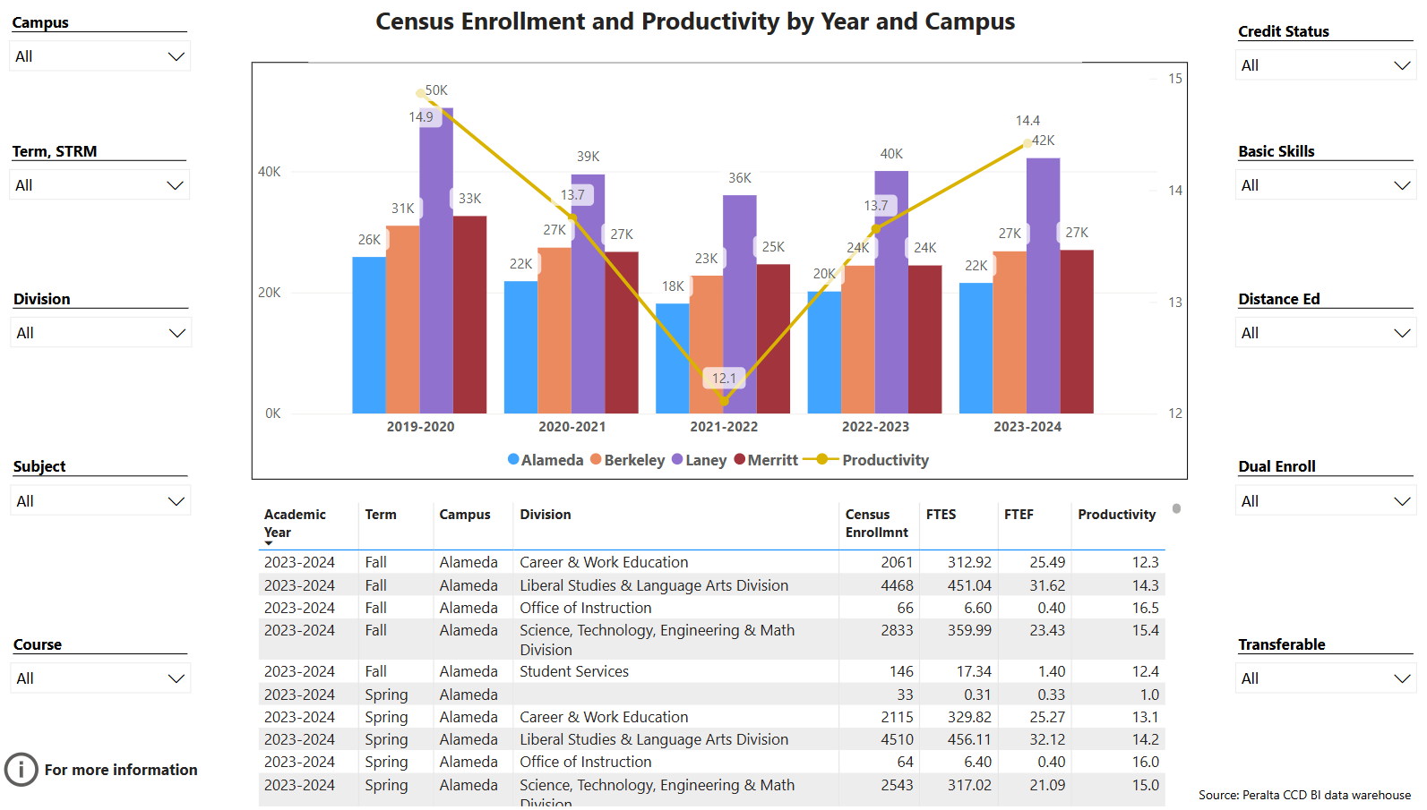
Enrollment Trends Power BI dashboard
Note: Please consider the most recent years when answering the questions below. Data with default filter is provided below. Use the link above to explore the data further.
Discuss recent enrollment trends. District-wide enrollment trends are shown above for comparison.
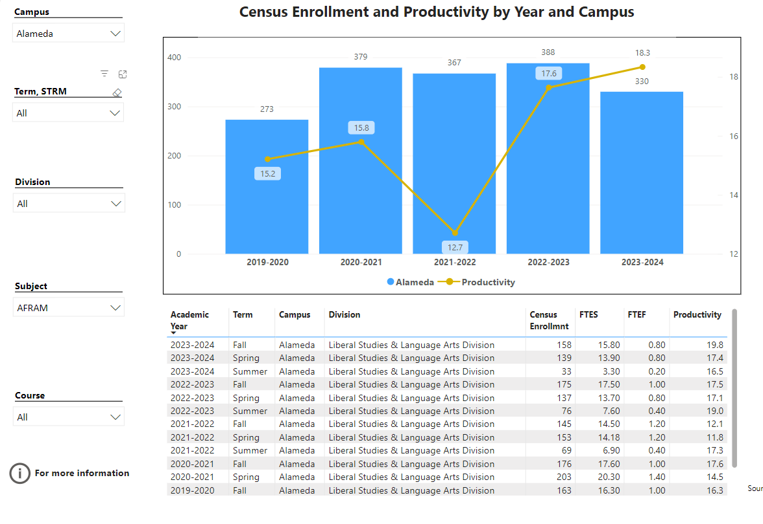 Enrollment (18.3) and production (19.8) overall has been steadily increasing since 2021, however, with more course offerings, and potential dual enrollment acquisitions we anticipate an increase in enrollment in the coming academic year. Our rise in dual enrollment requests and intercession courses, will further our growth and development as a department.

Course Completion Power BI Dashboard #1
Course Completion Power BI Dashboard #2
Institutional Set Standards
Consider your course completion rates in recent years (% of student who earned a grade of "C" or better). Data with default filter is provided below. Use the link above to explore the data further.
How does the course completion rate for your program or discipline compare to your college’s Institutional Set Standard for course completion (70% with stretch goal of 77%)? Also discuss the retention rate for your program or discipline, compared to the college average shown in data below, as well as what the discipline, department, or program has done to improve course completion and retention rates.
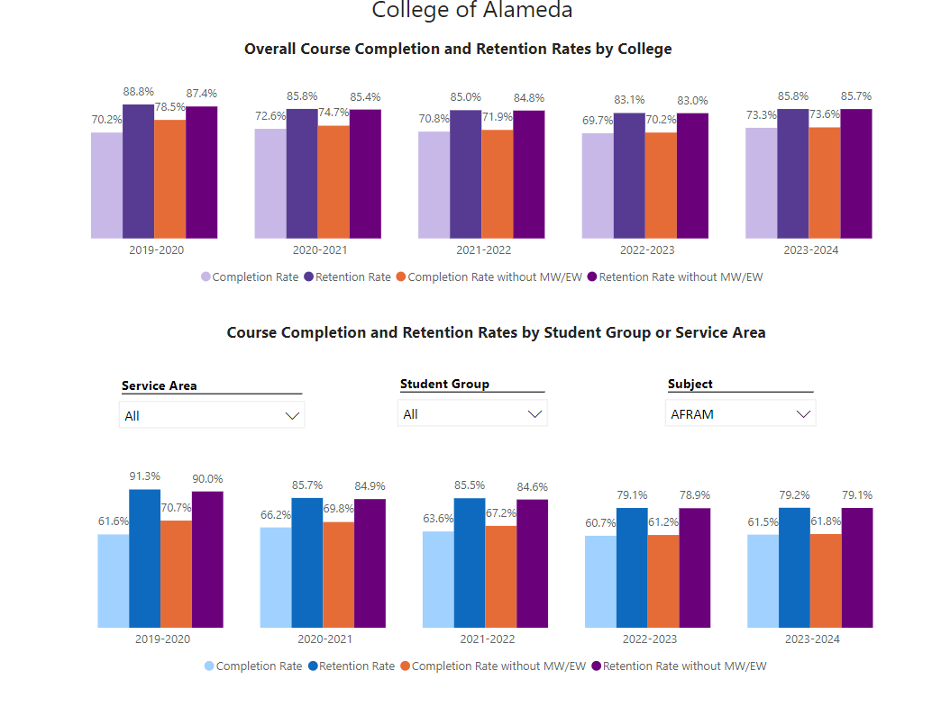
Recent success in success and retention rates are largely due to the department’s strategic scheduling of courses that meet student schedules, online offerings, and dual enrollment. Our trained professionals/faculty/staff are committed to complete equity and inclusion in our classrooms. We are aware of the importance of serving a multicultural community in the best and most innovative way possible.

Degrees & Certificates Power BI dashboard
Please provide an update on the degrees and certificates offered by the discipline, department, or program. Below data shows the number of degrees and certificates awarded by year, for the past three years. Use the link above to explore the data further.
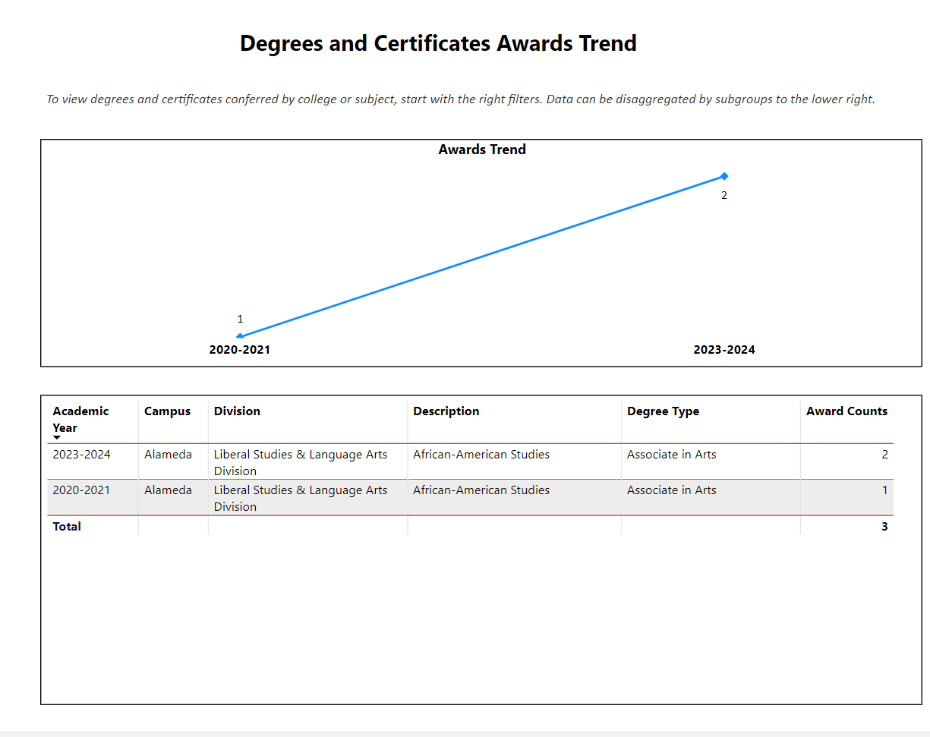
Our degree completion is up since 2021-2021 (doubled) but, we are seeking to improve in this area by updating and revising our AA degree with new and culturally relevant curriculum.

Describe any significant changes in the recent years and discuss what the changes mean to your program.
Our department schedule classes year-round (summer and both intersessions) to foster an accessible AFRAM AA degree completion. The department is adding additional transferable courses to the degree requirements to promote completion. We also have more entry points for our classes and offer our curriculum in a very innovative and dynamic way.

Describe the department's progress on Student Learning Outcomes (SLOs) and/or Service Area Outcomes (SAOs) since the last Program Review/APU.
Curriculum review and updating is an absolute constant within our department! We strive to bring our students the best and most innovative curriculum in the district and our improved success and enrollment rates reflect our endeavors.

Describe the outcomes and accomplishments from previous year’s funded resource allocation request. If your program did not receive any allocations, leave the boxes blank.
Brief description of funded request | Source (any additional award outside your base allocation) | Total Award Amount | Outcome/Accomplishment
Requested Funding For New Hardware For Instruction |  | $2,000 | Hardware for instructors purchased.
Requested Classroom Supplies |  | $500.00 | Purchased classroom supplies.

Prioritized Resource Requests Summary
In the boxes below, please add resource requests for your program. If there are no resource requested, leave the boxes blank.
Resource Category | Description/Justification | Full-Time Equivalent Percentage | Salary Grade (if applicable)
Personnel: Classified Staff

Personnel: Student Worker | 1 Student worker to support department in day to day class and department tasks and special events. |  | Per legal contractual agreement between student and college.
Personnel: Part Time Faculty | Retain 4 Part-Time  Instructors (each teach  at least one - three courses per semester) |  | Per contract
Personnel: Full Time Faculty

Personnel: Full Time Faculty, future anticipated need | Request one full time faculty to teach our developing MLAT curriculum. |  | Per contract

Resource Category | Description/Justification | Total Estimated Cost
Professional Development: Department wide PD needed | Additional Training on LTIs – Particularly on how to provide additional student support. | Cost of  third party  trainer.
Professional Development: Personal/Individual PD needed | PCCD Online Equity Training – we require time to  complete this training. | Cost of extra service.

Prioritized Resource Requests Summary - Continued

Resource Category | Description/Justification | Total Estimated Cost
Supplies: Software | Software updates Microsoft, PDF, Adobe. | $1,000
Supplies: Books, Magazines, and/or Periodicals | Videos, Documentaries, & Journal Subscriptions. | $1,000
Supplies: Instructional Supplies | Office Supplies for Online & In Person Classroom Use | $500.00
Supplies: Non-Instructional Supplies | Flash Drives,  Replacement Power Cords, headphones, cameras. | $1,0000
Supplies: Library Collections | Race & Ethnicity Journal $300  Contexts Magazine Journal $350 | $650.00

Resource Category | Description/Justification | Total Estimated Cost
Technology & Equipment: New | Lap tops, think pads, Video players, speakers, | 2,000
Technology & Equipment: Replacement | Flash Drives,  Replacement Power Cords, headphones, cameras. | 1,500

Prioritized Resource Requests Summary - Continued

Resource Category | Description/Justification | Total Estimated Cost
Facilities: Classrooms | N/A
Facilities: Offices | N/A
Facilities: Labs | N/A
Facilities: Other | N/A

Resource Category | Description/Justification | Total Estimated Cost
Library: Library materials | N/A
Library: Library collections | N/A

Resource Category | Description/Justification | Total Estimated Cost
OTHER | N/A

