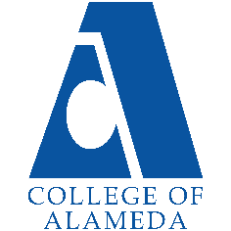
2024-25 Annual Program Update -
Biology

Program Overview
Please verify your program’s mission statement and program’s learning outcomes below, and make any corrections necessary.
Mission Statement
We strive to provide a learning environment that values diversity, intellectual discussion, critical thinking, and problem-solving. We provide students the opportunity to explore the science of life. We are committed to excellence in our teaching, and helping students acquire knowledge of basic facts and theories in Biology.

Biology – A.S. Degree Program Learning Outcomes
- Design the scientific method to formulate questions, explore experiments to test hypotheses, interpret experimental results to draw conclusions, communicate results both orally and in writing, and evaluate the use of the scientific method from published sources critically.
- Apply evolutionary theory at the molecular, cellular, organismal and population levels to explain the unity and diversity of living things.

List your program faculty and/or staff, and indicate whether they are full-time or part-time.
Leslie Reiman, Tenured Faculty
Edwin Ochong, Tenure-Track Faculty
Peter Niloufari, Adjunct Faculty
Scott Shultz, Adjunct Faculty
Constanze Weyhenmeyer, Laboratory Coordinator
Muwafaqu Alasad, Adjunct Faculty
Jonathan Siekmann Adjunct Faculty

Describe your current utilization of facilities, including labs and other space.
The Biology Department courses are being offered at the Science Annex located at 860 Atlantic Ave. In the building we share two classrooms (110 & 160) with Chemistry and Geology to hold our lectures for Biology 1A (General Biology, majors), 1B (General Biology, majors), 1 (Human Physiology), 1 (Microbiology), 2 (Human Anatomy), and 2 (Introduction to Biology) courses. In turn, we must hold some of our lectures in our laboratory rooms followed by their respective lab. This of course makes it challenging to schedule our courses in adequate space to support our students.

The Biology 1A (General Biology, majors), 1B (General Biology, majors), Bio 4 (Human Physiology), and Biology 3 (Microbiology) laboratories are held in room 140 since it is the only room that has Bunsen burners and fume hoods. The Biology 10 (Introduction to Biology) is held in room 134 and Biology 2 (Human Anatomy) is held in room 130. Room 131 houses our cadaver.
Room 135 is the office for the Laboratory Coordinator, which is directly attached to the Stock Room (136 & 137), the glassware is washed in room 144 and the Hazardous tissues and specimens are kept in room 143, while room 141 is now being used to store equipment for several experiments carried out in our Biology 1B course.

Currently, the Science Annex is also being shared with Merritt College where they use the inner center of the laboratory spaces for a Genomics course.

We initially offered Microbiology online for three semesters (Spring 2021-Spring 2022) and we have been offering Microbiology lecture and lab in-person since this Fall of 2022.

At this time, we have access to two Faculty offices in the building; however, we hope that the new Science building will allow for at least six offices for Full-time and Adjunct Faculty to meet with students and to carry out our daily work and responsibilities.

The Program Goals below are from your most recent Program Review or APU. If none are listed, please add your most recent program goals. Then, indicate the status of this goal, and which College and District goal your program goal aligns to. If your goal has been completed, please answer the follow up question regarding how you measured the achievement of this goal.
Program Goal | Provide students with skills necessary for critical thinking by integrating application exercises in each laboratory.
Status: In-Progress or Complete?  If complete, give a brief description of how you measured the goal completion. | Completed  We created Canvas New Quizzes to provide students with their laboratory exercises during lab in our Anatomy courses electronically for easy access from home prior to lab and immediate feedback.  The goal was measured through the improvement in student’s feedback, quick completion or labs, increased engagement with models during lab and their success in laboratory practical examinations.
Which college or district goal is aligned with your program goal? | Critical thinking and applied skills is another vision and mission for our college.

Program Goal | Provide appropriate series of courses and classes, which are necessary for our students to achieve their educational goals and/or to transfer to a 4-year college.
Status: In-Progress or Complete?  If complete, give a brief description of how you measured the goal completion. | Although this is in-progress, we will continue to offer Biology 1A for students transferring to 4-year colleges in upcoming terms.
Which college or district goal is aligned with your program goal? | Our school and the district adapted Guided Pathway to help our students to achieve their education goals.

Program Goal | That our teaching online and in person meets and exceeds the needs of our students by providing them a variety of options to take their courses.
Status: In-Progress or Complete?  If complete, give a brief description of how you measured the goal completion. | In progress—Several of our Faculty have taken courses to learn how to effectively teach online. In addition, some Faculty in our department have been teaching hybrid courses online for multiple years and are currently taking courses to improve their teaching Synchronous courses via Zoom and to improve their proficiency with their use of Canvas by taking Advanced courses in using Canvas.  Because of the pandemic we had to revise our program and we now are providing a diverse schedule in Fall 2024 offering a variety of modalities to meet the needs of our students.
Which college or district goal is aligned with your program goal? | Solve problems and make decisions in life and work using critical thinking, quantitative reasoning, community resources, and civil engagement.  and  Use technology and written and oral communication to discover, develop, and relate critical ideas in multiple environments.

Program Update – Enrollment Trends, Success Rates, and Degrees & Certificates
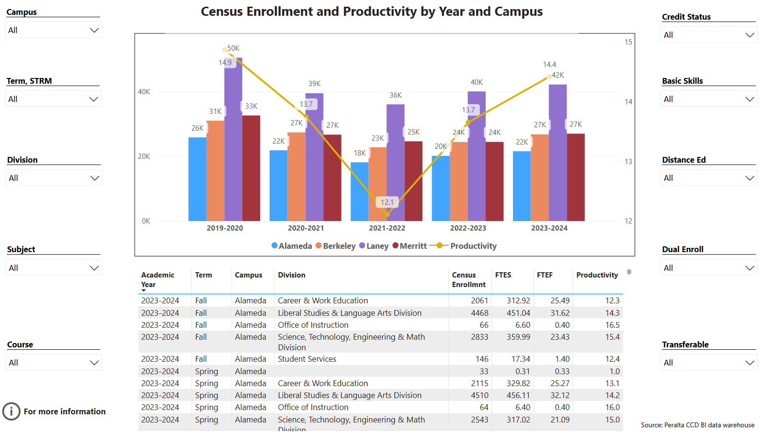
Enrollment Trends Power BI dashboard
Note: Please consider the most recent years when answering the questions below. Data with default filter is provided below. Use the link above to explore the data further.
Discuss recent enrollment trends. District-wide enrollment trends are shown above for comparison.
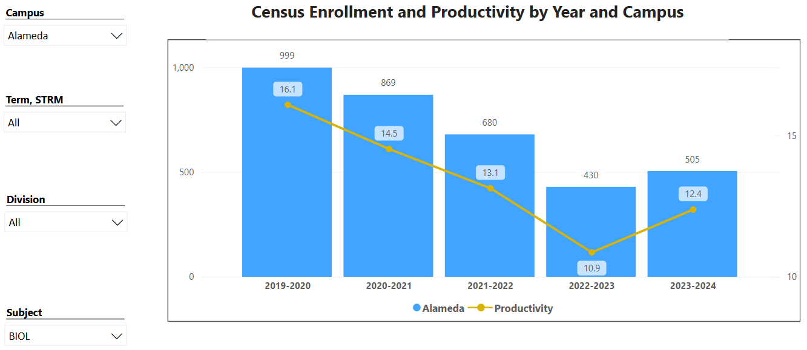

Overall, our school declined in enrollment and productivity from the years 2020 to 2022 vs Biology declining from the years 2020 to 2023 going beyond one year compared to our college. Although Biology is lagging, the data shows that we increased from 10.9% to 12.4% increasing by 1.5%. In addition, Biology had a higher increase from 10.9% to 12.4% in comparison to the college that went from 13.1% to 13.6%, increasing by 0.5%.

The data seems to be indicating that Biology is recovering much rapidly in comparison with our college. Based on the percent difference formula, enrollment in Biology went up by 17.4% compared to the overall enrollment at our college by 10%.

Course Completion Power BI Dashboard #1
Course Completion Power BI Dashboard #2
Institutional Set Standards
Consider your course completion rates in recent years (% of student who earned a grade of "C" or better). Data with default filter is provided below. Use the link above to explore the data further.
How does the course completion rate for your program or discipline compare to your college’s Institutional Set Standard for course completion (70% with stretch goal of 77%)? Also discuss the retention rate for your program or discipline, compared to the college average shown in data below, as well as what the discipline, department, or program has done to improve course completion and retention rates.
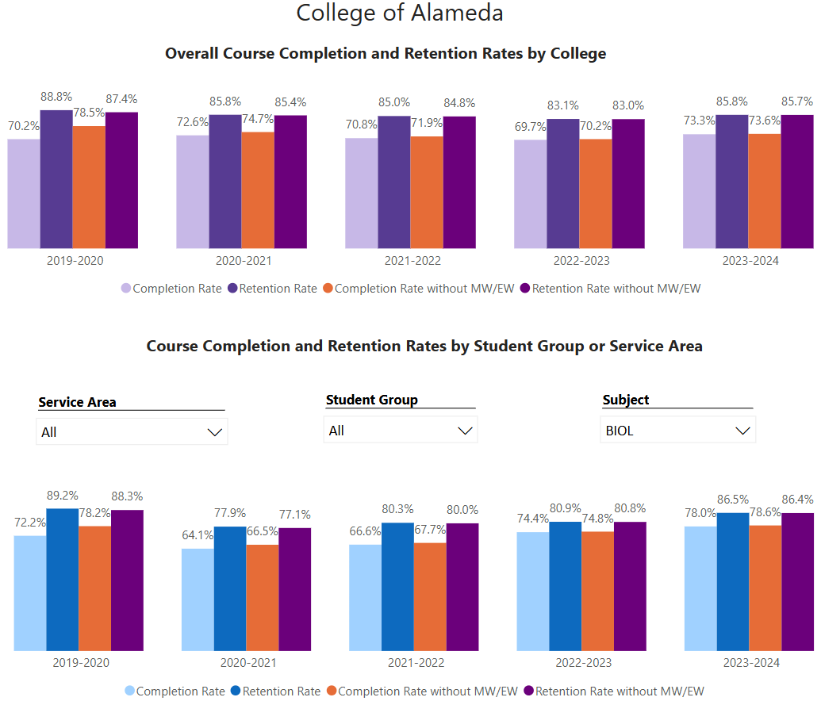

Completion Rate
Overall, the trend in Biology for the years 2020, 2023, and 2024 demonstrates higher rates of completion vs. the college average completion rates. Especially when looking at 2024, the data shows that we are recovering.
However, completion rates in 2021 and 2022 Biology completion rates were low compared to our college due to the COVID-19 pandemic. Perhaps having the element of laboratories normally needed to be run in person, played a role in the completion rates for Biology during the pandemic.

Retention Rate and Retention rate without MW/EW
For 2020 and 2024 Biology is above the college average. However, during the COVID-19 pandemic, retention went down as expected, but it has slowly increased and has recovered in 2024 seen by a retention rate of 86.5% vs. 85.8% for our college.
For retention rate without MW/EW, the trend matches the retention rate with MW/EW. There was a similar recovery in 2024 seen by retention rates of 86.4% in Biology vs. 85.7 in our college.

Completion Rate without MW/EW

For the completion rate without EW and MW the only difference in the trend was 2020 is now lower than the campus average. This is because Biology had less excused withdrawals and military withdrawals compared to the overall campus.

Efforts to Improve Success Rates
In Bio 2 (Human Anatomy), changes to improve success rates for students have included providing them with extra office hours, contacting student via a phone call prior to starting the course, providing students with more access to the Instructor via their Google Voicemail # to text or call with questions, providing extra credit projects, provide interactive custom labs designed and housed in Canvas for their constant access, getting to know all students one-on-one, maintaining a 100% learning environment in hybrid courses via Zoom and during in-person labs, taking courses to improve teaching synchronously online, and mentoring students who are not improving to foster their success by connecting with them one-on-one after lab.
In Bio 10 and our other courses, Faculty are constantly reminding students of their office hours, and their lab and lecture. In addition, they are conducting pre-lab mandatory formulation of 5 questions, post-lecture in class group activity formulation of 5 questions from the lecture covered, group activity quizzes at the end of lecture, weekly quizzes with bonus points toward their total grade, identify students who are doing poorly to provide them with one-on-one mentorship, connecting material covered in lecture with the laboratory experiments, and reviewing content from previous laboratories.

Degrees & Certificates Power BI dashboard
Please provide an update on the degrees and certificates offered by the discipline, department, or program. Below data shows the number of degrees and certificates awarded by year, for the past three years. Use the link above to explore the data further.
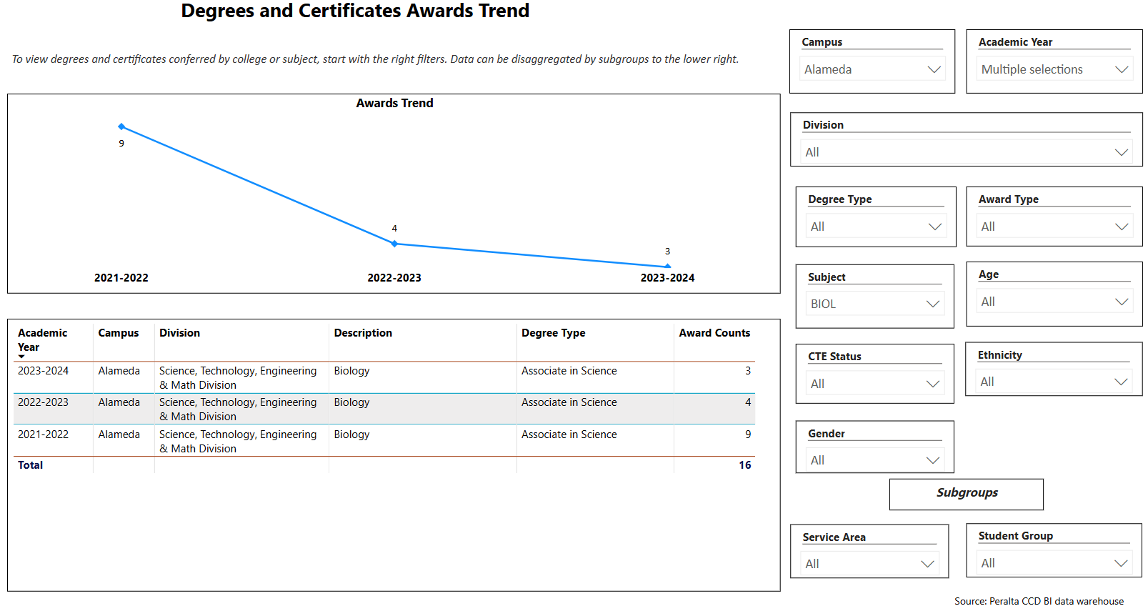

Overall, degree and certificate awards have gone down by 67% according to the data by using the percentage difference calculation. However, overall, the state has gone down in students earning degrees and certificates. Although, Biology did increase in degree and certificate awards in 2021-2022 it has averaged out to the initial number of awards in the years of 2019-2020. Perhaps this is because students seeking a Bachelor of Science are simply seeking to transfer to a four-year University.

Describe any significant changes in the recent years and discuss what the changes mean to your program.
Although data shows that Biology has not awarded many degrees, we see that the data shows that we are averaging out to the number of awards earned in 2019-2020.

We also planned to offer our courses in various modalities and have done so to increase our enrollment and accommodate to the needs of our students since most work full time. In addition, the MESA Connect program is being reassembled and is planned to launch Spring 2025 or sooner. Through the MESA Connect program we hope to be able to reach out to more students and serve their tutoring needs in the Science Annex at 860 Atlantic Ave. In addition, we plan to find a way to include the Sciences during Discovery Day when touring of our various programs.

Furthermore, we are offering our Human Anatomy and Physiology courses in a variety of modalities and times, for example we offer both courses in the evening to ensure students can go to work during the day to complete their prerequisites for Nursing, Physician Assistant, Physical Therapy, and other programs. Therefore, the mentioned classes quickly filled this Fall of 2024.

Although we first successfully offered the new course of Microbiology online (Spring 21-Spring 22) we have offered it now in-person since Fall 22 and it has continued to draw students to complete their prerequisites for the Nursing, Physician Assistant, Physical Therapy, and other programs.

Describe the department's progress on Student Learning Outcomes (SLOs) and/or Service Area Outcomes (SAOs) since the last Program Review/APU.
There is a need to continue work in this area and will move forward working with Faculty to ensure the completion of our SLO’s.
However, SLO assessments that were completed so far are above 90% success rate.

Describe the outcomes and accomplishments from previous year’s funded resource allocation request. If your program did not receive any allocations, leave the boxes blank.
Brief description of funded request | Source (any additional award outside your base allocation) | Total Award Amount | Outcome/Accomplishment
MODIFY THIS ONE.  Autoclave: Is needed to sterilize media to grow bacteria that must be used in every single Bio 3 (Microbiology) laboratory. In addition, media must be sterilized to be used in several experiments in our Bio 1A (General Biology, majors), and for an experiment in Bio 10 (Introduction to Biology). This device must also be used to sterilize all equipment that will come in direct contact with bacteria that must be grown during experiments in several of our courses. | Fund 11 General Restricted Funds, from project 0897 Instructional Funds | $19,700 | The autoclave has been used to sterilize the large amounts of media needed and used by students taking Bio 3 (Microbiology). In addition, the autoclave supports the use for the media also used for some of the experiments in Bio 1A, Bio 4, and Bio 10.  Furthermore, the autoclave is also used extensively to sterilize the media inoculated with bacteria after students in Bio 3, Bio 1A, Bio 4, and Bio 10 have analyzed their results.
30 Microscopes |  | $18,191.25 | Microscopes are being used extensively by students enrolled in Microbiology, General Biology and Human Physiology
35 Microscopes |  | $21,008.87 | Microscopes are being used extensively by students enrolled in Bio 10 (Introduction to Biology).
High precision digital scale to measure media needed for Biology 3 (Microbiology) since media must be prepared at the proper pH. Biology 1A, Biology 1B, Biology 10, and Biology 4. |  | $1,785.55 | The scale is being used to accurately measure the number of components needed to make media for Bio 3, Bio 1A, Bio 4, and Bio 10.
pH meter is used to support our Biology 3 (Microbiology) since media must be prepared at the proper pH. Biology 1A, Biology 1B, Biology 10, and Biology 4. |  | $523.29 | The pH meter is extensively used to measure and maintain the correct pH when media is made for Bio 3, Bio 1A, Bio 4, and Bio 10.
Micro incinerators for students to sterilize equipment during lab. |  | $4,469.30 | The Micro incinerators are being extensively used by students prior to and after inoculating bacterial plates during their laboratory.
BioSafety Cabinet for the Lab Coordinator to inoculate media. | Fund 11 General Restricted Funds, from project 0897 Instructional Funds. | $9,888.50 | The Biosafety Cabinet is used by the Laboratory Coordinator to inoculate media and to isolate bacterial isolates that will be used by students to identify bacteria through their biochemical pathways.

Prioritized Resource Requests Summary
In the boxes below, please add resource requests for your program. If there are no resource requested, leave the boxes blank.
Resource Category | Description/Justification | Full-Time Equivalent Percentage | Salary Grade (if applicable)
Personnel: Classified Staff

Personnel: Student Worker | Student worker to support Lab Coordinator. |  | $7,000
Personnel: Part Time Faculty | Provided there are available FTEF’s for the following semesters, we will need more Part-Time Faculty since our courses quickly filled this Fall of 2024. We are hopeful that our courses continue this positive trend for Spring 2025 and following semesters. |  | Unknown
Personnel: Full Time Faculty

Personnel: Full Time Faculty, future anticipated need

Resource Category | Description/Justification | Total Estimated Cost
Professional Development: Department wide PD needed | Faculty attendance at Conferences. For example, the American Association for the Advancement of Science and the Human Anatomy and Physiology Society | ~$5,000
Professional Development: Personal/Individual PD needed | Faculty attendance at Conferences. For example, the American Association for the Advancement of Science, American Society for Microbiology, and the Human Anatomy and Physiology Society | ~$6,000

Prioritized Resource Requests Summary - Continued

Resource Category | Description/Justification | Total Estimated Cost
Supplies: Software

Supplies: Books, Magazines, and/or Periodicals | Science scientific journal to keep up to date with the latest scientific breakthroughs to support all of our Biology courses. | $300/year
Supplies: Instructional Supplies | Four microphones. We will need microphones for each Faculty so that students can adequately hear our lectures since some Faculty will be using masks. Students will need to be able to hear our lectures and instructions for laboratory as well as instructions for safety before carrying a lab and during the lab. | ~$1,000
Supplies: Non-Instructional Supplies | Two high Ergonomic chairs for the Laboratory  One ergonomic chair for one office | $800  $500
Supplies: Library Collections

Resource Category | Description/Justification | Total Estimated Cost
Technology & Equipment: New | - Thirty Microscopes are needed for their extensive use by students enrolled in Bio 2 (Human Anatomy) for the identification of all Tissue Types making up the human body the entire semester.  - Refrigerator (2) The high standards of sterilization that must be met in microbiology necessitates the need for a dedicated refrigerator. Autoclaved and pre-made materials that require refrigeration can be specifically stored here. The lack of sufficient refrigeration facilities over-stretches our dedicated refrigerator and potentially is a major cause of contamination leading to a waste of resources and time. The refrigerator is needed to store petri plates with media, and bacteria that must be used for every single experiment in Bio 3 (Microbiology). In addition, a refrigerator is needed to store some bacterial isolates that will be used and maintained, as well as for the bacterial plates containing the bacteria that students will be growing within those plates prior to carrying out further biochemical tests.  - Biology models will be needed to support our Biology 10, 1A, and 1B courses.  Flower model (Giant Dicot model)  Two seed models  Early Man and Primate Skull Comparison Set  - Autoclave This piece of equipment is central and an integral component of the Microbiology lab and has tremendous utility in other courses such as General Biology and Introduction to biology. The key functionality of the autoclave is in meeting the required high degree of sterilization of our media and other materials. Contamination from unwanted microorganisms including airborne fungus is a common feature and can impact the outcome of our experiments and lead to waste of resources and time. Also, a leak of micro-organisms into the environment or unwanted spaces is a major concern. The autoclave plays a major role in waste management. Biohazard wastes must be autoclaved before being released from the lab.  - Autoclave scheduled maintenance costs. The autoclave requires routine maintenance costs. Sterilization of materials and bio-hazard wastes is a continuous process. This volume of work puts the autoclave at risk of being damaged. It is therefore critical that we set up an accompanied fund to the autoclave purchase specifically dedicated to its maintenance every 6 months. | ~$25,000  ~$6,900  $1,000  $400  $2,900  45,000  $7,000/year
Technology & Equipment: Replacement | - Two EKG machines will be needed to support laboratories carried out in our Bio 4 (Human Physiology) course. Students taking the course gain critical thinking skills and hands-on use of equipment to measure the heart rhythm as the many of them will be entering a variety of Allied Health Fields.  - Anatomical models will be needed to support the laboratories carried out in our Bio 2 (Human Anatomy) course. Students taking the course gain critical thinking skills, and the ability to understand the spatial location of the various organs, muscles, and structures in the human body. Several of the models have broken over the years due to wear and tear, in turn, we do not have an adequate number of models to support the success of our students. We need at least 5 eye models since all are broken and missing components, 5 ear models since most are broken and missing components, 5 skin models since we only have one, 4 leg models to make sure all groups have one leg to study during lab, 4 arm models to ensure all groups have one arm to study during lab, 5 myofibril models,  - Balances to support our Bio 10, Bio 1A students to weight substances during their lab.  - Centrifuges we need three of these to support Bio 3 and Bio 4 as they are needed to be used by students during lab.  - Respirometers two are needed to support Bio 4 (Physiology).  - Laboratory Carts two are needed to support all of our laboratories.  - Dissecting scopes we need to desperately replace 10 ancient barely usable scopes for our students in Bio 10, Bio 1A, and Bio 2 during their laboratories.  - Spectrophotometer The spectrophotometer is a must have equipment for our General Biology course. It is a valuable tool in our pigment analysis, calibration of micropipettes and organic biological molecule assays. The skills acquired from this analysis are invaluable to our students as they transition to the next steps of their academic career. The spectrophotometers we have are old models and some are broken down.  - Water bath The water bath is necessary in ensuring the accuracy of our temperature sensitive experiments. The insulation it provides guarantees that our experimental assays take place at the required temperatures. It has wide utility in microbiology, General biology and Introduction to biology courses.  - Microcentrifuge The microcentrifuge is necessary in spinning of the tubes. There is a potential of contamination during opening and closing of the tubes or challenges in getting samples from the tubes as there is a tendency of the sample to stick on the side of the tubes. The microcentrifuge addresses these problems. It is useful in microbiology, general biology, and introduction to biology courses.  - Eight DNA models (dynamic) The foundational role of the DNA in our understanding of organisms phenotypic character cannot be underestimated. DNA structure and function is taught in almost all our biology courses. The proposed double-helix structure of the DNA is what earned Watson and Crick their Nobel Prize. This model is framed upon that structure and plays a significant role in helping our students visualize the bonding of the bases and the position of the other components. Students can also manipulate it to understand how the DNA is duplicated and how the RNA can be read from the DNA template | ~$15,000  ~$25,000  ~$2,000  ~$1,500  ~$3,200  ~$1,000  ~$5,000  ~$8,000  ~$1000  ~$1000  ~$8,552

Prioritized Resource Requests Summary - Continued

Resource Category | Description/Justification | Total Estimated Cost
Facilities: Classrooms | Since student attendance to in-person classes is improving, we would benefit from more available space. Currently, we share classrooms with Chemistry and Geology. | Unknown
Facilities: Offices | It would be beneficial to plan on having more office space since we only have two offices available for two full-time Faculty. However, if our former Full-time Faculty returns to teach, they will need their own office. | Unknown
Facilities: Labs | Students are attending all of our labs in person. In turn, our laboratory space is fully being used. | Unknown
Facilities: Other

Resource Category | Description/Justification | Total Estimated Cost
Library: Library materials

Library: Library collections

Resource Category | Description/Justification | Total Estimated Cost
OTHER

