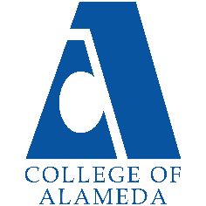
2024-25 Annual Program Update -
Dance

Program Overview
Please verify your program’s mission statement and program’s learning outcomes below, and make any corrections necessary.
Mission Statement
The objectives of the Dance Department include providing introductory courses that meet requirements of Associate of Arts (AA) degrees (including Dance Certificate of Achievement), courses geared toward a wide variety of dance techniques, dance history, and dance choreography transfer courses to four-year Universities and Colleges, and prerequisites for premier professional dance schools such as, Mills College, NYU, UC Berkeley, Cal-Arts, Cal-State Long Beach, UC Irvine, and Duke University.

Dance – A.A. Degree Program Learning Outcomes
- Demonstrate competence in and understanding of core dance techniques, including ballet and modern dance.
- Analyze and critique diversity in dance and dance appreciation.
- Participate in creating a dance showcase and demonstrate competence in beginning choreography, music for dance, and other aspects of personal and group performance.

Dance – Certificate of Achievement Program Learning Outcomes
- Demonstrate competence in and understanding of core dance techniques, including ballet and modern dance.
- Analyze and critique diversity in dance and dance appreciation.
- Participate in creating a dance showcase and demonstrate competence in beginning choreography, music for dance, and other aspects of personal and group performance.

List your program faculty and/or staff, and indicate whether they are full-time or part-time.
Danny Nguyễn, full-time
Stephanie Da Silva, part-time

Describe your current utilization of facilities, including labs and other space.
Dance Studio G-111 is a single, large 3,400 square foot studio which is utilized for all classroom delivery and as a performance studio at least twice a year like other colleges (i.e. Mills, CCSF, Foothill, and Contra Costa). Studio G-111 performance capabilities have been moderately improved by adding portable stage lights, side (“wings”) and back curtains to cover the surrounding mirrors during a performance, which enhanced our Winter 2024 semester performance.

The Program Goals below are from your most recent Program Review or APU. If none are listed, please add your most recent program goals. Then, indicate the status of this goal, and which College and District goal your program goal aligns to. If your goal has been completed, please answer the follow up question regarding how you measured the achievement of this goal.
Program Goal | Prepare students to start at a variety of dance levels, from very basic to professional level.
Status: In-Progress or Complete?  If complete, give a brief description of how you measured the goal completion. | In-Progress
Which college or district goal is aligned with your program goal? | Goal 2: Provide quality educational and student support services that result in equitable student access to educational opportunities and success in earning a degree or certificate.

Program Goal | Challenge students to reach higher and farther than they think they can.
Status: In-Progress or Complete?  If complete, give a brief description of how you measured the goal completion. | In-Progress
Which college or district goal is aligned with your program goal? | Goal 5: Foster an inclusive and caring culture that thrives on diversity and promotes social justice and equity.

Program Goal | Prepare students to teach beginning level dance at private dance studios and public schools.
Status: In-Progress or Complete?  If complete, give a brief description of how you measured the goal completion. | In-Progress
Which college or district goal is aligned with your program goal? | Goal 1: Develop and offer curriculum and learning that is innovative, with industry standards and labor market demands.

Program Update – Enrollment Trends, Success Rates, and Degrees & Certificates
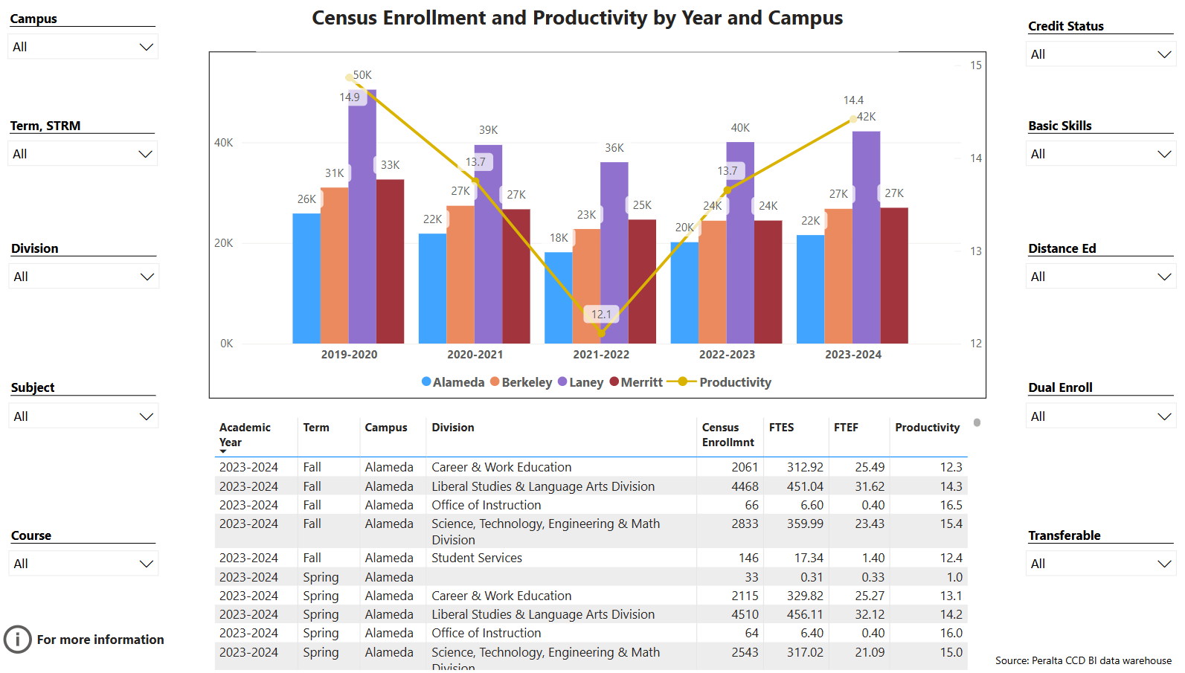
Enrollment Trends Power BI dashboard
Note: Please consider the most recent years when answering the questions below. Data with default filter is provided below. Use the link above to explore the data further.
Discuss recent enrollment trends. District-wide enrollment trends are shown above for comparison.
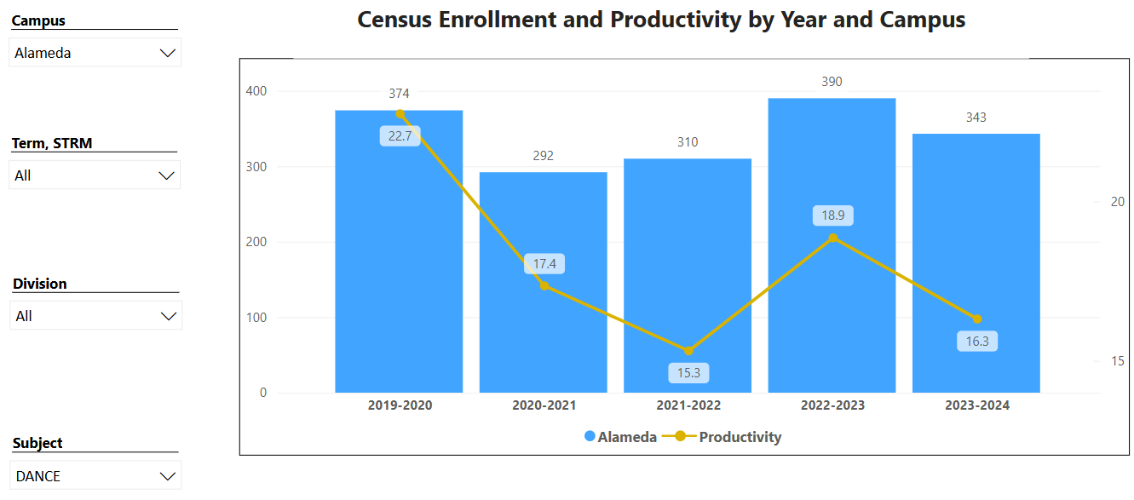

Academic years 2020-2021 and 2021-2022 reflect, in parallel with PCCD overall, the impact to enrollment as the COVID-19 pandemic occurred and the after effect as it ended. Academic year 2022-2023 reflected a rebound in enrollment that also paralleled PCCD overall, but surprisingly surpassed DANCE enrollment from year 2019-2020. It is likely that this resurgence was partly due to an overwhelming desire within the public to finally get out of lockdown and pursue regular activities again. Academic year 2023-2024 showed a slight decrease in enrollment over the prior year, but also the median enrollment across all 5 years. Why enrollment dropped is unknown at this point, but enrollment as high as the prior year was also not likely to be maintained. Looking ahead to 2024-2025 enrollment will likely plateau or decrease slightly since one full-time faculty will be on leave during Spring 2025 and fewer classes than usual will be offered.

Course Completion Power BI Dashboard #1
Course Completion Power BI Dashboard #2
Institutional Set Standards
Consider your course completion rates in recent years (% of student who earned a grade of "C" or better). Data with default filter is provided below. Use the link above to explore the data further.
How does the course completion rate for your program or discipline compare to your college’s Institutional Set Standard for course completion (70% with stretch goal of 77%)? Also discuss the retention rate for your program or discipline, compared to the college average shown in data below, as well as what the discipline, department, or program has done to improve course completion and retention rates.
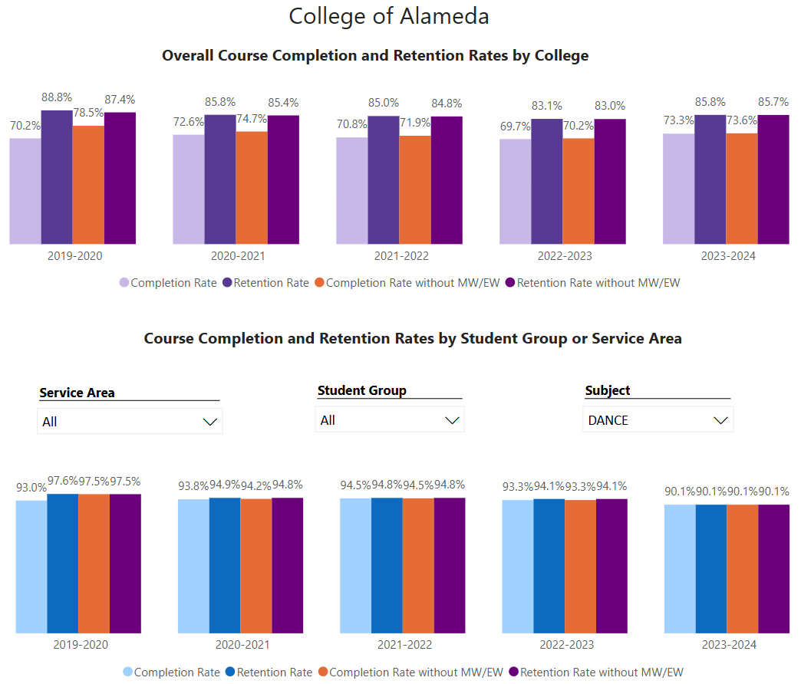

While completion / retention dropped slightly during Academic Year 2023-2024, a clear reason why it dropped is not known. Overall, DANCE completion / enrollment measures are still significantly higher than COA overall, averaging above 90% across all years represented for DANCE.

Degrees & Certificates Power BI dashboard
Please provide an update on the degrees and certificates offered by the discipline, department, or program. Below data shows the number of degrees and certificates awarded by year, for the past three years. Use the link above to explore the data further.
[No Dance degree appears awarded yet; update provided in last APU was: “A.A. Degree in Dance and Dance Certificate of Achievement were approved by CoA Curriculum Committee in Spring 2022 and the programs were implemented in Spring 2023. We need help advising students in meeting requirements for the A.A. degree and/or the certificate.”]

Though we worked hard to get the AA Degree in Dance and Dance Certificate of Achievement approved by the CoA Curriculum Committee, the single biggest outstanding obstacle to successful delivery. However, continues to be the lack of approval to deliver the Dance History course “Dance 02, Dance Diversity” that was also prepared. The earliest that Dance History might be offered is 2024-2025 though it remains to be approved and staffed even for the upcoming academic year.

Students wishing to earn either the degree or certificate are currently only able to do so at Laney. As a comparison, Laney granted a total of 4, including 1 degree and 3 certificates during 2023-2024.

Describe any significant changes in the recent years and discuss what the changes mean to your program.
Other than the Dance History course discussed before this point in this Program Review, no other significant changes to the Dance Program are being discussed or planned.

Describe the department's progress on Student Learning Outcomes (SLOs) and/or Service Area Outcomes (SAOs) since the last Program Review/APU.
[Outcomes assessment discussion goes here]

Each of the Dance department courses has defined, effective, documented SLOs.

Each of the Dance department program goals is aligned with the recent 2022 Vision for Success, PCCD & CoA’s Educational Master Plan, as well as being aligned with Service Area Outcomes.

We have no current plans to change or modify our SLOs.

Describe the outcomes and accomplishments from previous year’s funded resource allocation request. If your program did not receive any allocations, leave the boxes blank.
Brief description of funded request | Source (any additional award outside your base allocation) | Total Award Amount | Outcome/Accomplishment
Currently we are in our first semester with 1 part-time dance faculty added starting in Fall 2024.

We have purchased 16 LED light trees for our annual performances.

Prioritized Resource Requests Summary
In the boxes below, please add resource requests for your program. If there are no resource requested, leave the boxes blank.
Resource Category | Description/Justification | Full-Time Equivalent Percentage | Salary Grade (if applicable)
Personnel: Classified Staff

Personnel: Student Worker | - Obtain a dance instruction assistant to help demonstrate dance patterns which are limited or incomplete when only I demonstrate them.  - Obtain a musical accompanist to play to class instruction for modern, ballet, and choreography classes.
Personnel: Part Time Faculty

Personnel: Full Time Faculty

Personnel: Full Time Faculty, future anticipated need

Resource Category | Description/Justification | Total Estimated Cost
Professional Development: Department wide PD needed

Professional Development: Personal/Individual PD needed

Prioritized Resource Requests Summary - Continued

Resource Category | Description/Justification | Total Estimated Cost
Supplies: Software
Supplies: Books, Magazines, and/or Periodicals

Supplies: Instructional Supplies

Supplies: Non-Instructional Supplies | An appropriate augmentation to the community and performance aspects of Studio G-111 would be a permanent bulletin board in the back of the studio so we can post our fliers, schedules, and perhaps reviews from local newspapers.
Supplies: Library Collections

Resource Category | Description/Justification | Total Estimated Cost
Technology & Equipment: New

Technology & Equipment: Replacement

Prioritized Resource Requests Summary - Continued
Resource Category | Description/Justification | Total Estimated Cost
Facilities: Classrooms | Studio G-111 needs more suitable seating for a 150-person audience, such as bleachers along one wall, preferably collapsible and easy to store out of the way during class delivery, but readily available for performances and other impromptu usage.
Facilities: Offices

Facilities: Labs

Facilities: Other | The Dance Department may attract more attention if a large sign (COA Dance Department) were to be posted alongside the G-111 street-facing external walls.

Resource Category | Description/Justification | Total Estimated Cost
Library: Library materials

Library: Library collections

Resource Category | Description/Justification | Total Estimated Cost
OTHER

