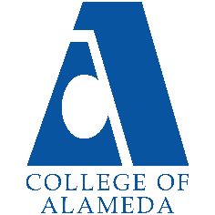
2024-25 Annual Program Update -
Dental Assisting

Program Overview
Please verify your program’s mission statement and program’s learning outcomes below, and make any corrections necessary.
Mission Statement
To provide an educational program that promotes an atmosphere of professionalism, integrity, and educational excellence. The Dental Assisting Program develops knowledge and skills that will enable students to function as an integral part of the dental healthcare team. Students will have the opportunity to acquire the knowledge and proficiency to successfully assist in providing great Oral healthcare to the community.

Dental Assisting – A.S. Degree Program Learning Outcomes
- Differentiate and evaluate specialty procedures within each of the dental specialties.
- Communicate verbally using acceptable dental terminology in regards to interpersonal skills and concerns for the patients’ welfare.
- Recognize, support and facilitate the importance of HIPPA laws.
- Demonstrate acceptable dental office procedures

Dental Assisting – Certificate of Achievement Program Learning Outcomes
- Differentiate and evaluate specialty procedures within each of the dental specialties.
- Communicate verbally using acceptable dental terminology in regards to interpersonal skills and concerns for the patients’ welfare.
- Recognize, support and facilitate the importance of HIPPA laws.
- Demonstrate acceptable dental office procedures.

List your program faculty and/or staff, and indicate whether they are full-time or part-time.
Carla Pegues: full-time
Renee Herold : part-time
Julie Rodriguez: part –time
Ledy Delfin-icatar : part-time
Chris Devine Pagatpatan : part-time

Describe your current utilization of facilities, including labs and other space.
A201, 204 206, 208,209,211,222,223, and 224.]

The Program Goals below are from your most recent Program Review or APU. If none are listed, please add your most recent program goals. Then, indicate the status of this goal, and which College and District goal your program goal aligns to. If your goal has been completed, please answer the follow up question regarding how you measured the achievement of this goal.
Program Goal | The DA department goal is to always ensure that our students obtain the knowledge necessary to perform their duties in an ethical, responsible and professional manner
Status: In-Progress or Complete?  If complete, give a brief description of how you measured the goal completion. | In-progress
Which college or district goal is aligned with your program goal? | Aligns with PCCD Goal to engage and leverage partners ( 4)

Program Goal | To educate and train our students to master the competency of infection control to educate and protect their community and dental team
Status: In-Progress or Complete?  If complete, give a brief description of how you measured the goal completion. | In- Progress
Which college or district goal is aligned with your program goal? | Aligns with PCCD goal to build programs of distinction (6)

Program Goal | Continue to meet with industry partners in Alameda County, advisory board members and accreditation (CODA) staff to ensure we are meeting regulated standards and to ensure […?]
Status: In-Progress or Complete?  If complete, give a brief description of how you measured the goal completion. | In -Progress]
Which college or district goal is aligned with your program goal? | Four ( 4) increase community and educational partnership. Aligns with PCCD goal to engage and leverage partners.

Program Update – Enrollment Trends, Success Rates, and Degrees & Certificates
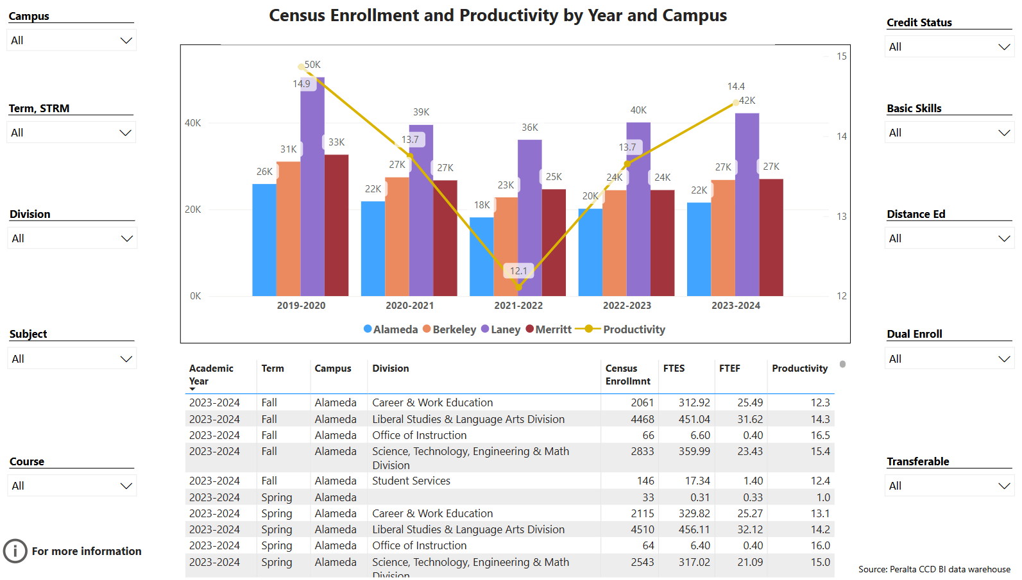
Enrollment Trends Power BI dashboard
Note: Please consider the most recent years when answering the questions below. Data with default filter is provided below. Use the link above to explore the data further.
Discuss recent enrollment trends. District-wide enrollment trends are shown above for comparison.
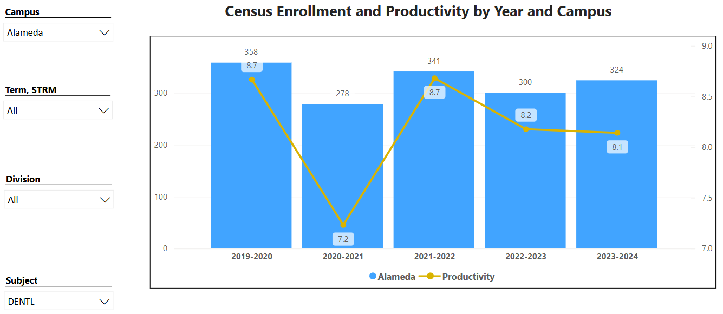

The enrollment trends for the DA department is improving and has been steady for the last 2-3 years ]

Course Completion Power BI Dashboard #1
Course Completion Power BI Dashboard #2
Institutional Set Standards
Consider your course completion rates in recent years (% of student who earned a grade of "C" or better). Data with default filter is provided below. Use the link above to explore the data further.
How does the course completion rate for your program or discipline compare to your college’s Institutional Set Standard for course completion (70% with stretch goal of 77%)? Also discuss the retention rate for your program or discipline, compared to the college average shown in data below, as well as what the discipline, department, or program has done to improve course completion and retention rates.
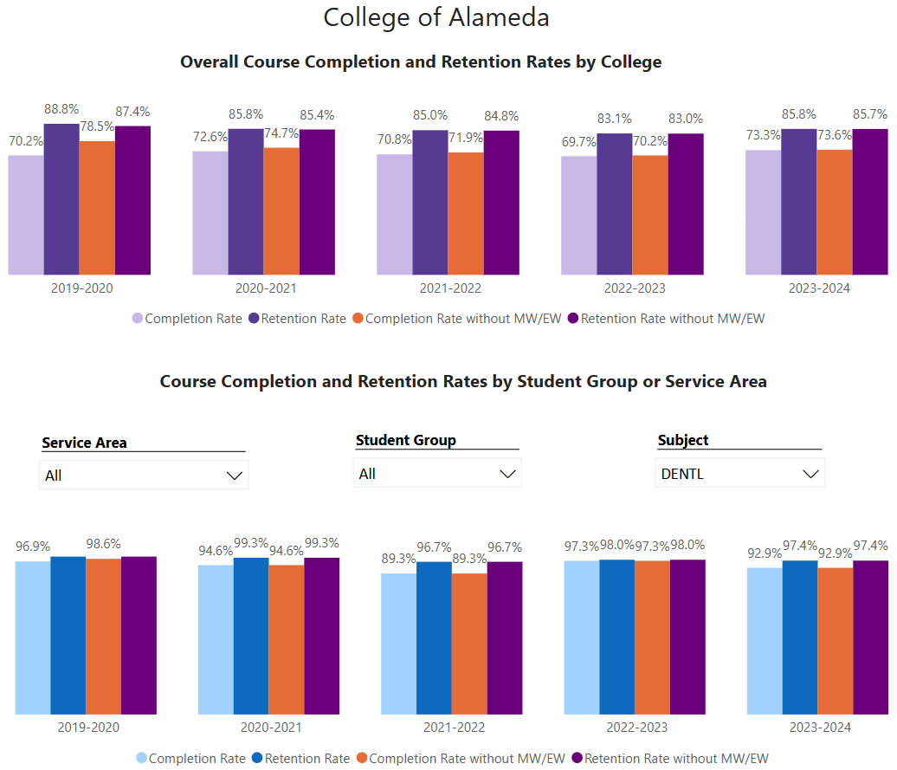
The DA department completion rate and retention rate is approximately 80-90 %]

Degrees & Certificates Power BI dashboard
Please provide an update on the degrees and certificates offered by the discipline, department, or program. Below data shows the number of degrees and certificates awarded by year, for the past three years. Use the link above to explore the data further.
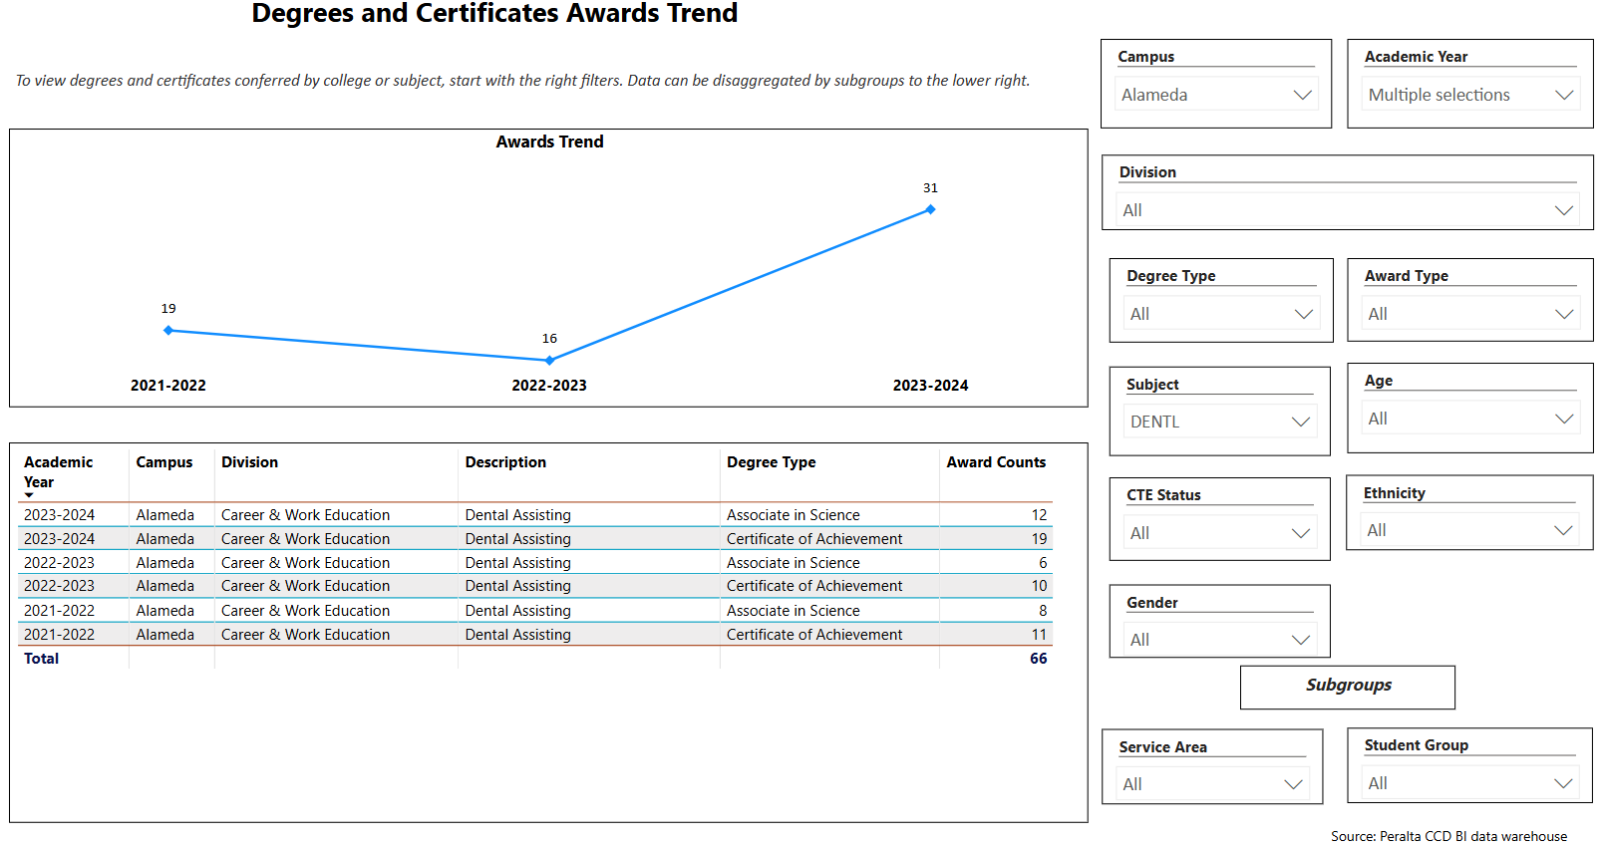

Describe any significant changes in the recent years and discuss what the changes mean to your program.
The economy has had some impact on student’s ability to attend school. A lot of our students are attending school as well as work a part-time job.

Describe the department's progress on Student Learning Outcomes (SLOs) and/or Service Area Outcomes (SAOs) since the last Program Review/APU.
[The DA program continues to progress and improve on SLO’s. ]

Describe the outcomes and accomplishments from previous year’s funded resource allocation request. If your program did not receive any allocations, leave the boxes blank.
Brief description of funded request | Source (any additional award outside your base allocation) | Total Award Amount | Outcome/Accomplishment
Tablets (4) |  | $1,000 | Staff is able to assist and grade competency at the chair/ lab, which provides immediate feedback to students.

Prioritized Resource Requests Summary
In the boxes below, please add resource requests for your program. If there are no resource requested, leave the boxes blank.
Resource Category | Description/Justification | Full-Time Equivalent Percentage | Salary Grade (if applicable)
Personnel: Classified Staff | N/A
Personnel: Student Worker | N/A
Personnel: Part Time Faculty | To assist with lab
Personnel: Full Time Faculty | N/A
Personnel: Full Time Faculty, future anticipated need | N/A

Resource Category | Description/Justification | Total Estimated Cost
Professional Development: Department wide PD needed | Professional development is vital to ensure that we are keeping up with Industry changes that are on-going. | $8,000
Professional Development: Personal/Individual PD needed | As Program Director and Infection Control Instructor. It is imperative that I attend ADEA Program Directors annual Conference and the ADS (OSAP) annual conference to stay current with industry changes and CODA regulations. | 10,000

Prioritized Resource Requests Summary - Continued

Resource Category | Description/Justification | Total Estimated Cost
Supplies: Software | Eagle soft software | $3,000
Supplies: Books, Magazines, and/or Periodicals | N/A
Supplies: Instructional Supplies | Dental material | $10,000
Supplies: Non-Instructional Supplies | N/A
Supplies: Library Collections | N/A

Resource Category | Description/Justification | Total Estimated Cost
Technology & Equipment: New | (2) new x-ray manikins  (2) size two digital sensors  (1) size one digital sensors  (4) star slow speed headpieces | $16,000  $24,000  $12,000  $8,000
Technology & Equipment: Replacement | (2 ) Repair x-ray manikins | $2,000

Prioritized Resource Requests Summary - Continued

Resource Category | Description/Justification | Total Estimated Cost
Facilities: Classrooms

Facilities: Offices | New faculty computers x4 | $8,000
Facilities: Labs

Facilities: Other

Resource Category | Description/Justification | Total Estimated Cost
Library: Library materials | N/A
Library: Library collections | N/A

Resource Category | Description/Justification | Total Estimated Cost
OTHER | N/A

