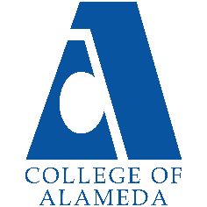
2024-25 Annual Program Update -
English for Speakers of Other Languages

Program Overview
Please verify your program’s mission statement and program’s learning outcomes below and make any corrections necessary.
Mission Statement
The College of Alameda ESOL program serves non-native speakers of English who need to learn sufficient English to communicate effectively and overcome their difficulties in reading, writing, speaking and understanding English. Instruction in English is offered to facilitate ESOL students' access to degree/transfer programs, academic programs, vocational programs and/or to prepare them for immediate employment. It is the goal of the program that students, upon the completion of the program, be able to participate meaningfully in American life.

English for Speakers of Other Languages: Advanced Certificate – Certificate of Proficiency Program Learning Outcomes
- Participate in campus and classroom culture at a level required for success as an advanced ESOL student.
- Express ideas fluently, accurately and appropriately in American English in preparation for non-ESOL courses.

English for Speakers of Other Languages: High Intermediate Certificate – Certificate of Proficiency Program Learning Outcomes
- Participate in campus and classroom culture at a level required for success as a high-intermediate ESOL student.
- Express ideas fluently, accurately and appropriately in American English in preparation for advanced ESOL courses.

English for Speakers of Other Languages: Intermediate Certificate – Certificate of Proficiency Program Learning Outcomes
- Participate in campus and classroom culture at a level required for success as an intermediate ESOL student.
- Express ideas fluently, accurately and appropriately in American English in preparation for high intermediate ESOL courses.

English for Speakers of Other Languages: High Beginning Certificate – Certificate of Proficiency Program Learning Outcomes
- Participate in campus and classroom culture at a level required for success as a high beginning ESOL student.
- Express ideas fluently, accurately and appropriately in American English in preparation for intermediate ESOL courses.

Bridge to Credit ESOL Certificate – CP1: Certificate of Competency Program Learning Outcomes
- Identify organizational tools for student success.
- Register for credit-level courses.
- Comprehend and respond appropriately to spoken American English at the level of entry-level credit ESOL courses.

ESOL Advanced - CP1: Certificate of Competency Program Learning Outcomes
- Demonstrate advanced skills in English listening, speaking, reading, and/or writing which will allow them to achieve their personal, vocational, and academic goals.

ESOL High Intermediate - CP1: Certificate of Competency Program Learning Outcomes
- Demonstrate high intermediate skills in English listening, speaking, reading, and/or writing which will allow them to achieve their personal, vocational, and academic goals.

ESOL Intermediate - CP1: Certificate of Competency Program Learning Outcomes
- Demonstrate intermediate skills in English listening, speaking, reading, and/or writing which will allow them to achieve their personal, vocational, and academic goals.

ESOL High Beginning - CP1: Certificate of Competency Program Learning Outcomes
- Demonstrate high beginning skills in English listening, speaking, reading, and/or writing which will allow them to achieve their personal, vocational, and academic goals.

List your program faculty and/or staff, and indicate whether they are full-time or part-time.
There are 5 faculty members in the ESOL faculty and two of them are full-time
Full-Time: Christa Ferrero-Castaneda and Didem Ekici
Part-Time: Brian Ng, Denise Urdang, and Jenny Lemper

Describe your current utilization of facilities, including labs and other space.
As a result of the COVID 19 pandemic, ESOL department has been conducting classes online like many other programs in the PCCD district. Before the pandemic, most classrooms at College of Alameda comfortably accommodated the average ESOL class, both in terms of room size and of seating type (movable chairs with tablet desks) and capacity. The ESOL department has transitioned to offering courses in the following modalities: hybrid in person, hybrid with weekly zoom meetings and fully online.

ESOL classes do not have labs and most of the classes are taking place in in "smart classrooms' which have every imaginable educational technology, including access to internet.

The Program Goals below are from your most recent Program Review or APU. If none are listed, please add your most recent program goals. Then, indicate the status of this goal, and which College and District goal your program goal aligns to. If your goal has been completed, please answer the follow up question regarding how you measured the achievement of this goal.
Program Goal | Educational Purpose: The major purpose and goal of the ESOL program is to provide quality instruction in reading, writing, speaking and critical thinking. The ESOL program intends to develop competency in students' understanding and use of the English language so that they may successfully enter and complete either a vocational or college level major and fully participate in the communities in which they live.
Status: In-Progress or Complete?  If complete, give a brief description of how you measured the goal completion. | This goal is an ongoing goal for the ESOL department. We require data to see how many students earned an ESOL Completion certificate and/or an associate’s degree.
Which college or district goal is aligned with your program goal? | The Vision of College of Alameda is that we are a diverse, supportive, empowering learning community for seekers of knowledge. We are committed to providing a creative, ethical and inclusive environment in which students develop their abilities as thinkers, workers and citizens of the world. Part of this support is to offer courses in modalities that meet the unique needs of College of Alameda’s ESOL student population.  As ESOL program, we help students gain the basic skills in English so that they become engaged learners that seek knowledge as lifelong learners with critical thinking skills

Program Goal | One of the goals of the program is to re-design the ESOL program and assessment process in order to comply with state mandate AB 705. AB 705 prevents the college from continuing to use the CELSA or any other standardized assessment in order to place ESOL students, so our department has formed an Onboarding Team in order to evaluate other assessment processes and pilot and validate a new system that was fully adopted in Fall 2020. This team has worked closely with the Peralta ESOL Advisory Committee (PEAC) in order to run pilots of a guided self-placement exam that aims to create a more equitable, accessible, and student-driven placement process. Additionally, we are working with PEAC to discuss district-wide adaptations to our program offerings that will beer-accommodate the 3-year meline that students with a stated goal of transfer have to complete pre-transfer level course. We have started implementing some changes including removing prerequisites of higher-level courses in our acceleration model, continuing to expand our non-credit program with mirror and support courses, and creating decision trees and other tools and protocols to support students in identifying the appropriate pathway for their chosen goal.
Status: In-Progress or Complete?  If complete, give a brief description of how you measured the goal completion. | In progress  In the process of updating course outlines.  Need districtwide discussions about all four colleges having the same guided self-placement tool since students swirl and take classes at our sister colleges.
Which college or district goal is aligned with your program goal? | Our program goal aligns with the district goal: Advance Student Access, Equity, and Success

Program Goal | ESOL student population at COA is quite diverse, and therefore, the needs of students vary. To be able to meet the student needs and address different types of learning styles, we try to diversify the modality of our classes such as synchronous, asynchronous and hybrid. Our goal is to be able to provide options for students to be able to choose the modality each class, but specifically for lower-level classes. With the support of student services programs such as EOPS and SALAAM, we would like to expand the class offerings to be able to reach out to more students with different abilities. This will also allow us to reach out to community partners and provide different modalities in non-credit classes and recruit more students. We are hoping we will get more allocations in the upcoming years to be able to achieve this program goal.
Status: In-Progress or Complete?  If complete, give a brief description of how you measured the goal completion. | In progress  We need to seek community partnerships for dual enrollment courses. Establishing community partnerships aligns with the department’s goal of recruiting students. We should survey existing ESOL student to see what modalities of instruction best fit their needs
Which college or district goal is aligned with your program goal? | This goal aligns with the district goal: Engage and Leverage partners

Program Update – Enrollment Trends, Success Rates, and Degrees & Certificates
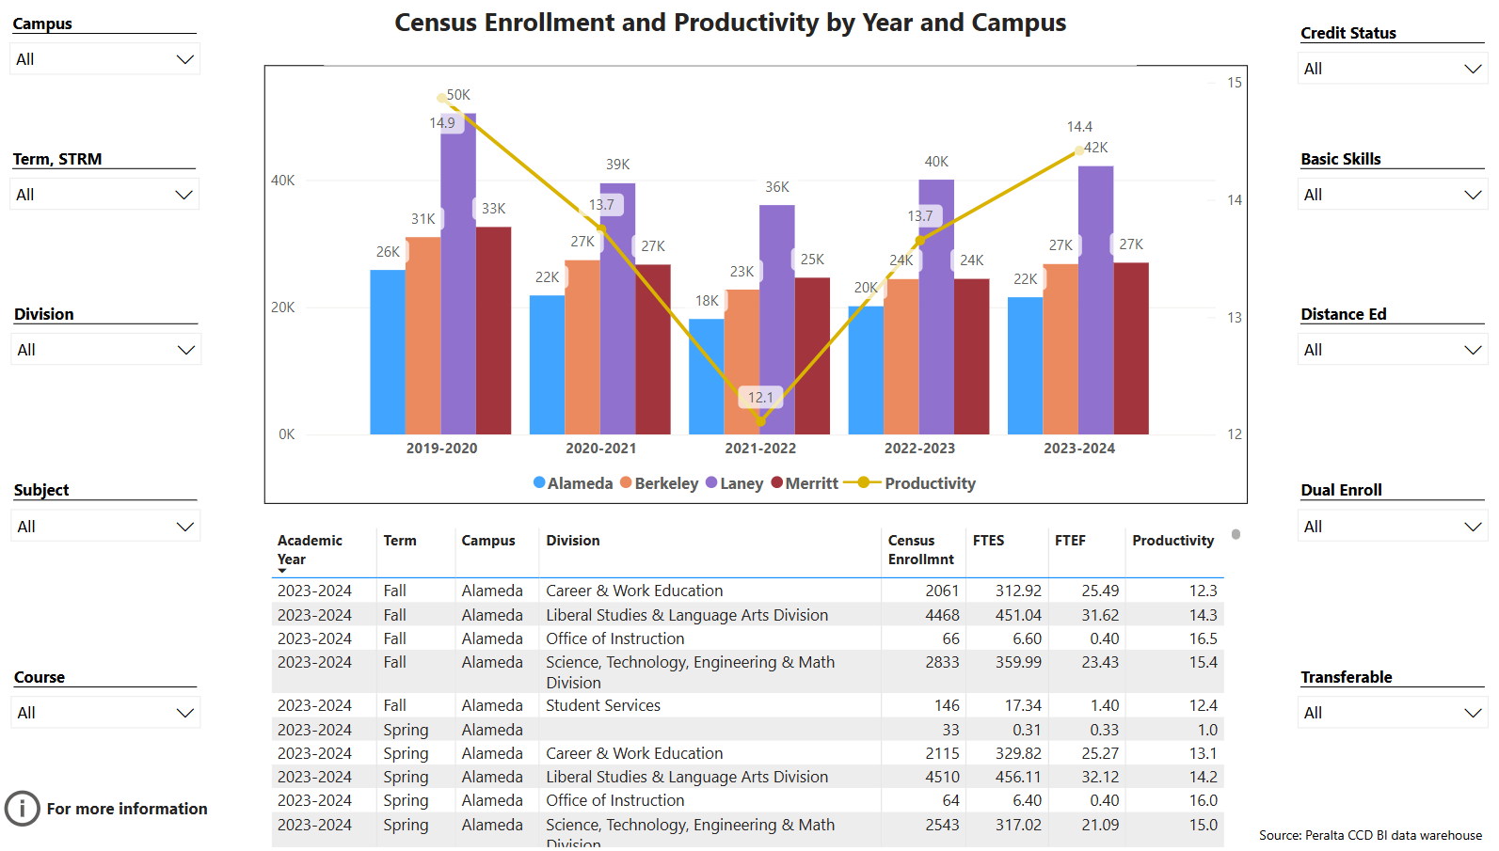
Enrollment Trends Power BI dashboard
Note: Please consider the most recent years when answering the questions below. Data with default filter is provided below. Use the link above to explore the data further.
Discuss recent enrollment trends. District-wide enrollment trends are shown above for comparison.
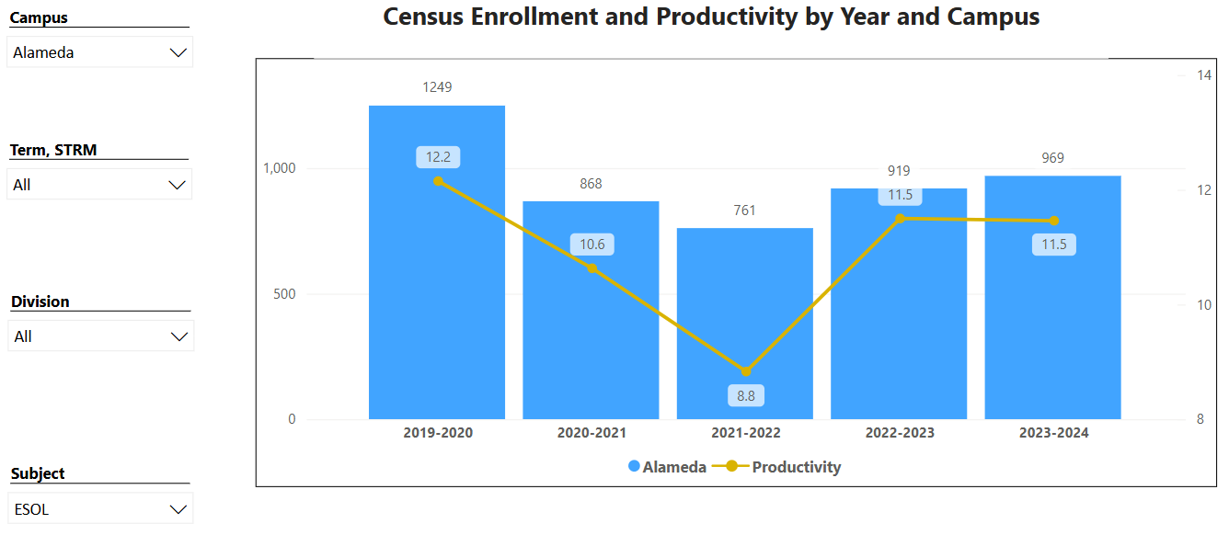

The ESOL department’s productivity and enrollment trends are consistent with College of Alameda’s productivity and enrollment with a decline in the 2021-2022 academic year. There was an increase in the following academic years and productivity has been consistent from 2022-2024.

Course Completion Power BI Dashboard #1
Course Completion Power BI Dashboard #2
Institutional Set Standards
Consider your course completion rates in recent years (% of student who earned a grade of "C" or better). Data with default filter is provided below. Use the link above to explore the data further.
How does the course completion rate for your program or discipline compare to your college’s Institutional Set Standard for course completion (70% with stretch goal of 77%)? Also, discuss the retention rate for your program or discipline, compared to the college average shown in data below, as well as what the discipline, department, or program has done to improve course completion and retention rates.
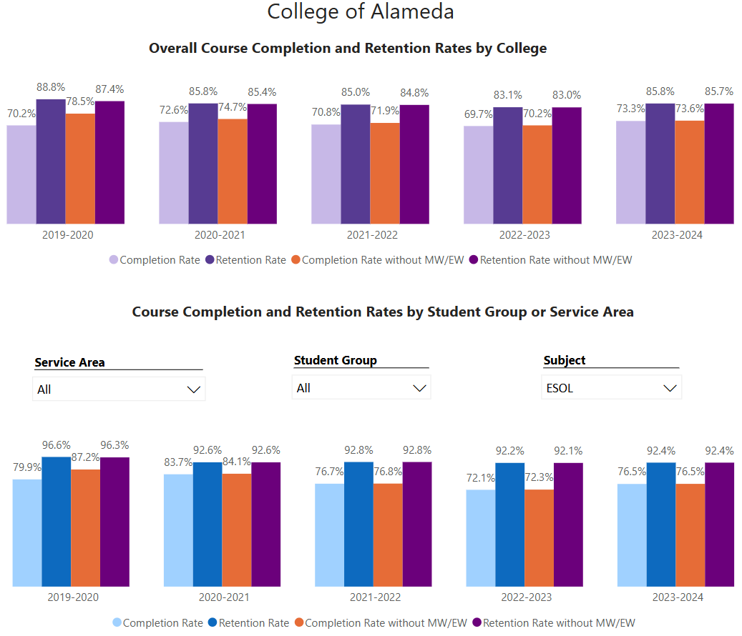
The ESOL department’s completion rates and retention rates higher than college average

Degrees & Certificates Power BI dashboard
Please provide an update on the degrees and certificates offered by the discipline, department, or program. Below data shows the number of degrees and certificates awarded by year, for the past three years. Use the link above to explore the data further.
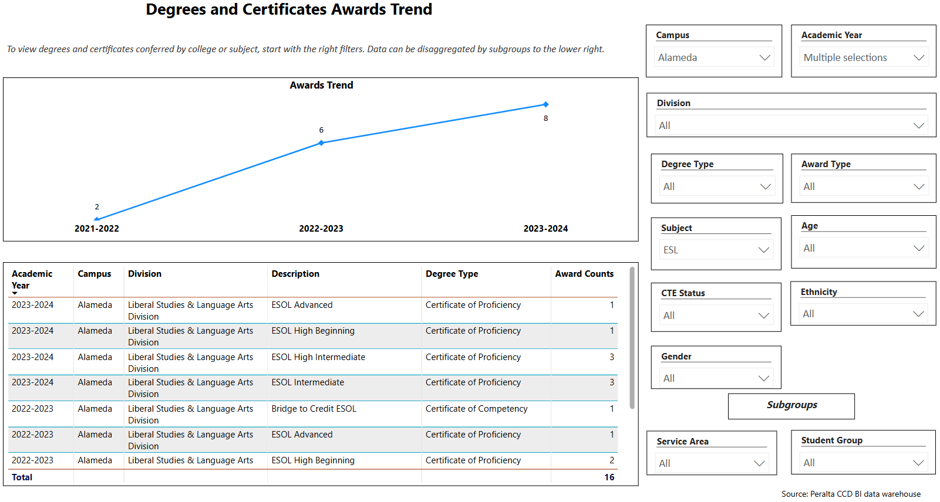
Consistent trend increasing the number of certificates awarded in 2021-2002 we awarded two certificates, the number of certificates we awarded increased to six in 2022-2023 and increased to eight in 2023-2024.

Describe any significant changes in the recent years and discuss what the changes mean to your program.
An intentional effort has been made within the ESOL department to make students aware of the certificate that is available to them. A certificate is offered at each level, A certificate is earned by completing 3 courses in the appropriate level. We emphasize this during our ESOL orientation that we offer at the beginning of the Fall and Spring semester.

Describe the department's progress on Student Learning Outcomes (SLOs) and/or Service Area Outcomes (SAOs) since the last Program Review/APU.
Our department is currently up to date in entering SLOs in Curricunet Meta for the 2023-2024 academic year

Describe the outcomes and accomplishments from previous year’s funded resource allocation request. If your program did not receive any allocations, leave the boxes blank.
Brief description of funded request | Source (any additional award outside your base allocation) | Total Award Amount | Outcome/Accomplishment

Prioritized Resource Requests Summary
In the boxes below, please add resource requests for your program. If there are no resource requested, leave the boxes blank.
Resource Category | Description/Justification | Full-Time Equivalent Percentage | Salary Grade (if applicable)
Personnel: Classified Staff | Help with ESOL department projects, LRC coordination, ESOL web site maintenance and student OER resources, assist students during the new onboarding process, do marketing and reach out and to assist with other clerical duties for the department |  | Need assistance from Dean or VPI
Personnel: Student Worker | Embedded tutors for new support courses and other courses in our department. Also, we need student workers that can help students register for their classes and use the new onboarding site. |  | Need assistance from Dean or VPI
Personnel: Part Time Faculty | A part time faculty who would be working as an ESOL coach (approximately for 5-8 hours a week) who would be helping students choose their classes, navigating in the new ESOL onboarding website, and using our social media, and website and other tools to reach out and marketing.  A dedicated counselor (5-10 hours a week) focused on helping students in support classes that would result in more collaboration with student services for students required to take the support courses. |  | Need assistance from Dean or VPI
Personnel: Full Time Faculty

Personnel: Full Time Faculty, future anticipated need | In 2017-2018 an ESOL full-time faculty member transferred to another discipline and this position has not been replaced.  Over the last three years, the demands and needs of the department, instructors, and students have increased because of AB705 state mandate. We have had to provide adjunct faculty with stipends to share the department workload with the one full-time faculty member to comply with AB705. Such projects have included developing the self-guided placement tool, updating the course outlines, recruitment and outreach, faculty training, and attending district wide committee meetings. |  | Need assistance from Dean or VPI

Resource Category | Description/Justification | Total Estimated Cost
Professional Development: Department wide PD needed | Faculty Stipends for SLO Training.  Online Teaching Training  Regional and State Conferences  Guided Pathways Developing more non-credit courses to be offered | $3,000-  $5,000
Professional Development: Personal/Individual PD needed | CATESOL Conferences  Professional Conferences | $1,000-  $1,500 per conference per person

Prioritized Resource Requests Summary - Continued

Resource Category | Description/Justification | Total Estimated Cost
Supplies: Software | Some instructional software tools for online classes are necessary for an effective online instruction. Some of them are Padlet, Canva, Screencastomatic, Adobe Spark, English language apps that require subscriptions etc.. | $500-$900
Supplies: Books, Magazines, and/or Periodicals | The ESOL program needs some books and magazines written specifically for students who speak English as their additional language. For example, English to English dictionaries with visuals, bilingual books and dictionaries, English grammar books etc. | $300-$700
Supplies: Instructional Supplies | Face to Face Instruction: White board markers, easel board, sticky notes, pens, folders  Remote Instruction: ear pods, headset, whiteboard,  document scanner | $1,500-  $2,000
Supplies: Non-Instructional Supplies | Copy paper, cartridge, printer hardware tools (mouse, keyboard, usb hub, speaker, flash drive etc.) | $1,500-  $2,000
Supplies: Library Collections | CD and DVDs that include videos and audios to improve listening and speaking skills for language learners, story books in different proficiency levels (beginner, intermediate, upper intermediate, advanced), books for high stake exams like TOEFL, IELTS etc. | $700-  $1,000

Resource Category | Description/Justification | Total Estimated Cost
Technology & Equipment: New | IPads (tablets) for faculty to use, Notability and other applications for grading online writing assignments | $4,000-  $5,000
Technology & Equipment: Replacement | Update laptops for ESOL faculty, (consider purchasing Mac Book Pros), printer/scanner for department | $6000-$7000

Prioritized Resource Requests Summary - Continued

Resource Category | Description/Justification | Total Estimated Cost
Facilities: Classrooms | Smart classrooms that are conducive to ESOL teaching  Document projector | $1,000-  $2,000
Facilities: Offices | Dedicated office space is needed for adjunct faculty. Currently more than 10-part timers share one space. Copy machine and scanner in the office space. | $3,000-  $5,000
Facilities: Labs | Dedicated space for ESOL Lab with ESOL software programs and tutors to assist ESOL students with assignments | $3,000-  $5,000
Facilities: Other | Dedicated Office Space with computers to develop an “ESOL Center” in which our students can receive help with on-boarding and advised into our classes. This center will also serve as an instructional center for classes and individual instruction/tutoring, as well as a library/resource center for our instructors | $3,000-  $5,000

Resource Category | Description/Justification | Total Estimated Cost
Library: Library materials | ESOL English Dictionaries | $300-  $500
Library: Library collections | ESOL Adapted short stories  Digital instructional tools for computer-based listening and speaking | $200-  $400

Resource Category | Description/Justification | Total Estimated Cost
OTHER | Funding for faculty to attend regional and state CATESOL conferences and to support professional development opportunities for faculty.  Reimbursement for professional development classes | $1,000-  $2,000

