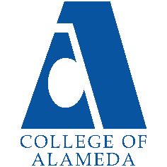
2024-25 Annual Program Update -
English

Program Overview
Please verify your program’s mission statement and program’s learning outcomes below, and make any corrections necessary.
Mission Statement
The English Department’s mission is to serve the educational and career objectives of our community: We offer a range of classes addressing college-level reading and writing skills as well as literature and creative writing, and are committed to presenting engaging material that explores the varied interests and needs of our students.

Associate of Arts Degree For Transfer in English – AA-T Degree Program Learning Outcomes
- Engage in active, purposeful, critical reading.
- Assess, in writing, the tools and materials given to succeed at the workplace or in the community and be able to suggest changes to increase effectiveness,
- Evaluate information critically to develop claims and support them.
- Develop an understanding and appreciation for worldwide cultures and diverse perspectives through active and purposeful reading and writing.

[Below degree still appears active in CurriQunet META, although not listed in the catalog.]
English – A.A. Degree

List your program faculty and/or staff, and indicate whether they are full-time or part-time.
Contract Faculty  Maurice Jones (Acting VPI S’22 and F’23)  Jay Rubin  Stefanie Ulrey  Patricia Nelson  Dr. Peter Pappas | Adjunct Faculty  Dr. Juanita Alexander  Michelle Little  Sandra Vaughn  Christopher Blood  Elizabeth Treadwell  Ann Chun | [List of personnel goes here]

Describe your current utilization of facilities, including labs and other space.
We use classrooms on all three floors of the H building, taking advantage of the technology in each.

The Program Goals below are from your most recent Program Review or APU. If none are listed, please add your most recent program goals. Then, indicate the status of this goal, and which College and District goal your program goal aligns to. If your goal has been completed, please answer the follow up question regarding how you measured the achievement of this goal.
Program Goal | Increase retention and success
Status: In-Progress or Complete?  If complete, give a brief description of how you measured the goal completion. | Ongoing
Which college or district goal is aligned with your program goal? | College Goal: Advance CoA teaching and learning District Goal: Advance Student Access, Equity, and Success

Program Goal | To develop AD-T for English, offering an alternating schedule of the required literature courses.
Status: In-Progress or Complete?  If complete, give a brief description of how you measured the goal completion. | Complete
Which college or district goal is aligned with your program goal? | College Goal: Advance CoA teaching and learning District Goal: Advance Student Access, Equity, and Success

Program Goal | Development of non-credit courses (and a certificate)
Status: In-Progress or Complete?  If complete, give a brief description of how you measured the goal completion. | Complete
Which college or district goal is aligned with your program goal? | College Goal: Advance CoA teaching and learning District Goal: Advance Student Access, Equity, and Success

Program Update – Enrollment Trends, Success Rates, and Degrees & Certificates
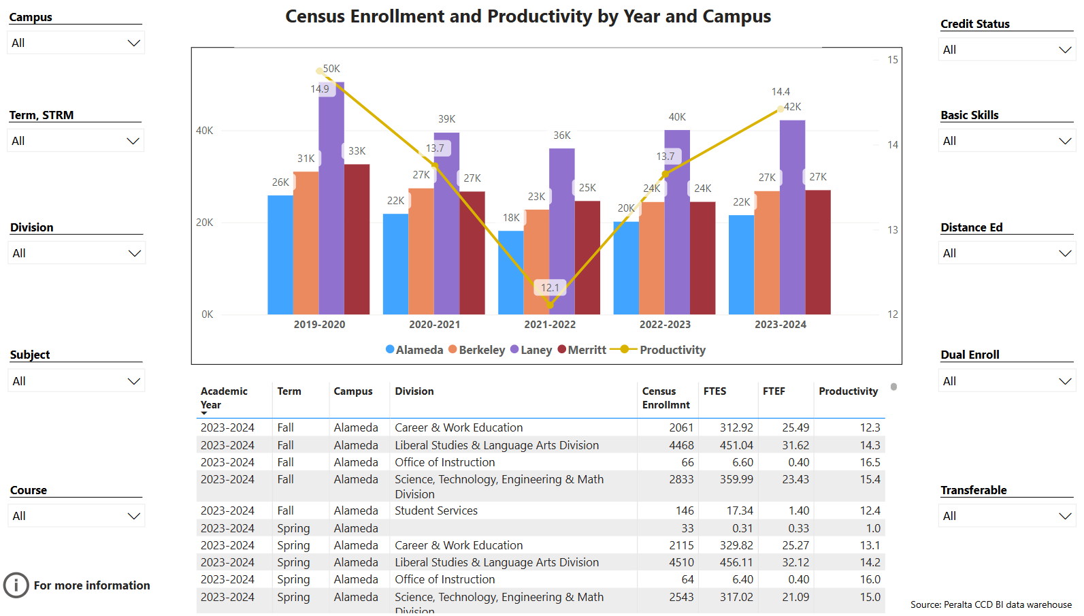
Enrollment Trends Power BI dashboard
Note: Please consider the most recent years when answering the questions below. Data with default filter is provided below. Use the link above to explore the data further.
Discuss recent enrollment trends. District-wide enrollment trends are shown above for comparison.
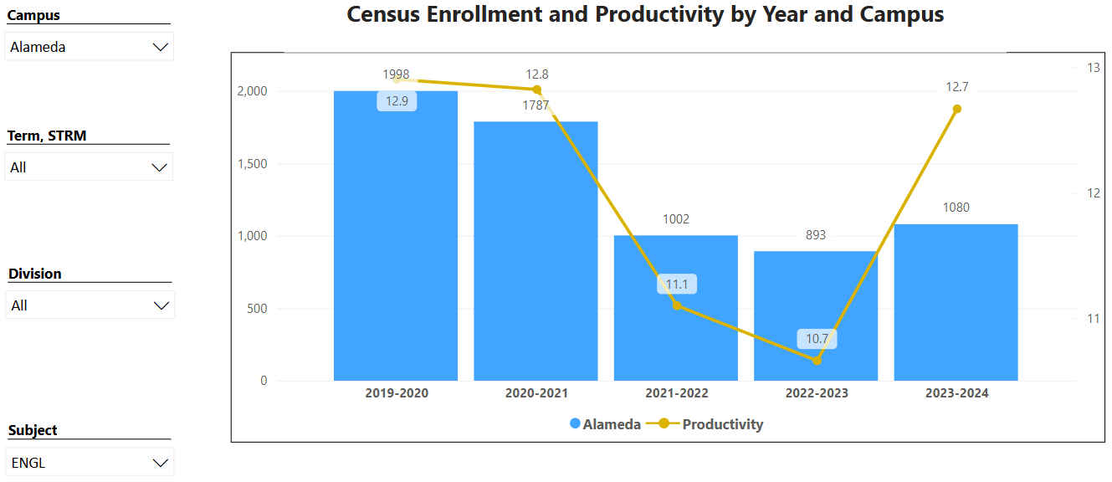

Enrollment trends of the department are similar to those of the college, as are productivity numbers for degree applicable courses (14.8/13.2, 15.1/12.9, 13.8/12.8, 12.1/11.0, 13.8/10.7). Because of the 35/30 PFT cap on enrollment in the department’s courses, it is to be expected that English productivity will lag behind the college’s average. During the academic years 2018-19, 2019-20, and 2020-21, the department served 12% of the student population. During the years 2021-22 and 2022-23, that percentage increased to 18 and 20 percent respectively. The increase has continued into 2023-24.

Course Completion Power BI Dashboard #1
Course Completion Power BI Dashboard #2
Institutional Set Standards
Consider your course completion rates in recent years (% of student who earned a grade of "C" or better). Data with default filter is provided below. Use the link above to explore the data further.
How does the course completion rate for your program or discipline compare to your college’s Institutional Set Standard for course completion (70% with stretch goal of 77%)? Also discuss the retention rate for your program or discipline, compared to the college average shown in data below, as well as what the discipline, department, or program has done to improve course completion and retention rates.
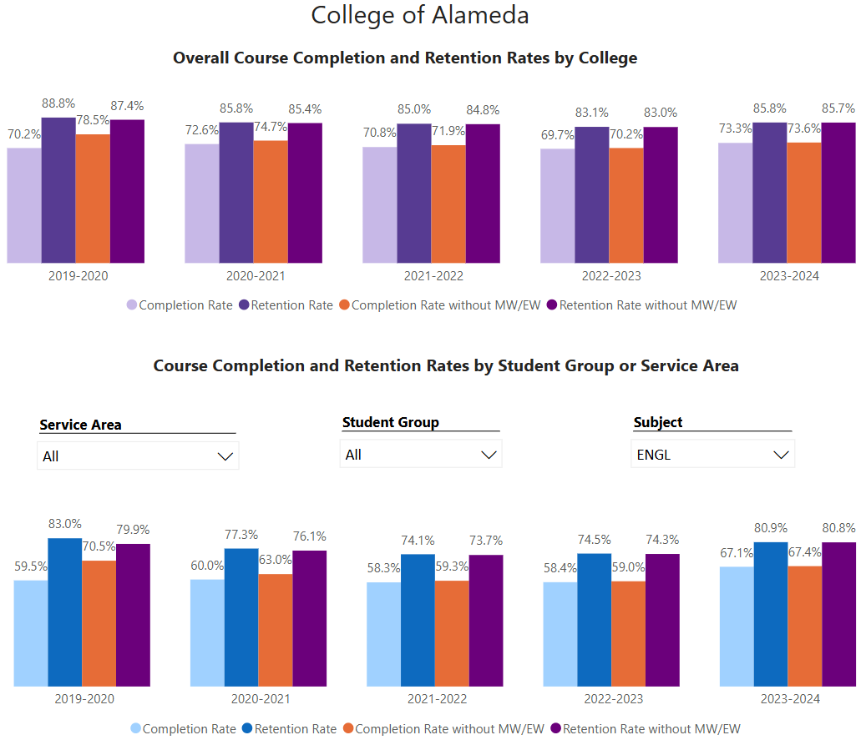

An evaluation of data for the English department over the past five years is complicated by both the pandemic (AY 2020-2021) and full implementation of AB 705 (AY 2021-2022). The next program review, with more normalized data sets, should be the focus for making any significant departmental changes.

In no year during the past five did the department-wide success and retention rate meet the Institution-Set Standard or 72%. 2020 came close (70%). However, in the last year rates were up significantly from the previous one.

Although the percent of completions is relatively steady (53-60%), one contributing factor to lower than desired success rates in AY 2021-22 and 2022-23 may be the placement of students into ENGL 1A/1AS during their first or second semester in college as well as a transfer-level math course as required by AB705/SCFF (piloted in 2018, fully implemented in AY 2021-2022). Both Composition and Reading and mathematics courses are high-unit, high stakes gateway courses, and the combination may put students under increased (and possibly unnecessary) pressure. A study should be done comparing the retention and success rates of students who take both subjects in the same term vs. those students who opt to take English and mathematics in separate terms of their first year. In the fall of 2024, English and Math launched their first collaboration in scheduling, and experiment to plan out our respective class schedules in attempt to offer sections of each subject at each level that did not conflict. This could explain the increase in completion and retention rates. English has also gradually scheduled more in-person sections than in previous years, and these sections are filling.

There is no significant difference in completion rates between ENGL 1A and ENGL 1AS, but the retention rate in ENGL 1AS is higher. This suggests that the additional support may be benefitting students in non-tangible ways unrelated to grades.

Degrees & Certificates Power BI dashboard
Please provide an update on the degrees and certificates offered by the discipline, department, or program. Below data shows the number of degrees and certificates awarded by year, for the past three years. Use the link above to explore the data further.
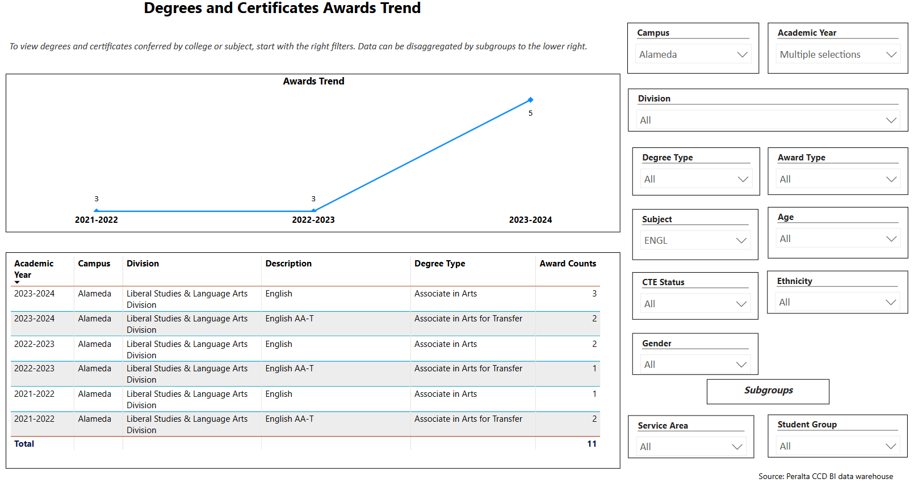
Since the beginning of our offering the degree, the number awarded has only increased by one. It is believed that the College must make a commitment to offering the literature sections needed to complete the degree in order for the number to increase significantly. Currently, sections are canceled with as many as 12 students enrolled even though it is common practice by student to enroll late. While the department understands the balance needed between enrollment and cost, we believe that degree-necessary sections must be allowed to run – even if low enrolled – in order to gain any traction.

Describe any significant changes in the recent years and discuss what the changes mean to your program.
There have been no significant changes to the English department except for faculty retiring, taking temporary administrative roles, and going on reduced load. At this time, however, the program is stable.

Describe the department's progress on Student Learning Outcomes (SLOs) and/or Service Area Outcomes (SAOs) since the last Program Review/APU.
Assessments were completed for the 2023 program update and remain current.

Describe the outcomes and accomplishments from previous year’s funded resource allocation request. If your program did not receive any allocations, leave the boxes blank.
Brief description of funded request | Source (any additional award outside your base allocation) | Total Award Amount | Outcome/Accomplishment

Prioritized Resource Requests Summary
In the boxes below, please add resource requests for your program. If there are no resource requested, leave the boxes blank.
Resource Category | Description/Justification | Full-Time Equivalent Percentage | Salary Grade (if applicable)
Personnel: Classified Staff

Personnel: Student Worker

Personnel: Part Time Faculty

Personnel: Full Time Faculty

Personnel: Full Time Faculty, future anticipated need | To address retirements and reassigned time, 2 full time faculty. | 100%

Resource Category | Description/Justification | Total Estimated Cost
Professional Development: Department wide PD needed

Professional Development: Personal/Individual PD needed

Prioritized Resource Requests Summary - Continued

Resource Category | Description/Justification | Total Estimated Cost
Supplies: Software

Supplies: Books, Magazines, and/or Periodicals

Supplies: Instructional Supplies | Markers, pens, post-its (poster and classic), etc. | $1500
Supplies: Non-Instructional Supplies

Supplies: Library Collections

Resource Category | Description/Justification | Total Estimated Cost
Technology & Equipment: New | Book scanner | $500
Technology & Equipment: Replacement

Prioritized Resource Requests Summary - Continued

Resource Category | Description/Justification | Total Estimated Cost
Facilities: Classrooms

Facilities: Offices

Facilities: Labs

Facilities: Other

Resource Category | Description/Justification | Total Estimated Cost
Library: Library materials

Library: Library collections | Additional titles to support the new Introduction to Asian American Literature course. Expanded subscriptions to include contemporary commentary and criticism directly related to Asian American Lit.

Resource Category | Description/Justification | Total Estimated Cost
OTHER

