COA Academic Senate
Meeting Minutes
Thursday, March 6, 2025
Meeting Called To Order at College of Alameda, H 280 & Zoom at 12:20 pm
Note: For Virtual attendance, senators indicate their votes in the Zoom Chat
Quorum: 50% + 1
In person Quorum: 7 or more senators (15 seats, 2 vacant)
Senators in Attendance: Jenn Fowler, Rich Kaeser, Andrew Park (note-taker), George Cruz, Bruce Pettyjohn, Carla Pegues, Cady Carmichael, Andrew Fittingoff, Jody Campbell, Cynthia Haro,
Guests in attendance: Jayne Smithson (DAS rep), Linda Dewrance, Ilse Gonzalez, Iolani Sodhy-Gereben,
Agenda Item | Summary | Motion
Agenda Review & Approval for March 6, 2025 | No changes. | Motion to approve Agenda March 6, 2025  First: C. Pegues  Second: C. Carmichael  M.S.U.
Review of minutes  February 20, 2025 | Any grammatical changes can be sent directly to A. Park or J. Fowler. | Motion to approve minutes from February 20, 2025  First: B. Pettyjohn  Second: G. Cruz  M.S.U.
Action Items:  None | None | None
Discussion Items:  - Undocumented Community Resource Center (I. Gonzalez)  - Spring 2025 Academic Senate Elections (J. Fowler)  - CoA Participatory Governance Handbook Update (J. Fowler) | Summary of #1  J. Fowler introduced Ilse Gonzalez, the Undocumented Community Resource Center coordinator, to present the item.  - UCRC provides assistance to students, including 1-on-1 meetings, mentorship, etc. Process is completely confidential.  - Assistance with DREAM Act eligibility, education on rights, etc.  Q: Any flyers that can be shared with students?  A: Yes, and image below (enlarge for QR code).  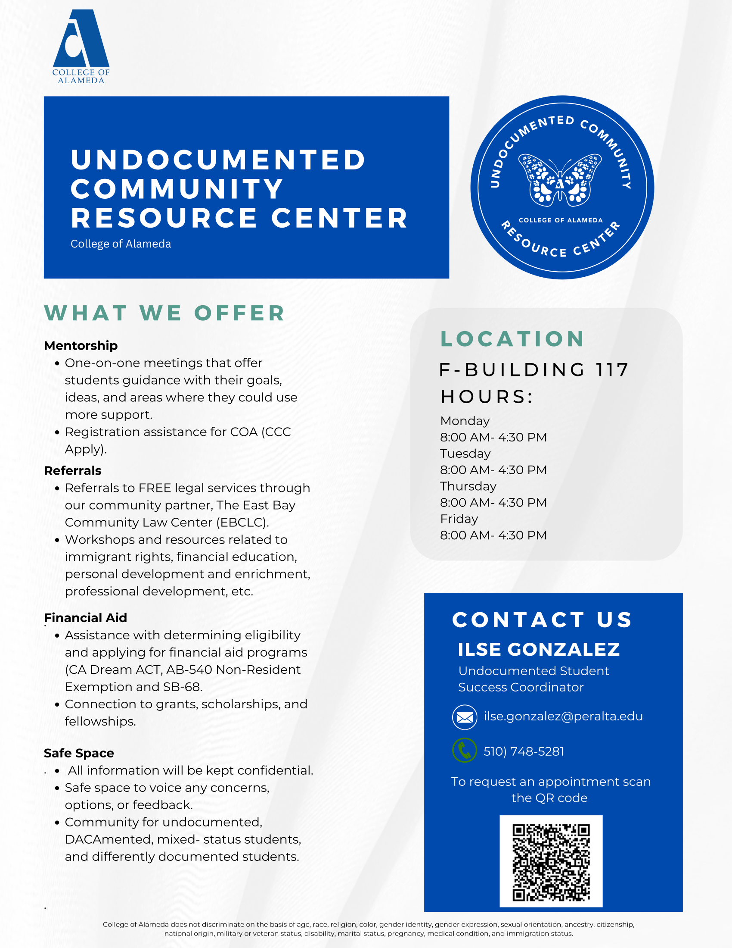  Summary of #2  J. Fowler introduced the item with the reminder of last year’s timeline and the seats that are coming up for election.  - Draft document sent out ahead of meeting was presented.  - Election of officers scheduled for May 1 meeting (after secret ballot election of any contested seats)  - CoA AS officers need to be elected in time for DAS officer elections.  - Seeking volunteers for election committee (3 senators who are not up for re-election)  - Encouraging senators to run for re-election, and consider encouraging new people to be involved  Participated in discussion: B. Pettyjohn, J. Fowler,  Summary of #3  J. Fowler introduced the item by sharing the old participatory governance handbook (2019-2020).  - Participatory governance handbook update was discussed in College Council  - Council recommends a taskforce to look through the manual and make the simple updates (change of dates, etc.)  - A long conversation needed for more substantive revisions, e.g. addressing what a “taskforce” is, etc.  - Feedback on this task force (size and composition)?  - Look forward to additional consultation process, similar to last time when the handbook was updated under Tim Karas.  Participated in discussion: C. Pegues, J. Fowler,
Officer Reports | President: Inviting all faculty to the newly tenured faculty reception on March 11 (flyer shared for the meeting below). Celebrating Didem Ekici and Josh Rose for CoA.  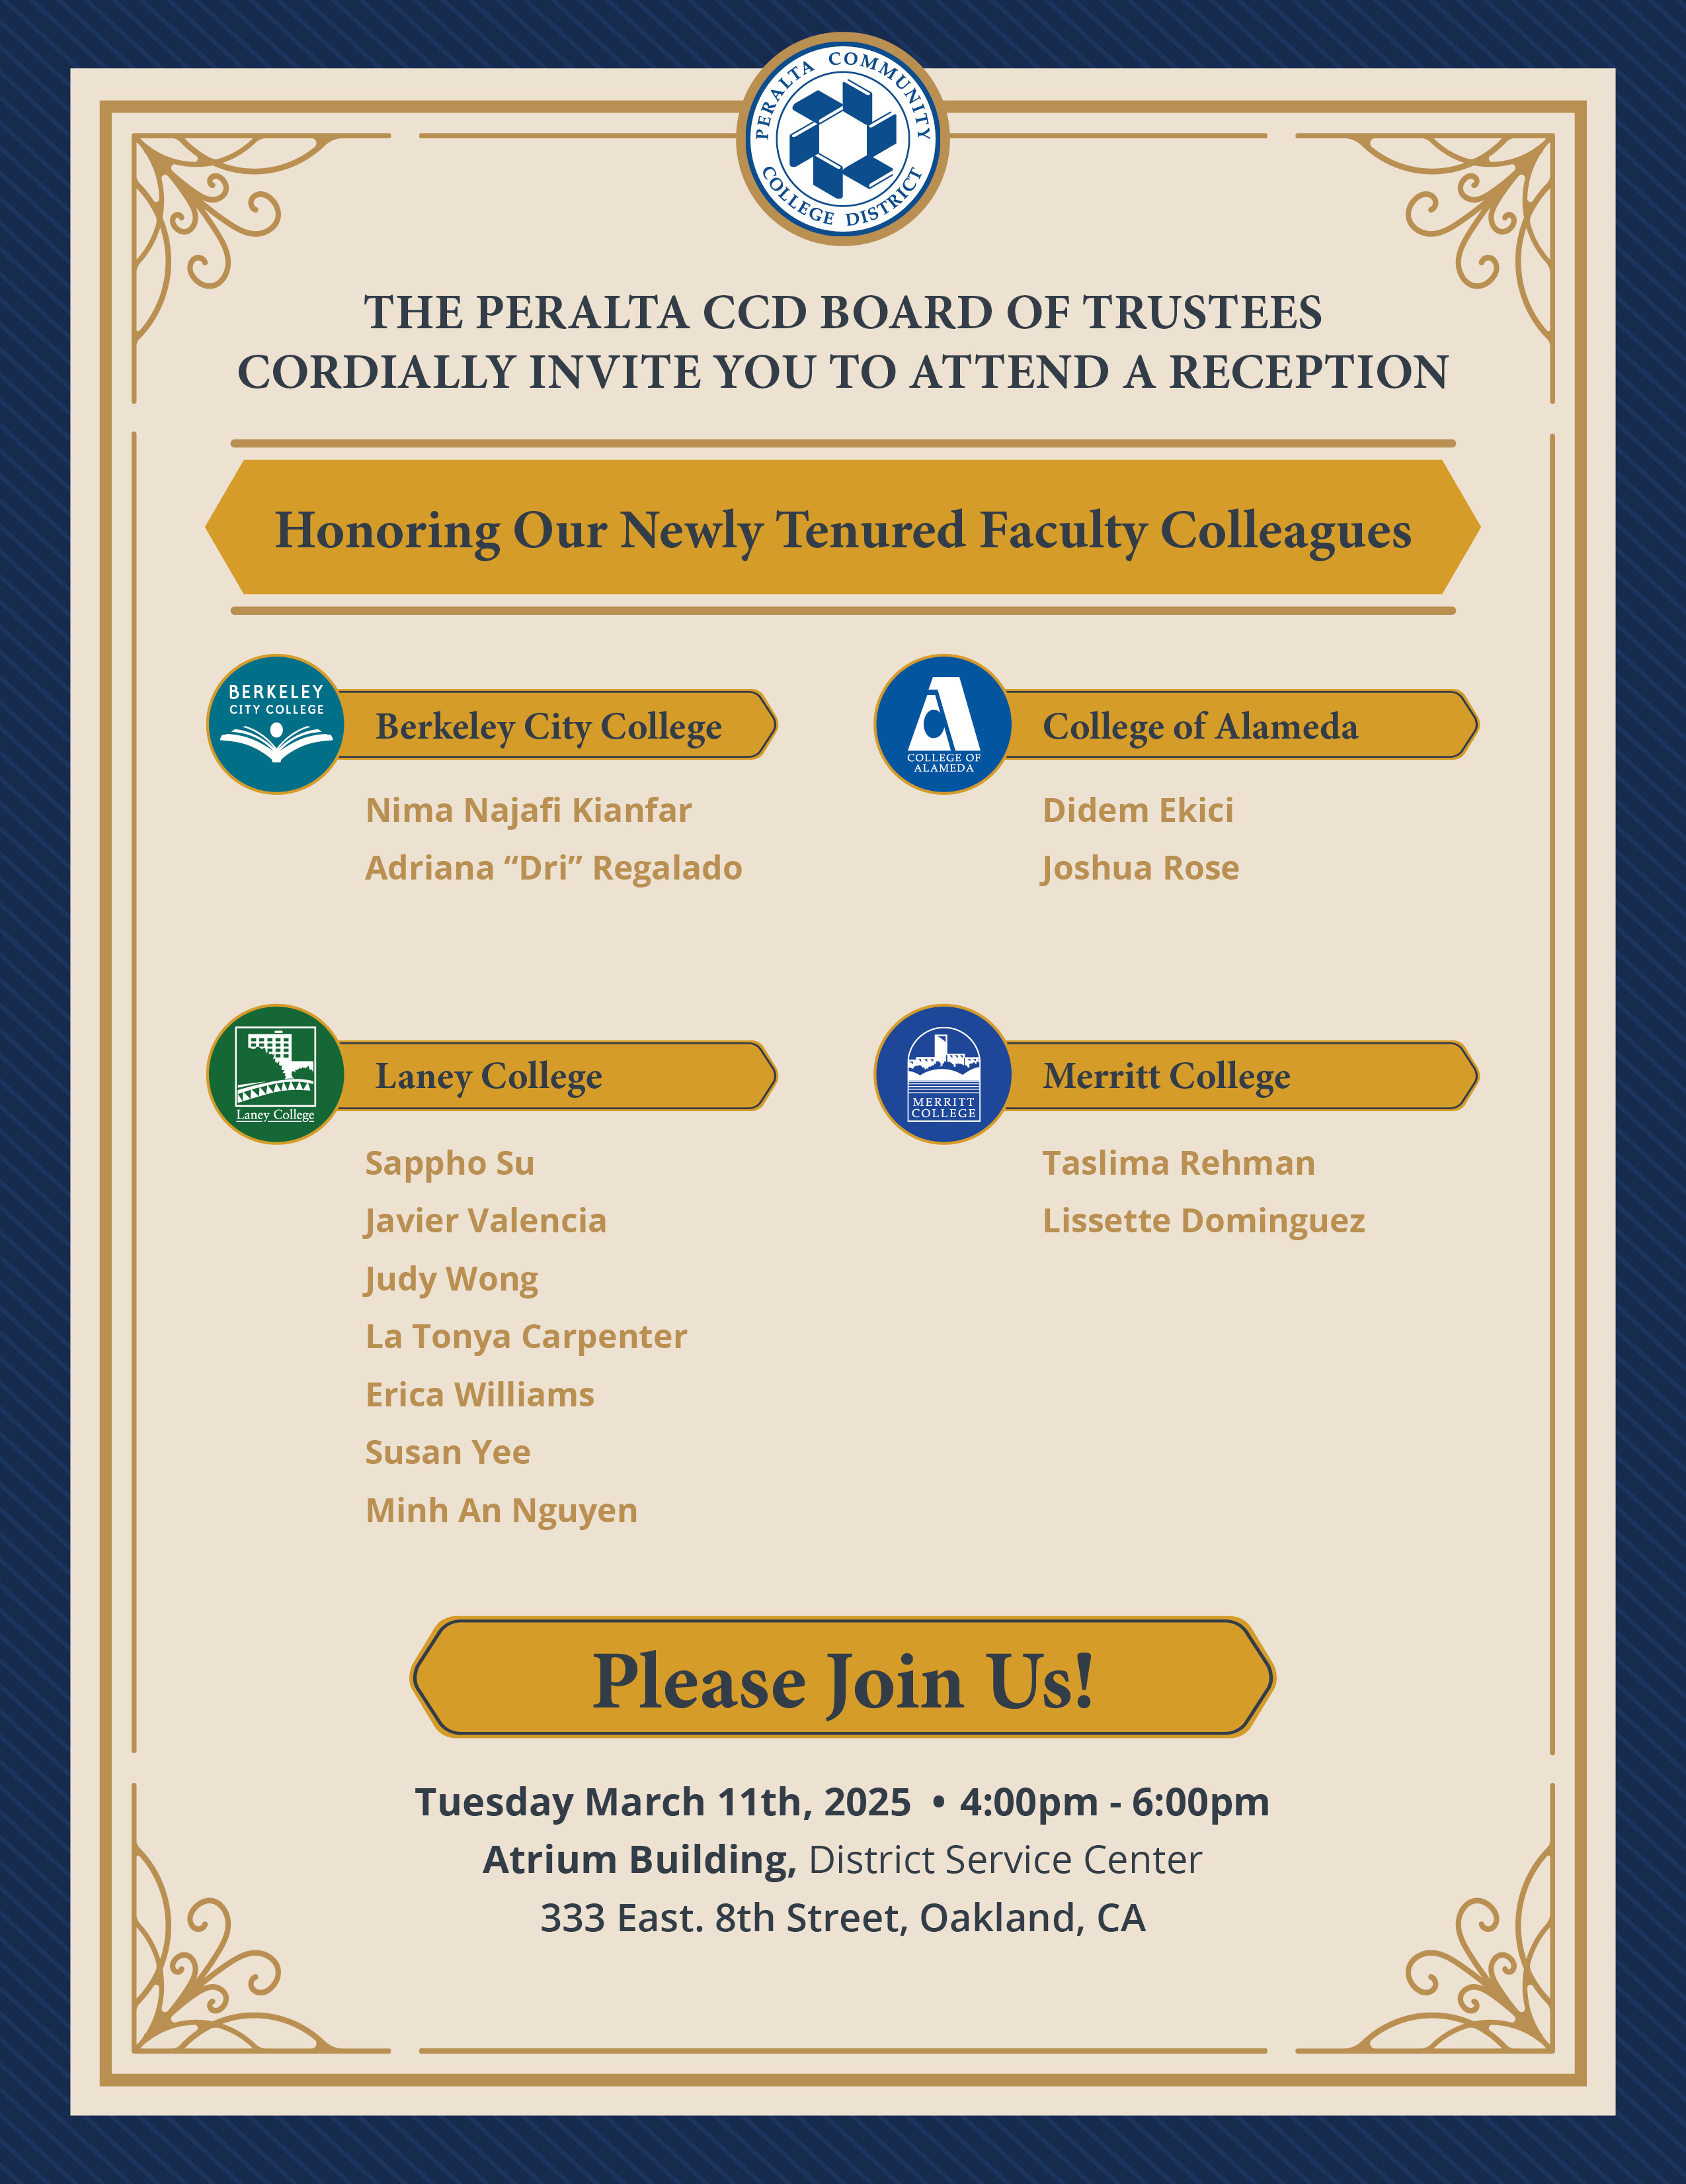  Highlighting student conduct and grievance team flyer shared earlier  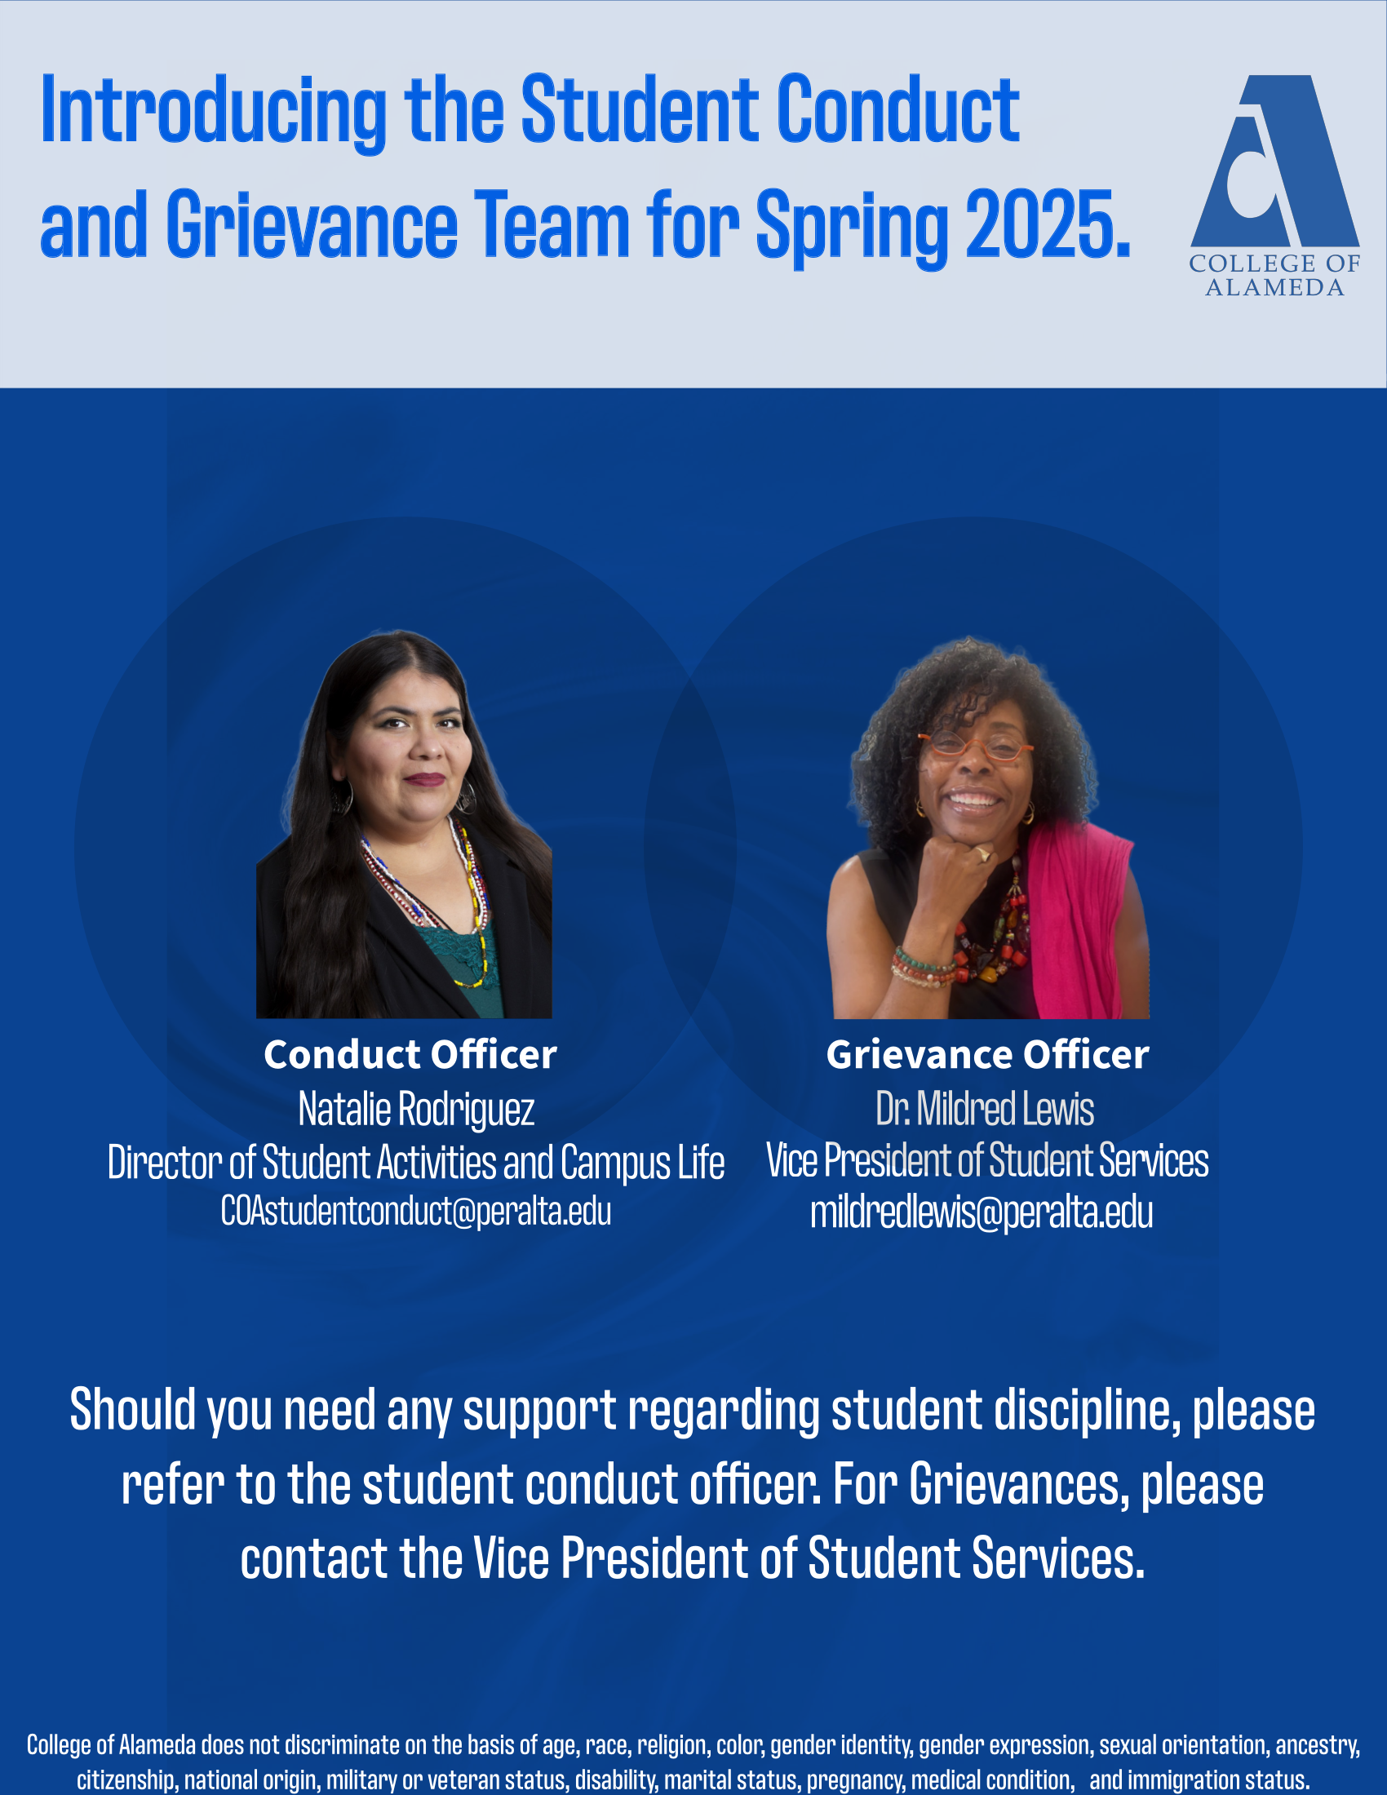  Reminder April 3 meeting is cancelled, falling during spring break.  Encourage faculty to consider the two special assignment positions that went out: ZTC interim coordinator (due March 12) and AB1111(CCN)/AB928(CalGETC) coordinator (due March 14)  Q: Where can we find more information about ZTC (goals, etc.)?  A: The first point of contact is our OER liaison, Olga Fish. For the ZTC grant, while we are looking for ZTC coordinator, reach out to VPI Nicole Porter directly. For library resources, reach out to Jane McKenna.  Vice President: Nothing to report.  Treasurer: Nothing to report.  Secretary: Nothing to report.
Announcements | No announcements.
DAS Updates/Actions | Jayne Smithson gave the DAS report. Main points:  - COO Nelson had a Q&A session with topics including:  - Bookstore change of availability: Follett initiated wanting to change the contract; textbook orders still possible online, to be mailed or picked up at the remaining Laney physical location  - Funding change: switch from allocation of FTEF to allocation of dollar amounts (based on FTES). Colleges have local autonomy to decide how the dollar amounts can support the classes to be offered (FTEF).  - Facilities conversation.  - Campus closure/consolidation: no officially published plan on closure/consolidation  - And other regularly scheduled reports were presented.  - Spring plenary attendance was discussed.  J. Fowler encourages people to attend the budget committee meetings on second Wednesday of each month from 12 p.m. to 1:30 p.m.  Participated in discussion: C. Carmichael, Jayne Smithson, J. Fowler
Public Comment | None.
Proposed agenda items for next meeting  Thursday, March 20, 2025 | Call for additional proposed agenda items was made.  Please email J. Fowler for any other agenda items.
Adjournment at 12:58 pm | Meeting adjourned at 12:58 p.m. with all agenda items having been addressed.

