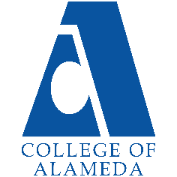
2024-25 Program Review – Instructional –
Art

Lead Author
Drew Burgess

Program Overview
Please verify the mission statement for your program. If there is no mission statement listed, please add it here.
Mission Statement
The mission of the Art Department at the College of Alameda is to provide courses leading to the fulfillment of general education, degrees in art and art history, and successful transfers to UCs and CSUs. The Art Department introduces students to the world of art and promotes lifelong learning.

Art – A.A. Degree Program Learning Outcomes
- Synthesis of art history studies and art studio innovation to promote decision making, problem solving, and empower the individual in society.
- Development of artistic creative skills to foster aesthetic reflection in life activities.
- Productive knowledge of the breadth of world creativity in order to respond, form positions, and make decisions of daily life.

Associate in Arts in Studio Arts for Transfer – AA-T Degree Program Learning Outcomes
- Synthesis of art history studies and art studio innovation to promote decision making, problem solving, and empower the individual in society.
- Development of artistic creative skills to foster aesthetic reflection in life activities.
- Productive knowledge of the breadth of world creativity in order to respond, form positions, and make decisions of daily life.

Associate of Arts in Art History for Transfer – AA-T Degree Program Learning Outcomes
- Demonstrate with scholarship knowledge of the purposes of art in history: Theoretical and practical knowledge of the historical background of art; examination of the varied reasons of art in societies of the past and present; study with respect to universal concerns of a human nature - the struggle to live, to express, to understand aesthetics, government and religion; art related to the formation of small societies as well as civilizations; synthesis of ideas concerning the diversity of backgrounds; evaluative understanding of the significance of art and social actions relative to global issues and the emergence of new artistic horizons. {Foundational Knowledge}
- Demonstrate skillful competence in a basic set of studio practices of art: Assess, evaluate, and interpret ideas found in art coupled with formal problems of studio art; practical, hands on study, to enable people so disciplined to communicate effectively, reach conclusions, and solve problems as ambassadors concerning the craft and criticism of art; concrete experience in the studio arts fostering intellectual growth, sensitivity to materials and problems should they choose a path of professional art, teaching, public service, community leadership or simply participate as members of the community. {Critical Art Thinking}
- Demonstrate analytical knowledge of the human achievement of creative arts: Examination of the scope of art with an appreciation of human values; exploration of art as a phenomena of the human mind, societies, individual expression and social conventions; meaningful discourse regarding personal identity, goals, and knowledge of the capacity of art as a determinate of social influence; analytical rigor to gain explanations concerning the subject of art as part of their everyday life in the context of the evolving world. {Personal Enrichment & Lifelong Learning}

Practitioner of Fine Art - Certificate of Achievement Program Learning Outcomes
- Examine historical works of art with analytical inquiry concerning fine art and modern society.
- Synthesize artistic ideas regarding global expressions of fine art.
- Analyze, read, write and express art history concepts to critically evaluate the role of fine art in society.
- Acquire materials, design, compose and construct works of fine art.
- Develop a presentation portfolio of original works of art and individualized expression.

Art Fundamentals - CP3 - Certificate of Accomplishment Program Learning Outcomes
- Students will be able to analyze works of art
- Students will be able to demonstrate basic processes of drawing, painting and mixed media.
- Students will be able to synthesize artistic elements, principles, and problem solving to engage with the world.

List your Faculty and/or Staff, and indicate whether they are full-time or part-time.
Cynthia Horn full-time
Drew Burgess full time

Part time instructors from previous semesters--no classes Fall 2024:
Gabriel Navar
Natasha Medvedev
Ashley Gardini

The Program Goals below are from your most recent Program Review or APU. If none are listed, please add your most recent program goals. Then, indicate the status of this goal, and which College and District goal your program goal aligns to. If your goal has been completed, please answer the follow up question regarding how you measured the achievement of this goal.
Program Goal | Develop a means to create an operational Art Gallery.  The Art Gallery space will need attention. A request has been made to paint the wall white. To have a gallery at the college will take time and commitment. The Art Department can place student works in the gallery during the semester as a start (and ongoing as our students are central to the expression that we most value). Thinking ahead the gallery could be a robust educational center engaging students from multiple disciplines. For example, a visiting artist could display works and give a lecture. To develop this cultural resource commitment is needed in terms of funding, security, insurance and operations.
Status: In-Progress or Complete?  If complete, give a brief description of how you measured the goal completion. | We are in progress on this goal. We have met with the president of the college and district contacts this Fall.  We are asking that students be instructed with skills in exhibition design, hanging of works, re-painting, touch up, adjustment of lighting and the care and cataloging of works. We want students to have the opportunity to learn how to present and market exhibitions.  We envision the Art Gallery as a resource for other departments. For example, visitations by students in writing programs.
Which college or district goal is aligned with your program goal? | The art department recognizes the gallery as a place of empowerment. The ability of students to conceptualize and bring to completion exhibits, community projects, and show student centered works is a vital aspect of the art curriculum, therefor we align with Peralta Principle no. 9:  “Community and Individual Empowerment: The welfare of our communities and our students is better served when they have the skills and knowledge to control their economic destinies and engage effectively in the process of governance, self-governance, and participation in their communities.”  https://www.peralta.edu/strategic-plan/mission

Program Goal | Developing new studio courses such as Figurative Painting
Status: In-Progress or Complete?  If complete, give a brief description of how you measured the goal completion. | This goal is in progress. We recognize an interest in figurative drawing and an educational need for the community. The goal is under consideration concerning the funding for models.
Which college or district goal is aligned with your program goal? | Peralta Value no. 4:  Innovation: The colleges and service centers support creative approaches to meet our communities' changing demographic, economic, and educational needs.  https://www.peralta.edu/strategic-plan/mission

Program Goal | Supporting additional in-person courses
Status: In-Progress or Complete?  If complete, give a brief description of how you measured the goal completion. | In the Spring of 2025 we plan to offer additional in-person courses in art history and studio art.
Which college or district goal is aligned with your program goal? | Goal number 5 of the 2022 Educational Master Plan:  “Reduce equity gaps across all of the above measures through faster improvements among traditionally underrepresented student groups, with the goal of cutting achievement gaps by 40 percent within 5 years and fully closing those achievement gaps within 10 years.”  https://alameda.edu/wp-content/uploads/2021/12/Alignment-of-Goals-2022-Vision-for-Success-Peralta-Community-College-District-CoAs-Educational-Master-Plan.pdf

Describe your current utilization of facilities, including labs and other space
2023-2024 APU “Students and Faculty are utilizing the art facility in the Liberal Arts Building. For fall of 2023 drawing and painting courses are in progress.”

2024-2025 We have utilized the rooms for drawing and painting and intend to increase studio offerings with mixed media and watercolor courses.

2023-2024 APU “The main art room is H208, classes are conducted in the room successfully. Students are engaged in the room. The adjoining room H206 is a storage/work room. Adjoining the storage/work room are offices for the full-time faculty and adjunct faculty. Past the storage room are gallery rooms H203 and H204. These rooms open to the larger interior area of the building. Students have access to the rooms for instructional purposes, exhibition of works, meetings, and openings.”

2024-2025 We had a Spring faculty exhibit in the gallery and mounted student artworks. In the Fall of 2024 we are communicating with the president’s office and district contacts to upgrade the gallery for the hanging of exhibitions. We are exhibiting the works of an adjunct faculty member and having a ‘meet and greet’ with the artist.

2023-2024 APU “H208 and H204 have projectors for instructional purposes and student engagement. Students have access to room H204 for collaboration on projects, working on assignments, planning, viewing, and hanging artworks, and team meetings. Students have access to H203 for the viewing of art, hanging works of art, critiques, community engagement, and collegial collaboration.”

2024-2025 The gallery is in process needing the ability to install exhibitions, hang works, patch and paint and adjust the lighting. Room H212 is being utilized for art history. The proximity of the room to the studio rooms is beneficial in creating a cohesive art department. We will increase or in-person offering of art history in Spring of 2025.

2023-2024 APU “Some features of the rooms need attention. A printer in the storage room needs factory installation”

2024-2025 We are waiting to receive the necessary funding to outfit the studio room with additional easels, taborets and a painting rack. The printer is working but needs some servicing.

Enrollment Trends
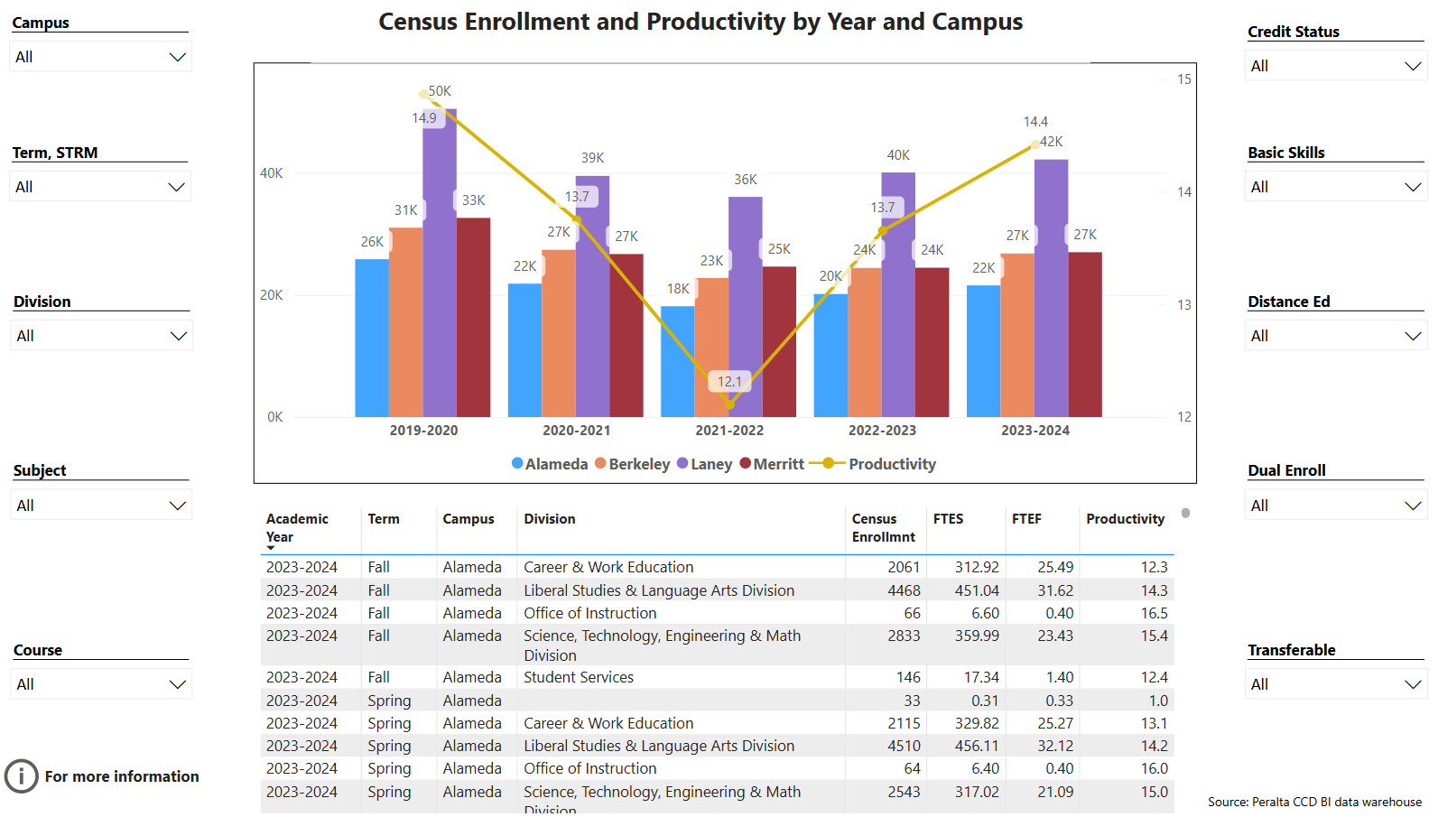
Enrollment Trends Power BI dashboard
Note: Please consider the most recent 3 years when answering the questions below. Data with default filter is provided below. Use the link above to explore the data further.
Discuss enrollment trends over the past three years.
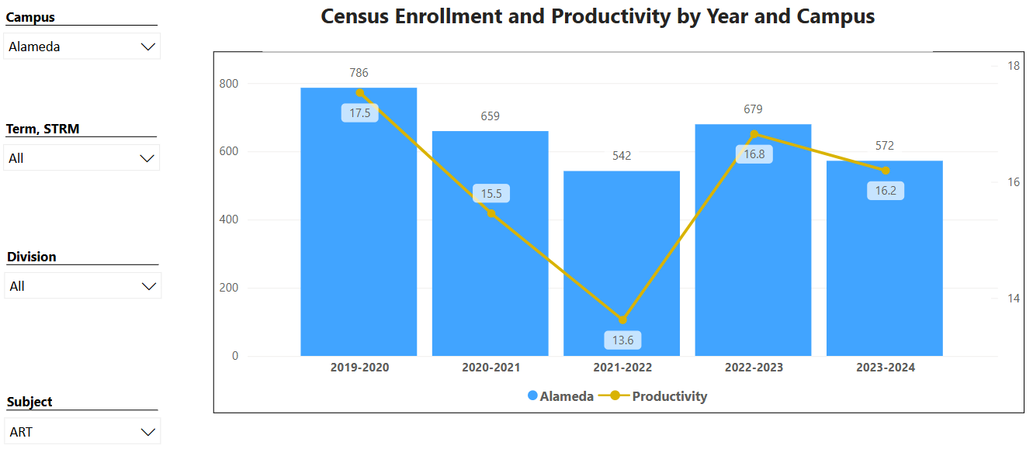

In the semesters following the Covid pandemic we have experienced an increase in enrollment. The art classes are filling each semester. We have decided to increase our studio offerings. The art history courses and studio courses engage students---for example, the in-person Art 1 has filled in the Fall of 2024.

2023-2024 APU” The enrollment trends and productivity dashboard display a reduction during the years of Covid 19 followed by an increase in enrollment in 2022 -2023. An enrollment taskforce has been formed at the College of Alameda in the Fall of 2023.”

2024-2025 It looks like there is a dip in enrollment for the College of Alameda in 2023-2024. In the art department the ‘feeling’ is that students want to be on campus---we are listening and intend to create ‘hands on’ course opportunities.

The link below shows list of course sections in your area sorted from lowest fill rate to the highest fill rate for the last three years. Consider and discuss whether the course offerings meet the needs of our students.
FillRate3YearsProgramReview.xlsx

The lowest number is for Art 2. Fall of 2021 was greatly impacted by the ‘fraudulent’ student issue. At that time instructors were alarmed, asking how productivity would be recorded. The Art 2 course had two thirds of the class removed at the commencement of the semester. The course was listed as full.

Recommendation for the Peralta District: Enable the ‘drop’ feature for instructors throughout the semester. Other districts of the area have this feature.

Discuss any action plan to better meet student needs and demands.
The art department now has two full time instructors. Together the instructors are mapping and planning coursework. At present the department is reviewing degrees and certificates. The chair of the department meets with students to advise on coursework in relation to earning degrees. For example, the chair communicated with counseling this week to consider the transcripts of a student and substitute a course, a course that aligned with the CoA course, to facilitate a plan for graduation.

As we update the catalog, map our AA degree, AAT Art History degree, and our AAT Studio Arts degree, with full and part time mapping sequences, we will better serve students. Students would be better served if we offered Art 47 3D design, or coordinated art offerings throughout the district. The course is not offered enough. For students to achieve the coursework they sometimes need to ‘swirl’.

An going innovative aspect of the department is the recognition of the tremendous empowerment of art. The 10 lessons of art noted by Stanford Professor Emeritus Elliot Eisner are foundational. Although the lessons refer to children—we note in the art department the child within is valued for people of all ages.

1. The arts teach children to make GOOD JUDGMENTS about qualitative relationships. Unlike much of the curriculum in which correct answers and rules prevail, in the arts, it is judgment rather than rules that prevail.

2. Thee arts teach children that problems can have MORE than ONE solution and that questions can
have more than one answer.

3. The arts celebrate multiple PERSPECTIVES. One of their large lessons is that there are many
ways to SEE and INTERPRET the world.

4. The arts teach children that in complex forms of problem solving purposes are seldom fixed, but
change with circumstance and opportunity. Learning in the arts requires the ABILITY and a WILLINGNESS to surrender to the unanticipated possibilities of the work as it unfolds.

5. The arts make VIVID the fact that neither words in their literal form nor numbers exhaust what we
can KNOW. The limits of our language do not define the limits of our COGNITION.

6. The arts teach students that SMALL DIFFERENCES can have LARGE EFFECTS. The arts traffic in subtleties.

7. The arts teach students to think through and within a material. All art forms employ some
means through which IMAGES become REAL.

8. The arts help CHILDREN LEARN to say what cannot be said. When children are invited to disclose what a work of art helps them FEEL, they must reach into their POETIC CAPACITIES to find the words
that will do the job.

9. The ARTS ENABLE us to have EXPERIENCE we can have from no other source and through such experience to DISCOVER the range and variety of what we are capable of FEELING.

10. The arts' position in the school curriculum symbolizes to the young what adults BELIEVE
is IMPORTANT.

Works cited:
Eisner, E. (2002). The Arts and the Creation of Mind, In Chapter 4, What the Arts Teach
and How It Shows. (pp. 70-92). Yale University Press.

Describe effective and innovative teaching strategies used by faculty to increase student learning and engagement.
Our full time drawing and painting instructor has utilized the art rooms with innovation. The courses are taught concurrently. It must be stated here, pointedly, that instruction in art with multiple levels and learning styles is demanding. The courses are well designed with instruction that recognizes unique abilities, personal growth, gentle engagement, and community spirit. The layering of projects culminating in social critiques, with analysis and time for personal narratives, is very successful.

How is technology used by the discipline department?
The classrooms have projection capabilities. Instructors present course content with the units. All of our courses utilize the Learning Management system Canvas.

Sometimes the technological challenges impact instruction—when the system malfunctions. The difficulty of achieving communication from the computers in the offices is impactful---some features such as Adobe are problematic.

A laptop upgrade is needed---some units are from 2015.

How does the discipline, department, or program maintain the integrity and consistency of academic standards with all methods of delivery, including face to face, hybrid, and Distance Education courses?
As stated above, the art department courses align with the state approved course outlines of record. Our transfer level courses articulate with UC and CSU colleges. We have established transfer agreements including two AATs.

Colleagues converse in departmental meetings concerning courses and standards. As stated, we have not found hybrid to work for the department. The fully online art history courses have a high standard, with zero cost, utilizing an approved Art History website with scholars holding PhDs as contributors. Students are educated with the high standard of effective writing including academic citation.

Curriculum
CurriQunet Meta
If necessary, use the CurriQunet META link to review the details of curriculum. Some summary information is provided below.
Please review your course outlines of record in CurriQunet META to determine if they have been updated in the past three years. Specify when your department will update, or deactivate, each one, within the next three years.
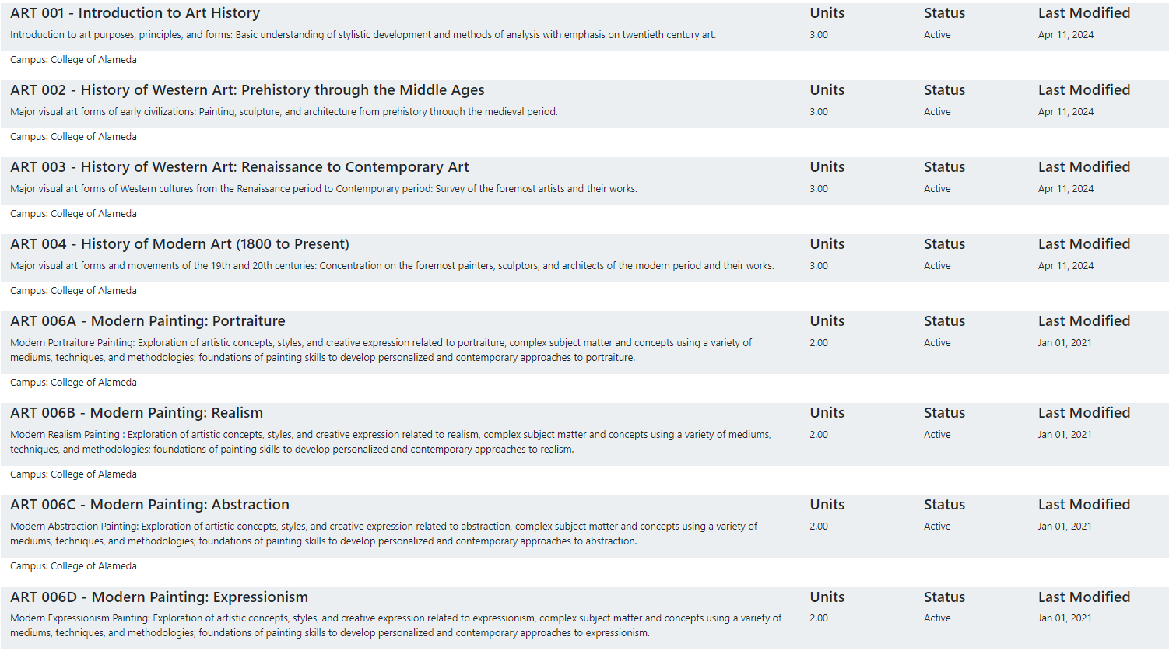
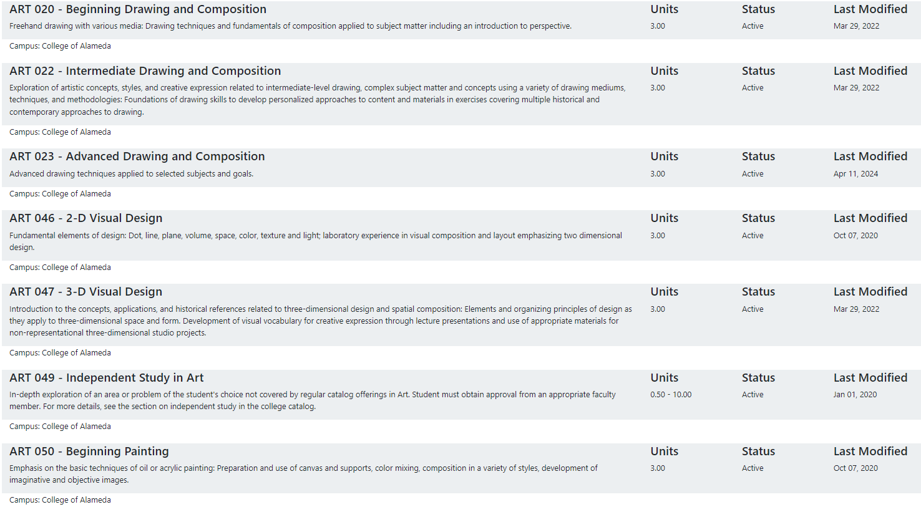
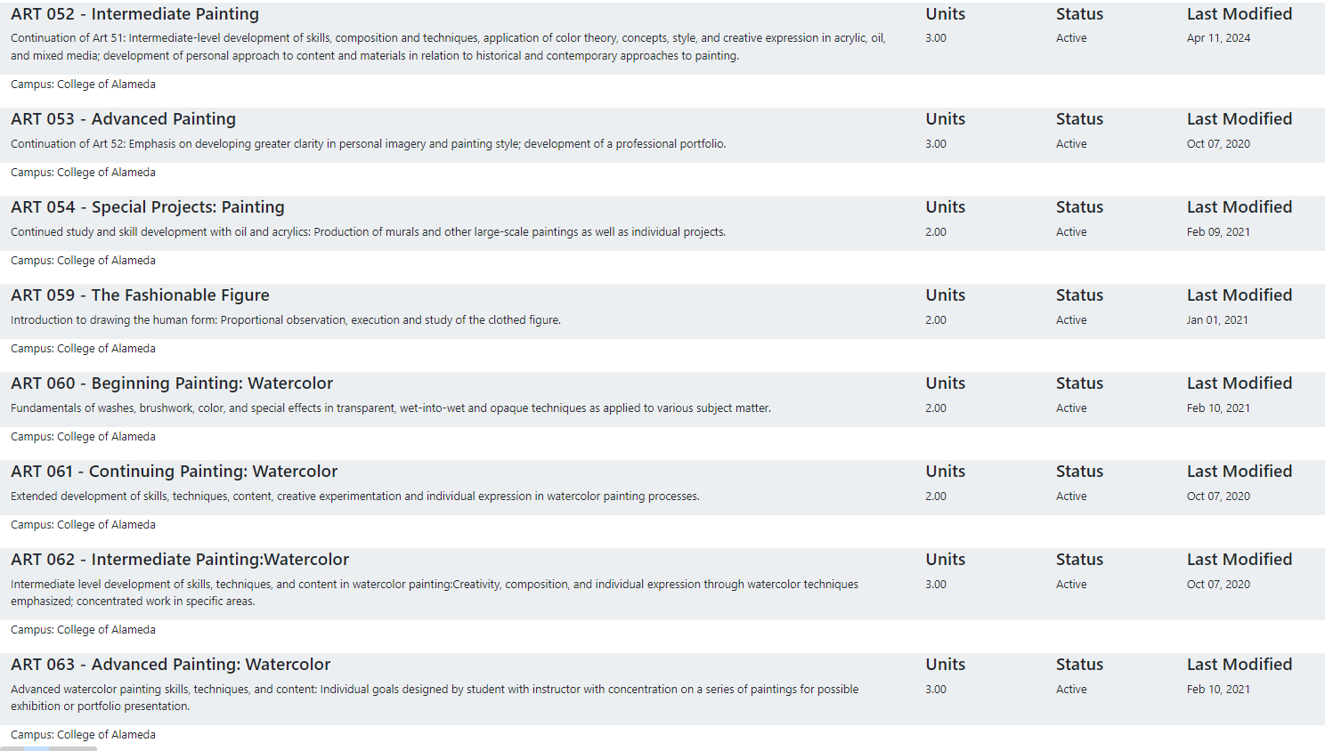
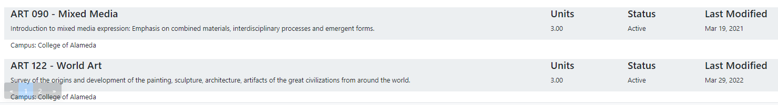

Some courses need updating. During Covid our courses were updated to achieve the DE component. There are a few courses we may deactivate---Art 054 and Art 059 for example.

Please summarize the Discipline, Department or program of study plans for curriculum plans for improvement. Below, please provide details for individual course improvement. Add plans for new courses here.
We will be reviewing our courses and considering changes to meet the demands of the educational spectrum of the contemporary world.

For example, we are in conversation with district colleagues concerning the need to update some course catalog descriptions.

We are considering two new courses, Figure Drawing and an art history course, Art of the Americas.

How is your program meeting the needs of students and/or articulation with four-year institutions?
This question is partially answered above: “As stated above, the art department courses align with the state approved course outlines of record. Our transfer level courses articulate with UC and CSU colleges. We have established transfer agreements including two AATs.

Colleagues converse in departmental meetings concerning courses and standards. As stated, we have not found hybrid to work for the department. The fully online art history courses have a high standard, with zero cost, utilizing an approved Art History website with scholars holding PhDs as contributors. Students are educated with the high standard of effective writing including academic citation.”

As we converse concerning four-year institutions questions have arisen. For example, the number of fully online coursework that is acceptable for transfer to UC and CSU schools.

There was a program at the College of Alameda whereby an agreement with an international school, contract education, was questioned by our department. As this question concerns four-year institutions, there was dialogue concerning contract education and alignment with community college standards of equity and inclusion.

We hear back from students who transfer to colleges across the country. Sometimes a college will ask for documentation of a course completed at the College of Alameda.

Assessment – Instructional
Student Learning Outcomes Assessment
Your Student Learning Outcomes for active courses are listed below. Please review and note any corrections or planned changes.
ART_SLOs.pdf

2023-2024 APU “The Art Department is progressing to assess the Departmental SLOs each semester. As we update curriculum there will be an opportunity to update SLOs within our courses. Some of the SLOs may need revision to adjust to new ideas, changing aspects of education, and to refresh our departmental approach in some areas. Many of our SLOs are fundamental to courses and do not need revision.”

2024-2025 We need some improvement on our assessment and revision of SLOs. The statement from the APU of last year is applicable this Fall. Overall, the SLOs are a consideration and are an integral aspect of courses. For example, SLOs are listed within our syllabi, engaged with in courses, and assessed. The alignment with Program Learning Outcomes needs some review. As the college updates courses for the uniform numbering system plan, the art department can focus with more attention to revisions of SLOs.

Please provide a high-level summary and your program’s interpretation of your SLO findings over the past year.
These are the Student Learning Outcomes for a core course in our department, Art 1. The outcomes are listed with forms of assessment.

STUDENT LEARNING OUTCOMES:
1. Evaluate creation of art in an historical context with an emphasis on modern life.
-essay
2. Identify broad themes of art located in the context of history and contemporary
society.
-exam, essay
3. Analyze properties of art creation in a variety of cultures and periods.
-exam, essay, written exercise
All of our work can be revisited, wordsmithed, and altered. It is worth noting that this might be change—but not improvement. The SLOs are general and applicable to the art the students study. In the formation of SLOs , and other curricular pieces for analysis, Blooms Taxonomy is employed:

1. Knowledge: arrange, define, duplicate, label, list, memorize, name, order, recognize, relate, recall,
repeat, reproduce state.
2. Comprehension: classify, describe, discuss, explain, express, identify, indicate, locate, recognize,
report, restate, review, select, translate,
3. Application: apply, choose, demonstrate, dramatize, employ, illustrate, interpret, operate, practice,
schedule, sketch, solve, use, write.
4. Analysis: analyze, appraise, calculate, categorize, compare, contrast, criticize, differentiate,
discriminate, distinguish, examine, experiment, question, test.
5. Synthesis: arrange, assemble, collect, compose, construct, create, design, develop, formulate,
manage, organize, plan, prepare, propose, set up, write.
6. Evaluation: appraise, argue, assess, attach, choose compare, defend estimate, judge, predict, rate,
core, select, support, value, evaluate.

A colleague from another college wished to clone our Mixed Media course. The colleague stated that it was the best course outline at Peralta they had encountered.

The College of Alameda art Department values student learning that engages with the writing of essays and writing to explore personal communication. SLOs provide opportunity for individualized instruction.

For example, “Evaluate creation of art in an historical context with an emphasis on modern life.” This Art 1 SLO is linked to an art history assignment where students are asked to interpret a work of art from history that displays grieving. The assignment is twofold in that the analysis of the historical work of art is present and there is synthesis with the lives of students in the society of today.

What were the most important things your department learned from assessment? Did implementation of your action plans result in better student learning?
All of the art department courses are highly structured. During the semester assignments directly engage with the goals outlined by components such as course objectives, lecture content, student performance objectives, and SLOs. The departmental mission aligns with the vision of the college and the district.

Yes, our plans have significantly shaped student learning. Every semester we note an increase of skills in studio courses and art history courses. For example, assessing painting and drawing courses, an independent observer may notice tremendous works the students produce due to the layers of tailored instruction. It happens all the time---passersby noting on the quality of work. As instructors we are in the position to measure results. A student may not entirely match the goals of an assignment yet growth is present. In this sense, our assessment recognizes, ‘personal best’ as a fluid concept when we engage with a range of students.

In art history courses the organization of student writings greatly improves at about week four. The assessment is tangible, the instruction is ordered to help students disseminate course content and restructure ideas.

Listed below are your programs (degrees and certificates) and the program learning outcomes (PLOs) for each. Please share your reflections on the PLOs and support from the college needed in assessing the PLOs over the next three years.
Our programs list Program Learning Outcomes in Curricunet. The PLOs align with ILOs. As the college prepares for upcoming accreditation visits, the art department is prepared to participate.

Support from the College might include Flex Day workshops for SLOs, PLOs, and ILOs. This has been achieved in prior semesters. For example, at a Flex Day workshop there was shared governance discussion of implementing a college wide Institutional Outcome to focus on.

College of Alameda Institutional Learning Outcomes (ILOs) were created to guide educational programs and services. They include:
- Problem Solving: Solve problems and make decisions in life and work using critical thinking, quantitative reasoning, community resources, and civil engagement.
- Communication and Technology: Use technology and written and oral communication to discover, develop, and relate critical ideas in multiple environments.
- Creativity: Exhibit aesthetic reflection to promote, participate and contribute to human development, expression, creativity, and curiosity.
- Diversity: Engage in respectful interpersonal communications, acknowledging ideas and values of diverse individuals that represent different ethnic, racial, cultural, and gender expressions.
- Civic Responsibility: Accept personal, civic, social and environmental responsibility in order to become a productive local and global community member.
How does your program participate in assessing the Institutional Learning Outcomes (ILOs)? If your program has not participated, how will you plan to incorporate these outcomes within your program?
As stated, we have participated on Flex Day. This process has been over years. The ILOs above are familiar, as a department we embrace these outcomes as a part of course development and as communication with the wider body of departments and divisions.

Our programs fully embrace and align with these objectives.

Course Completion
Course Completion Power BI Dashboard #1
Course Completion Power BI Dashboard #2
Institutional Set Standards
Consider your course completion rates over the past three years (% of student who earned a grade of "C" or better). Data with default filter is provided below. Use the link above to explore the data further.
How does the course completion rate for your program or discipline compare to your college’s Institutional Set Standard for course completion (70% with stretch goal of 77%)? Also discuss the retention rate for your program or discipline, compared to the college average shown in data below.
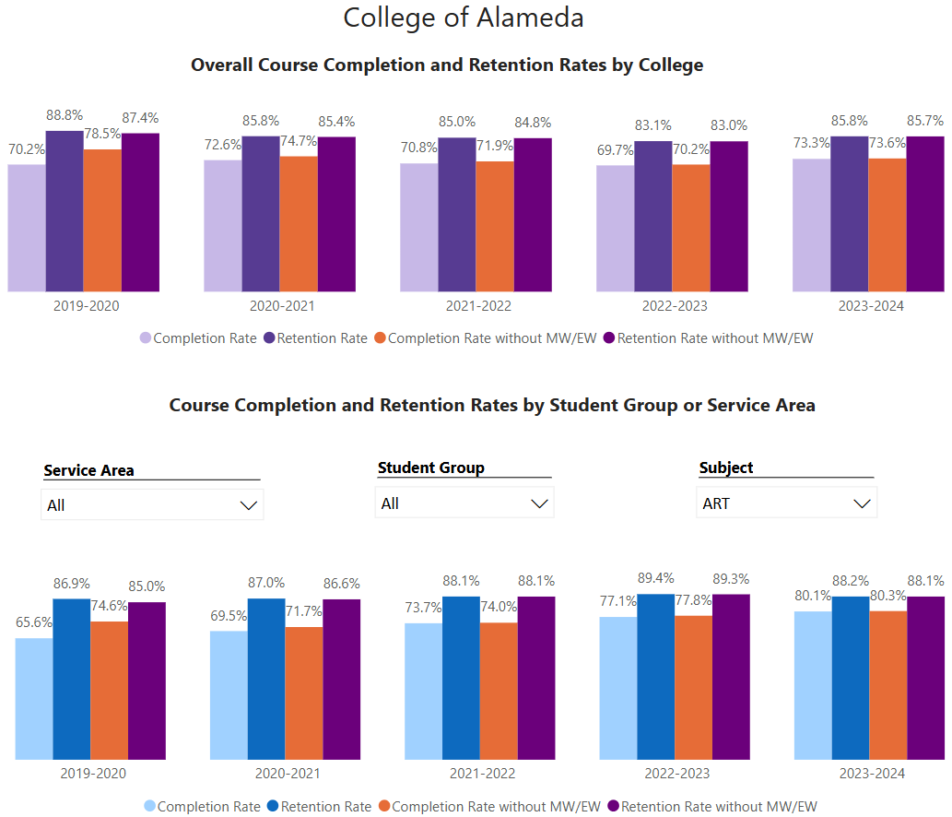

Data indicates overall Completion rates of 73% and Retention rates of 85% at the College of Alameda. For the LSLA division at the College of Alameda the rates are identical.

At present the completion rate for the LSLA division, as illustrated in the graph, is higher than the Institutional Set Standard.

What has the discipline, department, or program done to improve course completion and retention rates?
The Art Department instructors are available to meet with students in the H building facility. Students converse with instructors receiving encouragement and individualized ‘pointers’ to help with the completion of course assignments. Students return to the department.

For online courses, and circumstances of remote engagement, instructors meet with students on Zoom.

It is important for students to comprehend the objectives of assignments. Instructors design projects with achievable goals and reasonable time frames.

Equity Analysis
College of Alameda continues to focus on access, equity, and success. The goal is to create an inclusive environment where all students can thrive and meet their education and career goals.
Following is a brief description of equity data analysis, examining success rates of different ethnic groups (Asian, Black/African American, Hispanic/Latino, “Two or More”, “Unknown/NR”, White), age range, gender (Female, Male, Unknown Gender), and special population groups (Foster Youth, First Gen College, SAS).
Disparate Impact Analysis AY2023-24_Updated.xlsx
(look for the tab for your discipline).
Success rate data in Art for AY2023-24 was analyzed using the PPG-1 (percentage point gap minus 1) method, comparing the success rate of the given group against the success rate of everyone else. The success rate of the following groups falls significantly below the overall success rate of 74.1% for Art, outside the statistical margin of error:

- Hispanic/Latinx : 67.4% success rate
- Male : 69.0% success rate
- 35-54 age group: 58.3% success rate
- Low Income group: 71.6% success rate
- First Generation group: 68.4% success rate

While there are other groups whose success rates fall below the overall success rate for Art, either the percentage point gap difference is small or, because of the small sample size, a reliable conclusion cannot be drawn.

What can your discipline, department, or program do to improve course completion for disproportionately impacted groups?
The Art department recognizes and serves students of many backgrounds. Art courses are state approved with alignment concerning the outlines of record. Each student receives communication concerning stated student learning outcomes. Instructors are evaluated according to the policies of the college---all of the art department instructors have been evaluated with positive ratings.

Students are offered opportunities throughout the coursework and support from agencies within the college including vital supplies and food. The library distributes laptops. The majority of College of Alameda students receive financial aid. The California Community College system is implementing goals of low cost and zero cost for textbooks and materials. Our art department courses are offered in person and online.

The Art department is a transfer program coupled with local certificates. We offer mirrored noncredit courses. During Covid we taught hybrid courses. Observations of faculty indicated that hybrid courses did not work well. Students and faculty did not respond favorably to the modality. Regarding older students, we noticed that some wanted the in person instruction and tended to disregard the online portion.

A short drive in the area of our district campuses reveals significant public conditions of blight and communities in need. Conversations with students reveal the environment impacts performance. The art department is a place of care.

Art departments are extremely important. Many students may not be encouraged, given the social environment and family challenges, to embrace the transformative possibilities of creating art. We believe the arts are fundamental.

Space below is provided for additional discussion of equity-impacting factors not discussed above, including those that affect dual enrollment courses and/or online/hybrid courses.
As stated above, modalities such as hybrid were not well received in the art department. It is not to say the modality could not work. An outstanding feature of ‘success’ is the recognition of the value of art courses and personal expression.

We have courses that are fully online. A challenge for online asynchronous courses is the reality of fraudulent students—a statewide issue. The Peralta district is aware of the issue and plans for improvement are in progress. Instructors might face a loss of 25% of students due to the questions of who is a ‘real’ student.

Dual enrollment has been a goal of the College of Alameda for many years. The art department has had a relationship with several local schools, courses were completed. Dual enrollment is challenging in that the resources are often not present for courses requiring materials.

The key feature of success in the art department for students, with structured classes and assignments, is engaging with, and following through, with problem solving. Students benefit with the opportunity to craft works of art. The arts engage with themes of humanity including ideas of struggle, love, and beauty. The art program fosters the pursuit of personal growth.

We encourage the College of Alameda to support the expression, the skills learned, the unique education of art, by supporting students who may be first generation, Hispanic/Latinx, male, female, gender fluid, older students, students with disabilities, and students with mental health concerns. The Art Department seeks to engage with all students, of all backgrounds in a healthy, congenial, and holistic learning environment.

Degrees & Certificates Conferred
Does your program offer any degree/certificate programs? If your program does not, skip this section and continue to Engagement.
Degrees & Certificates Power BI dashboard
What has the discipline, department, or program done to improve the number of degrees and certificates awarded? Below data shows the number of degrees and certificates awarded by year, for the past three years. Use the link above to explore the data further.
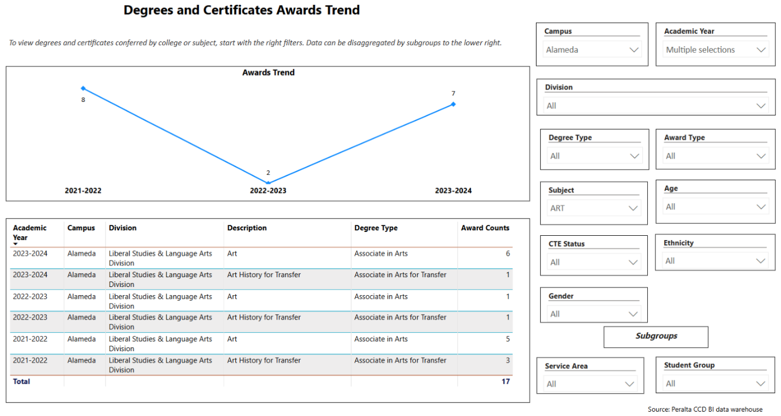

2023-2024 APU” Viewing the graph of degrees and certificates by the College of Alameda over a four year period from 2019 to 2023, the graph indicates there is a sharp decline in the award of degrees and certificates. The data aligns with the decline of student enrollment during the same period. As the College of Alameda furthers the implementation of Guided Pathways an emphasis on the completion of degrees and certificates is an integral goal.”

2024-2025 We are seeing an increase in the awarding of degrees. The department offers a total of FIVE opportunities. One of our certificates is tied to our non-credit coursework. In the Spring of 2025 we intend to offer Art 90 with the mirrored Art 590 course. This is true of the watercolor sequence as well. The non-credit courses have helped to diversify the classes and give a depth of options. Again, Guided Pathways may play a role in upcoming semesters. The college is involved with the creation of part time mapping this semester. Many students need time beyond two years to achieve their goals. We think it is important to consider the relationship of our coursework, our transfer degrees, our local transfer institutions, and the network of engagement that is available for students. We built a certificate for students who may wish to focus on fine art—Practitioner of Fine Art. In the department are returning adults who wish to be involved in a serious art program, to receive high quality instruction that is tailored for them in a congenial atmosphere.

Increasing the number of students who complete a certificate or degree is a shared goal across CoA’s Ed Master Plan Goals, PCCD Goals, the Chancellor’s Office Vision for Success, the Student-Centered Funding Formula, and Guided Pathways. What is planned for the next 3 years to increase the number of certificates and degrees awarded?
The department offers five opportunities, The AA degree, AAT in Art History, AAT in Studio Arts, The Practitioner of Fine Art, and Art Fundamentals.

The degrees and certificates are varied to serve students who may wish to transfer, receive a local degree, and/or engage with non-credit courses. We are offering Mixed Media in the Spring which has a credit and non-credit opportunity. Students taking non-credit courses can receive a certificate.

We would like to have art history instructors so that the range of courses can be offered regularly.

The department has planned for the Student-Centered Funding Formula for multiple years, hence, the five awards.

Engagement
Discuss how faculty and staff have engaged in institutional efforts such as committees, presentations, and departmental activities. Please list the committees that full-time faculty participate in.
Fulltime faculty have participated as Chair of Professional Development, Chair and Vice Chair of Curriculum Committee, Academic Senate appointee, Professional Development member, the College Council, Accreditation Faculty lead, Catalog Committee, District Academic Senate rep, Chair of Music, Art , and Dance, LGBTQ advisory, and more.

Discuss how faculty and staff have engaged in community activities, partnerships and/or collaborations.
When the new H building was created the Art Department faculty engaged in the process of design and the fulfillment of a mural for the building. There has been some engagement with the Frank Bette Art Center in Alameda.

At present the department is communicating with district personnel to achieve synergy between the exhibition possibilities of the District Office, the Laney College gallery, and the College of Alameda gallery.

Representatives of students basic needs, and ‘Tasty Tuesdays’, have discussed creating a mural for the F building. The Art department is engaged with the process.

Discuss how adjunct faculty members are included in departmental training, discussions, and decision-making.
Throughout many years adjunct instructors have voiced viewpoints and insights including course scheduling, course instruction, departmental processes, and decisions related to academic standards and course completion. Our adjunct instructors have participated in opportunities such as the Curriculum Institute and regional Academic Senate Plenaries.

Adjunct Instructors developed the AAT degrees.

The Art Department values the tremendous contribution adjunct instructors have made to further student success.

Prioritized Resource Requests Summary
In the boxes below, please add resource requests for your program. If there are no resource requested, leave the boxes blank.
Resource Category | Description/Justification | Full-Time Equivalent Percentage | Salary Grade (if applicable)
Personnel: Classified Staff

Personnel: Student Worker | A student worker for studio classes.
Personnel: Part Time Faculty | 2 adjunct Art History Instructors to fulfill our goals of completion.
Personnel: Full Time Faculty

Personnel: Full Time Faculty, future anticipated need | A full time art instructor.

Resource Category | Description/Justification | Total Estimated Cost
Professional Development: Department wide PD needed

Professional Development: Personal/Individual PD needed | College Art Association Conference | 1500.

Prioritized Resource Requests Summary - Continued

Resource Category | Description/Justification | Total Estimated Cost
Supplies: Software | Wi-Fi update for printer | 300.
Supplies: Books, Magazines, and/or Periodicals

Supplies: Instructional Supplies | Departmental supplies to facilitate studio coursework. | 4500.
Supplies: Non-Instructional Supplies | A painting rack, easels, and taborets. | 3500.
Supplies: Library Collections

Resource Category | Description/Justification | Total Estimated Cost
Technology & Equipment: New | Laptop upgrade | 1450.
Technology & Equipment: Replacement

Prioritized Resource Requests Summary - Continued

Resource Category | Description/Justification | Total Estimated Cost
Facilities: Classrooms | Consideration of changing classroom arrangement to facilitate the instruction of multiple studio courses. | 1700.
Facilities: Offices

Facilities: Labs | Gallery supplies including a ladder, paint to touch up the walls, patching compound, and hanging devices.  A hanging system for the gallery. | 1100.  2800.
Facilities: Other | Cleaning departmental windows, including the gallery. | 575.

Resource Category | Description/Justification | Total Estimated Cost
Library: Library materials

Library: Library collections

Resource Category | Description/Justification | Total Estimated Cost
OTHER

