
2024-25 Program Review – Instructional –
Astronomy

Lead Author
Andrew Park (with contributions from Araceli Lopez-Garibay during CoA Flex Day)

Program Overview
Please verify the mission statement for your program. If there is no mission statement listed, please add it here.
The mission of the Astronomy Department at College of Alameda is to introduce students to the Universe and insight into its mysteries. Students will learn how observations have shaped theories of basic astronomical phenomena and the evolution of the Universe.
We provide comprehensive and flexible programs that empower students to achieve their goals through offering of online and face-to-face sections of introductory astronomy.

List your Faculty and/or Staff, and indicate whether they are full-time or part-time.
Andrew Park – full-time ASTR/PHYS
Andrew Fittingoff – part-time ASTR/PHYS
Araceli Lopez-Garibay – part-time in-person ASTR
Amanda Truitt – part-time online ASTR/PHYS
Stephen Asztalos – part-time online ASTR/PHYS

The Program Goals below are from your most recent Program Review or APU. If none are listed, please add your most recent program goals. Then, indicate the status of this goal, and which College and District goal your program goal aligns to. If your goal has been completed, please answer the follow up question regarding how you measured the achievement of this goal.
Program Goal | Maintain or Increase ASTR 1/10 offering, and maintain/procure supplies and equipment for ASTR lecture demos.
Status: In-Progress or Complete? If complete, give a brief description of how you measured the goal completion. | In-Progress: we have been able to maintain the number of sections we offer for ASTR 1/10 in regular session; we still need progress on increasing the number of sections, which needs to happen through college-wide FTEF allocation process. We have a number of new ASTR lecture demos and have funds to purchase more if needed.
Which college or district goal is aligned with your program goal? | College Goal 2: Provide quality educational and …
Program Goal | Regular online ASTR/PHYS faculty meeting during semester; hold the first meeting by February 2023
Status: In-Progress or Complete? If complete, give a brief description of how you measured the goal completion. | In-Progress: We have held the meeting on March 10, 2023 and promised to meet on October 6, 2023, but it didn’t happen. We do communicate regularly via email and that may be all that’s needed for our small department. We should re-think this goal and potentially modify it.
Which college or district goal is aligned with your program goal? | College Goal 5: Foster an inclusive and caring culture …
Program Goal | As part of regular online ASTR/PHYS faculty meeting, discuss assessments and possible improvement of pedagogy and improved assessments
Status: In-Progress or Complete? If complete, give a brief description of how you measured the goal completion. | In-Progress: we need more support from CoA Office of Instruction on part-time faculty completing SLO assessments. Discussion of possible improvement of pedagogy can only follow after we had robust set of SLO assessments. At the moment financial support for completing SLO assessments is limited to full-time faculty at CoA.
Which college or district goal is aligned with your program goal? | College Goal 2: Provide quality educational and …
Program Goal | Evaluate feasibility of offering ASTR lab section at CoA, in coordination of Merritt’s ASTR lab section; short update by May 2023
Status: In-Progress or Complete? If complete, give a brief description of how you measured the goal completion. | In-Progress: It’s still under consideration. Merritt’s ASTR 20 hasn’t been re-activated yet, and with the new statewide common course numbering (CCN) including “astronomy with lab”, we need to see what the CCN template looks like before we make curricular changes.
Which college or district goal is aligned with your program goal? | College Goal 1: Develop and offer curriculum …

Describe your current utilization of facilities, including labs and other space
In-person ASTR lecture classes are scheduled in a similar matter as other CoA in-person classes (shared classrooms in H building). Available lecture demos for ASTR are stored in PHYS stockroom within ATLAN 100.

Enrollment Trends
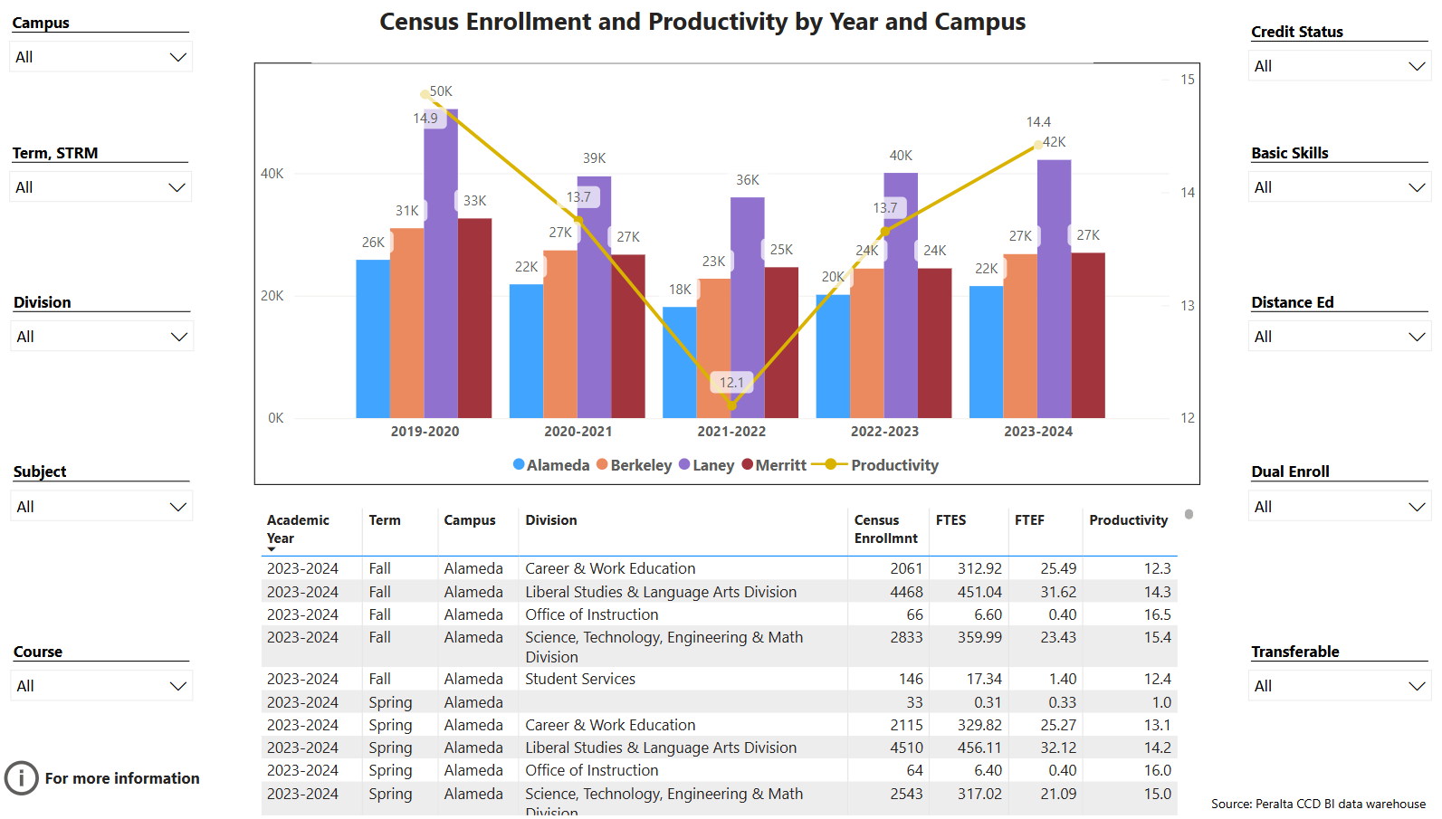
Enrollment Trends Power BI dashboard
Note: Please consider the most recent 3 years when answering the questions below. Data with default filter is provided below. Use the link above to explore the data further.
Discuss enrollment trends over the past three years.
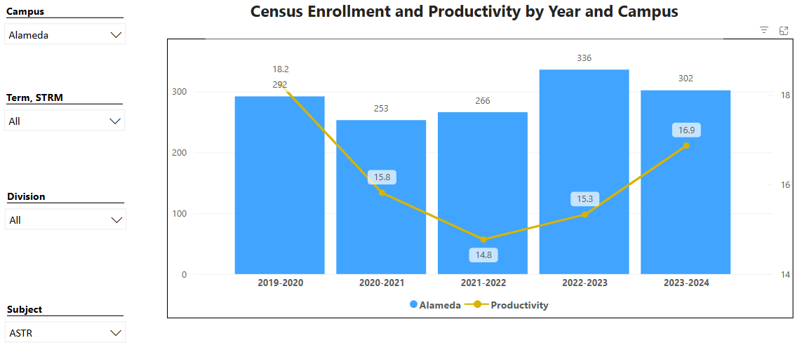

ASTR’s enrollment has completely recovered. Productivity of 17 is more or less the maximum achievable with primarily online class offerings (classes fill to 40 at the beginning of the semester, and with some students dropping out, 34 at census is basically the maximum enrollment we can expect per section). We believe any additional online sections offered will fill completely within these parameters, and the only thing we need to be mindful is making sure that our in-person section each semester will fill (that is, not offer so many online sections so that students who might have considered in-person section are lured away to the available online section).

Table below shows list of course sections in your area sorted from lowest fill rate to the highest fill rate for the last three years. Consider and discuss whether the course offerings meet the needs of our students.
Academic Year | Term | Campus | Course | Section ID | Census Enrollmnt | FTES | FTEF | Productivity | Enrl Cap | Fill Rate | Time of Day | Distance Ed
2021-2022 | S22 | Alameda | ASTR 1 | 1222223274 | 13 | 1.29 | 0.20 | 6.4 | 40 | 33% | DAY | On Campus
2022-2023 | S23 | Alameda | ASTR 1 | 1232220899 | 14 | 1.44 | 0.20 | 7.2 | 40 | 35% | DAY | On Campus
2022-2023 | S23 | Alameda | ASTR 1 | 1232225191 | 17 | 1.70 | 0.20 | 8.5 | 40 | 43% | DAY | Online / Classes totally online
2023-2024 | F23 | Alameda | ASTR 1 | 1234242973 | 23 | 2.30 | 0.20 | 11.5 | 40 | 58% | DAY | Online / Classes totally online
2023-2024 | S24 | Alameda | ASTR 1 | 1242220822 | 26 | 2.67 | 0.20 | 13.4 | 40 | 65% | DAY | On Campus
2022-2023 | F22 | Alameda | ASTR 1 | 1224243130 | 27 | 2.78 | 0.20 | 13.9 | 40 | 68% | DAY | On Campus
2022-2023 | M22 | Alameda | ASTR 1 | 1223230662 | 27 | 2.70 | 0.20 | 13.5 | 40 | 68% | DAY | Online / Classes totally online
2022-2023 | S23 | Alameda | ASTR 1 | 1232220898 | 27 | 2.70 | 0.20 | 13.5 | 40 | 68% | DAY | Online / Classes totally online
2022-2023 | F22 | Alameda | ASTR 1 | 1224245222 | 29 | 2.90 | 0.20 | 14.5 | 40 | 73% | DAY | Online / Classes totally online
2021-2022 | S22 | Alameda | ASTR 1 | 1222225358 | 29 | 2.90 | 0.20 | 14.5 | 40 | 73% | DAY | Online / Classes totally online
2023-2024 | F23 | Alameda | ASTR 1 | 1234240882 | 30 | 3.09 | 0.20 | 15.4 | 40 | 75% | DAY | On Campus
2022-2023 | F22 | Alameda | ASTR 1 | 1224243385 | 30 | 3.00 | 0.20 | 15.0 | 40 | 75% | DAY | Online / Classes totally online
2021-2022 | F21 | Alameda | ASTR 1 | 1214245353 | 32 | 3.20 | 0.20 | 16.0 | 40 | 80% | DAY | Online / Classes totally online
2021-2022 | S22 | Alameda | ASTR 1 | 1222223273 | 32 | 3.20 | 0.20 | 16.0 | 40 | 80% | DAY | Online / Classes totally online
2021-2022 | M21 | Alameda | ASTR 10 | 1213230708 | 28 | 2.80 | 0.20 | 14.0 | 34 | 82% | DAY | Online / Classes totally online
2023-2024 | M23 | Alameda | ASTR 1 | 1233230169 | 33 | 3.30 | 0.20 | 16.5 | 40 | 83% | DAY | Online / Classes totally online
2021-2022 | S22 | Alameda | ASTR 1 | 1222223272 | 33 | 3.30 | 0.20 | 16.5 | 40 | 83% | DAY | Online / Classes totally online
2023-2024 | F23 | Alameda | ASTR 1 | 1234240881 | 34 | 3.40 | 0.20 | 17.0 | 40 | 85% | DAY | Online / Classes totally online
2021-2022 | F21 | Alameda | ASTR 10 | 1214242805 | 30 | 3.00 | 0.20 | 15.0 | 34 | 88% | DAY | Online / Classes totally online
2023-2024 | F23 | Alameda | ASTR 1 | 1234244912 | 36 | 3.60 | 0.20 | 18.0 | 40 | 90% | DAY | Online / Classes totally online
2023-2024 | S24 | Alameda | ASTR 1 | 1242223180 | 36 | 3.60 | 0.20 | 18.0 | 40 | 90% | DAY | Online / Classes totally online
2021-2022 | F21 | Alameda | ASTR 10 | 1214244920 | 36 | 3.60 | 0.20 | 18.0 | 40 | 90% | DAY | Online / Classes totally online
2022-2023 | F22 | Alameda | ASTR 1 | 1224243129 | 37 | 3.70 | 0.20 | 18.5 | 40 | 93% | DAY | Online / Classes totally online
2022-2023 | S23 | Alameda | ASTR 1 | 1232223295 | 43 | 4.30 | 0.20 | 21.5 | 45 | 96% | DAY | Online / Classes totally online
2021-2022 | F21 | Alameda | ASTR 1 | 1214245354 | 33 | 3.30 | 0.20 | 16.5 | 34 | 97% | DAY | Online / Classes totally online
2022-2023 | F22 | Alameda | ASTR 1 | 1224243386 | 40 | 4.00 | 0.20 | 20.0 | 40 | 100% | DAY | Online / Classes totally online
2023-2024 | S24 | Alameda | ASTR 1 | 1242220820 | 41 | 4.10 | 0.20 | 20.5 | 40 | 103% | DAY | Online / Classes totally online
2023-2024 | S24 | Alameda | ASTR 1 | 1242223308 | 43 | 4.30 | 0.20 | 21.5 | 40 | 108% | DAY | Online / Classes totally online
2022-2023 | S23 | Alameda | ASTR 1 | 1232220897 | 45 | 4.50 | 0.20 | 22.5 | 40 | 113% | DAY | Online / Classes totally online
Total |  |  |  |  | 904 | 90.67 | 5.80 | 15.6 | 1147 | 79%
Applied filters:
ACAD_YEAR_LONG is 2022-2023, 2023-2024, or 2021-2022
NAME_SHORT is Alameda
SUBJECT is ASTR

Lower-enrolled sections are from some time ago, reflecting situations that won’t be repeated (intersession classes overscheduled/scheduled too late). While On Campus sections show generally weaker demand (at most 75% fill rate in Fall 2023, then 65% fill rate in Spring 2024), we are committed to maintaining at least one in-person section of Astronomy lecture so that we serve all students well, not just those who will succeed well in online classes.

Some of the overfilled sections may indicate not enough sections being offered (and instructors for those sections being generous toward student requests); we continue to advocate for additional FTEF for ASTR lecture classes, so that we don’t have to overfill existing sections.

Discuss any action plan to better meet student needs and demands.
We continue to advocate for additional FTEF for ASTR lecture classes, so that we don’t have to overfill existing sections.

Describe effective and innovative teaching strategies used by faculty to increase student learning and engagement.
Andrew Fittingoff pioneered the online Astronomy course on the new Canvas LMS, making use of advanced features of Canvas. Amanda Truitt and Araceli Lopez-Garibay developed course materials that align with OpenStax Astronomy, an open educational resource (OER) that is freely available to students.

How is technology used by the discipline, department?
As a discipline with most of its course offerings being asynchronous online classes, the Canvas LMS is the single most heavily relied-on piece of technology. Other technology being used by individual instructors (online textbooks, etc.) are not specifically supported or maintained by the college.

The in-person Astronomy lecture class is scheduled in one of the smart rooms in the new H-building. Araceli Lopez-Garibay, our in-person instructor, makes extensive use of the smart-room technology, including the touchscreen whiteboard.

How does the discipline, department, or program maintain the integrity and consistency of academic standards with all methods of delivery, including face to face, hybrid, and Distance Education courses?
Andrew Fittingoff, Amanda Truitt, and Araceli Lopez-Garibay all teach (or have taught recently) face-to-face classes in Astronomy or in related fields such as Physics. This varied and ongoing experience of our ASTR instructors ensures that the same academic standards are maintained with all our courses across all modes of instruction.

Curriculum
CurriQunet Meta
If necessary, use the CurriQunet META link to review the details of curriculum. Some summary information is provided below.
Please review your course outlines of record in CurriQunet META to determine if they have been updated in the past three years. Specify when your department will update, or deactivate, each one, within the next three years.
College | Subject Code | Course # | Course Title | Updated On
College of Alameda | ASTR | 001 | Introduction to Astronomy | 9/11/2019
College of Alameda | ASTR | 010 | Descriptive Astronomy | 7/15/2019

ASTR courses are in need of update; Title 5 update will happen within Fall 2024.

Please summarize the Discipline, Department or program of study plans for curriculum plans for improvement. Below, please provide details for individual course improvement. Add plans for new courses here.
No near-term planned changes in curriculum.

How is your program meeting the needs of students and/or articulation with four-year institutions?
We offer online sections of ASTR 1 as we see the demand; we also ensure at least one section of ASTR 1 is available in-person for the students who benefit from in-person instruction (vs. asynchronous online instruction). We monitor articulation agreements with UCs and CSUs (for physical science general education courses that our ASTR department offers, there isn’t a specific learning/skill objective needing to be met), and we will wait to offer ASTR 10 again, until UC has fully approved it for its GE areas (as of Fall 2024/Spring 2025, ASTR 10 still isn’t listed for UC-S in UC Areas).

Assessment – Instructional
Student Learning Outcomes Assessment
Your Student Learning Outcomes for active courses are listed below. Please review and note any corrections or planned changes.
Subject Course# | SLOs | Last Assessed
ASTR 001 | SLO1 - Differentiate between planets, stars, galaxies, and the universe in terms of scale. | Fall 2019
ASTR 001 | SLO2 - Explain and discuss basic astronomical phenomena, including the seasons, the phases of the Moon, eclipses, and planetary motion. | Fall 2020
ASTR 001 | SLO3 - Explain and discuss the origin, development, and properties of planetary systems, stars, galaxies, and the universe.
ASTR 001 | SLO4 - Explain how theories in astronomy are based on observations.
ASTR 010 | SLO1 - Explain and discuss basic astronomical phenomena, including the seasons, the phases of the Moon, eclipses, and planetary motion.
ASTR 010 | SLO2 - Differentiate between planets, stars, galaxies, and the universe in terms of scale.
ASTR 010 | SLO3 - Explain and discuss the origin, development, and properties of planetary systems, stars, galaxies, and the universe.

Please provide a high-level summary and your program’s interpretation of your SLO findings over the past year.
We need more recently completed SLO assessments. This will happen as soon as either:
- The full-timer (Andrew Park) is assigned to teach an Astronomy lecture class, or
- There is financial support from the college for part-time faculty completing SLO assessments.

What were the most important things your department learned from assessment? Did implementation of your action plans result in better student learning?
We need more recently completed SLO assessments. This will happen as soon as either:
- The full-timer (Andrew Park) is assigned to teach an Astronomy lecture class, or
- There is financial support from the college for part-time faculty completing SLO assessments.

Listed below are your programs (degrees and certificates) and the program learning outcomes (PLOs) for each. Please share your reflections on the PLOs and support from the college needed in assessing the PLOs over the next three years.
[ASTR does not have degrees or certificates.]

ASTR department does not have a certificate or a degree with associated PLOs. We would like to participate in PLO assessments for degrees that list ASTR courses for breadth or degree-specific requirements (e.g. associate in liberal arts).

College of Alameda Institutional Learning Outcomes (ILOs) were created to guide educational programs and services. They include:
- Problem Solving: Solve problems and make decisions in life and work using critical thinking, quantitative reasoning, community resources, and civil engagement.
- Communication and Technology: Use technology and written and oral communication to discover, develop, and relate critical ideas in multiple environments.
- Creativity: Exhibit aesthetic reflection to promote, participate and contribute to human development, expression, creativity, and curiosity.
- Diversity: Engage in respectful interpersonal communications, acknowledging ideas and values of diverse individuals that represent different ethnic, racial, cultural, and gender expressions.
- Civic Responsibility: Accept personal, civic, social and environmental responsibility in order to become a productive local and global community member.
How does your program participate in assessing the Institutional Learning Outcomes (ILOs)? If your program has not participated, how will you plan to incorporate these outcomes within your program?
ASTR department and/or faculty have not been invited to participate in assessing the ILOs. We would welcome such invitation.

Course Completion
Course Completion Power BI Dashboard #1
Course Completion Power BI Dashboard #2
Institutional Set Standards
Consider your course completion rates over the past three years (% of student who earned a grade of "C" or better). Data with default filter is provided below. Use the link above to explore the data further.
How does the course completion rate for your program or discipline compare to your college’s Institutional Set Standard for course completion (70% with stretch goal of 77%)? Also discuss the retention rate for your program or discipline, compared to the college average shown in data below.
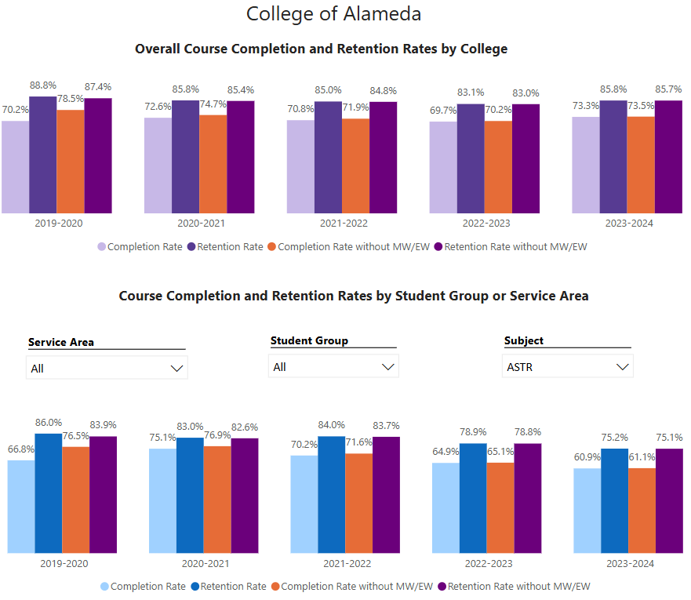

Overall success rates in ASTR have fallen over the last two years. We need a department-wide conversation discussing the root causes of this drop. While the overall success rate in in-person classes is lower (possibly due to difference in student population being served), even isolating data analysis to the online sections, we are not currently meeting the institution set standard in ASTR.

What has the discipline, department, or program done to improve course completion and retention rates?
We will reflect this information in our future program reviews after a department-wide conversation has taken place. This is the first program review cycle in a while in which ASTR course success rate has fallen below the institution set standard.

Equity Analysis
College of Alameda continues to focus on access, equity, and success. The goal is to create an inclusive environment where all students can thrive and meet their education and career goals.
Following is a brief description of equity data analysis, examining success rates of different ethnic groups (Asian, Black/African American, Hispanic/Latino, “Two or More”, “Unknown/NR”, White), age range, gender (Female, Male, Unknown Gender), and special population groups (Foster Youth, First Gen College, SAS). Detailed data table can be found at this link (look for the tab for your discipline).
Success rate data in ASTR for AY2023-24, excluding non-credit courses and contract education courses, was analyzed using the PPG-1 (percentage point gap minus 1) method, comparing success rate of the given group against the success rate of everyone else. The success rate of following groups fall significantly below the overall success rate of 60% for ASTR, outside the statistical margin of error:
- Unknown Gender: 20.0% success rate
- 30-34 age group: 40.0% success rate
- 35-54 age group: 46.3% success rate
- Foster youth: 31.3% success rate
- Low-income: 57.5% success rate

While there are other groups whose success rates fall below the overall success rate for ASTR, either the percentage point gap difference is small or, because of the small sample size, a reliable conclusion cannot be drawn.

What can your discipline, department, or program do to improve course completion for disproportionately impacted groups?
These disparately impacted groups weren’t included with the data we were given for the last program review cycle (last program review cycle, Hispanic/Latino population was identified as disparately impacted, who I am glad to see are no longer disparately impacted). We will discuss the factors that might be impacting these groups and reflect that information in future program reviews.

Space below is provided for additional discussion of equity-impacting factors not discussed above, including those that affect dual enrollment courses and/or online/hybrid courses.
We do see lower success rates in our in-person classes; we will discuss what we can do as a department to better support our in-person students.

Degrees & Certificates Conferred
Does your program offer any degree/certificate programs? If your program does not, skip this section and continue to Engagement.
Degrees & Certificates Power BI dashboard
What has the discipline, department, or program done to improve the number of degrees and certificates awarded? Below data shows the number of degrees and certificates awarded by year, for the past three years. Use the link above to explore the data further.
[ASTR does not have degrees or certificates.]

Increasing the number of students who complete a certificate or degree is a shared goal across CoA’s Ed Master Plan Goals, PCCD Goals, the Chancellor’s Office Vision for Success, the Student-Centered Funding Formula, and Guided Pathways. What is planned for the next 3 years to increase the number of certificates and degrees awarded?
ASTR does not have standalone degrees; we primarily serve the college as a “service discipline” (that is, provide classes that satisfy physical science general education requirement; we may offer physical science lab courses in some distant future).

Engagement
Discuss how faculty and staff have engaged in institutional efforts such as committees, presentations, and departmental activities. Please list the committees that full-time faculty participate in.
No full-time faculty regularly teaches in ASTR. The sole full-time faculty meeting minimum qualification in ASTR (Andrew Park) mostly teaches PHYS courses; his involvement in institutional efforts will be noted on PHYS program review.

Part-time faculty Andrew Fittingoff is currently serving on College of Alameda Academic Senate.
Part-time faculty Araceli Lopez-Garibay has served on a hiring committee at College of Alameda.

Discuss how faculty and staff have engaged in community activities, partnerships and/or collaborations.
The part-time faculty in ASTR teach across the district at our sister campuses, including Laney and Merritt.

Discuss how adjunct faculty members are included in departmental training, discussions, and decision-making.
We communicate regularly by email, and we will re-assess our need for real-time discussion opportunities and follow up.

Prioritized Resource Requests Summary
In the boxes below, please add resource requests for your program. If there are no resource requested, leave the boxes blank.
Resource Category | Description/Justification | Full-Time Equivalent Percentage | Salary Grade (if applicable)
Personnel: Classified Staff

Personnel: Student Worker

Personnel: Part Time Faculty | ASTR courses are always in demand, and we don’t have enough FTEF budget to offer our usual “2 online sections, 1 in-person section” (plus one summer section) every semester. We would like to have enough FTEF budget to offer a minimum of 2 online sections and 1 in-person section each semester (which will all fill to capacity). | additional 0.20 FTEF, for the academic year | ??
Personnel: Full Time Faculty

Personnel: Full Time Faculty, future anticipated need | In about 25 years when Andrew Park retires, we will need a new full-time faculty who can teach ASTR and PHYS.

Resource Category | Description/Justification | Total Estimated Cost
Professional Development: Department wide PD needed | Support for department-wide meeting and SLO assessment efforts is needed. We would like to request a small stipend payment for time part-time faculty spend on assessing SLOs and attend department-wide meeting to discuss SLO assessment results. | $500 - $1000 for all PT faculty participating
Professional Development: Personal/Individual PD needed | Individual faculty will request through PD committee.

Prioritized Resource Requests Summary - Continued

Resource Category | Description/Justification | Total Estimated Cost
Supplies: Software

Supplies: Books, Magazines, and/or Periodicals

Supplies: Instructional Supplies | ASTR lecture demos need continued maintenance. | $500
Supplies: Non-Instructional Supplies

Supplies: Library Collections

Resource Category | Description/Justification | Total Estimated Cost
Technology & Equipment: New | There are spaces on CoA campus that can be used to host astronomical observation opportunity (“Star Party”). We need new equipment, specifically telescope, to make this possible. The budget requested here is for entry-level telescopes and accessories capable of observing planets and their features (moons of Jupiter and rings of Saturn). | $2500
Technology & Equipment: Replacement

Prioritized Resource Requests Summary - Continued

Resource Category | Description/Justification | Total Estimated Cost
Facilities: Classrooms

Facilities: Offices

Facilities: Labs

Facilities: Other

Resource Category | Description/Justification | Total Estimated Cost
Library: Library materials

Library: Library collections

Resource Category | Description/Justification | Total Estimated Cost
OTHER

