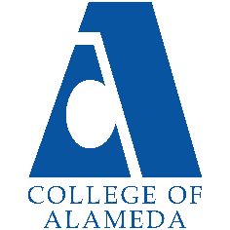
2024-25 Program Review – Instructional –
Communications

Lead Author
Jennifer Fowler

Program Overview
Please verify the mission statement for your program. If there is no mission statement listed, please add it here.
Mission Statement
Communication focuses on how people use messages to generate and interpret meaning in diﬀerent contexts, cultures, channels, and media. Communication skills are among the top qualities employers look for in job candidates. The mission of College of Alameda is to serve the educational needs of its diverse community by providing comprehensive and ﬂexible programs and resources that empower students to achieve their goals. The Communication Department directly supports this mission by helping students learn why people interact the way they do while improving their own verbal, nonverbal, and written communication skills.
Program Learning Outcomes
Communication Studies – A.A. Degree
- Build greater competence in interpersonal, small group, and public communication.
- Express ideas and viewpoints with greater clarity.
- Develop conflict management and leadership skills.
Associate in arts in Communication Studies for Transfer – AA-T Degree (Update may be needed; link goes to a program summary on META for a proposal in Review stage) Program Learning Outcomes
- Build greater competence in interpersonal, small group, and public communication.
- Express ideas and viewpoints with greater clarity.
- Develop conflict management and leadership skills.
Communication Studies – Certificate of Achievement Program Learning Outcomes
- Build greater competence in interpersonal, small group, and public communication.
- Express ideas and viewpoints with greater clarity.
- Develop conflict management and leadership skills.

List your Faculty and/or Staff, and indicate whether they are full-time or part-time.
Jennifer Fowler, Full-Time
Ashlie Andrew, Part-Time
Brielle Erike, Part-Time
Pati Shojaee, Part-Time
Kwesi Wilson, Part-Time

The Program Goals below are from your most recent Program Review or APU. If none are listed, please add your most recent program goals. Then, indicate the status of this goal, and which College and District goal your program goal aligns to. If your goal has been completed, please answer the follow up question regarding how you measured the achievement of this goal.
Program Goal | Continue SLO assessments and stay current every year. This will allow our department to meet accreditation standards.
Status: In-Progress or Complete?  If complete, give a brief description of how you measured the goal completion. | In-Progress. We are working to stay current and have a timeline to accomplish this goal by the end of the year.
Which college or district goal is aligned with your program goal? | College Goal: Data-Driven Decision Making  District Goal: Build Programs of Distinction

Program Goal | Increase faculty access to technology and digital teaching tools.
Status: In-Progress or Complete?  If complete, give a brief description of how you measured the goal completion. | Complete. We tracked faculty participation in training sessions for new technology and digital tools, along with the number of new tools adopted in their classes.
Which college or district goal is aligned with your program goal? | College: Advance CoA teaching and learning  District: Build Programs of Distinction

Program Goal | N/A
Status: In-Progress or Complete?  If complete, give a brief description of how you measured the goal completion. | N/A
Which college or district goal is aligned with your program goal? | N/A

Describe your current utilization of facilities, including labs and other space
The Communication department utilizes a mix of on-campus and the Canvas learning management system to support its blend of in-person and distance education courses. On-campus classrooms are used for courses that benefit from in-person instruction. Counseling, tutoring centers, and career services are available both in-person and online.

Enrollment Trends
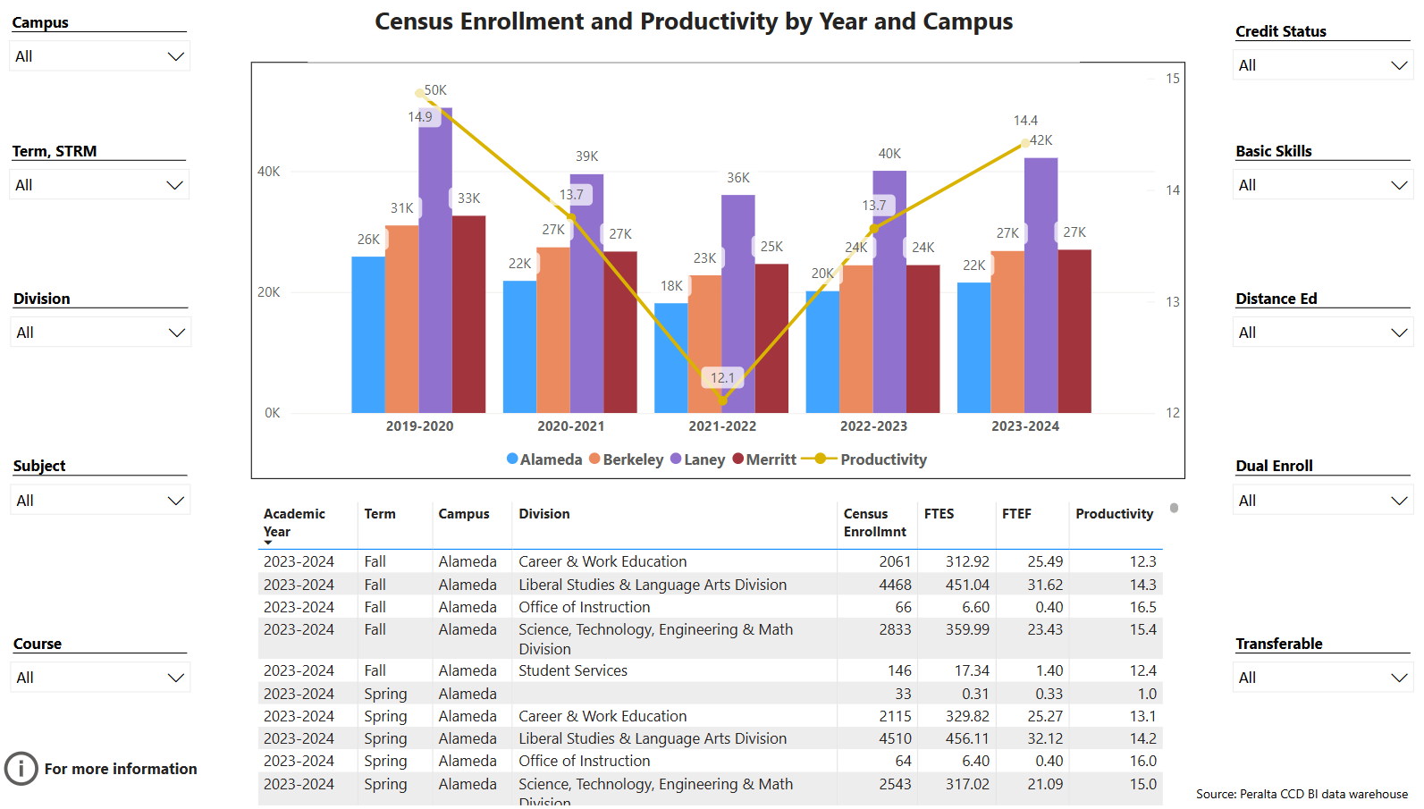
Enrollment Trends Power BI dashboard
Note: Please consider the most recent 3 years when answering the questions below. Data with default filter is provided below. Use the link above to explore the data further.
Discuss enrollment trends over the past three years.
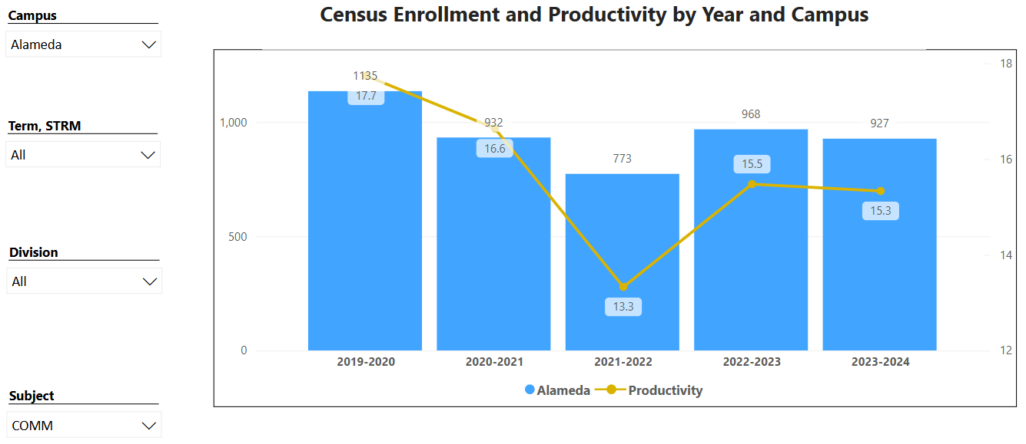
Over the past three years, enrollment in the Communication Department has shown signs of recovery following a significant drop during the 2021-2022 academic year. This decline, from 927 to 773 students, likely reflects the impact of the COVID-19 pandemic, affecting institutions globally. Enrollment increased to 836 in 2022-2023, indicating a partial recovery as more students returned to campuses and COVID restrictions eased. However, numbers slightly decreased to 827 in 2023-2024, suggesting a stabilization phase but remaining below the pre-pandemic enrollment of 1,115 in 2019-2020.

Productivity levels have fluctuated less dramatically than enrollment, maintaining relatively stable scores even during enrollment declines. This steadiness indicates consistent instructional productivity despite changing enrollment numbers. Overall, while the Alameda campus has seen an improvement in enrollment since the initial pandemic-related dip, it has yet to reach pre-pandemic levels, potentially signaling a new baseline for student numbers.

The link below shows list of course sections in your area sorted from lowest fill rate to the highest fill rate for the last three years. Consider and discuss whether the course offerings meet the needs of our students.
FillRate3YearsProgramReview.xlsx

The fill rate summary for Communication Department courses reveals variations in demand across different offerings. Some courses consistently have lower fill rates (e.g., COMM 45 with an average fill rate of approximately 58%), suggesting that the primarily in-person and hybrid modality for COMM 45 may not align with student needs or interests. In contrast, other courses, such as COMM 19, show higher fill rates, indicating stronger student demand.

These patterns suggest that certain courses might benefit from realignment. For example, courses with lower fill rates could be re-evaluated for content relevance, timing, or modality. Increasing the availability of high-demand courses, or adjusting enrollment caps to match realistic demand, could better meet student needs and improve overall enrollment productivity within the department.

Discuss any action plan to better meet student needs and demands.
The Communication Department will reevaluate low fill rate courses through curriculum assessment and modality/scheduling adjustments. We will keep an eye on student survey data in faculty observations or create new surveys to understand why certain courses have lower fill rates. This may reveal specific areas where the curriculum could be updated to increase relevance and appeal. We will also explore alternative times or modalities for low-fill-rate courses. For instance, our distance education courses overwhelmingly have stronger enrollment than in-person or hybrid.

Describe effective and innovative teaching strategies used by faculty to increase student learning and engagement.
Faculty enhance student learning and engagement through a variety of innovative strategies. These include the flipped classroom model, where students learn content outside class and engage in hands-on activities during class. Project-based learning and real-world applications help students see the relevance of studies, while gamification, digital tools, and group speech presentations make learning more interactive and fun.

How is technology used by the discipline department?
Faculty in the Communication Department use a range of technologies to enhance student learning and engagement. They use digital presentation tools like PowerPoint and Prezi, incorporate video and multimedia with platforms such as YouTube, and facilitate online discussions through Canvas and other LTI tools. Virtual meetings via Zoom enable hybrid learning, while interactive polling tools like Kahoot! engage students in real-time. Additionally, learning analytics within Canvas help faculty track student progress to support student retention and success. Together, these technologies support a flexible, interactive, and student-centered educational environment.

How does the discipline, department, or program maintain the integrity and consistency of academic standards with all methods of delivery, including face to face, hybrid, and Distance Education courses?
The Communication Department ensures academic integrity and consistency across all methods of delivery by maintaining unified curriculum standards and learning outcomes across all formats. Standardized assessments and grading rubrics ensure fair and objective evaluations, while faculty receive specialized training for distance education to uphold academic rigor. The department regularly reviews course materials and delivery methods to maintain quality, and faculty foster consistent communication and engagement with students in all formats. Technology tools support equitable access to resources and guidance, ensuring students have a comparable educational experience regardless of modality.

Curriculum
CurriQunet Meta
Please review your course outlines of record in CurriQunet META to determine if they have been updated in the past three years. Specify when your department will update, or deactivate, each one, within the next three years.
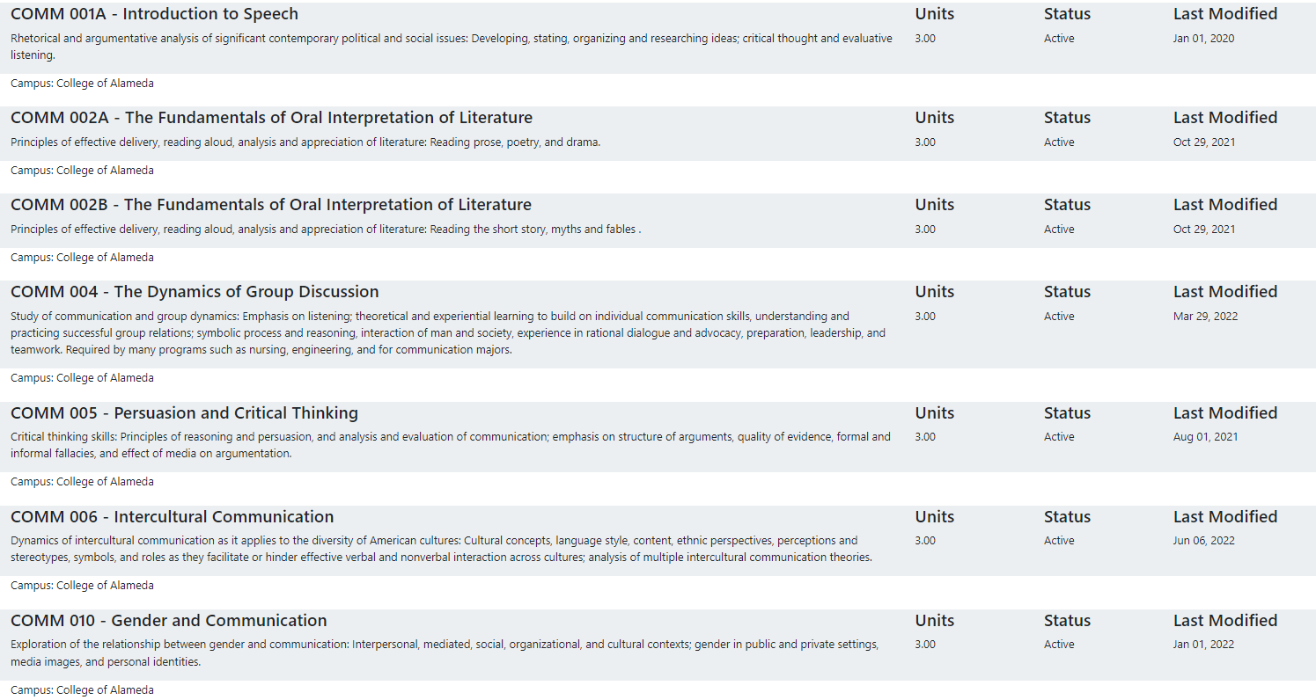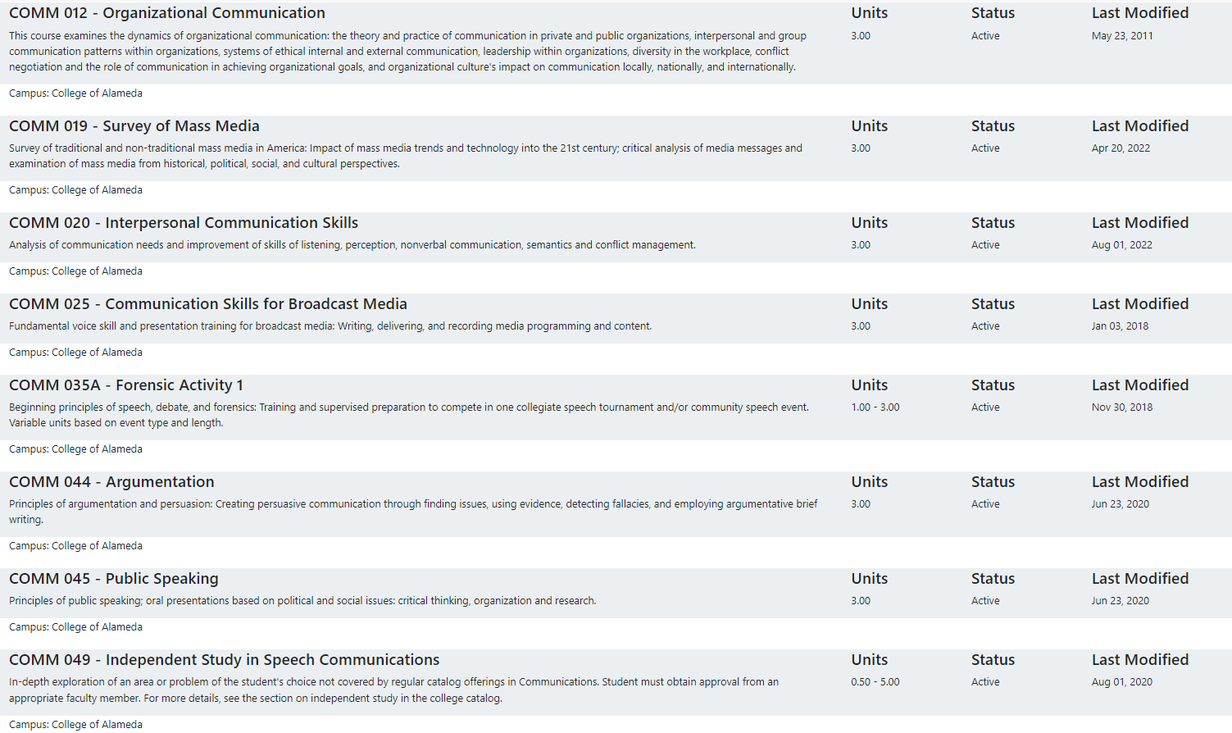

As advised by our local curriculum committee, we are waiting for upcoming Common Course Numbering work to make updates instead of doing it in pieces. This will allow us to make improvements to course content, student learning outcomes, and all areas of the course outline of record that need updating.

Please summarize the Discipline, Department or program of study plans for curriculum plans for improvement. Below, please provide details for individual course improvement. Add plans for new courses here.
Please see the note above about waiting for Common Course Numbering work.

How is your program meeting the needs of students and/or articulation with four-year institutions?
The Communication Department supports student needs and facilitates smooth articulation with four-year institutions by aligning its curriculum with transfer requirements, particularly for the CSU and UC systems. Courses focus on developing essential skills such as public speaking, critical thinking, and intercultural communication, which are valuable for both academic success and career readiness. The department collaborates with counseling colleagues to guide students on course selection and transfer requirements, ensuring they are well-prepared for further studies. Flexible course delivery, including face-to-face, hybrid, and online options, accommodate diverse student schedules. Regular updates to course content and articulation agreements help maintain alignment with four-year institutions, making it easier for students to transfer and complete education goals efficiently.

Assessment – Instructional
Student Learning Outcomes Assessment
Your Student Learning Outcomes for active courses are listed below. Please review and note any corrections or planned changes.
COMM_SLOs.pdf

SLOs will be updated in accordance with the mandated AB1111 and Common Course Number work in the months and year ahead.

Please provide a high-level summary and your program’s interpretation of your SLO findings over the past year.
Over the past year, our Student Learning Outcomes (SLO) assessment has shown that the Communication Department effectively supports student achievement in core skills, particularly in public speaking, critical thinking, and collaborative communication. While most students meet or exceed expectations in these foundational areas, our analysis indicates that some students could benefit from further emphasis on applied and context-based learning, especially in areas like intercultural communication and advanced critical analysis.

What were the most important things your department learned from assessment? Did implementation of your action plans result in better student learning?
The Communication Department’s assessments revealed that students excel in foundational skills like public speaking and critical thinking, but face challenges in applying theoretical concepts to real-world contexts, especially in intercultural and persuasive communication. This finding led to action plans focused on adding experiential learning, such as case studies and real-world scenarios, to improve practical application skills. Early results indicate that these adjustments have enhanced student engagement and their ability to analyze and apply complex concepts, aligning with our goals for academic and career readiness. Overall, these changes have contributed to a more effective learning experience.

Listed below are your programs (degrees and certificates) and the program learning outcomes (PLOs) for each. Please share your reflections on the PLOs and support from the college needed in assessing the PLOs over the next three years.
The Communication Department would benefit from increased support in several key areas. First, access to professional development in assessment methods would help faculty refine our data collection and analysis processes, ensuring our evaluations are robust and actionable. Second, support for technology tools that streamline data collection and allow for more detailed tracking of student progress would improve the efficiency and accuracy of our assessments. Lastly, dedicated time and stipends for part-time faculty to collaborate on assessment would facilitate a more consistent and reflective approach to PLO assessment.

College of Alameda Institutional Learning Outcomes (ILOs) were created to guide educational programs and services. They include:
- Problem Solving: Solve problems and make decisions in life and work using critical thinking, quantitative reasoning, community resources, and civil engagement.
- Communication and Technology: Use technology and written and oral communication to discover, develop, and relate critical ideas in multiple environments.
- Creativity: Exhibit aesthetic reflection to promote, participate and contribute to human development, expression, creativity, and curiosity.
- Diversity: Engage in respectful interpersonal communications, acknowledging ideas and values of diverse individuals that represent different ethnic, racial, cultural, and gender expressions.
- Civic Responsibility: Accept personal, civic, social and environmental responsibility in order to become a productive local and global community member.
How does your program participate in assessing the Institutional Learning Outcomes (ILOs)? If your program has not participated, how will you plan to incorporate these outcomes within your program?
The college has not participated in a coordinated assessment of ILOs. This is an area of growth for us as a college, requiring strong administrative support and coordinator with faculty leaders. We plan to include themes from the ILOs when updating our course outlines of record during upcoming Common Course Numbering work.

Course Completion
Course Completion Power BI Dashboard #1
Course Completion Power BI Dashboard #2
Institutional Set Standards
Consider your course completion rates over the past three years (% of student who earned a grade of "C" or better). Data with default filter is provided below. Use the link above to explore the data further.
How does the course completion rate for your program or discipline compare to your college’s Institutional Set Standard for course completion (70% with stretch goal of 77%)? Also discuss the retention rate for your program or discipline, compared to the college average shown in data below.
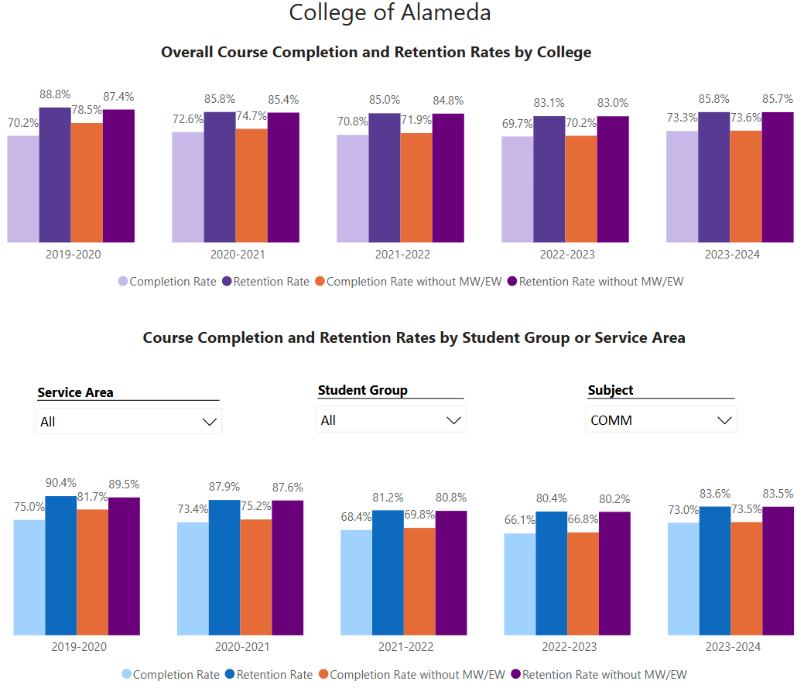
Over the past five academic years, the College of Alameda’s overall course completion rates have consistently met its Institutional Set Standard of 70. The Communication Department’s completion rates have been similar, generally meeting the standard in most years, though they fall short of the college’s stretch goal of 77%. In 2023-2024, the Communication discipline had a completion rate of 73%, which aligns with the college’s standard but remains below the aspirational target.

In terms of retention, the college-wide rates have been steadily high, reaching 85.7% in 2023-2024. The Communication discipline, however, has struggled with lower retention rates compared to the college average, although there has been gradual improvement in recent years. By 2023-2024, the retention rate for Communication rose to 73.5%, showing progress but still trailing the college’s overall retention performance. This trend suggests that while course completion in Communication aligns with institutional expectations, additional efforts may be needed to boost retention to match college-wide levels.

What has the discipline, department, or program done to improve course completion and retention rates?
To improve course completion and retention rates, the Communication Department promotes tutoring services and uses flexible teaching methods. Furthermore, community-building efforts, such partnering with counselors and connecting students with learning communities on campus fosters a supportive peer environment, which can improve motivation and persistence.

Equity Analysis
College of Alameda continues to focus on access, equity, and success. The goal is to create an inclusive environment where all students can thrive and meet their education and career goals.
Following is a brief description of equity data analysis, examining success rates of different ethnic groups (Asian, Black/African American, Hispanic/Latino, “Two or More”, “Unknown/NR”, White), age range, gender (Female, Male, Unknown Gender), and special population groups (Foster Youth, First Gen College, SAS).
Disparate Impact Analysis AY2023-24_Updated.xlsx
(look for the tab for your discipline).
Success rate data in COMM for AY2023-24 was analyzed using the PPG-1 (percentage point gap minus 1) method, comparing the success rate of the given group against the success rate of everyone else. The success rate of the following groups falls significantly below the overall success rate of 70.6% for COMM outside the statistical margin of error:

- 30 – 34 Age Range Group: 55.9% Success Rate
- Foster Youth: 32.4 % Success Rate
- Low Income Group: 68.0% Success Rate

While there are other groups whose success rates fall below the overall success rate for COMM, either the percentage point gap difference is small or, because of the small sample size, a reliable conclusion cannot be drawn.

What can your discipline, department, or program do to improve course completion for disproportionately impacted groups?
To improve course completion rates for disproportionately impacted groups, the Communication Department can continue adopting culturally responsive teaching practices and develop a more inclusive curriculum. This approach makes course content more relatable and engaging by reflecting the diverse backgrounds of students. Additionally, creating dedicated support programs, such as mentorship opportunities and discipline specific learning communities, can foster a sense of belonging and provide role models who guide students through academic challenges. Peer mentors and alumni from similar backgrounds can be instrumental in helping students stay engaged and committed to their courses.

Flexible course formats, such as online or hybrid classes, allow students with outside responsibilities to succeed, and training faculty on equity and inclusion ensures a supportive classroom environment.

Space below is provided for additional discussion of equity-impacting factors not discussed above, including those that affect dual enrollment courses and/or online/hybrid courses.
Nothing additional to report.

Degrees & Certificates Conferred
Does your program offer any degree/certificate programs? If your program does not, skip this section and continue to Engagement.
Degrees & Certificates Power BI dashboard
What has the discipline, department, or program done to improve the number of degrees and certificates awarded? Below data shows the number of degrees and certificates awarded by year, for the past three years. Use the link above to explore the data further.
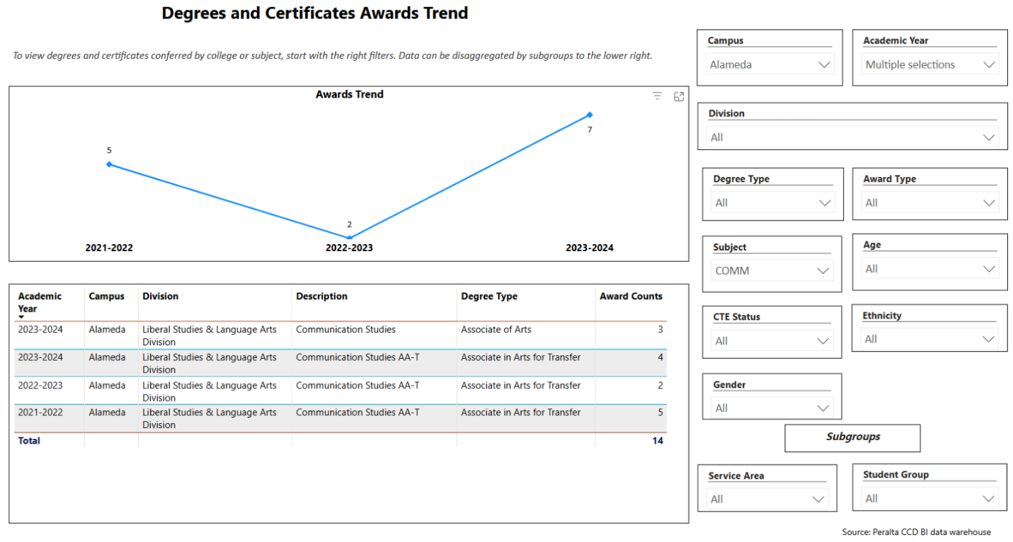
To increase the number of degrees and certificates awarded, the Communication Department can focus on continued work creating clear program pathways with support from counselors to help students stay on track toward graduation. Expanded course availability, including flexible scheduling options, ensures students can access required classes without delay. Additionally, promoting career and transfer pathways related to our degrees and certificate can motivate students by linking their academic efforts to concrete career outcomes.

Increasing the number of students who complete a certificate or degree is a shared goal across CoA’s Ed Master Plan Goals, PCCD Goals, the Chancellor’s Office Vision for Success, the Student-Centered Funding Formula, and Guided Pathways. What is planned for the next 3 years to increase the number of certificates and degrees awarded?
Over the next three years, the Department hopes to collaborate with the college as a whole to implement several initiatives to increase the number of certificates and degrees awarded, aligning with goals from the Education Master Plan, the Chancellor’s Vision for Success, and Guided Pathways. Key among these efforts is strengthening Guided Pathways, with a focus on clarifying program maps, improving onboarding, and enhancing advising, all aimed at helping students navigate their programs more efficiently. Additionally, the college can continue expanding targeted student support services such as counseling, tutoring, and financial aid assistance, with a special emphasis on supporting disproportionately impacted groups to ensure equity in completion rates.

Engagement
Discuss how faculty and staff have engaged in institutional efforts such as committees, presentations, and departmental activities. Please list the committees that full-time faculty participate in.
Our full-time faculty member, Jennifer Fowler, holds the following committee and leadership roles on campus.

Academic Senate President
District Academic Senate
Curriculum Committee
District Technology Committee Co-Chair
Zero Textbook Cost Taskforce
LGBTQIA+ Taskforce
College Council
Department Chairs
ACCJC Midterm Report Workgroup
Served on two ACCJC Visiting Teams

Discuss how faculty and staff have engaged in community activities, partnerships and/or collaborations.
This is an area of growth for our department. We used to maintain a strong working relationship with the American Association of University Women (AAUW), and hosted several events with the over the years. However due to COVID and changes in leadership, this partnership waned illustrating a need to reconnect or discover new community partnerships and collaborations.

Discuss how adjunct faculty members are included in departmental training, discussions, and decision-making.
Adjunct faculty are included in departmental discussions and decision-making. Open lines of communication are established via email to help them stay informed about department, cluster, or college initiatives. They are regularly invited to contribute to curriculum development, updates, or schedule development discussions.

Prioritized Resource Requests Summary
In the boxes below, please add resource requests for your program. If there are no resource requested, leave the boxes blank.
Resource Category | Description/Justification | Full-Time Equivalent Percentage | Salary Grade (if applicable)
Personnel: Classified Staff | N/A
Personnel: Student Worker | N/A
Personnel: Part Time Faculty | N/A
Personnel: Full Time Faculty | N/A
Personnel: Full Time Faculty, future anticipated need | N/A

Resource Category | Description/Justification | Total Estimated Cost
Professional Development: Department wide PD needed | N/A
Professional Development: Personal/Individual PD needed | N/A

Prioritized Resource Requests Summary - Continued

Resource Category | Description/Justification | Total Estimated Cost
Supplies: Software | N/A
Supplies: Books, Magazines, and/or Periodicals | N/A
Supplies: Instructional Supplies | Typical instructional supplies to support on-campus and distance education courses. | $2000
Supplies: Non-Instructional Supplies | N/A
Supplies: Library Collections | N/A

Resource Category | Description/Justification | Total Estimated Cost
Technology & Equipment: New | Laptop and Office Printer | $3000
Technology & Equipment: Replacement

Prioritized Resource Requests Summary - Continued

Resource Category | Description/Justification | Total Estimated Cost
Facilities: Classrooms | N/A
Facilities: Offices | N/A
Facilities: Labs | N/A
Facilities: Other | N/A

Resource Category | Description/Justification | Total Estimated Cost
Library: Library materials | N/A
Library: Library collections | N/A

Resource Category | Description/Justification | Total Estimated Cost
OTHER | N/A

