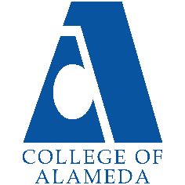
2024-25 Program Review – Instructional –
Humanities

Lead Author
Jennifer Fowler

Program Overview
Please verify the mission statement for your program. If there is no mission statement listed, please add it here.
Mission Statement
Humanities is an interdisciplinary field that involves the study of creative human thought and expression. The main objective of studying Humanities at College of Alameda is to examine significant cultural artifacts, enduring artistic creations, and touchstone ideas and beliefs from a variety of scholarly and personal perspectives. As an integral part of general education, Humanities encourages students to examine diverse forms of creativity and innovation to gain perspective on their own lives and the world around them. COA courses in the Humanities typically explore such fields as the visual arts, literature, media, popular culture, folklore, storytelling, humor, games, religion, music, dance, cuisine, fashion, tourism, and technology.
Humanities – A.A. Degree Program Learning Outcomes
- Increase critical understanding of the aesthetics of human-made environments.
- Analyze selected works of creative expression in relation to various historical and cultural contexts.
- Synthesize elements from a wide range of disciplines to appreciate and evaluate artworks, ideas, and performances from around the world.

List your Faculty and/or Staff, and indicate whether they are full-time or part-time.
Matthew Goldstein, Full-Time
Lisa Arellano, Part-Time
Cassie Lipowitz, Part-Time
Kendra Pearson, Part-Time
Christopher Rubin, Part-Time
Avy Valladares, Part-Time

Program Goal | Expand the number of courses offered. This will allow our department to increase our reach and allow students to use our courses to meet diverse personal and academic goals.
Status: In-Progress or Complete?  If complete, give a brief description of how you measured the goal completion. | In-Progress. The department made great strides forward adding HUMAN 60 Introduction to LGBTQ Studies to our Spring schedule course offerings. We will continue to monitor the fiscal outlook and advocate for additional FTEF to add more courses and sections.
Which college or district goal is aligned with your program goal? | College: Leverage existing resources to maximize academic opportunities for all students and provide accessible and inclusive physical and virtual learning environments that promote equitable academic excellence.  College: Develop and offer curriculum and learning that is innovative, with industry standards and labor market demands.  District: Advance Student Access, Equity, and Success

Program Goal | N/A
Status: In-Progress or Complete?  If complete, give a brief description of how you measured the goal completion. | N/A
Which college or district goal is aligned with your program goal? | N/A

Program Goal | N/A
Status: In-Progress or Complete?  If complete, give a brief description of how you measured the goal completion. | N/A
Which college or district goal is aligned with your program goal? | N/A

Describe your current utilization of facilities, including labs and other space
The Humanities department utilizes a mix of on-campus and the Canvas learning management system to support its blend of in-person and distance education courses. On-campus classrooms are used for courses that benefit from in-person instruction. Counseling, tutoring centers, and career services are available both in-person and online.

Enrollment Trends
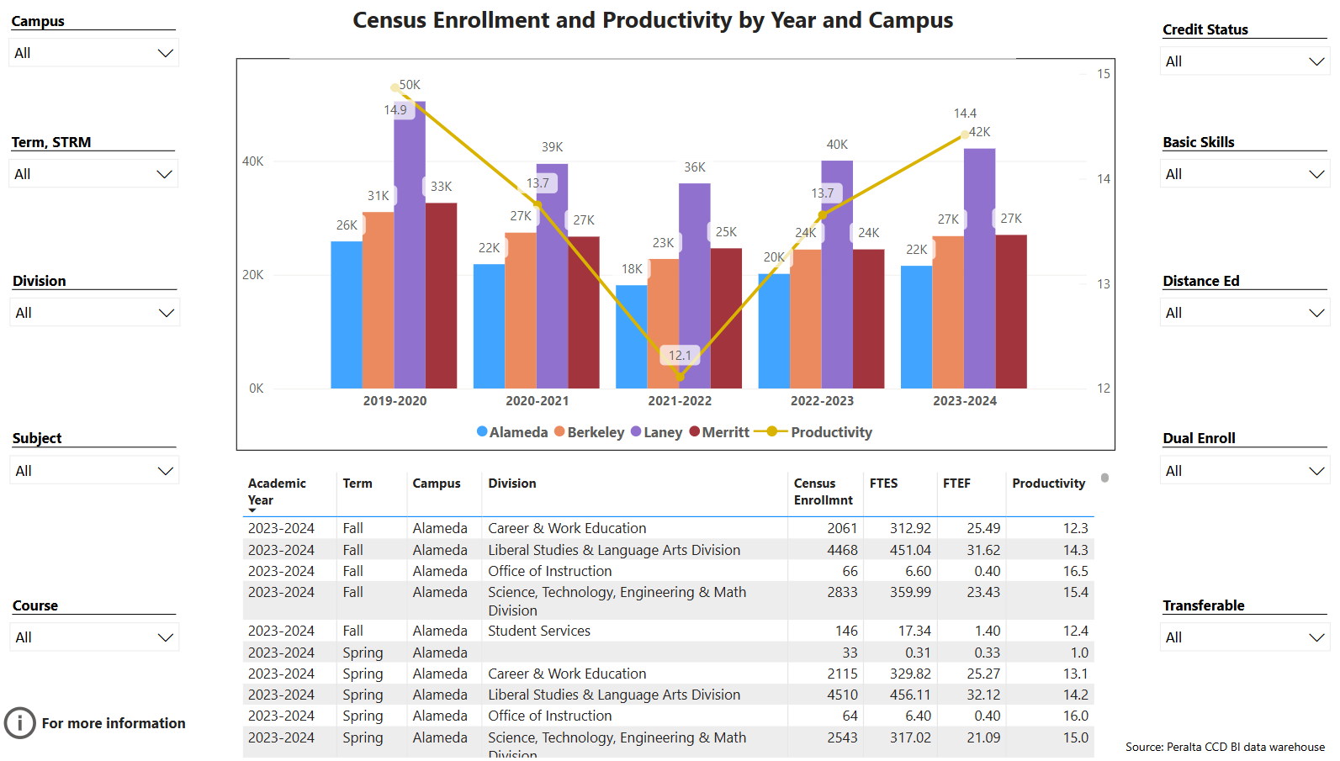
Enrollment Trends Power BI dashboard
Discuss enrollment trends over the past three years.
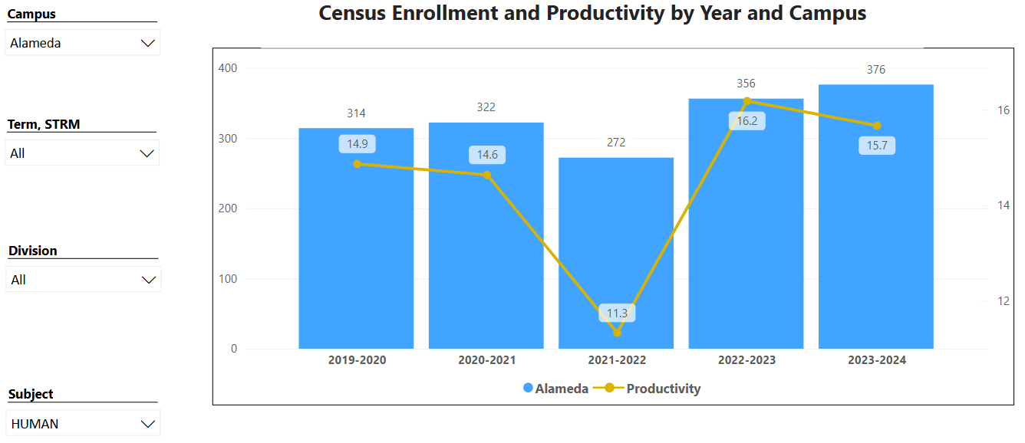
Over the past three years, enrollment in the Humanities department showed a strong rebound following COVID induced enrollment lows in 2021-2022, where numbers dropped to 272 students. Enrollment significantly increased in 2022-2023 to 356 students. Growth continued into 2023-2024, reaching 376 students. This upward trend indicates effective departmental course scheduling and faculty engagement with students throughout the pandemic.

Productivity trends mirror enrollment changes, with the lowest productivity (11.3) also recorded in 2021-2022. The following year, productivity surged to 16.2, aligning with the rise in student enrollment. However, in 2023-2024, productivity slightly decreased to 15.7 despite further enrollment growth, which may suggest evaluating course scheduling to better meet student needs.

The link below shows list of course sections in your area sorted from lowest fill rate to the highest fill rate for the last three years. Consider and discuss whether the course offerings meet the needs of our students.
FillRate3YearsProgramReview.xlsx

Fill rates across courses range from 60% to over 100%, with an average fill rate of 73%. While a 73% average suggests sound demand, courses with lower fill rates, such as those in the 60% range, may warrant examination for factors such as modality or scheduling issues. The higher fill rates (80% and above) in multiple courses reflect strong demand, suggesting that these courses align well with student needs. The course with a 105% fill rate indicates excess demand, implying that additional sections or expanded capacity might be beneficial for high-demand courses if sustained overtime.

Discuss any action plan to better meet student needs and demands.
We will have departmental discussions about fill rates and evaluate whether it can be used to inform class schedule decisions.

Describe effective and innovative teaching strategies used by faculty to increase student learning and engagement.
Humanities faculty use a variety of innovative teaching strategies that cater to diverse learning styles. Contemporary, real-world issues and culturally relevant materials are incorporated into instruction to make content relatable and engaging. Reflection activities, such as journals and other self-assessments, help students internalize and understand their learning progress. Faculty incorporate open educational resources in courses, where pedagogically appropriate, to ease textbook cost burdens for students.

How is technology used by the discipline department?
Technology plays a crucial role in facilitating learning in the department. Canvas is the central hub for course materials, announcements, assignments, and grades. Zoom is used for office hours and to support instructional needs that can be delivered virtually. Faculty incorporate relevant videos and digital media to provide context and varied perspectives on Humanities topics. These tools bridge the gap between theoretical material in the discipline and interactive learning, ensuring that students remain engaged and supported in their studies.

How does the discipline, department, or program maintain the integrity and consistency of academic standards with all methods of delivery, including face to face, hybrid, and Distance Education courses?
Maintaining the integrity and consistency of academic standards in the department, regardless of course modality, is paramount. All courses have well-defined, standardized learning objectives, ensuring all students achieve the same academic outcomes. Distance education courses are designed with a rigorous framework that emphasizes engagement, accessibility, and clear expectations. The CVC-OEI Online Course Design rubric is used as a guide where appropriate to ensure courses meet best practices in online course design principles. Faculty consistently take opportunities to engage in ongoing professional development to stay current with best practices to maintain integrity in all teaching environments.

Curriculum
CurriQunet Meta
If necessary, use the CurriQunet META link to review the details of curriculum. Some summary information is provided below.
Please review your course outlines of record in CurriQunet META to determine if they have been updated in the past three years. Specify when your department will update, or deactivate, each one, within the next three years.
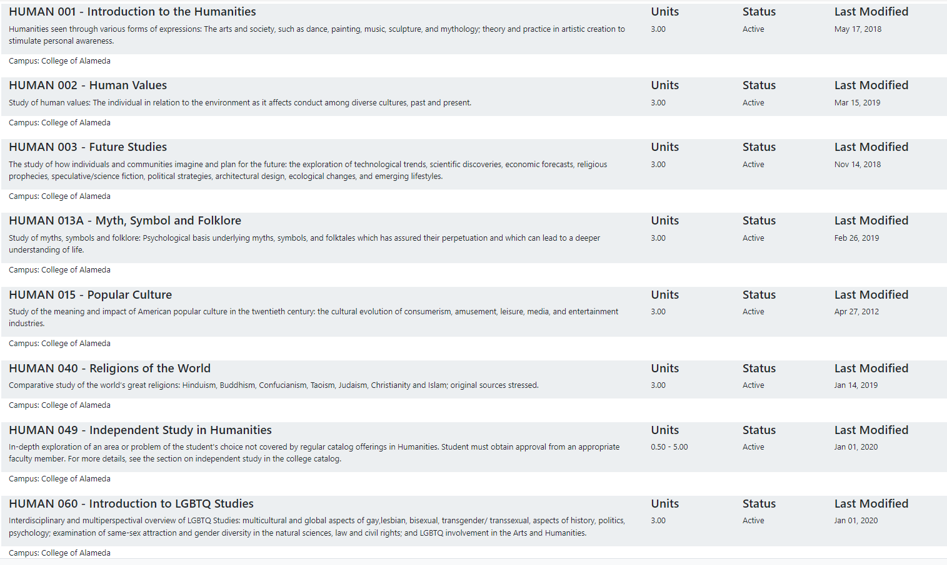

As advised by our local curriculum committee, we are waiting for upcoming Common Course Numbering work to make updates instead of doing it in pieces. This will allow us to make improvements to course content, student learning outcomes, and all areas of the course outline of record that need updating.

Please summarize the Discipline, Department or program of study plans for curriculum plans for improvement. Below, please provide details for individual course improvement. Add plans for new courses here.
Please see the note above about waiting for Common Course Numbering work.

How is your program meeting the needs of students and/or articulation with four-year institutions?
The Humanities department meets student needs by ensuring articulation with four-year institutions is achieved through alignment with transfer requirements and relevant curriculum. This ensures that credits will transfer smoothly to four-year institutions, satisfying general education or elective requirements for a wide range of majors.

Assessment – Instructional
Student Learning Outcomes Assessment
Your Student Learning Outcomes for active courses are listed below. Please review and note any corrections or planned changes.
HUMAN_SLOs.pdf

All SLOs will be updated in accordance with the mandated AB1111 and Common Course Number work in the months and year ahead.

Please provide a high-level summary and your program’s interpretation of your SLO findings over the past year.
With the lead HUMAN faculty member on release for senate work and high turnover among part-timers in the discipline, SLO assessment has fallen behind schedule. The department expects to return to rigorous and timely SLO analysis in the upcoming academic year, when the lead faculty member is expected to return to instruction, and the roster of part-time faculty members becomes more settled

What were the most important things your department learned from assessment? Did implementation of your action plans result in better student learning?
Historically, assessment has led to valuable refinements both to the language of the SLOs themselves and, more importantly, to the content and delivery of class materials. Implementation of, e.g., a more thoroughgoing Canvas orientation following the assessment of Humanities 1 SLO No. 1 has in subsequent semesters led to stronger student performances on “objective” examinations.

Listed below are your programs (degrees and certificates) and the program learning outcomes (PLOs) for each. Please share your reflections on the PLOs and support from the college needed in assessing the PLOs over the next three years.
Program Learning Outcomes

Upon successful completion of this program, students will be able to:
- Increase critical understanding of the aesthetics of human-made environments
- Analyze selected works of creative expression in relation to various historical and cultural contexts
- Synthesize elements from a wide range of disciplines to appreciate and evaluate artworks, ideas, and performances from around the world

The Humanities Department PLOs encourage a holistic, interconnected view of learning, where students draw from various disciplines to appreciate and critique creative outputs. To meet the interdisciplinary demands of these PLOs, access to a range of resources is essential. This includes art collections, historical databases, and cross-disciplinary case studies. Support in curating and maintaining a collection of diverse multimedia resources would enrich the curriculum and provide students with a global perspective.

College of Alameda Institutional Learning Outcomes (ILOs) were created to guide educational programs and services. They include:
- Problem Solving: Solve problems and make decisions in life and work using critical thinking, quantitative reasoning, community resources, and civil engagement.
- Communication and Technology: Use technology and written and oral communication to discover, develop, and relate critical ideas in multiple environments.
- Creativity: Exhibit aesthetic reflection to promote, participate and contribute to human development, expression, creativity, and curiosity.
- Diversity: Engage in respectful interpersonal communications, acknowledging ideas and values of diverse individuals that represent different ethnic, racial, cultural, and gender expressions.
- Civic Responsibility: Accept personal, civic, social and environmental responsibility in order to become a productive local and global community member.
How does your program participate in assessing the Institutional Learning Outcomes (ILOs)? If your program has not participated, how will you plan to incorporate these outcomes within your program?
Our college has not participated in a coordinated assessment of ILOs. This is an area of growth for us as a college, requiring strong administrative support and coordinator with faculty leaders. We plan to include themes from the ILOs when updating our course outlines of record during upcoming Common Course Numbering work.

Course Completion
Course Completion Power BI Dashboard #1
Course Completion Power BI Dashboard #2
Institutional Set Standards
Consider your course completion rates over the past three years (% of student who earned a grade of "C" or better). Data with default filter is provided below. Use the link above to explore the data further.
How does the course completion rate for your program or discipline compare to your college’s Institutional Set Standard for course completion (70% with stretch goal of 77%)? Also discuss the retention rate for your program or discipline, compared to the college average shown in data below.
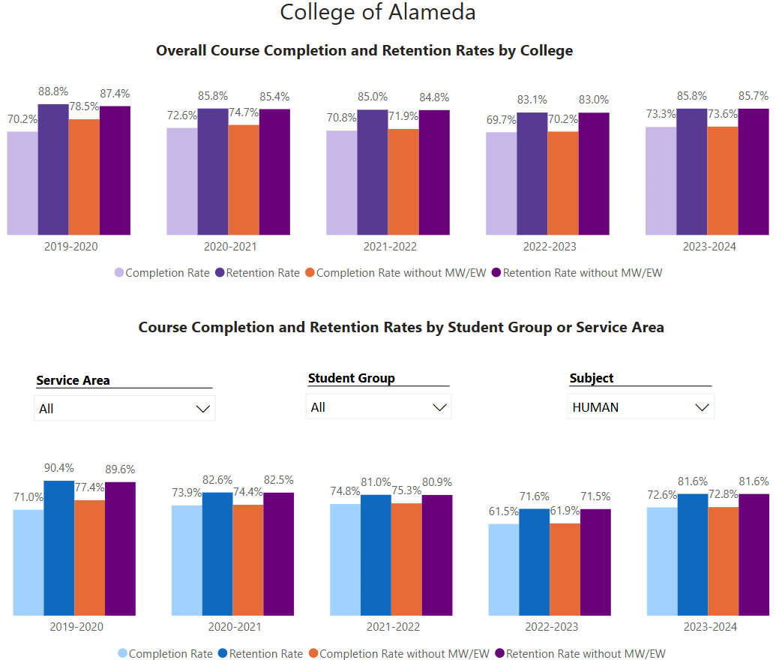
Humanities course completion rates generally meet the Institutional Set Standard of 70%, though they often fall short of the 77% stretch goal. However, a notable drop occurred in 2022-2023, with a
Humanities retention rates have mostly lagged behind the college-wide average, with the exception of the 2023-2024 academic year. Retention rates also dropped significantly in 2022-2023 to 61.9%, compared to the college's 70.2%. The 2023-2024 academic year showed improvement, with Humanities retention rising to 72.8%, now above the college-wide average. This suggests that while recent efforts may be yielding positive results, further investigation into factors impacting retention and completion—especially the dip in 2022-2023—could help strengthen overall program performance.

What has the discipline, department, or program done to improve course completion and retention rates?
To improve course completion and retention rates, the Humanities Department has focused on strategic scheduling and flexible course modalities. Recognizing that students’ needs and preferences have evolved, we adjusted class schedules to better align with students’ work and family obligations. We’ve slowly and strategically added more on-campus classes back to the course schedule, keeping an eye on broader college-wide enrollment trends and a growing demand for more in-person classes.

Equity Analysis
College of Alameda continues to focus on access, equity, and success. The goal is to create an inclusive environment where all students can thrive and meet their education and career goals.
Following is a brief description of equity data analysis, examining success rates of different ethnic groups (Asian, Black/African American, Hispanic/Latino, “Two or More”, “Unknown/NR”, White), age range, gender (Female, Male, Unknown Gender), and special population groups (Foster Youth, First Gen College, SAS).
Disparate Impact Analysis AY2023-24_Updated.xlsx
(look for the tab for your discipline).
Success rate data in HUMAN for AY2023-24 was analyzed using the PPG-1 (percentage point gap minus 1) method, comparing the success rate of the given group against the success rate of everyone else. The success rate of the following groups falls significantly below the overall success rate of 72.2% for HUMAN outside the statistical margin of error:

- 35-54 Age Range Group: 52.9% Success Rate
- Foster Youth: 37.5% Success Rate
- Low Income: 68.1% Success Rate
- Not SAS: 71.0% Success Rate

While there are other groups whose success rates fall below the overall success rate for HUMAN, either the percentage point gap difference is small or, because of the small sample size, a reliable conclusion cannot be drawn.

What can your discipline, department, or program do to improve course completion for disproportionately impacted groups?
To improve course completion rates for disproportionately impacted groups, the Humanities Department can implement targeted strategies focusing on academic support, culturally relevant curriculum, and community-building initiatives. This can foster a greater sense of belonging and motivation to succeed, as students see their own experiences reflected in course content and opportunities to connect with the broader community at the college.

Space below is provided for additional discussion of equity-impacting factors not discussed above, including those that affect dual enrollment courses and/or online/hybrid courses.
Continuing to put on new or reworked courses that foreground the experiences and interests of underserved and marginalized communities—the reactivation of HUMAN 60: Queer Studies is a recent, successful example—appears to be the surest way to address equity shortcomings in the discipline. Offering more direct support via the development of Humanities-specific tutoring, Humanities student affinity groups, and learning communities—perhaps in coordination with SALAM, PUENTE, and UMOJA—might also prove effective.

Degrees & Certificates Conferred
Does your program offer any degree/certificate programs? If your program does not, skip this section and continue to Engagement.
Degrees & Certificates Power BI dashboard
What has the discipline, department, or program done to improve the number of degrees and certificates awarded? Below data shows the number of degrees and certificates awarded by year, for the past three years. Use the link above to explore the data further.
The faculty lead attempted to develop an ADT in Humanities and ultimately got put on hold at the state level—the state argued that Humanities enrollments across California hadn’t yet reached the critical mass necessary to make a HUMAN ADT a worthwhile investment. But Humanities courses continue to be an important and oft-selected part of students’ general education requirements as they pursue Liberal Arts degrees (the most commonly awarded degree at the college).

Increasing the number of students who complete a certificate or degree is a shared goal across CoA’s Ed Master Plan Goals, PCCD Goals, the Chancellor’s Office Vision for Success, the Student-Centered Funding Formula, and Guided Pathways. What is planned for the next 3 years to increase the number of certificates and degrees awarded?
Collaboration with learning communities and the development of a Humanities certificate—perhaps in association with the seven CSU Humanities departments—are central components of the department’s plan to increase the number or degrees and certificates awarded over the next three years.

Engagement
Discuss how faculty and staff have engaged in institutional efforts such as committees, presentations, and departmental activities. Please list the committees that full-time faculty participate in.
Although it has but a single fulltime faculty member, Humanities has played a significant role in a variety of committees, shared-governance bodies, and extracurricular campus work. Curriculum Committee, Academic Seante, district- and college-level hiring committees, and Guided Pathways workgroups are just a few of the sites of HUMAN Dept. involvement.

Discuss how faculty and staff have engaged in community activities, partnerships and/or collaborations.
Humanities faculty have participated in local college nights, collaborated with the Office of International Education to staff contract education classes, and encouraged visits to their classrooms from representatives from student services and student health offices. Humanities faculty have also been involved in Tasty Tuesday food distribution and registration week tabling.

Discuss how adjunct faculty members are included in departmental training, discussions, and decision-making.
Adjunct faculty are included in departmental discussions and decision-making. Open lines of communication are established via email to help them stay informed about department, cluster, or college initiatives. They are regularly invited to contribute to curriculum development, updates, or schedule development discussions.

Prioritized Resource Requests Summary
In the boxes below, please add resource requests for your program. If there are no resource requested, leave the boxes blank.
Resource Category | Description/Justification | Full-Time Equivalent Percentage | Salary Grade (if applicable)
Personnel: Classified Staff | N/A
Personnel: Student Worker | N/A
Personnel: Part Time Faculty | N/A
Personnel: Full Time Faculty | N/A
Personnel: Full Time Faculty, future anticipated need | N/A

Resource Category | Description/Justification | Total Estimated Cost
Professional Development: Department wide PD needed | N/A
Professional Development: Personal/Individual PD needed | N/A

Prioritized Resource Requests Summary - Continued

Resource Category | Description/Justification | Total Estimated Cost
Supplies: Software | N/A
Supplies: Books, Magazines, and/or Periodicals | N/A
Supplies: Instructional Supplies | Typical instructional supplies to support on-campus and distance education courses. | $500
Supplies: Non-Instructional Supplies | N/A
Supplies: Library Collections | N/A

Resource Category | Description/Justification | Total Estimated Cost
Technology & Equipment: New | N/A
Technology & Equipment: Replacement | N/A

Prioritized Resource Requests Summary - Continued

Resource Category | Description/Justification | Total Estimated Cost
Facilities: Classrooms | N/A
Facilities: Offices | N/A
Facilities: Labs | N/A
Facilities: Other | N/A

Resource Category | Description/Justification | Total Estimated Cost
Library: Library materials | N/A
Library: Library collections | N/A

Resource Category | Description/Justification | Total Estimated Cost
OTHER | N/A

