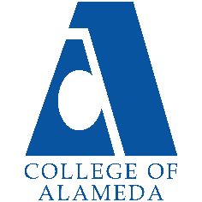
2024-25 Program Review – Instructional –
Philosophy

Lead Author
Jennifer Fowler

Program Overview
Mission Statement
Philosophy is a discipline that examines fundamental questions about everyday life and the natural world. Philosophy classes at College of Alameda will prepare students to:
- Demonstrate knowledge of the major questions, central methods, issues, figures, and arguments in the core areas of philosophy and its history.
- Use formal and informal logic to identify, construct, analyze, evaluate, and respond to arguments.
- Deal with value questions with clarity, fairness, and open-mindedness.
- Make connections with philosophical traditions and everyday life, including their professional, family, and social lives.
- Clearly articulate ideas and arguments in writing and speech.
By studying philosophy, students will gain wisdom, clarity, and awareness about a wide variety of philosophical issues that arise within different cultural and historical contexts.
No Degrees or Certificates are on record for Philosophy.

List your Faculty and/or Staff, and indicate whether they are full-time or part-time.
David Peterson, part-time faculty. We have no full-time faculty or ability to hire more part-time faculty due to fiscal challenges and absence of more FTEF to allocate.

Program Goal | Expand the number of courses offered. This will allow our department to increase our reach and allow students to use our courses to meet diverse personal and academic goals.
Status: In-Progress or Complete?  If complete, give a brief description of how you measured the goal completion. | In-Progress. Fiscal challenges, reductions in FTEF, and lack of new full-time faculty positions impede the ability to expand the number of courses offered.
Which college or district goal is aligned with your program goal? | College: Develop and offer curriculum and learning that is innovative, with industry standards and labor market demands.  District: Advance Student Access, Equity, and Success.

Program Goal | N/A: The department cannot establish any new goals until our fiscal climate stabilizes and we’re able to grow our course offerings beyond the single course we’ve been able to offer each term. More funding and FTEF from the District and College is necessary.
Status: In-Progress or Complete?  If complete, give a brief description of how you measured the goal completion. | N/A
Which college or district goal is aligned with your program goal? | N/A

Program Goal | N/A: The department cannot establish any new goals until our fiscal climate stabilizes and we’re able to grow our course offerings beyond the single course we’ve been able to offer each term. More funding and FTEF from the District and College is necessary.
Status: In-Progress or Complete?  If complete, give a brief description of how you measured the goal completion. | N/A
Which college or district goal is aligned with your program goal? | N/A

Describe your current utilization of facilities, including labs and other space
Currently, our utilization of facilities is minimal, as we exclusively teach online classes because they are significantly more likely to garner high enrollment than on-campus courses. This format allows us to operate without the need for physical labs or classroom space, relying on Canvas digital materials for all instructional activities.

Enrollment Trends
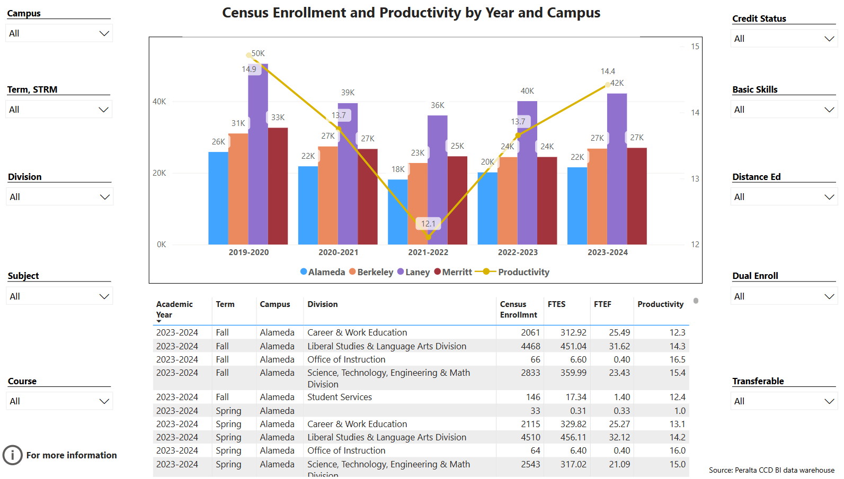
Enrollment Trends Power BI dashboard
Discuss enrollment trends over the past three years.
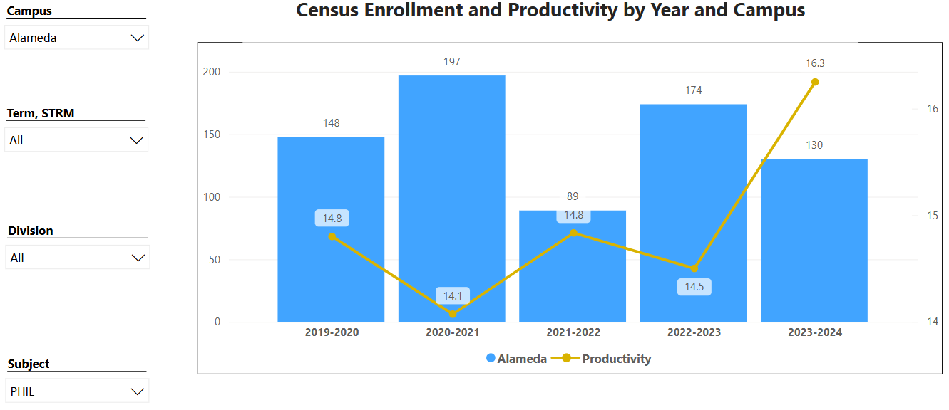

While enrollment fluctuates with notable highs in 2020-2021 and 2022-2023, productivity has been on an upward trend, especially from 2021-2022 onwards. The recent rise in productivity in 2023-2024 reflects increased enrollment at College of Alameda and Peralta Community College District as a whole. It also illustrates there are more students enrolled per section of each course offered with classes at or near full enrollment, and an ability to retain those students until the end.

The link below shows list of course sections in your area sorted from lowest fill rate to the highest fill rate for the last three years. Consider and discuss whether the course offerings meet the needs of our students.
FillRate3YearsProgramReview.xlsx

Fill rates for our sole Philosophy class offered at the college, PHIL 1, shows consistency across various terms from 2021 to 2024. This stability benefits students who need Philosophy in an online format for graduation requirements.

Discuss any action plan to better meet student needs and demands.
While the Philosophy courses at College of Alameda are generally have reasonable enrollment fill rates, improvement can be made with more FTEF and including in-person or hybrid options. However as mentioned, with severely limited FTEF and the ability to only offer one class per semester, we have to remain online because we know the course will fill and not get cut.

Describe effective and innovative teaching strategies used by faculty to increase student learning and engagement.
Since our courses remain entirely online, our faculty use diverse and innovative strategies to increase student learning engagement. Short quizzes, reflections, or low-stakes tests provide continuous feedback to students and faculty, allowing adjustments to teaching and learning strategies in real-time. Faculty provide multiple ways to learn (visual, auditory, kinesthetic) and express knowledge (written, oral, project-based), allowing students to engage with material in ways that suit their strengths. Zero textbook cost course materials are used to reduce financial barriers for students.

How is technology used by the discipline department?
Technology plays a crucial role in facilitating learning in the department that remains fully online. Canvas is the central hub for course materials, announcements, assignments, and grades. Zoom is used for office hours and instructional needs beyond the asynchronous learning environment. Faculty incorporate relevant videos and interactive media to provide historical context and varied perspectives on philosophical topics. These tools bridge the gap between theoretical material in the Philosophy discipline and interactive learning, ensuring that students remain engaged and supported in their studies.
How does the discipline, department, or program maintain the integrity and consistency of academic standards with all methods of delivery, including face to face, hybrid, and Distance Education courses?
In a department that only offers one course online, maintaining the integrity and consistency of academic standards in Distance Education (DE) courses is paramount. DE courses have well-defined, standardized learning objectives that align with in-person course versions, ensuring all students achieve the same academic outcomes. DE courses are designed with a rigorous framework that emphasizes engagement, accessibility, and clear expectations. The CVC-OEI Online Course Design rubric is used as a guide and tool to ensure courses meet high-quality design principles. Our faculty member consistently takes opportunities to engage in ongoing professional development on DE pedagogy to stay current with best practices and tools to maintain integrity in online teaching.

Curriculum
CurriQunet Meta
Please review your course outlines of record in CurriQunet META to determine if they have been updated in the past three years. Specify when your department will update, or deactivate, each one, within the next three years.
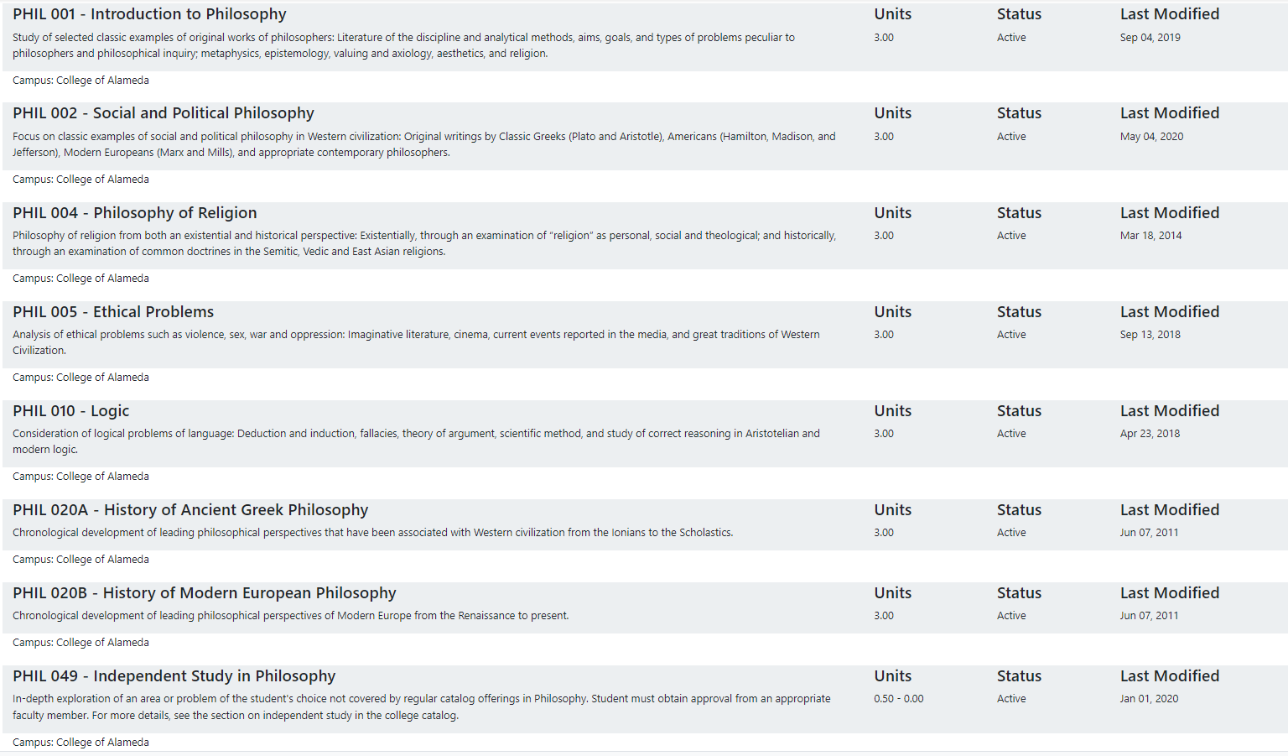

Our course has not updated our course outlines of record. As a Department Chair over Philosophy that does not have equivalency to teach the discipline, I hesitate to make curriculum changes and updates unless absolutely needed. We need financial support from the college to provide our part-time faculty funding for the time and resources necessary to make updates.

Please summarize the Discipline, Department or program of study plans for curriculum plans for improvement. Below, please provide details for individual course improvement. Add plans for new courses here.
We are waiting for the upcoming Common Course Numbering work we are required to engage in over the next year or two to make all major updates at once instead of doing it in pieces. This will allow us to make improvements to course content, student learning outcomes, and all areas of the course outline of record that need updating.

How is your program meeting the needs of students and/or articulation with four-year institutions?
As a department that offers a single general education course (PHIL 1), meeting student needs and ensuring articulation with four-year institutions is achieved through alignment with transfer requirements and ensuring relevant curriculum. PHIL 1 is designed to meet the general education requirements that align with common transfer pathways, such as the Intersegmental General Education Transfer Curriculum (IGETC) or the CSU General Education Breadth requirements. This ensures that credits will transfer smoothly to four-year institutions, satisfying general education or elective requirements. Faculty also focus on reflect current topics and themes that resonate with students, which includes exploring contemporary ethical issues or logical reasoning skills broadly valuable for a wide range of majors.

Assessment – Instructional
Student Learning Outcomes Assessment
Your Student Learning Outcomes for active courses are listed below. Please review and note any corrections or planned changes.
PHIL_SLOs.pdf

All SLOs will be updated in accordance with the mandated AB1111 and Common Course Number work in the months and year ahead.

Please provide a high-level summary and your program’s interpretation of your SLO findings over the past year.
Over the past year, our program's assessment of Student Learning Outcomes (SLOs) has provided valuable insights into student achievement and areas for improvement. Overall, our findings indicate that students are meeting or exceeding expectations in critical areas, such as analytical thinking, written communication, and application of key concepts. This reflects the effectiveness of our instructional strategies and curriculum design in fostering these core competencies.

What were the most important things your department learned from assessment? Did implementation of your action plans result in better student learning?
By analyzing assessment data, we learned which Philosophy concepts students excelled in and which presented challenges. This analysis included both quantitative data and qualitative feedback from students, providing a comprehensive view of learning success. Faculty use this data to review assessments and make course adjustments in future semester to lead to better attainment of SLOs.

Listed below are your programs (degrees and certificates) and the program learning outcomes (PLOs) for each. Please share your reflections on the PLOs and support from the college needed in assessing the PLOs over the next three years.
Philosophy does not have degrees and certificates, but the steady enrollment growth and productivity in our discipline suggests that students find values in our broad program learning goals, allowing students to gain wisdom, clarity, and awareness about a wide variety of philosophical issues that arise within different cultural and historical contexts.

College of Alameda Institutional Learning Outcomes (ILOs) were created to guide educational programs and services. They include:
- Problem Solving: Solve problems and make decisions in life and work using critical thinking, quantitative reasoning, community resources, and civil engagement.
- Communication and Technology: Use technology and written and oral communication to discover, develop, and relate critical ideas in multiple environments.
- Creativity: Exhibit aesthetic reflection to promote, participate and contribute to human development, expression, creativity, and curiosity.
- Diversity: Engage in respectful interpersonal communications, acknowledging ideas and values of diverse individuals that represent different ethnic, racial, cultural, and gender expressions.
- Civic Responsibility: Accept personal, civic, social and environmental responsibility in order to become a productive local and global community member.
How does your program participate in assessing the Institutional Learning Outcomes (ILOs)? If your program has not participated, how will you plan to incorporate these outcomes within your program?
Our college has not participated in the coordinated assessment of ILOs for years. We plan to include themes from the ILOs when updating our course outlines of record during upcoming Common Course Numbering work.

Course Completion
Course Completion Power BI Dashboard #1
Course Completion Power BI Dashboard #2
Institutional Set Standards
Consider your course completion rates over the past three years (% of student who earned a grade of "C" or better). Data with default filter is provided below. Use the link above to explore the data further.
How does the course completion rate for your program or discipline compare to your college’s Institutional Set Standard for course completion (70% with stretch goal of 77%)? Also discuss the retention rate for your program or discipline, compared to the college average shown in data below.
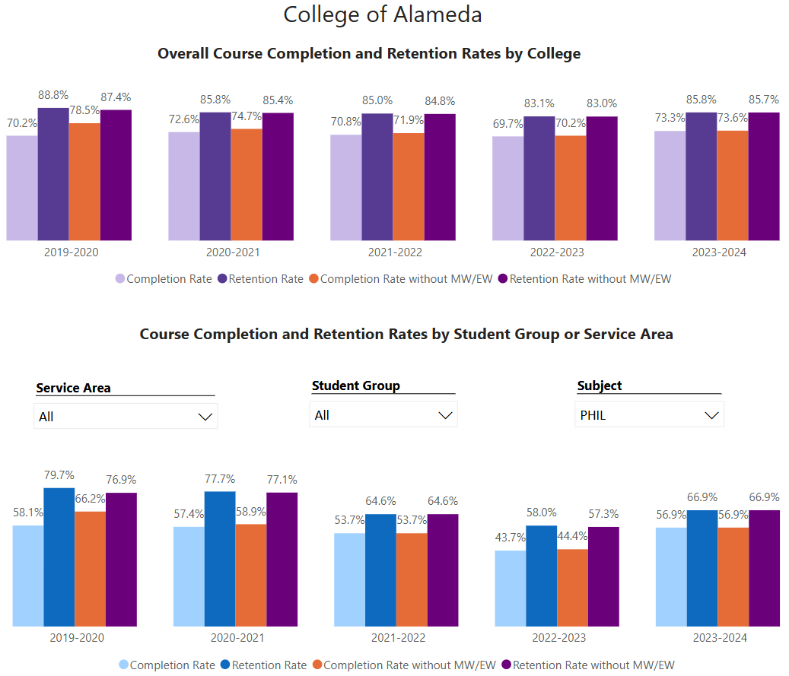

The Philosophy course completion rate is consistently below both the set standard and stretch goal for College of Alameda. Additionally, the Philosophy retention rates are generally lower than the college average. For example, in 2023-2024, the college retention rate is approximately 85.7%, whereas Philosophy retention is 66.9%.

There are several possible reasons this may be the case. Philosophy often requires strong critical thinking, abstract reasoning, and writing skills. Students who may not have had substantial prior exposure to these skills might find Philosophy courses particularly challenging. If students enroll in Philosophy without an expectation of the level of difficulty or the demands of critical reading and writing, they may be more likely to drop out or struggle to complete assignments, affecting both retention and completion rates.

What has the discipline, department, or program done to improve course completion and retention rates?
Improving course completion and retention rates in Philosophy has required a multifaceted approach to support students academically. Faculty are dedicated to creating more engaging and accessible course materials, and offering additional resources tailored to students’ diverse learning needs. Faculty also break down complex assignments or modules in Canvas into smaller, scaffolded tasks that allow students to gradually build competence.

Equity Analysis
College of Alameda continues to focus on access, equity, and success. The goal is to create an inclusive environment where all students can thrive and meet their education and career goals.
Following is a brief description of equity data analysis, examining success rates of different ethnic groups (Asian, Black/African American, Hispanic/Latino, “Two or More”, “Unknown/NR”, White), age range, gender (Female, Male, Unknown Gender), and special population groups (Foster Youth, First Gen College, SAS).
Disparate Impact Analysis AY2023-24_Updated.xlsx
(look for the tab for your discipline).
Success rate data in PHIL for AY2023-24 was analyzed using the PPG-1 (percentage point gap minus 1) method, comparing the success rate of the given group against the success rate of everyone else. The success rate of the following groups falls significantly below the overall success rate of 54.8% for PHIL outside the statistical margin of error:

- Low Income: 50.0% Success Rate
- Non-specified First Generation: 25.0% Success Rate

While there are other groups whose success rates fall below the overall success rate for PHIL, either the percentage point gap difference is small or, because of the small sample size, a reliable conclusion cannot be drawn.

What can your discipline, department, or program do to improve course completion for disproportionately impacted groups?
To improve Philosophy course completion and retention rates, the department can focus on preparing students for the course demands and offering targeted support. Strategies may include providing a pre-course orientation, breaking down assignments into manageable steps, using relatable content, and incorporating interactive learning techniques. Additional support, such as tutoring, writing assistance, and regular feedback, can address specific student needs. Regularly gathering and responding to student feedback will also allow the course to adapt to evolving needs and challenges, ultimately making Philosophy more approachable and engaging for all groups of students.

Space below is provided for additional discussion of equity-impacting factors not discussed above, including those that affect dual enrollment courses and/or online/hybrid courses.
Nothing additional to note, other than what is covered above.

Degrees & Certificates Conferred
Degrees & Certificates Power BI dashboard
What has the discipline, department, or program done to improve the number of degrees and certificates awarded? Below data shows the number of degrees and certificates awarded by year, for the past three years. Use the link above to explore the data further.
N/A. PHIL does not have degrees or certificates.

Increasing the number of students who complete a certificate or degree is a shared goal across CoA’s Ed Master Plan Goals, PCCD Goals, the Chancellor’s Office Vision for Success, the Student-Centered Funding Formula, and Guided Pathways. What is planned for the next 3 years to increase the number of certificates and degrees awarded?
N/A. PHIL does not have degrees or certificates.

Engagement
Discuss how faculty and staff have engaged in institutional efforts such as committees, presentations, and departmental activities. Please list the committees that full-time faculty participate in.
PHIL does not have any full-time faculty.

Discuss how faculty and staff have engaged in community activities, partnerships and/or collaborations.
Although our department is limited to one part-time faculty member, he regularly engages in collaboration with other Philosophy scholars in the discipline.

Discuss how adjunct faculty members are included in departmental training, discussions, and decision-making.
Adjunct faculty are included in departmental discussions and decision-making. Open lines of communication are established via email to help them stay informed about department, cluster, or college initiatives. They are regularly invited to contribute to curriculum development, updates, or schedule development discussions.

Prioritized Resource Requests Summary
In the boxes below, please add resource requests for your program. If there are no resource requested, leave the boxes blank.
Resource Category | Description/Justification | Full-Time Equivalent Percentage | Salary Grade (if applicable)
Personnel: Classified Staff | N/A
Personnel: Student Worker | N/A
Personnel: Part Time Faculty | If enrollment grows, more part-time faculty with availability to teach on-campus
Personnel: Full Time Faculty | N/A
Personnel: Full Time Faculty, future anticipated need | N/A

Resource Category | Description/Justification | Total Estimated Cost
Professional Development: Department wide PD needed | PD on growing and sustaining small departments with limited FTEF and funding. | Unsure
Professional Development: Personal/Individual PD needed | Ongoing Distance Education training opportunities. | Unsure

Prioritized Resource Requests Summary - Continued

Resource Category | Description/Justification | Total Estimated Cost
Supplies: Software | N/A
Supplies: Books, Magazines, and/or Periodicals | N/A
Supplies: Instructional Supplies | Typical classroom supplies that support our distance learning environment, such as a microphone, digital teaching materials, etc. | $200
Supplies: Non-Instructional Supplies | N/A
Supplies: Library Collections | N/A

Resource Category | Description/Justification | Total Estimated Cost
Technology & Equipment: New | N/A
Technology & Equipment: Replacement | N/A

Prioritized Resource Requests Summary - Continued

Resource Category | Description/Justification | Total Estimated Cost
Facilities: Classrooms | N/A
Facilities: Offices | N/A
Facilities: Labs | N/A
Facilities: Other | N/A

Resource Category | Description/Justification | Total Estimated Cost
Library: Library materials | N/A
Library: Library collections | N/A

Resource Category | Description/Justification | Total Estimated Cost
OTHER | N/A

