
2024-25 Program Review – Instructional –
Physics

Lead Author
Andrew Park

Program Overview
Please verify the mission statement for your program. If there is no mission statement listed, please add it here.
The mission of the Physics Department at College of Alameda is to integrate problem-solving with a firm conceptual foundation and laboratory exercises. Students spend time working with other students in class, discussing physics concepts and solving problems together.

List your Faculty and/or Staff, and indicate whether they are full-time or part-time.
Andrew Park – full-time ASTR/PHYS
Andrew Fittingoff – part-time ASTR/PHYS
Amanda Truitt – part-time online ASTR/PHYS
Stephen Asztalos – part-time online ASTR/PHYS

Araceli Lopez-Garibay – part-time in-person ASTR (and MQ for ASTR is identical to MQ for PHYS)

The Program Goals below are from your most recent Program Review or APU. If none are listed, please add your most recent program goals. Then, indicate the status of this goal, and which College and District goal your program goal aligns to. If your goal has been completed, please answer the follow up question regarding how you measured the achievement of this goal.
Program Goal | Continue to maintain Physics lab equipment
Status: In-Progress or Complete? If complete, give a brief description of how you measured the goal completion. | In-Progress: we have updated some PHYS 4A labs with new PASCO smart carts, alongside new laptops. Other maintenance and updates continue as needs arise.
Which college or district goal is aligned with your program goal? | College Goal 2: Provide quality educational and …
Program Goal | Regular online ASTR/PHYS faculty meeting during semester; hold the first meeting by February 2023
Status: In-Progress or Complete? If complete, give a brief description of how you measured the goal completion. | In-Progress: We have held the meeting on March 10, 2023 and promised to meet on October 6, 2023, but it didn’t happen. We do communicate regularly via email and that may be all that’s needed for our small department. We should re-think this goal and potentially modify it.
Which college or district goal is aligned with your program goal? | College Goal 5: Foster an inclusive and caring culture …
Program Goal | As part of regular online ASTR/PHYS faculty meeting, continue evaluating effectiveness of online mode of lecture instruction for PHYS 10 and PHYS 4 and seek ways to improve it.
Status: In-Progress or Complete? If complete, give a brief description of how you measured the goal completion. | In-Progress: we need more support from CoA Office of Instruction on part-time faculty completing SLO assessments. Discussion of possible improvement of pedagogy can only follow after we had robust set of SLO assessments. At the moment financial support for completing SLO assessments is limited to full-time faculty at CoA.
Which college or district goal is aligned with your program goal? | College Goal 2: Provide quality educational and …
Program Goal | Start Offering, by Spring 2024 or Fall 2024, PHYS 3A and PHYS 3B (new goal for AY 2021-2022), with an aim of replacing PHYS 4A-4B-4C offering with PHYS 3A-3B offering.
Status: In-Progress or Complete? If complete, give a brief description of how you measured the goal completion. | In-Progress: There has been a minor delay in offering PHYS 3A in Spring 2025 (not yet UC articulated), but we are on track to offer PHYS 3A for the first time in Spring 2026 and consider offering PHYS 3B in future semesters, monitoring enrollments and demand for PHYS 3B. We will likely offer PHYS 4A indefinitely into future (and offering of PHYS 4B depending on if we can switch to offering PHYS 3B; PHYS 4C will be discontinued as soon as we can offer fully-articulated PHYS 3A).
Which college or district goal is aligned with your program goal? | College Goal 1: Develop and offer curriculum …

Describe your current utilization of facilities, including labs and other space
All facilities needs for PHYS, inclusive of scheduling of in-person lab and lecture classes, are met through the exclusive use of ATLAN 100. Attached smaller rooms inside ATLAN 100 serve both as office space and lab equipment/lecture demo storage. Classes are scheduled within the limitation of a single classroom availability.

Enrollment Trends
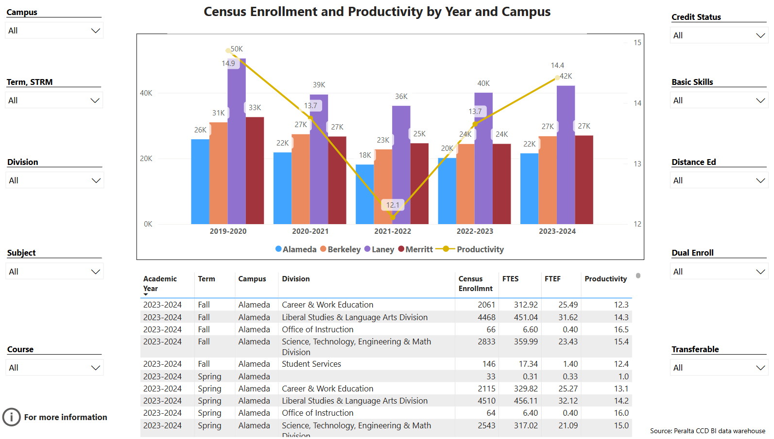
Enrollment Trends Power BI dashboard
Note: Please consider the most recent 3 years when answering the questions below. Data with default filter is provided below. Use the link above to explore the data further.
Discuss enrollment trends over the past three years.
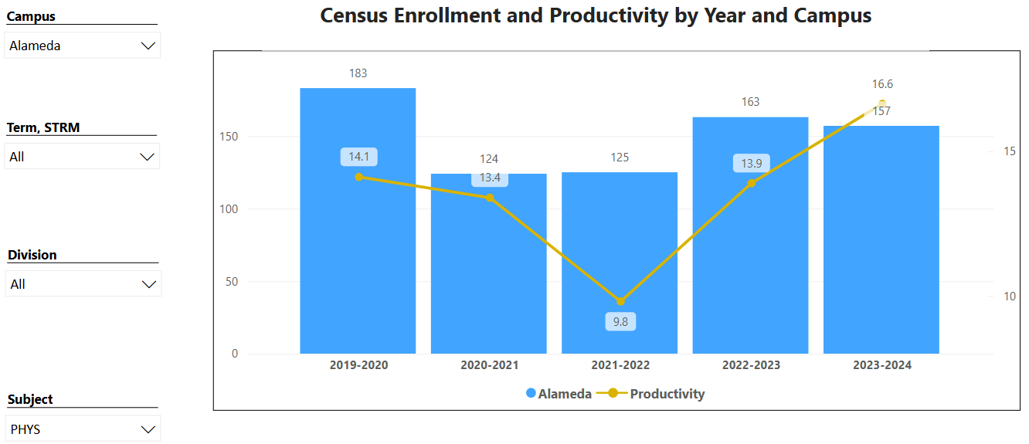

PHYS enrollment has largely recovered. While productivity can be higher (with lab section equated at 80%, 17.5 productivity should be achievable), it looks like the enrollment challenges are now a past problem for CoA Physics. However, the original reasons that led us to consider PHYS 3A-3B sequence still remain, which is that CoA is too small a college to sustainably offer 3-semester engineering physics sequence (to support 1 section of PHYS 4C each spring, we really need to be big enough to offer 2 sections of PHYS 4A and 1 section of PHYS 4B every semester). So, we are still on the same track we were on as of last program review cycle.

Table below shows list of course sections in your area sorted from lowest fill rate to the highest fill rate for the last three years. Consider and discuss whether the course offerings meet the needs of our students.
Academic Year | Term | Campus | Course | Section ID | Census Enrollmnt | FTES | FTEF | Productivity | Enrl Cap | Fill Rate | Time of Day | Distance Ed
2021-2022 | F21 | Alameda | PHYS 4B | 1214244855 | 6 | 1.44 | 0.43 | 3.4 | 30 | 20% | DAY | Online / Classes totally online
2021-2022 | S22 | Alameda | PHYS 4C | 1222224362 | 12 | 2.56 | 0.43 | 6.0 | 40 | 30% | DAY | Online / Classes totally online
2021-2022 | F21 | Alameda | PHYS 4A | 1214240654 | 10 | 2.33 | 0.43 | 5.5 | 30 | 33% | DAY | Online / Classes totally online
2023-2024 | S24 | Alameda | PHYS 4C | 1242220841 | 18 | 3.84 | 0.43 | 9.0 | 40 | 45% | DAY | Online / Classes totally online
2022-2023 | S23 | Alameda | PHYS 4C | 1232220948 | 19 | 4.05 | 0.43 | 9.5 | 40 | 48% | DAY | Online / Classes totally online
2022-2023 | F22 | Alameda | PHYS 4A | 1224240665 | 20 | 4.67 | 0.43 | 10.9 | 40 | 50% | DAY | Online / Classes totally online
2022-2023 | F22 | Alameda | PHYS 4B | 1224240985 | 21 | 4.48 | 0.43 | 10.5 | 40 | 53% | DAY | Online / Classes totally online
2022-2023 | S23 | Alameda | PHYS 10 | 1232220693 | 24 | 3.20 | 0.27 | 12.0 | 40 | 60% | DAY | Online / Classes totally online
2023-2024 | F23 | Alameda | PHYS 10 | 1234240831 | 27 | 3.60 | 0.27 | 13.5 | 40 | 68% | DAY | Online / Classes totally online
2021-2022 | S22 | Alameda | PHYS 4A | 1222220748 | 27 | 6.30 | 0.43 | 14.8 | 40 | 68% | DAY | Online / Classes totally online
2021-2022 | F21 | Alameda | PHYS 10 | 1214242963 | 31 | 4.13 | 0.27 | 15.5 | 34 | 91% | DAY | Online / Classes totally online
2023-2024 | F23 | Alameda | PHYS 4B | 1234240846 | 37 | 7.89 | 0.43 | 18.5 | 40 | 93% | DAY | Online / Classes totally online
2023-2024 | S24 | Alameda | PHYS 4A | 1242220656 | 37 | 8.63 | 0.43 | 20.3 | 40 | 93% | DAY | Online / Classes totally online
2022-2023 | F22 | Alameda | PHYS 10 | 1224240957 | 37 | 4.93 | 0.27 | 18.5 | 40 | 93% | DAY | Online / Classes totally online
2023-2024 | F23 | Alameda | PHYS 4A | 1234240622 | 38 | 8.87 | 0.43 | 20.8 | 40 | 95% | DAY | Online / Classes totally online
2021-2022 | S22 | Alameda | PHYS 10 | 1222220750 | 39 | 5.20 | 0.27 | 19.5 | 40 | 98% | DAY | Online / Classes totally online
2022-2023 | S23 | Alameda | PHYS 4A | 1232220691 | 42 | 9.80 | 0.43 | 23.0 | 40 | 105% | DAY | Online / Classes totally online
Total |  |  |  |  | 445 | 85.93 | 6.45 | 13.3 | 654 | 68%
Applied filters:
ACAD_YEAR_LONG is 2022-2023, 2023-2024, or 2021-2022
NAME_SHORT is Alameda
SUBJECT is PHYS

PHYS 4B section in Fall 2021 that ran with 6 students remains a record. Physics Department deeply appreciates the college administration’s support 3 years ago, and the PHYS 4B enrollment since then (21 in Fall 2022, 37 in Fall 2023, and comparable numbers in Fall 2024 [not on list above]) proves the administration’s wisdom in keeping the then-low-enrolled class.

PHYS 4C will likely never fill above 20 students, and this is one of the primary remaining reasons for College of Alameda to switch to PHYS 3A-3B sequence and use our PHYS 4A-4B sections only to support our sister colleges’ PHYS 4C sections.

Discuss any action plan to better meet student needs and demands.
For the reasons discussed above, CoA Physics Department plans to switch to PHYS 3A-3B sequence, both to better support our biological science major students and to keep our offering within something that will be sustainable with the student needs and demands at a college of our size.

Describe effective and innovative teaching strategies used by faculty to increase student learning and engagement.
Andrew Park developed an extensive set of lecture videos (available at department YouTube channel, both publicly and as part of Canvas course, youtube.com/c/CoAPhysics), as well as sets of assessment materials aligned with OpenStax University Physics, an open educational resource (OER) that is freely available to students. Stephen Asztalos brings his teaching philosophy from years of teaching comparable courses at CSU.

How is technology used by the discipline, department?
For the online lecture components (for PHYS 10, 4A, 4B, and 4C), the Canvas LMS is the single most heavily relied-on piece of technology. Other technology being used by individual instructors (online textbooks, MyOpenMath, etc.) are not specifically supported or maintained by the college.

The in-person lab sections (for PHYS 4A, 4B, and 4C) extensively rely on the technology built into and/or maintained in ATLAN 100, such as the ceiling projector and the portable short-throw projector. The newly purchased Windows 11 laptops (primarily for students’ use during lab; these replaced the existing Windows 7 laptops) have also been used for various instructional purposes.

How does the discipline, department, or program maintain the integrity and consistency of academic standards with all methods of delivery, including face to face, hybrid, and Distance Education courses?
After a brief experimentation with online lab during the COVID years, a departmental decision has been made to maintain in-person lab component (for PHYS 4A, 4B, and 4C), precisely so that we can “maintain the integrity and consistency of academic standards.” While the lecture component remains online, with the linked lecture-lab setup, students’ performance in lab can be used to complement academic standards maintained in lecture.

In addition, Physics Department plans to re-introduce in-person/hybrid lecture component when PHYS 3A class can finally be offered at College of Alameda with full articulation to our intersegmental partners.

Curriculum
CurriQunet Meta
If necessary, use the CurriQunet META link to review the details of curriculum. Some summary information is provided below.
Please review your course outlines of record in CurriQunet META to determine if they have been updated in the past three years. Specify when your department will update, or deactivate, each one, within the next three years.
College | Subject Code | Course # | Course Title | Updated On
College of Alameda | PHYS | 003A | General Physics | 8/25/2022
College of Alameda | PHYS | 003B | General Physics | 8/25/2022
College of Alameda | PHYS | 004A | General Physics with Calculus | 2/25/2021
College of Alameda | PHYS | 004B | General Physics with Calculus | 2/25/2021
College of Alameda | PHYS | 004C | General Physics with Calculus | 3/15/2021
College of Alameda | PHYS | 010 | Introduction to Physics | 4/25/2018
College of Alameda | PHYS | 010L | Introduction to Physics Laboratory | 10/3/2018
College of Alameda | PHYS | 049 | Independent Study in Physics | 8/1/2020

All PHYS courses (except for PHYS 3A and 3B) appear to be due for an update. Title 5 update process will be started for all PHYS courses (excepting PHYS 3A and 3B) in Fall 2024. In addition, PHYS 10 is still in need of recovering UC articulation; consultation process necessary to modify PHYS 10’s “required preparation” will begin in Fall 2024.

Please summarize the Discipline, Department or program of study plans for curriculum plans for improvement. Below, please provide details for individual course improvement. Add plans for new courses here.
No additional changes to the curriculum beyond those mentioned above are planned in the near-term.

How is your program meeting the needs of students and/or articulation with four-year institutions?
Our PHYS 10 offering meets the physical science general education requirements (and a small number of students who may be preparing for PHYS 4A), as well as students going into vocational programs with a single-semester physics requirement (e.g. radiology tech programs).

Our PHYS 4A, 4B, and 4C courses meet the needs of students intending to major in physical sciences and engineering programs by teaching them fundamental physics problem-solving skills necessary for success in their upper division courses and later in their profession.

Our PHYS 3A and 3B courses will meet the needs of students intending to major in biological sciences, as well as those in “pre-med” preparation, by teaching them fundamental physics problem-solving skills necessary to support their progress in their chosen major/profession.

Assessment – Instructional
Student Learning Outcomes Assessment
Your Student Learning Outcomes for active courses are listed below. Please review and note any corrections or planned changes.
Subject Course# | SLOs | Last Assessed
PHYS 003A | SLO1 - Discuss the concepts of physics, and apply them to situations relevant to the course and in biological sciences.
PHYS 003A | SLO2 - Develop descriptions of physical systems using mathematics and calculate measurable quantities.
PHYS 003A | SLO3 - Set up laboratory equipment safely, Plan and carry out experimental procedures, Identify possible sources of error, Reduce and interpret data, and Prepare clear written reports.
PHYS 003B | SLO1 - Discuss the concepts of physics, and apply them to situations relevant to the course and in biological sciences.
PHYS 003B | SLO2 - Develop descriptions of physical systems using mathematics and calculate measurable quantities.
PHYS 003B | SLO3 - Set up laboratory equipment safely, Plan and carry out experimental procedures, Identify possible sources of error, Reduce and interpret data, and Prepare clear written reports.
PHYS 004A | SLO1 - Discuss the concepts of physics, and apply them to situations relevant to the course. | Spring 2024
PHYS 004A | SLO2 - Develop descriptions of physical systems using mathematics and calculate measurable quantities. | Spring 2022
PHYS 004A | SLO3 - Set up laboratory equipment safely, Plan and carry out experimental procedures, Identify possible sources of error, Reduce and interpret data, and Prepare clear written reports. | Spring 2023
PHYS 004B | SLO1 - Discuss the concepts of physics, and apply them to situations relevant to the course. | Fall 2021
PHYS 004B | SLO2 - Develop descriptions of physical systems using mathematics and calculate measurable quantities. | Fall 2022
PHYS 004B | SLO3 - Set up laboratory equipment safely, Plan and carry out experimental procedures, Identify possible sources of error, Reduce and interpret data, and Prepare clear written reports. | Fall 2023
PHYS 004C | SLO1 - Discuss the concepts of physics, and apply them to situations relevant to the course. | Spring 2024
PHYS 004C | SLO2 - Develop descriptions of physical systems using mathematics and calculate measurable quantities. | Spring 2022
PHYS 004C | SLO3 - Set up laboratory equipment safely, Plan and carry out experimental procedures, Identify possible sources of error, Reduce and interpret data, and Prepare clear written reports. | Spring 2023
PHYS 010 | SLO1 - Using written language, students explain and discuss the physics concepts listed in the course content, and apply them to everyday phenomena and interdisciplinary examples. | Spring 2021
PHYS 010 | SLO2 - Students apply simple formulas to calculate measurable quantities that describe the physical environment related to the concepts of physics. | Spring 2019
PHYS 010 | SLO3 - Students explain and discuss physical principles underlying classroom demonstrations. | Spring 2018
PHYS 010L | SLO1 - Students set up laboratory equipment safely, plan and carry out experimental procedures, identify possible sources of error, reduce and interpret data, and prepare clear written reports. | Spring 2019
PHYS 010L | SLO2 - Students apply simple formulas to calculate measurable quantities that describe the physical environment related to the concepts of physics.
PHYS 010L | SLO3 - Students explain and discuss physical principles underlying laboratory experiments.
PHYS 049 | SLO1 - Investigate, assess and communicate findings of specific independent project(s) as discussed with instructor.

Please provide a high-level summary and your program’s interpretation of your SLO findings over the past year.
Summary given here relates to PHYS 4A, 4B, and 4C SLO assessments only, as PHYS 10 SLO assessments are out of date.

In PHYS 4A, 4B, and 4C, I (Andrew Park) implemented a form of oral exam (“required 1-on-1 meeting”, in the way it is described in course materials), in which students are quizzed on their written work. The primary motivation for this was to ensure that written work that is completed via academically dishonest means does not result in a grade of A or B for a student. While the overall outcome of this oral exam was highly effective, both in preventing unfair advantage gained through academic dishonesty and allowing students who put in the necessary work to catch up to earn the higher grades, through demonstration of their mastery of physics problem-solving techniques at this 1-on-1 meeting, this new grading procedure revealed a weakness in the existing SLO assessment paradigm, as students who successfully completed the required 1-on-1 meeting were not showing up as meeting SLO #1 (“Discuss the concepts of physics, and apply them to situations relevant to the course”) and/or SLO #2 (“Develop descriptions of physical systems using mathematics and calculate measurable quantities”).

So, a new assessment method, based on completion of SLO assessment rubric by the instructor (me, Andrew Park) at the end of a successful required 1-on-1 meeting, is currently being implemented in Fall 2024 PHYS 4A and 4B courses.

What were the most important things your department learned from assessment? Did implementation of your action plans result in better student learning?
That holistic assessment of SLOs #1 and #2 is difficult to do just by looking at a sample or a collection of completed assignments. The 1-on-1 conversation with each student gives a much more complete picture of whether a student has met the SLO #1 and/or SLO #2, and since the course grading procedure already built in this conversation (mostly in trying to deter academic dishonesty, not necessarily change/improve SLO assessment), we should leverage this going forward and assess SLOs at the end of these required 1-on-1 conversations.

Listed below are your programs (degrees and certificates) and the program learning outcomes (PLOs) for each. Please share your reflections on the PLOs and support from the college needed in assessing the PLOs over the next three years.
[PHYS does not have degrees or certificates.]

PHYS department does not have a certificate or a degree with associated PLOs. We would like to participate in PLO assessments for degrees that list PHYS courses for breadth or degree-specific requirements (e.g. associate in liberal arts, and a couple associate’s degrees in STEM).

College of Alameda Institutional Learning Outcomes (ILOs) were created to guide educational programs and services. They include:
- Problem Solving: Solve problems and make decisions in life and work using critical thinking, quantitative reasoning, community resources, and civil engagement.
- Communication and Technology: Use technology and written and oral communication to discover, develop, and relate critical ideas in multiple environments.
- Creativity: Exhibit aesthetic reflection to promote, participate and contribute to human development, expression, creativity, and curiosity.
- Diversity: Engage in respectful interpersonal communications, acknowledging ideas and values of diverse individuals that represent different ethnic, racial, cultural, and gender expressions.
- Civic Responsibility: Accept personal, civic, social and environmental responsibility in order to become a productive local and global community member.
How does your program participate in assessing the Institutional Learning Outcomes (ILOs)? If your program has not participated, how will you plan to incorporate these outcomes within your program?
PHYS department and/or faculty have not been invited to participate in assessing the ILOs. We would welcome such invitation.

Course Completion
Course Completion Power BI Dashboard #1
Course Completion Power BI Dashboard #2
Institutional Set Standards
Consider your course completion rates over the past three years (% of student who earned a grade of "C" or better). Data with default filter is provided below. Use the link above to explore the data further.
How does the course completion rate for your program or discipline compare to your college’s Institutional Set Standard for course completion (70% with stretch goal of 77%)? Also discuss the retention rate for your program or discipline, compared to the college average shown in data below.
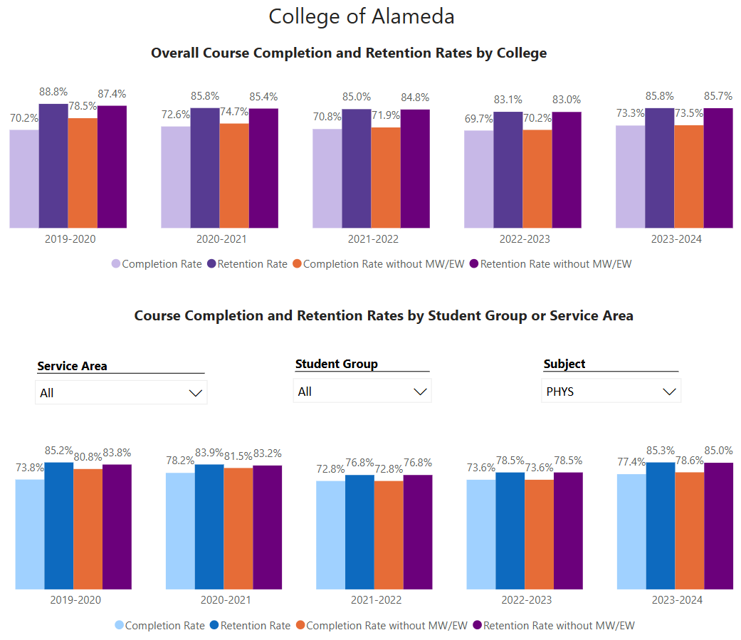

Success rates in PHYS meet and exceed the college institution set standards. While PHYS 10 taken alone falls slightly short of these standards, especially in more recent semesters, there may be idiosyncratic reasons for these PHYS 10 sections that can be mitigated without impacting PHYS program offerings.
What has the discipline, department, or program done to improve course completion and retention rates?
For PHYS 4A, 4B, and 4C, clearly delineating the standards for what students need to accomplish in order to meet the grading standards for A, B, and C has resulted in more students persisting and earning these grades, leading to an improved completion rate.

One area lacking is where students may have been intimidated by the oral exam (so never scheduled the required 1-on-1 meeting and ended the class with a grade of C, even though their written work suggested they could earn at least a B). we are trying offering more support options through an embedded tutor and “practice meetings” to build confidence for the students to go through the oral exam that is required for grades of A and B.

Equity Analysis
College of Alameda continues to focus on access, equity, and success. The goal is to create an inclusive environment where all students can thrive and meet their education and career goals.
Following is a brief description of equity data analysis, examining success rates of different ethnic groups (Asian, Black/African American, Hispanic/Latino, “Two or More”, “Unknown/NR”, White), age range, gender (Female, Male, Unknown Gender), and special population groups (Foster Youth, First Gen College, SAS). Detailed data table can be found at this link (look for the tab for your discipline).
Success rate data in PHYS for AY2023-24, excluding non-credit courses and contract education courses, was analyzed using the PPG-1 (percentage point gap minus 1) method, comparing success rate of the given group against the success rate of everyone else. The success rate of following groups fall significantly below the overall success rate of 75% for PHYS, outside the statistical margin of error:
- Hispanic / Latino: 56.8% success rate
- Female: 53.5% success rate
- 25-29 age group: 43.8% success rate
- Low-income: 68.6% success rate

While there are other groups whose success rates fall below the overall success rate for PHYS, either the percentage point gap difference is small or, because of the small sample size, a reliable conclusion cannot be drawn.

What can your discipline, department, or program do to improve course completion for disproportionately impacted groups?
We are gratified to see that some of the groups who were previously identified as disparately impacted are now showing in the data as performing similarly as other groups. We still have work to continue in better serving the Hispanic / Latino group (in fact the second largest group we serve in PHYS department at College of Alameda) better. We believe providing more encouragement and support (aimed at helping students persist through the coursework) will be successful in achieving these goals.

And we need to start a departmental conversation on how to better support our low-income students (majority of our students) and young but slightly older students (who are not coming to us directly out of high school).

It is possible that the disparate impact showing for women is an example of Simpson’s paradox—female students in PHYS 4A, 4B, and 4C are succeeding at rates same as or better than male students in the same classes, but majority of our women in PHYS classes are in PHYS 10, where class-wide success rate is lower. We need further analysis of data, as well as a plan for helping all students in PHYS 10.

Space below is provided for additional discussion of equity-impacting factors not discussed above, including those that affect dual enrollment courses and/or online/hybrid courses.
PHYS has no dual enrollment courses (although we would welcome the opportunity), and all our lecture courses are online (and lab is required to be in-person/hybrid for articulation reasons). We do plan to offer PHYS 3A with hybrid lecture soon and are excited to see better success and equity outcomes in hybrid lecture courses.

Degrees & Certificates Conferred
Does your program offer any degree/certificate programs? If your program does not, skip this section and continue to Engagement.
Degrees & Certificates Power BI dashboard
What has the discipline, department, or program done to improve the number of degrees and certificates awarded? Below data shows the number of degrees and certificates awarded by year, for the past three years. Use the link above to explore the data further.
[PHYS does not have degrees or certificates.]

Increasing the number of students who complete a certificate or degree is a shared goal across CoA’s Ed Master Plan Goals, PCCD Goals, the Chancellor’s Office Vision for Success, the Student-Centered Funding Formula, and Guided Pathways. What is planned for the next 3 years to increase the number of certificates and degrees awarded?
PHYS does not have standalone degrees; we primarily serve the college as a “service discipline” (that is, provide classes that satisfy physics requirement for other degrees such as Biology or Mathematics, as well as physical science general education requirement (PHYS 10).

With the recent regulatory changes (CalGETC and ongoing work in transfer alignment project), it may become possible to offer Physics AS-T; the department will propose the degree as soon as it becomes possible at College of Alameda (currently any pathway proposed has too many units to be approved).

Engagement
Discuss how faculty and staff have engaged in institutional efforts such as committees, presentations, and departmental activities. Please list the committees that full-time faculty participate in.
Andrew Park – Following are institutional efforts by the sole PHYS full-timer, roughly in the order of amount of time taken in a typical week:
* Faculty union rep: serves as one of the two campus co-chairs for CoA; primarily functions as a liaison for faculty experiencing working condition/salary issues, and provides advice on matters of CBA interpretation.
* Academic senates – serves on CoA academic senate (secretary) and district academic senate (DAS; treasurer); handles logistics for ASCCC events funded through DAS fund.
* SLOAC for STEM division – serves on approval queue in CurriQunet META for SLOAC role; answers questions related to SLOs and CurriQunet META
* Institutional Effectiveness Committee (service ended in September 2024) – serves as one of the three co-chairs for the committee; note-taker at most meetings.
* Other informal participations, particularly in matters relating to open educational resources (OER).

Discuss how faculty and staff have engaged in community activities, partnerships and/or collaborations.
The part-time faculty in PHYS teach across the district at our sister campuses, such as Merritt, and at neighboring universities.

The full-time faculty Andrew Park was recently highlighted in American Association of Physics Teachers member spotlight for October 2024: https://www.aapt.org/Membership/spotlight_october2024.cfm

Discuss how adjunct faculty members are included in departmental training, discussions, and decision-making.
We communicate regularly by email, and we will re-assess our need for real-time discussion opportunities and follow up.

Prioritized Resource Requests Summary
In the boxes below, please add resource requests for your program. If there are no resource requested, leave the boxes blank.
Resource Category | Description/Justification | Full-Time Equivalent Percentage | Salary Grade (if applicable)
Personnel: Classified Staff

Personnel: Student Worker

Personnel: Part Time Faculty | The sole full-timer in PHYS is currently regularly overloaded. When transition to PHYS 3A/3B is complete, one of these sections should be taught by a part-time faculty. | No additional FTEF needed | ??
Personnel: Full Time Faculty

Personnel: Full Time Faculty, future anticipated need | In about 25 years when Andrew Park retires, we will need a new full-time faculty who can teach ASTR and PHYS.

Resource Category | Description/Justification | Total Estimated Cost
Professional Development: Department wide PD needed | Support for department-wide meeting and SLO assessment efforts is needed. We would like to request a small stipend payment for the time part-time faculty spend on assessing SLOs and attend department-wide meeting to discuss SLO assessment results. | $500 - $1000 for all PT faculty participating
Professional Development: Personal/Individual PD needed | Individual faculty will request through PD committee.

Prioritized Resource Requests Summary - Continued

Resource Category | Description/Justification | Total Estimated Cost
Supplies: Software

Supplies: Books, Magazines, and/or Periodicals

Supplies: Instructional Supplies | Physics lab requires ongoing maintenance, both for repair and replacement of existing lab activities and for designing and offering new lab activities. We request continued supplies funding. | $1000
Supplies: Non-Instructional Supplies

Supplies: Library Collections

Resource Category | Description/Justification | Total Estimated Cost
Technology & Equipment: New | New equipment (e.g. modern oscilloscopes) needed to fully furnish Physics lab. | $4000
Technology & Equipment: Replacement

Prioritized Resource Requests Summary - Continued

Resource Category | Description/Justification | Total Estimated Cost
Facilities: Classrooms | We request continued exclusive use of ATLAN 100 for Physics purposes (Physics lecture/lab classes) only. | $0
Facilities: Offices | We request continued exclusive use of ATLAN 100 for Physics, so that Physics full-timer can access ATLAN 102 (office space inside ATLAN 100) at predictable times. | $0
Facilities: Labs | We request continued exclusive use of ATLAN 100 for Physics purposes (Physics lecture/lab classes) only. | $0
Facilities: Other

Resource Category | Description/Justification | Total Estimated Cost
Library: Library materials

Library: Library collections

Resource Category | Description/Justification | Total Estimated Cost
OTHER

