**College of Alameda**

2024-25 Program Review Template – **Puente**

**Lead Author:**

|  |
| --- |
| William Ramos Ochoa – Acting Dean of Career and Workforce Education/Acting HSI Director |

**Program Overview**

Provide your service area’s mission statement. If your service area does not have a mission statement, what is your timeline for creating a mission statement?

|  |
| --- |
| Its mission is to increase the number of educationally underrepresented students who enroll in four-year colleges and universities, earn college degrees and return to the community as mentors and leaders to future generations. The program is interdisciplinary in approach, with writing, counseling and mentoring components. |

List your program faculty and/or staff.

|  |
| --- |
| William Ramos Ochoa – Acting Dean of Career and Workforce Education/ Acting HSI Director  Johanna Carranza – HSI Faculty Coordinator  Teresa Castro - Counselor |

List the essential functions of your department, program or unit and provide a description of how the unit aligns with the college mission.

|  |
| --- |
| As part of the HSI Title V Grant, the College of Alameda (CoA) implemented Student Support Services and Programming (ACCESO and Puente) while developing best practices to better serve students during the transition to In Person Services and Programming. The HSI (Hispanic Serving Institution) Team has continued to adapt and strengthen best practices to best address HSI students' needs. This would include meeting grant objectives, including increasing enrollment, academic success, quality instructional models, financial literacy, and faculty/staff training for Puente program related services.  The primary functions of the Puente Learning Community are to provide instruction through a cohort-based model, particularly in English and Counseling.  Additional services for the Puente program are to provide Counseling Services for all Puente students that are enrolled at College of Alameda.  Puente students, or Puentistas, enroll in two linked courses during the fall (English 1A & Counseling 24) and spring (English 5 & Counseling 57) semesters, and work closely with their counselor, English instructor, and mentor to prepare for transfer to four-year colleges and universities. The writing curriculum focuses on the development of college-level essay writing, reading, research, and critical thinking skills, a necessary foundation for educational success. All students welcome! |

List your program goals from your most recent Program Review or APU (Annual Program Update). Then, provide an update on the status of the goal. Has your program achieved the goal? Have any of your goals been revised or are any still in progress? Lastly, make sure to discuss which College or District goal your program goal aligns to.

If no program goals exist or if this is your first program review, create 2-3 goals and align them with a college or District goal.

|  |  |
| --- | --- |
| **Program Goal** | Offer Cohort Based – English and Counseling Courses |
| Status: In-Progress or Complete? | In Progress |
| Which college or district goal is aligned with your program goal? | The Puente Program is currently going through a restructuring year. Puente is planning to enroll for a new cohort during the SP 25 semester. |

|  |  |
| --- | --- |
| **Program Goal** | To continue to develop and sustain the Puente Community at College of Alameda |
| Status: In-Progress or Complete? | In Progress |
| Which college or district goal is aligned with your program goal? | Increase Retention and Persistence Rates, Advance teaching and learning, continue to strengthen community of practice amongst students, staff and faculty. |

|  |  |
| --- | --- |
| **Program Goal** | Provide Counseling Services to strengthen Guided Pathways for Puente Students |
| Status: In-Progress or Complete? | In Progress |
| Which college or district goal is aligned with your program goal? | Provide one to one counseling support on a semester basis. Develop Student Education Plans and support with triaging students through AA Completion and Certification completion. |

[Course Success & Retention Rates – Student Services (internal only)](https://app.powerbi.com/groups/me/reports/ff194db6-2abe-4847-84b3-005a8629eb9d/ReportSection86d6f65e2fb41a73da4d?ctid=eea16a16-48af-477b-9113-05b1c01123ff&experience=power-bi)

Please go to Student Services Details Page.

Then click on your Service Area.

Compare to Graphic above.

Do the students served by your service area differ from the College's overall student population? If so, elaborate on how the service area is identifying and addressing the needs of the student population.

|  |
| --- |
| Per the Course Success and Retention Rates – Student Service, the COA Puente Program differs from the Completion and Retention rates of the general College of Alameda Population. When taking into consideration 2023 - 2024 Completion Rates, Puente had a 50 % completion when compared to COA’s 72.6 % completion, the Completion rate difference between Puente and COA was 22.6%. Secondly, Puente’s Retention rate was 91.7 % compared to COA’s 89.9% Retention rate, the Retention rate difference between Puente and COA was 1.8 % respectively.  When taking into consideration the difference of 22.6% Course Completion about Puente (50%) having a lower completion rate than COA (72.6%), it is important to take into consideration the various transitions of student services providers about the Hispanic Serving Institution (HSI) Title V team. During the Fall 2024 semester there was a transition of the HSI Director and two part time counselors that were supporting our Puente Student Population. This hindered the momentum of Program Services for Puente Students. In addition, an Acting Dean of LSLA began to support these endeavors during the month of September.  We have identified these stressors soon after the transitions and began restructuring HSI programming by receiving support through faculty with developing an HSI Faculty Coordinator position and hiring a part time Puente Counselor to support Puente Programming and Activities. Soon after we began to provide in reach services to our Puente student to begin strengthening program services and rebuilding sense of belonging for students. |

Which groups of students are underrepresented among those who received services, particularly by race/ethnicity and gender?

|  |
| --- |
| 20 students served during the 2023 – 2024 semester identified as Latinx, the 3 remaining students are unknown. In the 2023 – 2024 academic year, we had 13 students that have identified as female and 10 students that have identified as male. |

Describe how external factors such as advisory board recommendations, federal or state mandates, changing demographics, and/or COVID-19 has impacted the support services your program or administrative unit provides.

How has your program addressed these changes or challenges to ensure students are supported and can continue to work towards meeting their educational goals?

|  |
| --- |
| During this reporting period, the project continued to support the college’s long-term fiscal stability by supporting with outreach, in-reach, retention, and professional development. Project staff continued to conduct outreach several outreach presentations at local high schools, as well as in community college events and activities. In addition, HSI Project staff supported and participated in COA’s ACCESO student orientations, and summer bridge programming in collaboration with MESA.  Lastly, as many colleges in California, we continue to struggle with acclimating our student population to in person learning and to continue to strengthen a sense of belonging and a college going culture Post COVID. The Puente project has continued to allow COA to serve Latinx students, low-income students, and underrepresented students in a way that we would not have been able to do without the support of the HSI Title V grant due to the fiscal limitations of the institution. |

**Data Analysis**

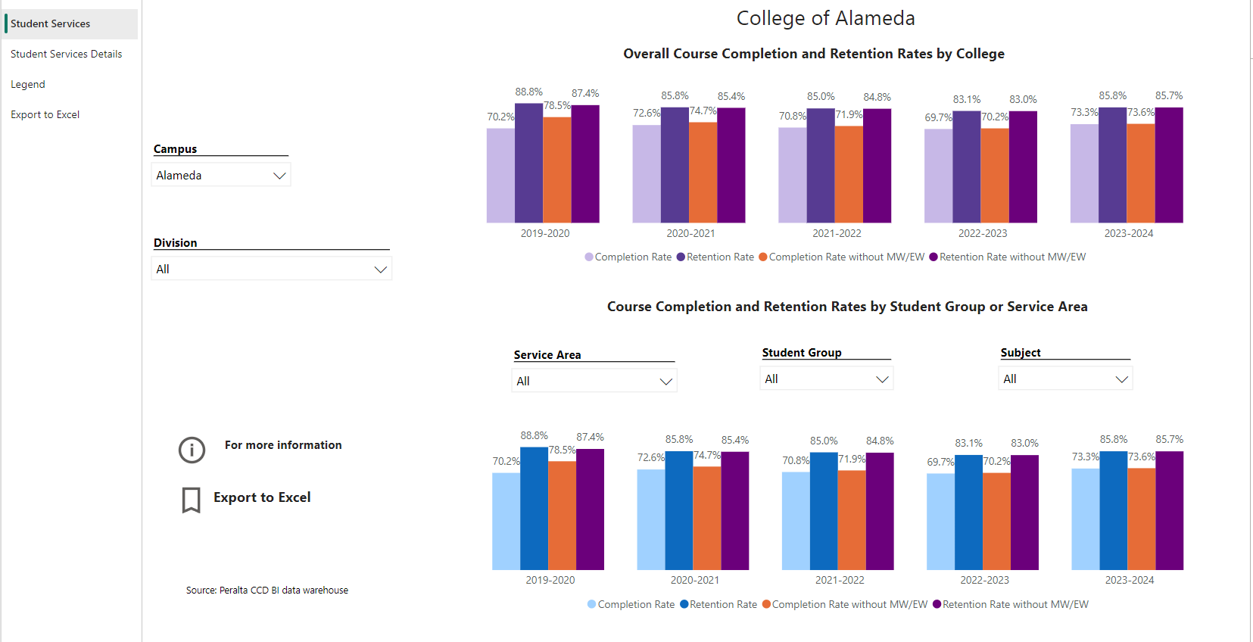

[**Course Success & Retention Rates – Student Services**](https://app.powerbi.com/view?r=eyJrIjoiNjk3NDJjOTItNzI5MS00MDhjLWJhN2EtZjcxNzU4OTBiZDBjIiwidCI6ImVlYTE2YTE2LTQ4YWYtNDc3Yi05MTEzLTA1YjFjMDExMjNmZiIsImMiOjZ9&pageName=ReportSection86d6f65e2fb41a73da4d)

Click on your Service Area after Clicking on Dashboard Link

Consider your program’s course completion rates over the past three to five years (% of students who earned a grade of "C" or better).

How does the course completion rate for your program compare to your college's College-Set Standard for course completion of 70% and the stretch goal of 77%?

|  |
| --- |
| When comparing the various years (2021-2022 AY, 2022-2023 AY, 2023-2024 AY) of Puente completion rates, there has been a significant change regarding student completion (Obtaining a C grade or better). The most significant change in success rate was the change between 2022 – 2023 AY to 2023 – 2024 AY, due to transitions in student services personnel. Puente students had become accustomed to certain HSI team members (i.e. Counselors, Faculty, Director and Program Specialist) that developed a robust community of practice and sense of belonging for the Puente cohort that participated during the 2022 – 2023 AY. When compared to COA’s College set standard of 70 % - 77 %, there is a significant disparity in comparison to Puentes Completion rate of 50 % in 2023 – 2024 AY, the 20 % difference is concerning as we should continue our increase in completion from Puente’s 2022 – 2023 AY being 82.1 %. Currently for 2024 -2025 AY, Puente is currently undergoing a restructuring year where the program is having the ability to reprogram and strengthen the success of our current Puente cohorts and not have the obligation to enroll a new cohort. We have been in communication with the Puente National Office and have begun strategizing and organizing a plan for the 2024 – 2025 AY, especially when HSI funds will not be available. |

On average the course retention rate (number of students are retained in the course) for College of Alameda has been **85%** for the past three years. Examine the course retention rates for your program over the last three years. How does your program course retention rate compare to the college?

|  |
| --- |
| When taking into consideration retention rates from 2021 – 2022 (81.3%), 2022 – 2023 (89.3%), and 2023 – 2024 (91.7%) we have steadily been increasing retention rates for our Puente students here at College of Alameda. In comparing retention rates of College of Alameda students to Puente students, Puente has surpassed COA’s benchmark of the 85% retention rate average by about (6.7%). This percentage difference shows that although Puente has been undergoing staffing transitions, there continues to be an increase in retaining our students through our comprehensive services. |

**Equity**

College of Alameda continues to focus on access, equity, and success. The goal is to create an inclusive environment where all students can thrive and meet their education and career goals. As pertaining student success metrics from the Student Equity Achievement Plan and the Student-Centered Funding Formula, we analyzed most current cohort state data of disproportionate impacted groups in completion of transfer level English and Math, persistence, transfer rate, and goal completion.

For more information on equity click on the [StudentSuccessMetricsforDIgroups21-22.xlsx](https://peralta4.sharepoint.com/:x:/s/COAProgramReviewAPU/EQeObnoQcNBDl4aDs36j21UB0hDtODWPuRR-w5n6OaU-xA?e=3QJEc6)

Discuss how your program has worked to address these equity gaps. Incorporate examples of your program data where applicable.

|  |
| --- |
| Puente has supported in addressing access, equity, and success by providing a learning community focused on supporting Latine/x students through a cohort model. Puente students, or Puentistas, enroll in two linked courses during the fall (English 1A & Counseling 24) and spring (English 5 & Counseling 57) semesters, and work closely with their counselor, English instructor, and mentor to prepare for transfer to four-year colleges and universities. The writing curriculum focuses on the development of college-level essay writing, reading, research, and critical thinking skills, a necessary foundation for educational success.  During the Fall 2023 and Spring 2024 semesters, our new Puente Cohort (cohort 4) of 19 students, 95% completed Eng 1A, 100 % completed Coun 24, 74% completed Eng 5, and 89 % completed Coun 57 with a C or higher. |

**Student Learning Outcomes Assessment**

List your Service Area Outcomes (SAOs) and/or Student Learning Outcomes (SLOs)

|  |
| --- |
| [This department has not been given access to SLO’s and SAO’s] |

Please provide a high-level summary and your program’s interpretation of your SAO/SLO findings over the past year.

|  |
| --- |
| [This department has not been given access to SLO’s and SAO’s] |

What were the most important things your department learned from assessment? Did implementation of your action plans result in better student learning?

|  |
| --- |
| [This department has not been given access to SLO’s and SAO’s] |

**Degrees & Certificates Conferred**

Increasing the number of students who complete a certificate or degree is a shared goal across CoA’s Ed Master Plan Goals, PCCD (Peralta Community College District) Goals, the Chancellor’s Office Vision for Success, the Student-Centered Funding Formula, and Guided Pathways.

How can your program contribute to increasing the number of certificates and degrees awarded over the next three years?

For more information on awards click on the [**Degrees & Certificates Dashboard link**](https://app.powerbi.com/view?r=eyJrIjoiZjU2M2M5MzItOTcwZi00Y2U1LWJmODUtYTc0YjlhZGI2ZDhjIiwidCI6ImVlYTE2YTE2LTQ4YWYtNDc3Yi05MTEzLTA1YjFjMDExMjNmZiIsImMiOjZ9&pageName=ReportSectionde32556e136b0a8caccd)

|  |
| --- |
| Puente students work closely with their Puente counselor to explore career options, develop an academic educational plan and identify their goals through the Puente Development courses, Counseling 24 (College Success Skills) and Counseling 57 (Career and Life Planning), as well as individual counseling sessions.  Students visit campuses of the University of California and other four-year colleges and attend an annual Puente student transfer conference. |

**Engagement**

How has your department participated in college wide efforts such as committees, presentations, and departmental activities?

|  |
| --- |
| Participated in SEA Committee, presentation on student services related programming such as counseling services, professional development and college success workshops via HSI Title V Grant/Puente. Program participation in Latinx Graduation Committee. Supported District Wide Graduation logistics and provided graduation sashes for all Peralta Graduates. |

How has your department engaged in community activities, partnerships and/or collaborations?

|  |
| --- |
| Puente Students participated in Puente Annual Student Conference, 4 college field trips and college campus activities (Latinx History Month) |

**Prioritized Resource Requests Summary**

In the boxes below, please add resource requests for your program. If there are no resources requested, leave the boxes blank.

|  |  |  |
| --- | --- | --- |
| **Resource Category** | **Description/Justification** | **Total Estimated Cost** |
| Personnel: Classified Staff |  |  |
| Personnel: Student Worker |  |  |
| Personnel: Part Time Faculty |  |  |
| Personnel: Full Time Faculty | Per the MOU and Puente Framework, the program requires one full time English and Counseling Faculty to support program efforts. This is in alignment with the national Puente program requirements. | $230,000 |

|  |  |  |
| --- | --- | --- |
| **Resource Category** | **Description/Justification** | **Total Estimated Cost** |
| Professional Development: Department wide PD (Professional Development) needed |  |  |
| Professional Development: Personal/Individual PD needed |  |  |
| Supplies: Software |  |  |
| Supplies: Books, Magazines, and/or Periodicals |  |  |
| Supplies: Instructional |  |  |
| Supplies: Non-Instructional |  |  |
| Supplies: Library Collections |  |  |
| Technology & Equipment |  |  |
| Library materials/collections |  |  |
| Facilities: Classrooms/Labs |  |  |
| Facilities: Offices |  |  |
| Other |  |  |