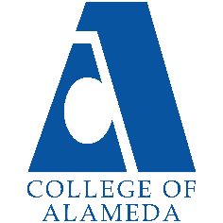
College of Alameda
2024-25 Annual Program Update – Admissions and Records

Program Overview
Please provide your program’s mission statement and program’s learning outcomes
The mission of College of Alameda is to serve the educational needs of its diverse community by providing comprehensive and flexible programs and resources that empower students to achieve their goals.

The mission of College of Alameda Student Services Division is committed to guiding, empowering, and inspiring students to achieve their academic, career and personal goals through a student centered and caring approach.

The Office of Admissions and Records is committed to the values by welcoming and admitting diverse population from the community we serve. We provide face to face and online service to ensure students continue their success with achieving their certificate or degree.

List your program faculty and/or staff.
John Nguyen, Dean of Enrollment
Marcean Bryant, Senior Admission and Records Specialist
Michelle Chen, A&R Evaluator
Margarita Pinilla, A&R Evaluator
Munira Ahmed, A&R clerk
Emma Zheng, A&R clerk (Hourly)
Mohammed Ahmed, (Student Worker)

Describe your current utilization of facilities, including labs and other space.
2 office cubicles, open office with 4 computers

List your program goals from your most recent Program Review or APU. Then, provide an update on the status of the goal. Has your program achieved the goal? Have any of your goals been revised or are any still in progress? Lastly, make sure to discuss which College or District goal your program goal aligns to.
If no program goals exist or if this is your first program review, work to create 2-3 goals and align them with a college or District goal.
Program Goal | A&R will continue to post important deadlines and dates around campus such as add/drop with W and without Ws, and degree petition dates.
Status: In-Progress or Complete? | In Progress
Which college or district goal is aligned with your program goal? | All campuses and District use same academic calendar. CoA’s goal is to strengthen data driven/informed decision making and to reduce loss of students prior to start of classes

Program Goal | Working with Institutional Research and Student Services at large to create a comprehensive student satisfaction survey to assess our services in the next year
Status: In-Progress or Complete? | In Progress
Which college or district goal is aligned with your program goal? | All campuses and District use same academic calendar.  CoA’s goal is to strengthen data driven/informed decision making and to reduce loss of students prior to start of classes

Program Goal | Work with Faculty to adhere to deadline date to submit their Census and Attendance roster on time
Status: In-Progress or Complete? | In Progress
Which college or district goal is aligned with your program goal? | All campuses and District use same academic calendar. CoA’s goal is to strengthen data driven/informed decision making and to reduce loss of students prior to start of classes

Program Update
Using the dashboards, review and reflect upon the data for your program.
Course Success & Retention Rates – Student Services (internal only)
Course Completion and Retention Rates – Student Services Dashboard
Enrollment Trends and Productivity Dashboard
Degrees and Certificates Dashboard

Course Completion and Retention Rates
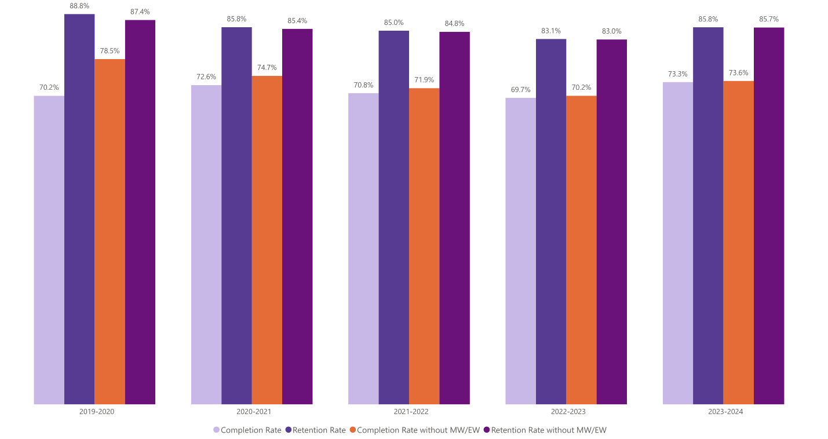

Enrollment Trends
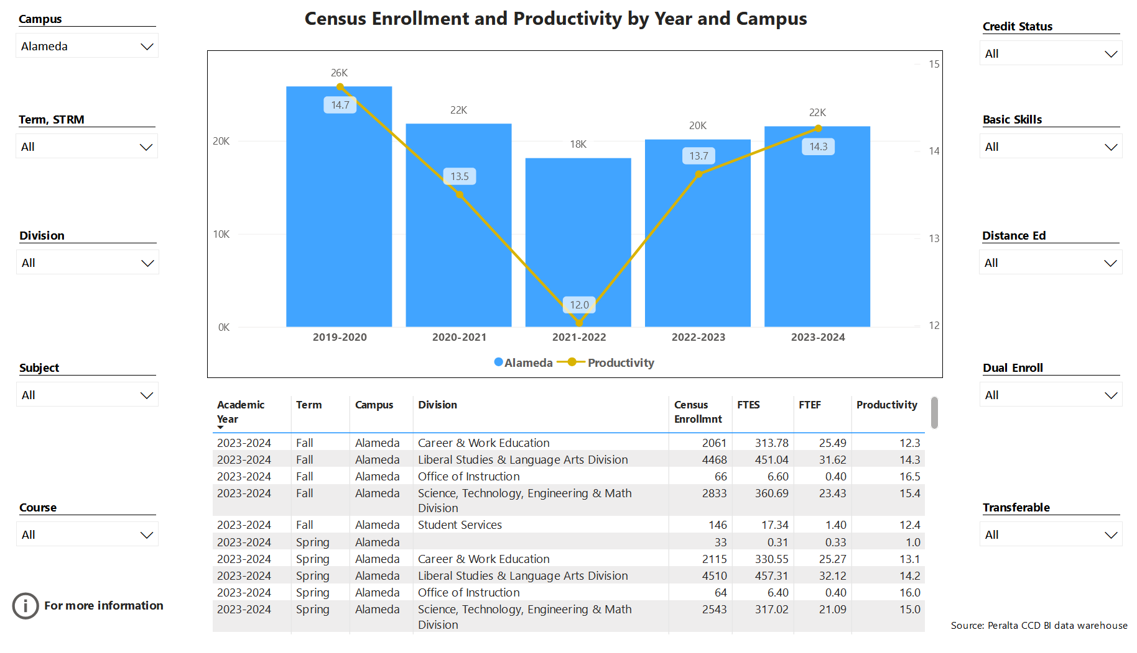

Degrees and Certificates
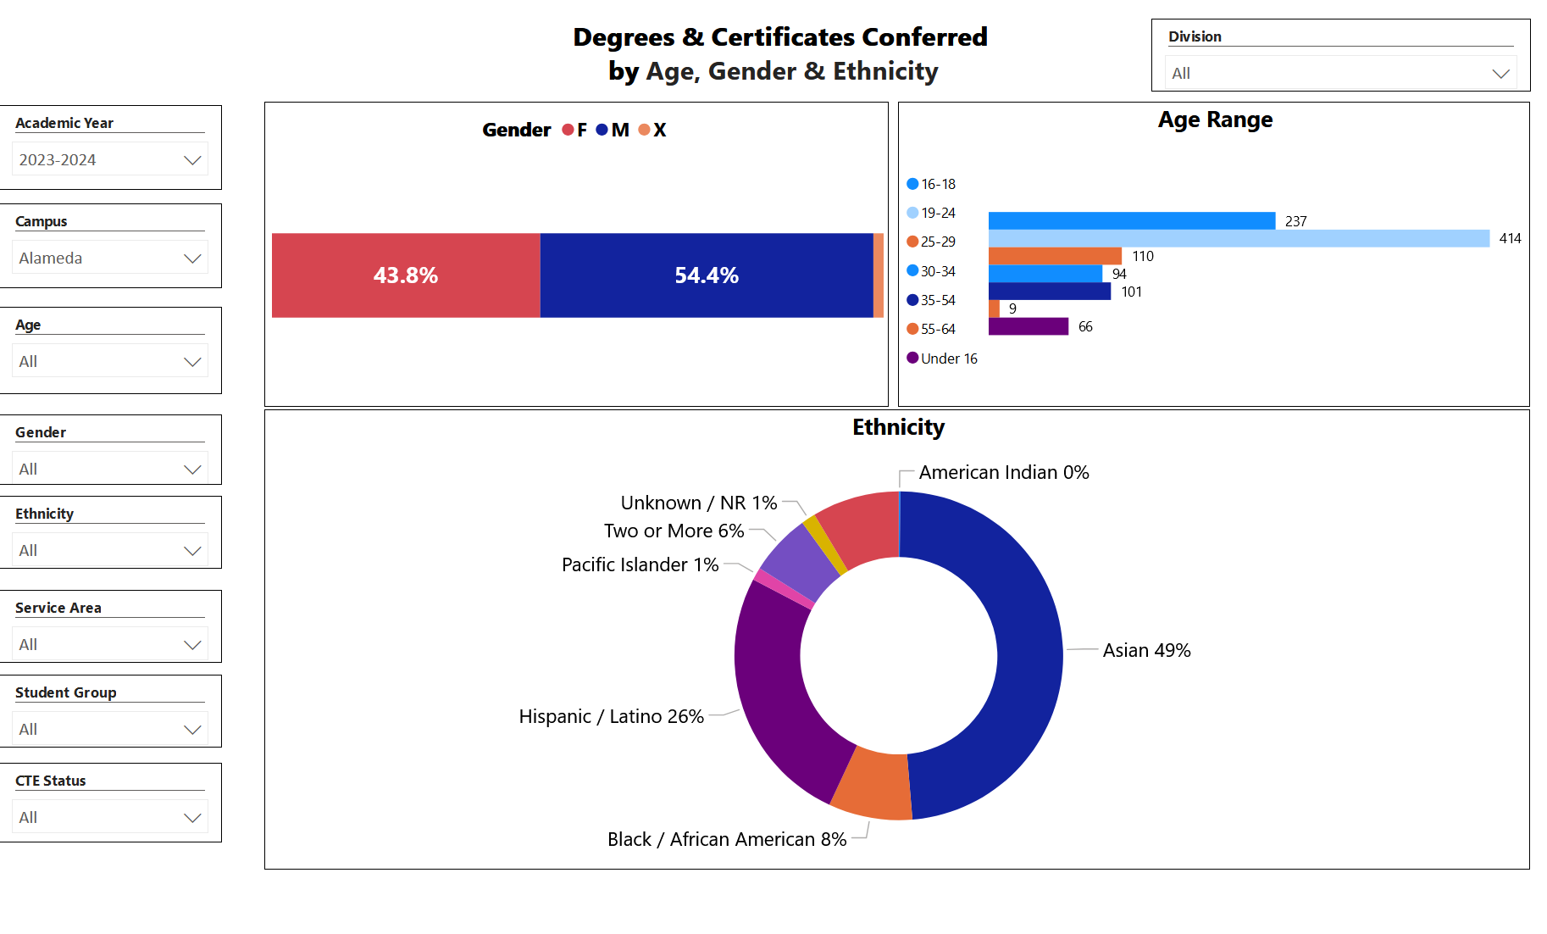

Describe any significant changes and discuss what the changes mean to your program. Consider whether performance gaps exist for disproportionality impacted students by using filters to disaggregate the data. Focus upon the most recent year and/or the years since your last comprehensive program review. Cite data points to support your reflection.
For more information on equity click from CCCCO most current data(2021-2022) on student success metrics on the StudentSuccessMetricsforDIgroups21-22.xlsx
District has provided us access to verify and upload Spam/Fraudulent student application which has improved the wait for new and returning students application to download into our system. Overall, retention and completion rates across the college have shown an upward trend; however, Black and Latinx students continue to experience lower rates than other student groups. To increase completion and retention rates among Black and Latinx students, Admissions & Records (A&R) will promote learning communities such as Umoja and Puente. Additional, A&R will emphasize the importance of other key support resources, including financial aid services, the learning resource center, and basic needs.
Describe the department's progress on Student Learning Outcomes (SLOs) and/or Service Area Outcomes (SAOs) since the last Program Review/APU.
We have seen an increase with our student population that they are using their student portal to navigate how to drop/add through their student portal and access Canvas.

Describe the outcomes and accomplishments from previous year’s funded resource allocation request. If your program did not receive any allocations, leave the boxes blank.
Brief description of funded request | Source (any additional award outside your base allocation) | Total Award Amount | Outcome/Accomplishment
Hired full time evaluator |  | 70K

Prioritized Resource Requests Summary
In the boxes below, please add resource requests for your program. If there are no resources requested, leave the boxes blank.
Resource Category | Description/Justification | Total Estimated Cost
Personnel: Classified Staff | Permanent full time or hourly Senior Clerk/ To assist with increased online services and in person, SR.clerk can also assist evaluator and clerk with daily job functions. | 60K
Personnel: Student Worker | Assist with daily filing, and office function | 7K
Personnel: Part Time Faculty
Personnel: Full Time Faculty

Resource Category | Description/Justification | Total Estimated Cost
Professional Development: Department wide PD needed | Attend CACRO meeting $250.00 (4 people to attend). | $1000.00
Professional Development: Personal/Individual PD needed
Supplies: Software

Supplies: Books, Magazines, and/or Periodicals

Supplies: Instructional Supplies

Supplies: Non-Instructional Supplies | 5 Large Capacity Shredders | S500.00
Supplies: Library Collections

Technology & Equipment | 6 New Computers  5 Ink Printers with Scanners  Toner  3 Laptops (assist with Outreach)  2 Plotter printers  6 Ergonomic Chair  6 Ergonomic keyboards & Mouse | $6000.00  $1500.00  $1000.00  $2100.00  $1000.00  $6000.00  $500.00
Library: Library materials/collections

Facilities: Classrooms/Labs

Facilities: Offices

Other

