
College of Alameda
2024-25 Annual Program Update – Health Services

Program Overview
Please provide your program’s mission statement and program’s learning outcomes
College of Alameda is committed to furthering the equality of the educational opportunity and success for all students by providing access to health services which promote the physical, emotional, social, and spiritual well-being of its students. This well-being contributes to the educational aim of our community colleges by promoting student retention and academic success.

Our Wellness Center at College of Alameda is dedicated to providing accessible, compassionate, evidence-based and trauma-informed mental health support services to empower our community college community. Through innovative programming, personalized counseling, and collaborative community partnerships and engagements, we strive to foster holistic well-being and resilience for all students, faculty, and staff on our campus.

List your program faculty and/or staff.
Lisa Sawadogo, Health Services Coordinator
Debbie Green, LMFT Supervisor
Ismael de Guzman, LMFT
Destiny Walker, AMFT – Part-Time Faculty (FDIP)
Mirisen Ozpek, MFT Intern
Rashmi Guttal, MSW Intern

Describe your current utilization of facilities, including labs and other space.
Health Services is currently housed in the Cougar Village CV – 124. The area is used for mental health counseling and health services support.

Health Services is also provided by Baywell Health at Laney College in the Student Center 4th Floor, Room 410

List your program goals from your most recent Program Review or APU. Then, provide an update on the status of the goal. Has your program achieved the goal? Have any of your goals been revised or are any still in progress? Lastly, make sure to discuss which College or District goal your program goal aligns to.
If no program goals exist or if this is your first program review, work to create 2-3 goals and align them with a college or District goal.
Program Goal | Assess success at providing culturally sensitive services for students by surveying students about their experience with wellness services.
Status: In-Progress or Complete? | In Progress
Which college or district goal is aligned with your program goal? | College: Increase retention and persistence rates District: Advance student access, equity, and success

Program Goal | Launch workshops and informational sessions for disproportionately impacted student groups to improve awareness and access to health services.
Status: In-Progress or Complete? | In Progress
Which college or district goal is aligned with your program goal? | College: Increase retention and persistence rates District: Advance student access, equity, and success

Program Goal | Establish peer-led health initiatives where trained student peer mentors provide wellness guidance and promote health services.
Status: In-Progress or Complete? | In Progress
Which college or district goal is aligned with your program goal? | College: Increase retention and persistence rates District: Advance student access, equity, and success

Program Update
Using the dashboards, review and reflect upon the data for your program.
Course Success & Retention Rates – Student Services (internal only)
Course Completion and Retention Rates – Student Services Dashboard
Enrollment Trends and Productivity Dashboard
Degrees and Certificates Dashboard

Course Completion and Retention Rates
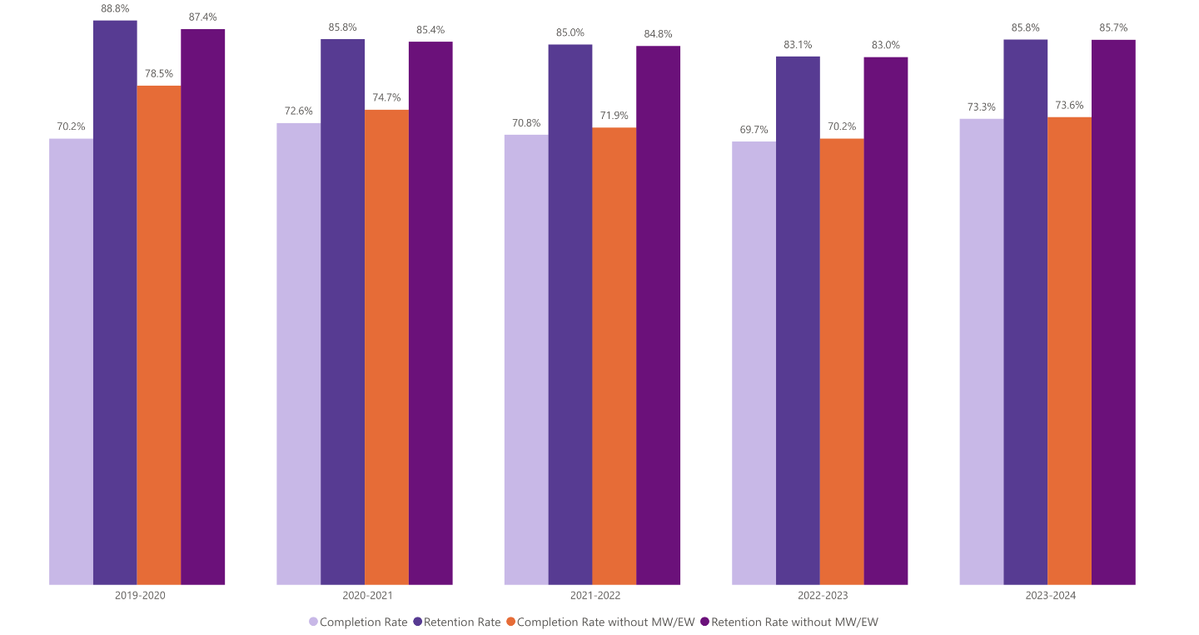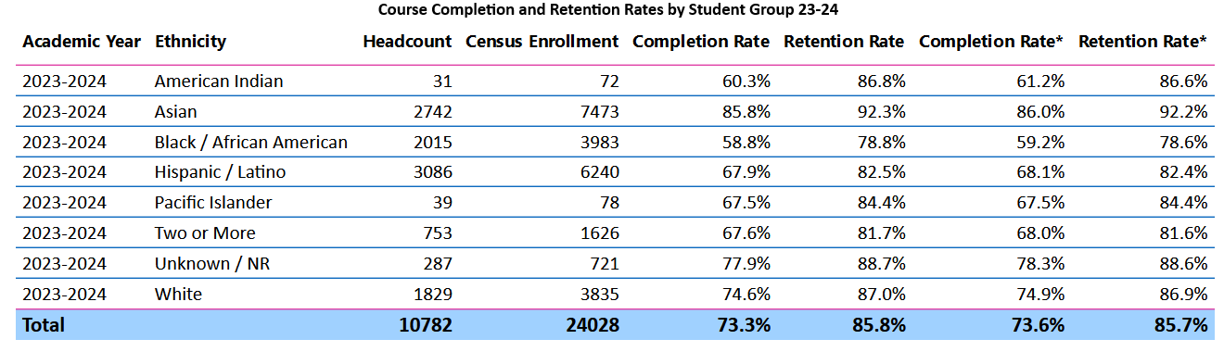

Enrollment Trends
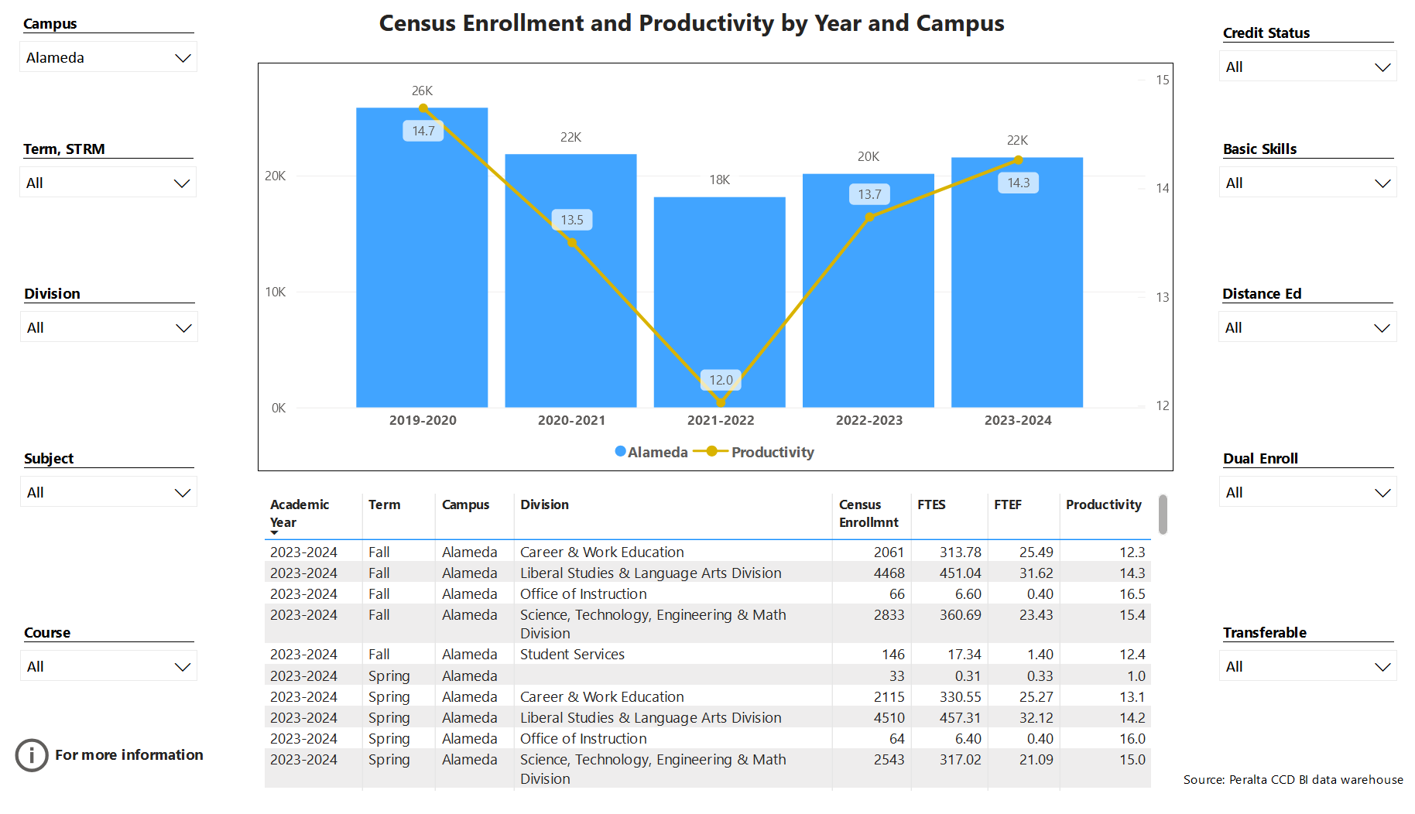

Degrees and Certificates
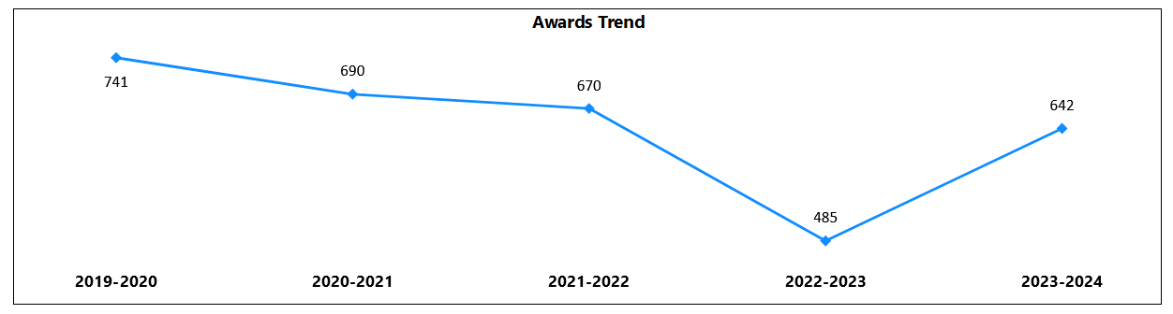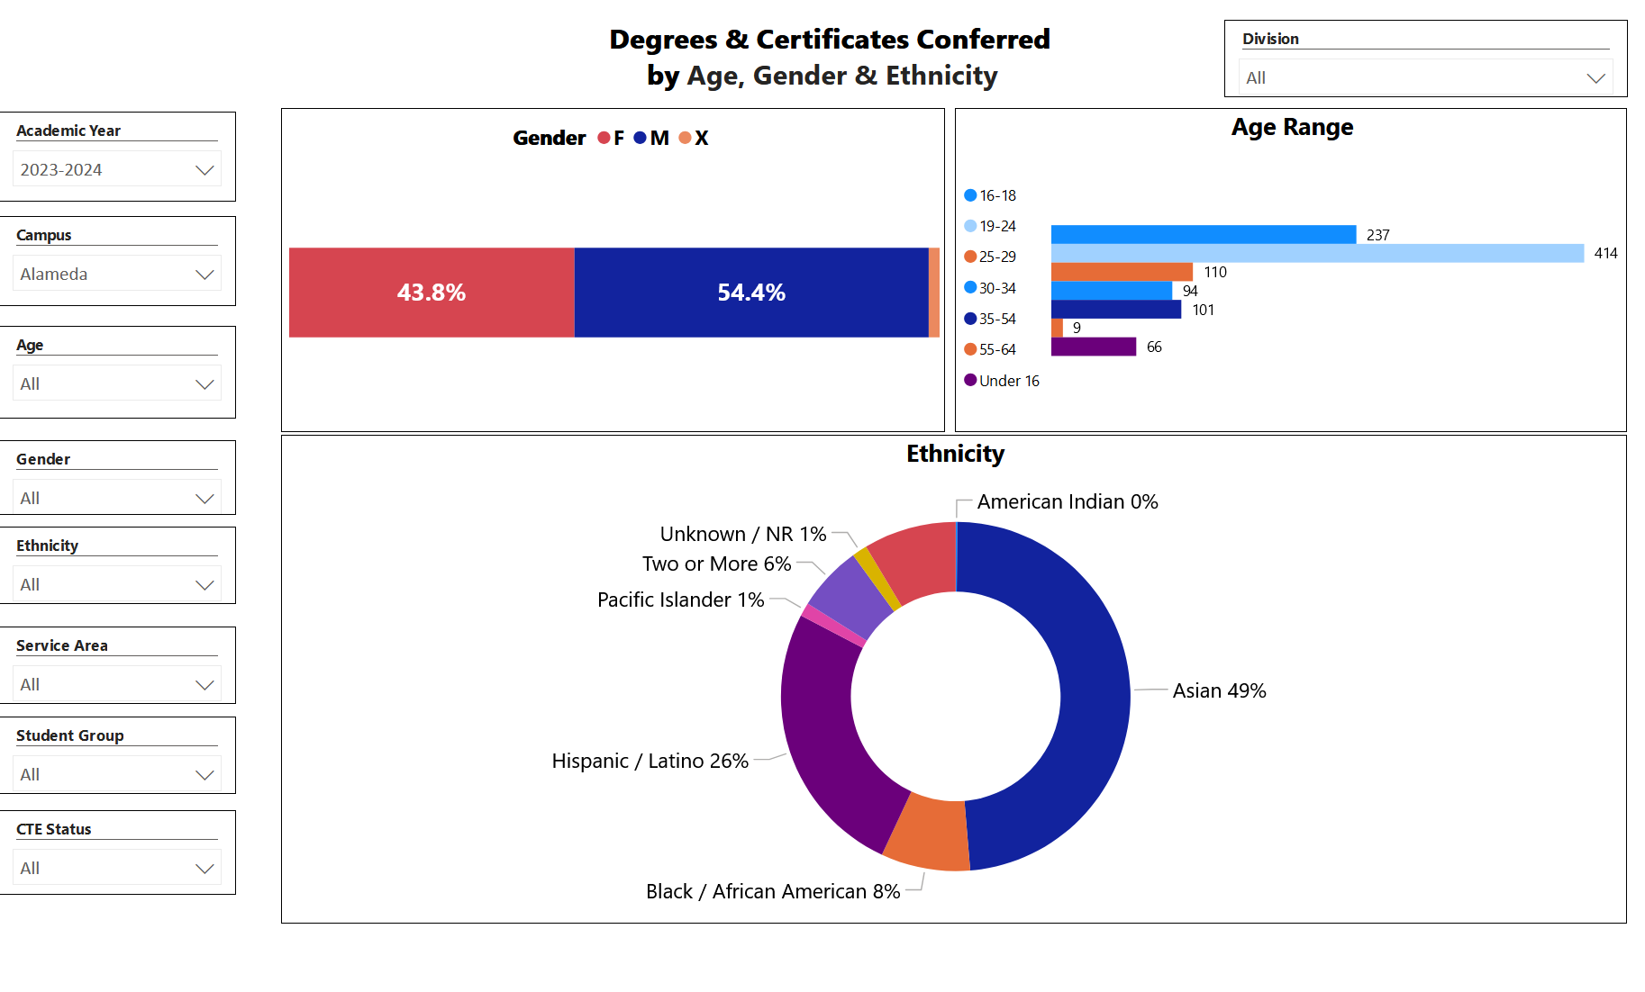

Describe any significant changes and discuss what the changes mean to your program. Consider whether performance gaps exist for disproportionality impacted students by using filters to disaggregate the data. Focus upon the most recent year and/or the years since your last comprehensive program review. Cite data points to support your reflection.
For more information on equity click from CCCCO most current data(2021-2022) on student success metrics on the StudentSuccessMetricsforDIgroups21-22.xlsx
Although overall retention and completion rates at the college have improved compared to the previous year, Black and Latinx students continue to face lower outcomes relative to other student groups. To help close the retention and completion gap for Black and Latinx students, Health Services will focus on culturally responsive services, enhancing access to mental health resources, and connecting students to learning communities such as Puente an Umoja.
Describe the department's progress on Student Learning Outcomes (SLOs) and/or Service Area Outcomes (SAOs) since the last Program Review/APU.
- Healthier Decision-Making – the department has organized successful workshops for specific student groups including LGBQIA+ groups and students working through grief.
- Improved Coping Strategies – efforts have been directed to support students identify coping mechanisms through workshops.

Describe the outcomes and accomplishments from previous year’s funded resource allocation request. If your program did not receive any allocations, leave the boxes blank.
Brief description of funded request | Source (any additional award outside your base allocation) | Total Award Amount | Outcome/Accomplishment
1 Part-Time Mental Health Counselor Faculty |  | $78,000 | The hiring of a part-time mental health counselor faculty has provided additional support for our students. This increased student engagement and provided more appointments for students.
2 – MFT Trainees |  | $10,400 | Under the supervision of a licensed LMFT Supervisor, the trainees provided additional appointments for students.

Prioritized Resource Requests Summary
In the boxes below, please add resource requests for your program. If there are no resources requested, leave the boxes blank.
Resource Category | Description/Justification | Total Estimated Cost
Personnel: Classified Staff

Personnel: Student Worker

Personnel: Part Time Faculty | 3 Part-Time FDIP (Faculty Diversity Internship Program) Consistent increase in severe mental health needs of students and need for experienced, licensed therapist to assist with crisis assessments and on-going support for students. There is also a need for licensed mental health counselors to cover summer hours and supervision of interns. | $90,000
Personnel: Full Time Faculty | There is a need for an 11- month contract and extra service. The Health Services Coordinator position is a big job with multiple essential functions. The demand for mental health and wellness services will continue to grow. The job is impossible to do in a 10-month, 30 hour per week contract.  1 – Full-Time Mental Health Specialist | 11-month contract $10,000  Extra Service - $6,100  $145,000

Resource Category | Description/Justification | Total Estimated Cost
Professional Development: Department wide PD needed
Professional Development: Personal/Individual PD needed
Supplies: Software

Supplies: Books, Magazines, and/or Periodicals

Supplies: Instructional Supplies

Supplies: Non-Instructional Supplies

Supplies: Library Collections

Technology & Equipment | Smart Classroom – In our new space there is a need to have the ability to present workshops and provide trainings for the campus community. | $20,000
Library: Library materials/collections

Facilities: Classrooms/Labs

Facilities: Offices

Other

