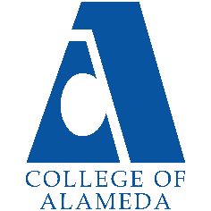
College of Alameda
2024-25 Annual Program Update – Outreach

Program Overview
Please provide your program’s mission statement and program’s learning outcomes
Outreach serves as the first point of contact, engages students and potential students, provides resources, options, and aids students, regardless of their circumstances and/or background in completing a successful enrollment process

List your program faculty and/or staff.
Juliana Garcia Outreach Specialist has supported outreach efforts since August 19th. Ryan Gregory Enrollment Services Coordinator started in his position on October 28th.
The department is planning on hiring 3-4 student workers through FWS or with other funds if available.

Describe your current utilization of facilities, including labs and other space.
Outreach organizes tours across all different departments and facilities on campus including ATECH, Fab Lab, DMECH, ADAM, Library, and A-Building with student services. The Outreach Specialist’s office is in room F-115 and the Enrollment Services Coordinator is in the A-Building.

List your program goals from your most recent Program Review or APU. Then, provide an update on the status of the goal. Has your program achieved the goal? Have any of your goals been revised or are any still in progress? Lastly, make sure to discuss which College or District goal your program goal aligns to.
If no program goals exist or if this is your first program review, work to create 2-3 goals and align them with a college or District goal.
Program Goal | Provide targeted support and information to the public regarding the application process, orientation, and counseling (ensure information is consistently updated, platforms consistently re-evaluated).
Status: In-Progress or Complete? | In-progress
Which college or district goal is aligned with your program goal? | Providing quality educational and student support services that result in equitable student access to educational opportunities.

Program Goal | Encourage students who are below 6 units to enroll in late start classes or weekend classes to increase their enrollment and better fit their schedules. Use incentives such as clipper card, and grants that are offered through Basic Needs office.
Status: In-Progress or Complete? | In-progress
Which college or district goal is aligned with your program goal? | - Providing quality educational and student support services that result in equitable student access to educational opportunities.  - Leverage existing resources to maximize academic opportunities for all students  and provide accessible and inclusive physical and virtual learning environments that  promote equitable academic excellence.

Program Goal | Engage our current partners such as Girls Inc, OUSD, and AUSD. Reach out to cultivate relationships with new partners such as Underground Teen Center, MUA, Washoe Native Program, Sudanese for Northern California and Hayward
Status: In-Progress or Complete? | In-progress
Which college or district goal is aligned with your program goal? | Be rooted in the community and engage in ongoing partnerships with our sister colleges, P–16 educational partners, community organizations, and local and regional  industry partners.

Program Update
Using the dashboards, review and reflect upon the data for your program.
Course Success & Retention Rates – Student Services (internal only)
Course Completion and Retention Rates – Student Services Dashboard
Enrollment Trends and Productivity Dashboard
Degrees and Certificates Dashboard

Course Completion and Retention Rates
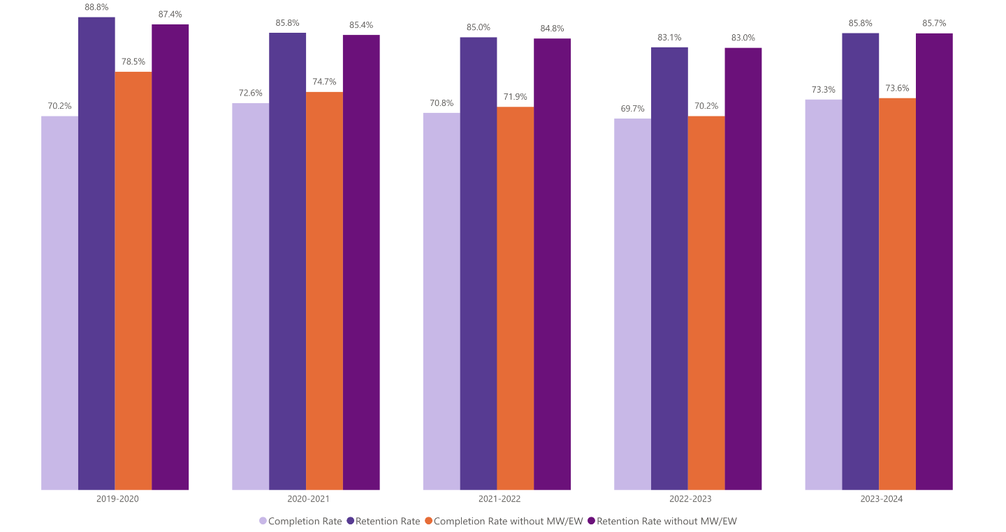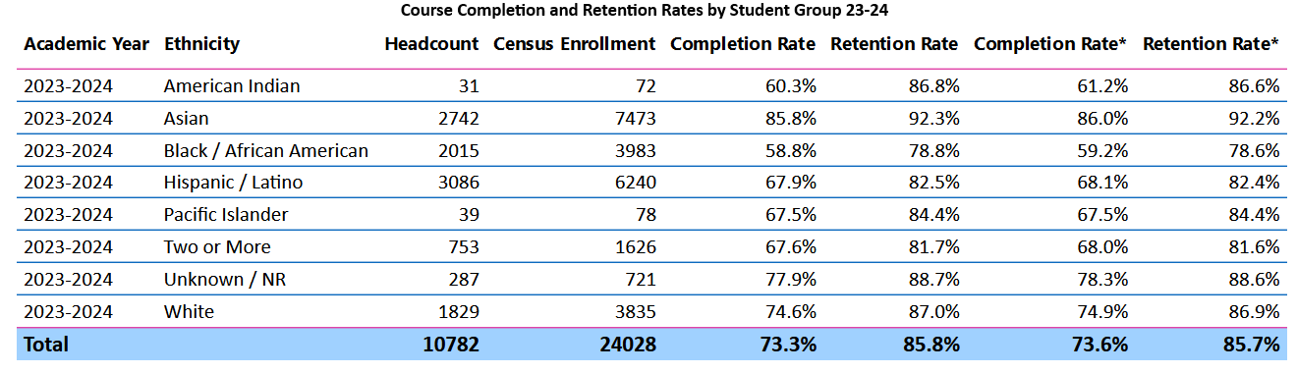

Enrollment Trends
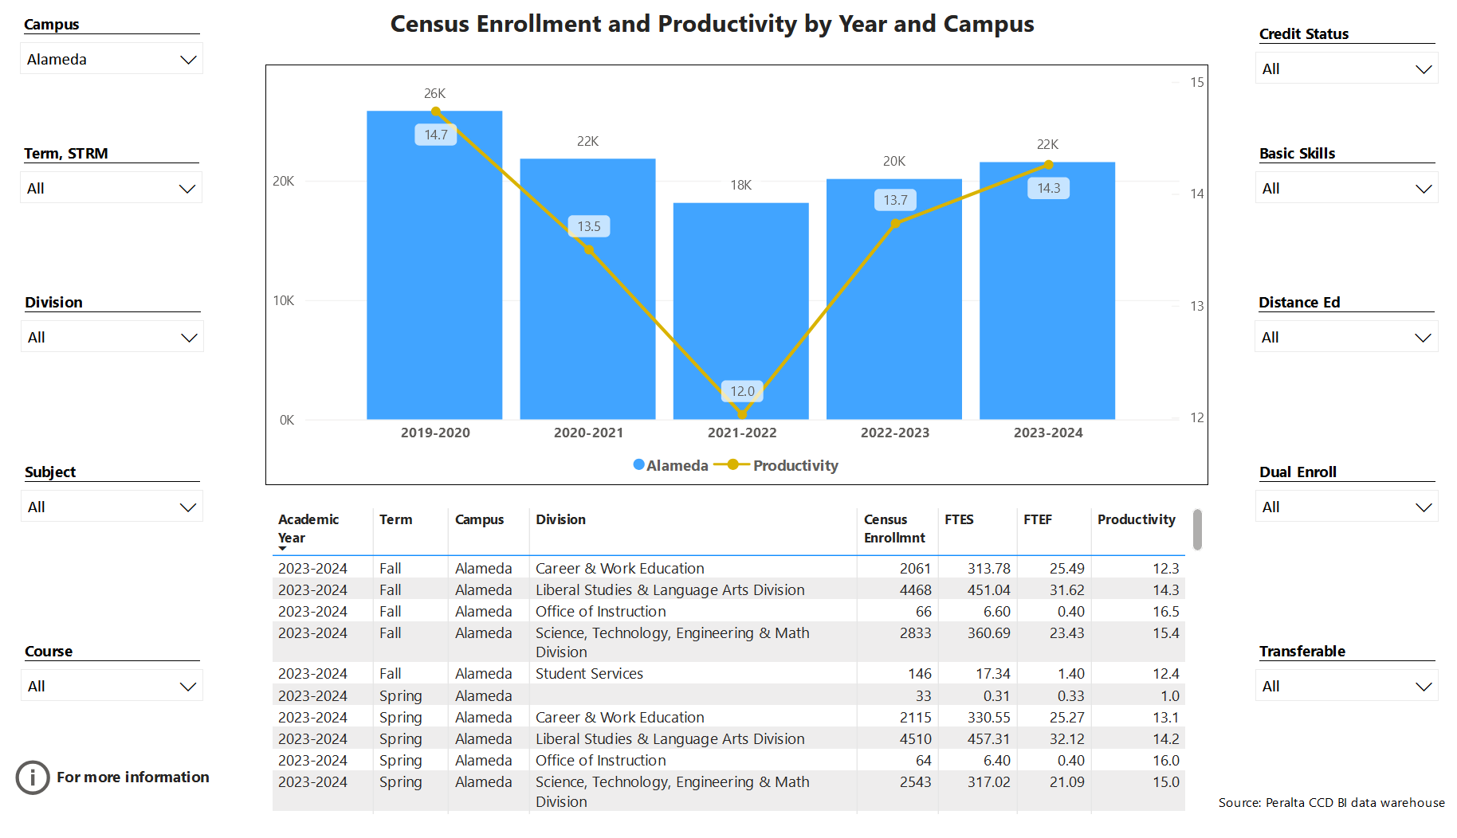

Degrees and Certificates
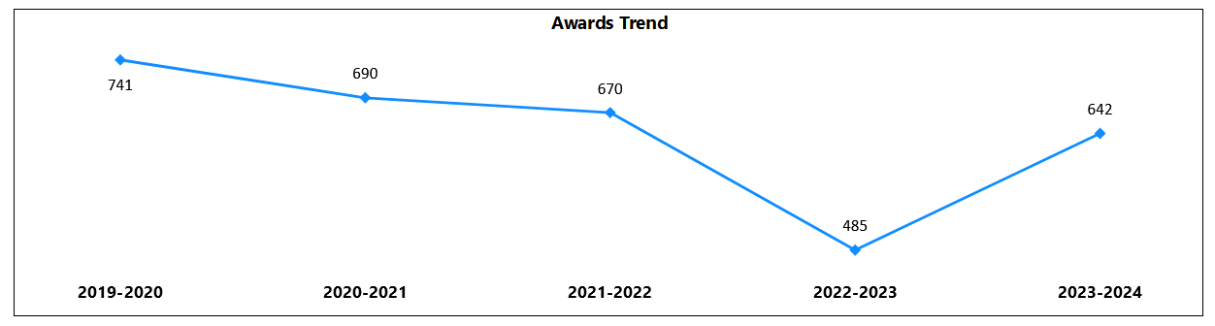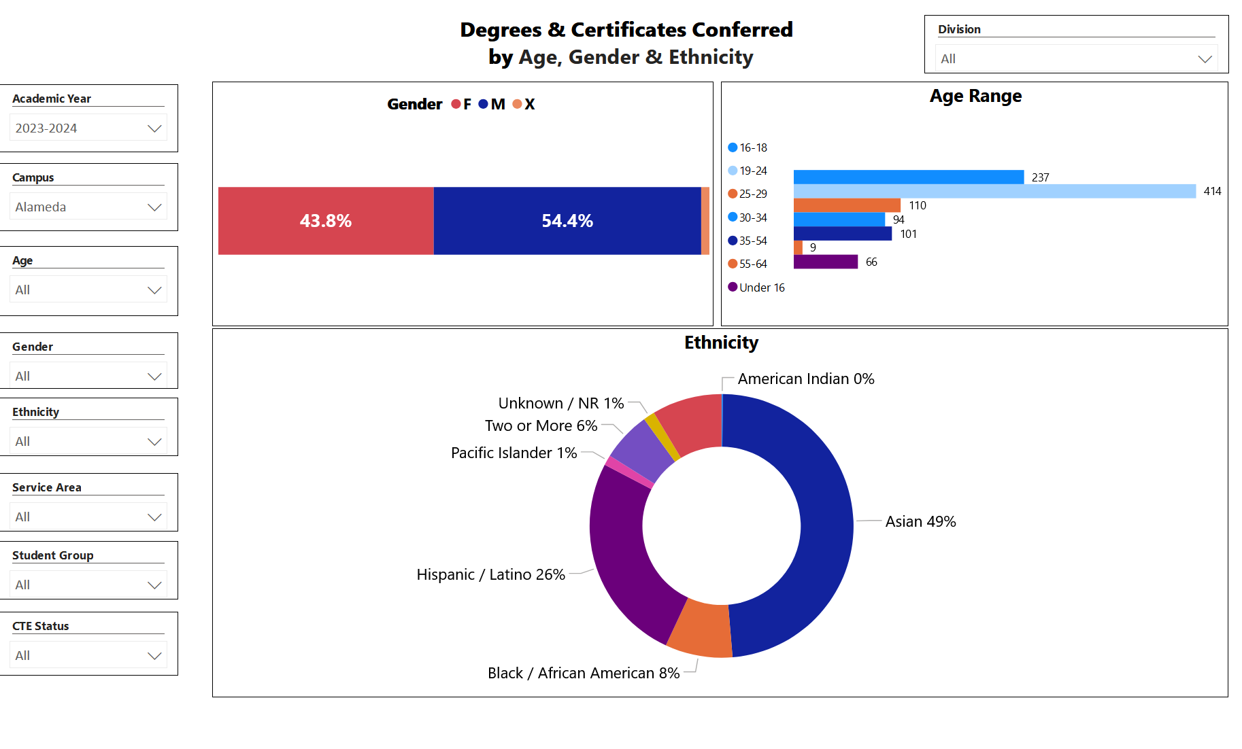

Describe any significant changes and discuss what the changes mean to your program. Consider whether performance gaps exist for disproportionality impacted students by using filters to disaggregate the data. Focus upon the most recent year and/or the years since your last comprehensive program review. Cite data points to support your reflection.
For more information on equity click from CCCCO most current data(2021-2022) on student success metrics on the StudentSuccessMetricsforDIgroups21-22.xlsx
Overall retention and completion rates across the college have increased from the previous year, but Black and Latinx students still have lower rates compared to other groups. Census enrollment has increased from 20K to 22K compared to the previous school year and awards conferred has also increased substantially from 485 to 642. To increase completion and retention rates for Black and Latinx students we will highlight Umoja and Puente along with resources to support students such as financial aid, learning resource center, and basic needs center.
Describe the department's progress on Student Learning Outcomes (SLOs) and/or Service Area Outcomes (SAOs) since the last Program Review/APU.
Since the last Program Review/APU, the Outreach department has made significant strides in refining our Student Area Outcomes (SAOs). The department has been focused on increasing student engagement and connection to the college through various outreach strategies.

1) Increased Outreach and Partnerships
- Outreach has expanded its connections with local high school and community partners. This helps with strengthening pipelines for new student enrollment and awareness of our programs and resources.
- Data has shown an increase in the number of community events attended, resulting in higher interest among potential students.

2) Progress on SAOs
- Ensure students have the resources and information needed for enrollment. Students now better understand how to apply for college and have more knowledge.
2) Continuous Improvement
- The department has been committed to keeping data of outreach efforts. By comparing the yearly data, the department has been able to identify positive trends, such as an increased in community partnerships resulting in higher rates of completed applications.

Describe the outcomes and accomplishments from previous year’s funded resource allocation request. If your program did not receive any allocations, leave the boxes blank.
Brief description of funded request | Source (any additional award outside your base allocation) | Total Award Amount | Outcome/Accomplishment

Prioritized Resource Requests Summary
In the boxes below, please add resource requests for your program. If there are no resources requested, leave the boxes blank.
Resource Category | Description/Justification | Total Estimated Cost
Personnel: Classified Staff | Hourly support to help with outreaching events | 20,000
Personnel: Student Worker | 3 Student workers | 30,000
Personnel: Part Time Faculty
Personnel: Full-Time Faculty

Resource Category | Description/Justification | Total Estimated Cost
Professional Development: Department wide PD needed
Professional Development: Personal/Individual PD needed
Supplies: Software

Supplies: Books, Magazines, and/or Periodicals

Supplies: Instructional Supplies

Supplies: Non-Instructional Supplies

Supplies: Library Collections

Technology & Equipment

Library: Library materials/collections

Facilities: Classrooms/Labs

Facilities: Offices

Other | Outreaching swag, brochures/flyers | $15,000

