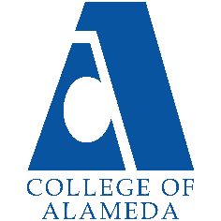
College of Alameda
2024-25 Annual Program Update – Student Accessibility Services

Program Overview
Please provide your program’s mission statement and program’s learning outcomes
The mission of Student Accessibility Services (SAS) is to provide exemplary support services, instruction and access to students with disabilities. SAS supports students with disabilities in instructionally related activities consistent with the mission, vision, and values of the College of Alameda and in compliance with federal and state laws. With equal access as its hallmark, the faculty and staff of SAS are committed to the following:
- Opportunity: To ensure equal educational opportunities to students with disabilities who have the potential for achieving academic and vocational goals consistent with a community college program.
- Empowerment: To empower students with disabilities to achieve independence and integration leading to maximum participation in the college and the community.
- Awareness: To provide information and support to College of Alameda employees and students in carrying out the institution’s responsibility to students with disabilities.
List your program faculty and/or staff.

Full Time

Rachel Goodwin, SAS Coordinator/Counselor (1.0 FTE faculty)

Denise Maffett, SAS Staff Assistant (1.0 FTE classified professional)
Michelle Custino, Adapted Computer Technician (1.0 FTE classified professional)
Jacinda Marshall, SAS Counselor (1.0 FTE faculty)
Nadeesha Dias, SAS Counselor (1.0 FTE Faculty)
Lynn Rex, Learning Disability Specialist/Instructor (1.0 FTE faculty)
Aurora Laniohan, SAS Data Specialist/WAIII Assistant (hourly/temporary full-time classified professional)
Wanda Wright, Instructional Assistant/Educational Coach - Contract Ed, SAS, and College to Career (hourly/temporary full-time classified professional)
Part Time
Michelle Custino, Alternate Media Specialist (overtime extra assignment classified professional)
Maria Brown, Instructor for contract education (hourly part-time faculty)
Beth Rudolf, Instructor for SAS (Cognitive Skills)
Randy Watkins, Instructor for SAS (Assistive Technology Instructor)
Nancy Freed, Instructional Aide Learning Skills Program (hourly part-time classified professional)
Geraldine Hasse, Instructional Aide Learning Skills Program (hourly part-time classified professional)
Van Tran, Instructional Aide Learning Skills Program (hourly part-time classified professional)
Vy Tran, Instructional Aide Learning Skills Program (hourly part-time classified professional)
Student Workers (hired as note takers for SAS students, and as lab and office assistants)
Sign Language Interpreters (variable number and hours based on student accommodation needs)
VACANT
Support Services Specialist (hourly/temporary full-time classified professional)

Describe your current utilization of facilities, including labs and other space.
D-117: SAS is housed primarily and this office suite. Space is fully utilized for SAS counseling, student-facing front office services, accommodation coordination, proctored testing for students requiring individual testing spaces, adaptive equipment storage, SAS meetings, and records and document storage.
D-116: SAS Adapted Computer Lab is used for alternate media production, to serve students requiring computer access assistance/instruction, and is a classroom/lab space for LRNRE 211 Computer Access.
D-115B: SAS Instructional Faculty office
L-210: this space is used for Educational Assistance Class instruction (Learning Skills Program and Diagnostic Assessment classes), secure document storage (LD assessment materials) and full-time instructor, LD Specialist, office.
A-225: Cognitive Skills program classes are taught in this computer lab classroom.
H building classrooms: Classes for our Contract Education program are taught in assigned H building classrooms.

List your program goals from your most recent Program Review or APU. Then, provide an update on the status of the goal. Has your program achieved the goal? Have any of your goals been revised or are any still in progress? Lastly, make sure to discuss which College or District goal your program goal aligns to.
If no program goals exist or if this is your first program review, work to create 2-3 goals and align them with a college or District goal.
Program Goal | SAS will work with the District to complete the implementation of Accessible Information Management (AIM), a district-wide SAS file and accommodation management system. AIM will serve to: Improve remote access for SAS faculty and classified professionals to student SAS files, increase the fluidity with which students’ accommodations can be provided, improve the student experience for students enrolled at multiple PCCD campuses.
Status: In-Progress or Complete? | In progress – Instructor notification letters and student file elements are active; Equipment loan module is active and in use at COA. Instructor portals are nearing implementation. Alternate Media components, notetaking component and several other essential elements are not yet active. Implementation is reliant on the AIM faculty facilitator (district hired stipend position) and PCCD IT.
Which college or district goal is aligned with your program goal? | PCCD Goals  A - Advance Student Access, Equity, and Success  C- Build Programs of Distinction  D-Strengthen Accountability, Innovation and Collaboration  COA Goals  Increase access to college programs/coursework through collaboration with other PCCD colleges  Advance COA Teaching and learning.  Reduce loss of students prior to the start of classes.  Strengthen data-driven/informed decision making..

Program Goal | SAS seeks to hire sufficient permanent classified professional staff to meet the program’s staffing needs. To date SAS has had to rely on long-term, full-time, hourly classified staff. These positions deserve the respect and security of permanency. SAS relies on these staff members for the provision of mandated MIS data reporting, student accommodations, and instructional faculty support.
Status: In-Progress or Complete? | In-Progress: There has been no successful movement on this goal. As noted previously, while other temporary/hourly classified professionals in the district were converted to permanent status, district and union personnel did not proceed with this conversion for SAS’s long-term, full-time hourly/temporary personnel. Additionally, budgetary constraints have limited SAS’s ability to even replace hourly classified professional staff member who died in the 2023-24 academic year. SAS has “made due” with current staffing, reliant on faculty coordinator, counselors and other hourly staff to attempt to cover the responsibilities of the role left vacant due to the employee’s death.
Which college or district goal is aligned with your program goal? | PCCD Goals  A – Advance Student Access, Equity, and Success  D– Strengthen Accountability, Innovation, and Collaboration  E – Develop and Manage Resources to Advance Our Mission  COA Goals  Advance COA teaching and learning.  Reduce loss of students prior to the start of classes.  Strengthen data-driven/informed decision making.

Program Update

Using the dashboards, review and reflect upon the data for your program.

Course Success & Retention Rates – Student Services (internal only)
Course Completion and Retention Rates – Student Services Dashboard
Enrollment Trends and Productivity Dashboard
Degrees and Certificates Dashboard

Course Completion and Retention Rates
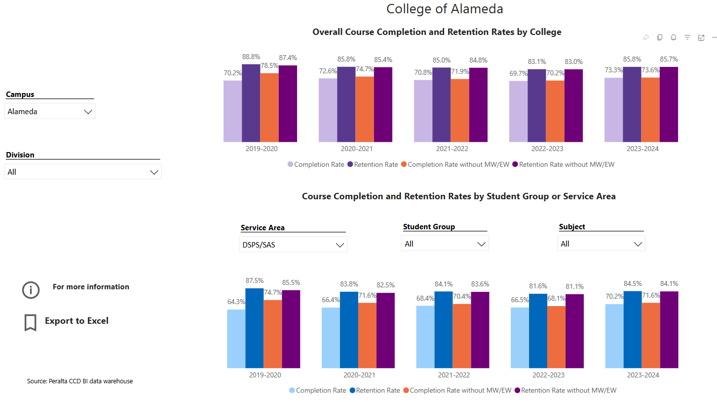

In the 2023-24 year SAS-affiliated students at COA had course completion rate 3.1% lower than the overall campus population course completion rates; 2.0% lower for completion rate without MW/EW. Retention rates were 1.3% lower than those of the overall campus population; 1.6% lower for retention rate without MW/EW. These discrepancies in completion and retention are similar to, but smaller than those found in prior years.

Enrollment Trends
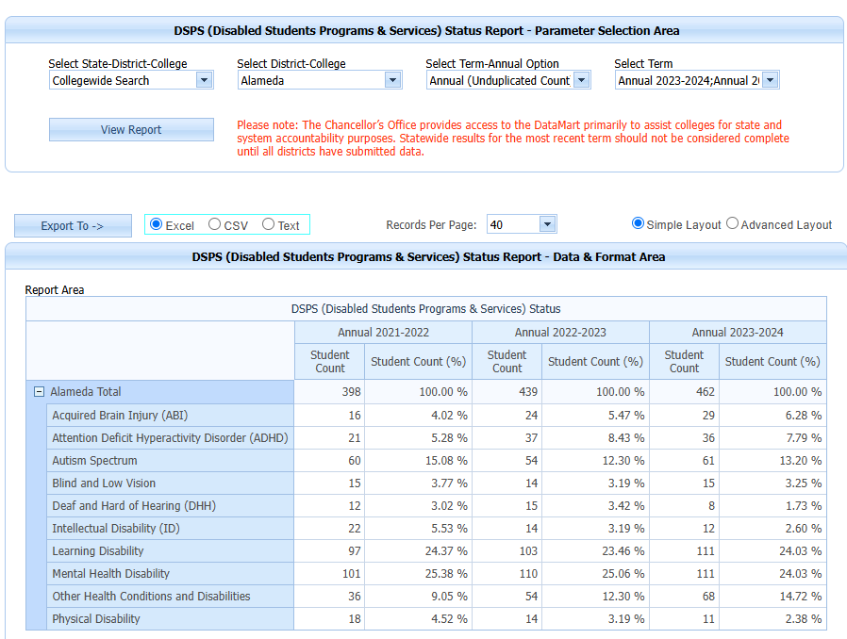

Degrees and Certificates

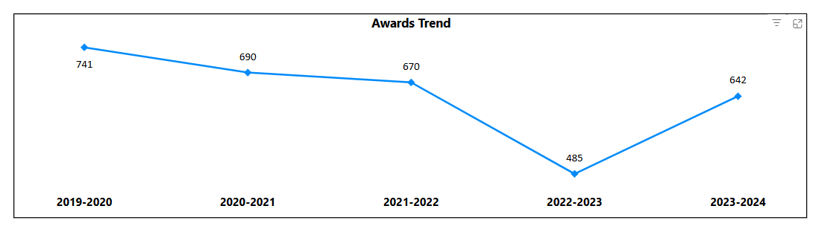
College of Alameda awarded 642 earned degrees and certificates in 2023-24, this up from a low of 485 in 2022-23.

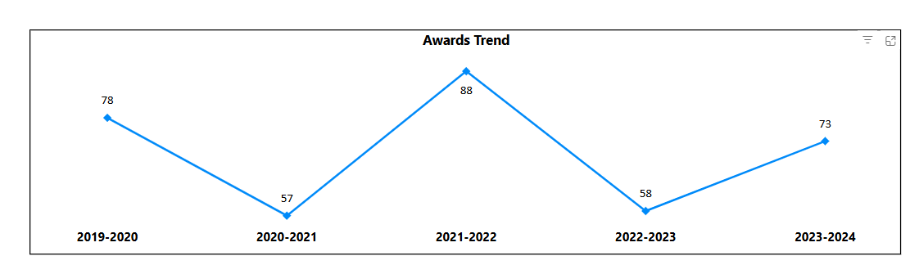
SAS students at COA earned 73 degrees and certificates in 2023-24, this up from 58 in 2022-23 and below the peak of 88 awards in 2021-22. The peak in 2021-22 may be related to SAS students who returned to complete or petition for completed awards after the COVID-19 pandemic and return to in-person services and instruction.

Describe any significant changes and discuss what the changes mean to your program. Consider whether performance gaps exist for disproportionality impacted students by using filters to disaggregate the data. Focus upon the most recent year and/or the years since your last comprehensive program review. Cite data points to support your reflection.
For more information on equity click from CCCCO most current data(2021-2022) on student success metrics on the StudentSuccessMetricsforDIgroups21-22.xlsx
Student Accessibility Services (SAS) student populations fluctuate and the changes in enrollment of students with disabilities may be due to numerous factors.

SAS saw a significant drop in student enrollment after the onset of the COVID-19 pandemic. In fall 2019 SAS served 405 students, in fall 2020 SAS served 254 students, in fall 2021 SAS served 266 students, in fall 2022 SAS served 309 students, and in fall 2023 SAS served 331 students. Much of this drop is likely due to the change in instructional modality to distance learning and the many impacts that the COVID-19 pandemic has had on our students. We see growth each year since fall 2021, but we are not yet back to pre-pandemic student enrollment is SAS.
Over the past several years SAS unduplicated student count has dropped from peak of 582 in 2018-19 to a low of 368 in 2020-21, and the program has been slowly regaining student count, reaching 462 in 2023-24.

Comparing overall College of Alameda student completion and retention rates to those of SAS students, students enrolled in SAS have completion rates somewhat lower than those of the campus population as a whole. SAS students enroll in classes across every campus discipline, and without detailed research, we are unable to identify the campus-specific factors that influence the completion and retention rates for SAS students. Factors to consider: limited options in teaching modality for some required courses, changes in course instructional terms post-registration (full term classes being changed by the college to late-start, shorter-term instruction), and variable levels of instructor engagement and compliance in the accommodation process, among others. SAS engages in the campus-wide planning to improve course completion and retention.

SAS personnel continue to participate in the implementation process for Guided Pathways, as well as engaged in discussions about the role of SAS in response to AB705 and AB1705 implementation.

Implementation of AB 705 and AB 1705 may compound the need for added Educational Assistance classes and additional supports as students are compelled to take college and transfer level courses in English and math, particularly with the reduction and/or elimination of remedial coursework. Many students with disabilities arrive at the college without adequate academic preparation, having had their high school curriculum modified significantly. These students will require greater support in order to succeed in college coursework given that college work is not modified, truncated, or altered in the manner that much of their prior K-12 work may have been.

SAS has also experienced a significant challenge in identifying and hiring qualified Sign Language Interpreters. In the wake of AB 5, a state law that required companies statewide to reclassify/hire independent contractors as employees, many ASL interpreters have left the field. This statewide shortage, in conjunction with PCCD’s low pay rate for hourly interpreters versus the industry standard, has severely negatively impacted Deaf students in need of interpreting services. While SAS has sought ICC’s with agencies, PCCD processes for ICC approval and worker shortages within those agencies, continues to present challenges when ASL interpreting is needed for basic communication access in COA classes. The PCCD District Interpreting Coordinator has been advocating for competitive compensation for ASL interpreters, and the district has recently approved two full-time district interpreters.

SAS provides class presentations to numerous classes, including math, accounting, science, African-American studies, and English, to make students aware of our services. SAS provides outreach presentations to high schools and adult transition programs throughout the year.

SAS reaches out by email to all students registered with our program to ensure that they are aware of Priority Registration dates and counseling availability. Students who enroll at multiple PCCD campuses must request their accommodations each term at each campus where they are enrolled. COA SAS monitors the AIM accommodation system and sends outreach emails to students reminding them to meet with a COA SAS counselor to set up their accommodations, if they have not already done so.

Describe the department's progress on Student Learning Outcomes (SLOs) and/or Service Area Outcomes (SAOs) since the last Program Review/APU.
SAO 3 was assessed in Spring 2024
A survey was sent out by email to all students who registered with SAS during the 2023-2024 academic year. Students were asked to assess the degree to which they agree that SAS staff and faculty worked with them to identify the appropriate academic accommodations necessary to address their individual disability needs using Likert scale responses.
Student Accessibility Services (SAS) sent this survey to the 324 unduplicated students who were enrolled with SAS for the 2023-2024 academic year. We received 25 responses, a 7.72% response rate. Of the 25 responses, 22 (88%) answered "Strongly Agree" or "Agree" to the question: "SAS staff and faculty worked with me to identify the appropriate academic accommodations necessary to address my individual disability needs". The remaining 3 responses included "Disagree" (N=2) and "Strongly Disagree" (N=1).
SAS exceeded our 75% SAO goal with 88% of the student who responded to the survey reporting agreement (strongly agree or agree) that SAS staff and faculty worked with me to identify the appropriate academic accommodations necessary to address my individual disability needs.
While SAS exceeded our goal based on the survey respondents, it would be beneficial to find a way to increase the response rate. Additionally, it would be useful to request students provide contact information if they would be willing to discuss their survey responses in greater detail.
SAS SAO 2 was assessed in Spring 2023:
SAO 2: Goal Setting: Through an interactive process with their SAS counselor students will identify and develop a Student Educational Plan, focused on individual academic, vocational, and/or personal growth goals.
Data analysis of student records was completed to determine the number os SAS students with existing Student Educational Plans was completed. Utilization of MIS data for COA SAS for the term being assessed provided the sample of students to review; the researcher then completed a review of the Peralta student information system (Campus Solutions) to review the SEPs for the sample group of SAS students.
Of the 225 students receiving COA SAS services in spring 2023, 183 have worked with a counselor and had an active Student Educational Plan in Campus Solutions. This yields a 81.33% rate of students meeting the SAO success criteria, and meets our goal of a minimum of 80% of SAS students having created and SEP with a counselor.
18.67% percent (N=42) of the students registered with COA's SAS in spring 2023 do not have SEPs. It would be worth reviewing those individual student cases to determine if there is a reason that the student does not have an SEP. SAS Counselors plan to review data on students who do not have Student Education Plans to determine whether additional professional development is needed, or whether it may be student based (some students only attend a single class, sometimes only a 3-week intersession classes, and may only meet to establish accommodations, for example).

SAS SAO 1 was assessed in Spring 2022:
A survey was sent out by email to all students who registered with SAS during the 2021-22 academic year.

One survey question included was "The SAS program is a welcoming and positive environment making it comfortable to request assistance." Students could respond by selecting: "Strongly Agree", "Agree", "Disagree", or "Strongly Disagree". The surveys were also made available in alternate formats and information on how to request alternate format surveys was included in the original email and at the beginning of the online survey.
Despite sending the survey to all students who were registered with SAS in 2021-22 (336 unduplicated students at the time of survey) we had only 38 responses, a 11.31% response rate. Of those responding, 97.37 percent of students reported that they either "Strongly Agree" (n=35) or "Agree" (n=2) that SAS provides services in a welcoming and positive environment. This indicates that those students who completed the survey felt positive about SAS. Only one student replied "Disagree" (n=1). While this response is highly positive and the results demonstrate that SAS has met the assessment criteria, the overall number of respondents was very low.
While SAS identifies no service gap based on the results of this survey, and the survey results indicate high levels of satisfaction among the survey respondents, the very low response rate may result in sample bias. In the future, SAS hopes to be able to present such a survey to students through additional avenues (in-person, email, text, etc.) in order to elicit a greater response rate.

Describe the outcomes and accomplishments from previous year’s funded resource allocation request. If your program did not receive any allocations, leave the boxes blank.
Brief description of funded request | Source (any additional award outside your base allocation) | Total Award Amount | Outcome/Accomplishment
Computer refresh for the D116 Adapted Computer Lab to replace obsolete computers that cannot run current software. | Funding was identified by the VPSS and the Dean of Counseling and Special programs. | Approx. $13000. | This refresh was supposed to occur in the 2023-24 AY, but the funds were not identified and the purchase was not completed at that time.  In the 2024-25 AY funding was identified, and a purchase order was issued, however, the technology has not yet been received nor installed.

Prioritized Resource Requests Summary
In the boxes below, please add resource requests for your program. If there are no resources requested, leave the boxes blank.
Resource Category | Description/Justification | Total Estimated Cost
Personnel: Classified Staff | - 1.0 FTE Support Services Specialist (Accommodations) – cost split college/SAS (responsible for instructor notification, accommodated testing, note taking services, equipment check out to students and compliance issues for alternative media requests). Justification: legal compliance with ADA/Section 504/ SAS currently relies upon long term, hourly full-time personnel who receive no assurance of reemployment and whose position has been threatened by the PCCD HR department with some regularity.  - 1.0 FTE Senior Clerical Assistant cost split college/SAS (responsible for student file maintenance/compliance, MIS input, data management, and other tasks). SAS currently relies upon hourly full-time personnel who receive no assurance of reemployment and whose position has been threatened by the PCCDHR department with some regularity.  - Hourly IAs to assist in SAS Learning Skills, Cognitive Skills and Computer Access courses for students with disabilities. Needed to support access and success for students with disabilities.  - Hourly sign language interpreters and real-time captioners. Required to provide language appropriate access to students who are deaf and hard of hearing.  These positions are essential to the operation of the SAS and meeting federal, state and Title 5 requirements and laws | $90000  $90000  $30000  Varies greatly dependent on enrollment of Deaf students & instructional modality.
Personnel: Student Worker | - Note-takers to provide legally mandated accommodations  - Student workers for labs & office. | $50/notetaker/class – total number of notetakers/classes varies each term.  Depends on instructional & service modality & needs
Personnel: Part Time Faculty | - Part-time faculty to teach Educational Assistance Classes to support the success of students with disabilities.  - 0.5 FTE Assistive Technology Instructor. Previous instructor retired. SAS is offering limited offerings of these classes utilizing a part-time hourly instructor  - Up to 0.5 FTE Cognitive Skills Instructor. Previous instructor retired spring 2020. SAS is offering limited offerings of these classes utilizing a part-time hourly instructor. | $25000/year  $25000/year
Personnel: Full Time Faculty | - College funding to support additional SAS Counselors hours (adjunct, extra service, or additional month). To ensure appropriate coverage during spring intersession, summer, fall intersession and throughout the academic year.  - College funding to support additional SAS Coordinator hours (additional month or extra service). To ensure appropriate program coverage. | $15500-$30000 depending on the number of counselors/hours/and contracting options.  $16000

Resource Category | Description/Justification | Total Estimated Cost
Professional Development: Department wide PD needed | - Training by the college/district on budget, newly implemented technology, system changes, and reporting requirements.  - Health and Safety trainings. | TBD
Professional Development: Personal/Individual PD needed | - Support for registration and travel for Professional Development workshops, trainings, and conferences for faculty and classified professionals to ensure that program personnel remain current in their fields of work. | $6000-8000 if travel inclusive
Supplies: Software | - Updated adaptive software for Adapted Computer Learning Center lab and classes.  - Support for Instructional Neuropsychonline instructional computer program for Cognitive Skills program.  - Updated adaptive technology hardware for use by students.  - Ongoing District or College support of district-wide online data/accommodation management software. | $8000-$25000
Supplies: Books, Magazines, and/or Periodicals | N/A
Supplies: Instructional Supplies | - Assorted Classroom Supplies to be determined as needs may vary based on mode of instruction.  - Learning Disability Assessment licensed standardized testing materials | Varies  $7000
Supplies: Non-Instructional Supplies | - Office Supplies  - Cleaning/sanitizing supplies needed for safety of classified professionals, faculty, and student.  - Personal Protective Equipment for use when working on campus. | Varies  TBD  TBCes
Supplies: Library Collections | N/A
Technology & Equipment | - Learning Skills Program requires Laptops and Tablets for the administration of the soon-to-be required/implemented updated Learning Disability standardized testing materials.  - Smartboards for Adapted Computer Learning Center and Learning Skills Program  - Refresh of computers, printers, and equipment in the Adapted Computer Learning Center (D116)  - Refresh of computers, printers and equipment in the Learning Skills Program (L210) current computers are obsolete and may leave the College vulnerable to malware attacks.  - Refresh of computers in the SAS offices (D117 suite).  - Maintenance contract for the high speed scanner used for creating texts in alternate format to ensure reliable  - Equipment to support HyFlex teaching options for SAS Educational Assistance Classes. | TBD  TBD  D116 Computer purchase in-progress F2024  TBD  TBD  TBD  TBD

Library: Library materials/collections | N/A
Facilities: Classrooms/Labs | - L210 classroom requires major upgrades to HVAC in order to ensure a safe, healthy learning environment free of extreme heat and cold and in alignment with health safety precaution guidelines.  - L210 classroom requires needs electrical upgrades to ensure consistent power and functionality necessary for effective teaching.  - Adapted Computer Learning Center (D116) requires functional HVAC in order to ensure a safe, healthy learning environment free of extreme heat and cold and in alignment with health safety precaution guidelines | TBD  TBD  TBD
Facilities: Offices | - SAS office /ACLC (D117 & D116) and Learning Skills Program (L210) offices need upgrades to HVAC in order to ensure a safe, healthy work environment free of extreme heat and cold.  - SAS office door needs replacement as current door is not wide enough for some students to enter independently in wide wheelchairs. This door’s automatic door opening button/arm also needs ongoing repair/adjustment in order to operate correctly. | TBD  TBD
Other | - Dedicated space appropriate for the provision of proctored testing for student with disabilities. Space must allow for appropriate distancing for health and safety precautions and allow sufficient ventilation and air exchange.  - Dedicated space for the production of brailled material. This space must be secured to store SAS brailling equipment. Due to the loud nature of braille production this space needs to be separate from SAS classes, labs and offices.  - Dedicated, accessible space, for the storage of materials that have been removed from previously assigned spaces.

