COA Academic Senate
Meeting Minutes
Thursday, March 20, 2025
Meeting Called To Order at College of Alameda, H 280 & Zoom at 12:20 pm
Note: For Virtual attendance, senators indicate their votes in the Zoom Chat
Quorum: 50% + 1
In person Quorum: 7 or more senators (15 seats, 2 vacant)
Senators in Attendance: Jenn Fowler, Rich Kaeser, Andrew Park (note-taker), Carla Pegues, Sue Altenbach, Bruce Pettyjohn, George Cruz, Kwesi Wilson, Cady Carmichael, Andrew Fittingoff, Jacinda Marshall, Jody Campbell, Cynthia Haro,
Guests in attendance: Rhiannon Follenfant, Jayne Smithson (DAS rep),
Agenda Item | Summary | Motion
Agenda Review & Approval for March 20, 2025 | No changes. | Motion to approve Agenda March 20, 2025  First: G. Cruz  Second: K. Wilson  M.S.U.
Review of minutes  March 6, 2025 | Any grammatical changes can be sent directly to A. Park or J. Fowler. | Motion to approve minutes from March 6, 2025  First: S. Altenbach  Second: G. Cruz  M.S.U.
Action Items:  None | None | None
Discussion Items:  - AS Election Committee (J. Fowler)  - Processes for Program Review (R. Follenfant)  - Inquiry Question Survey (J. Fowler) | Summary of #1  J. Fowler started the agenda item by thanking the election committee members who volunteered to serve on the committee: G. Cruz, C. Carmichael, and K. Wilson  - Nomination forms will be shared with the committee members.  - Senate only holds elections when there are contested elections (more than one nomination).  - Previously, in contested elections, ElectionBuddy was used. We have also used Qualtrics.  - If there is a contested election this year, the election committee will need to figure out the secret ballot process (possibly using ElectionBuddy).  - Another possibility is paper ballot; several senators expressed support for electronic ballot. Past (pre-COVID) process for paper ballot was discussed.  - Consensus was support for electronic balloting.  Participated in discussion: R. Kaeser, K. Wilson, J. Fowler, Rhiannon Follenfant, B. Pettyjohn, S. Altenbach, G. Cruz  Summary of #2  J. Fowler started the item by introducing CoA researcher Rhi Follenfant. The document for “New Program Review Cycle (2024 to 2027)” was shared.  - CE programs are required to review more frequently.  - What we have been calling “Annual Program Update” will be “Abbreviated Program Review” (to match the language in the law).  - Abbreviated Program Review does not need to be done every year, so this will simplify and streamline our review process.  Screenshots document shared below.  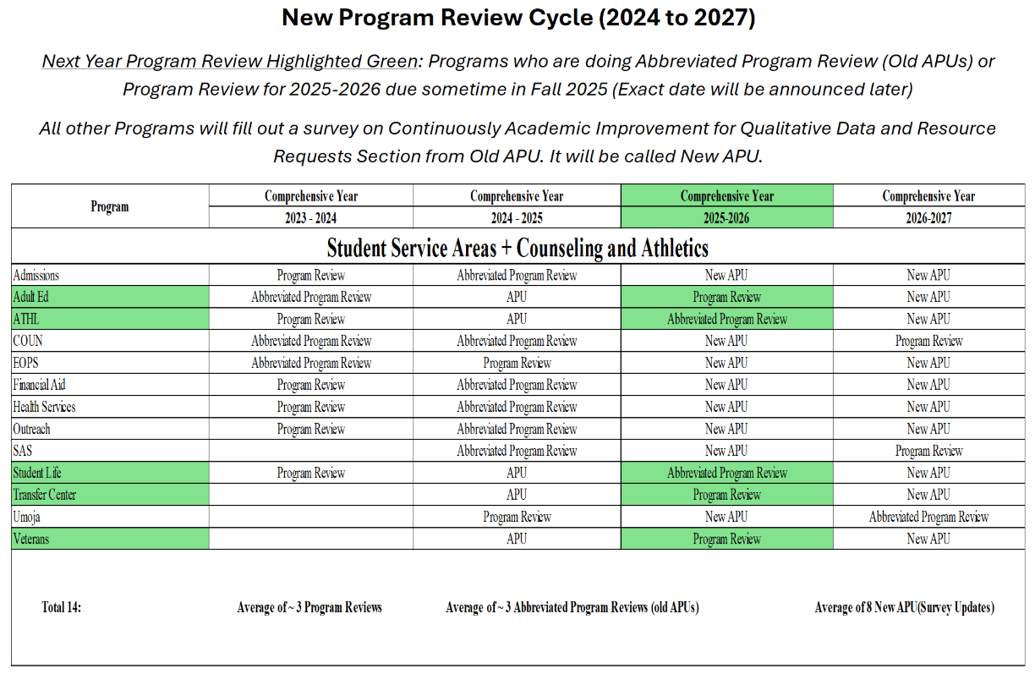  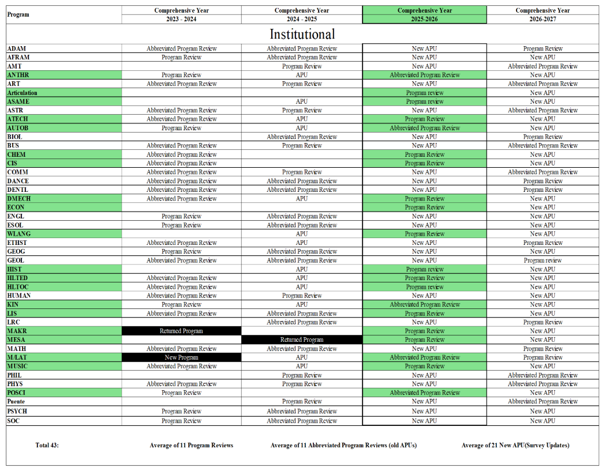  - Data packet will be provided with the program review template.  - The final proposal/draft will come to academic senate after IEC consideration/vote.  - Expect to see the action item in April 17 academic senate meeting for the plan approval.  Participated in discussion: Jayne Smithson, C. Pegues, Rhiannon Follenfant, J. Fowler,  Summary of #3  J. Fowler introduced the item by sharing the question sent out by Nickey Heredia in the President’s Office, “Planning and Budget Committee Inquiry to the College of Alameda”.  - Each committee will come up with an “inquiry question” for the academic year which will focus the discussion/action plans for the committee.  - The survey link shared in chat.  - The Inquiry: “What would it look like to radically redesign the structures and procedures for budget planning and fund allocation that center agreement upon institutional priorities?” Space for up to six responses.  - One example discussed at CoA: Next year being more collaborative in scheduling (e.g. departments coordinating with each other).  - Another example: how lively (or not lively) CoA main campus is with those present in-person. (Is the campus a “ghost town”?)  - Initial discussion about the responses will happen tomorrow.  Participated in discussion: Rhiannon Follenfant, C. Pegues, J. Fowler, B. Pettyjohn, S. Altenbach,  Related to the inquiry question but not directly, a question of “who is in charge of facilities” was asked, with the example of delays in AMT facility renovation in mind, which led to loss of 1 (out of 3) cohorts in the AMT program. [Question will be posed to the district facilities committee, and possibly the CoA department chairs’ meeting.]
Officer Reports | President: Congratulations to sabbatical awardee, Christa Ferrero-Castaneda.  ASCCC Spring Plenary is coming up (C. Haro will be the voting delegate for CoA); the proposed resolutions are being considered at the Area meetings. [Shared in chat: ASCCC Resolutions: https://asccc.org/resolutions-process  Area B Meeting: Friday, March 21, 2025 – 9:00a.m. – 2:00p.m. at CCSF and Zoom: https://events.zoom.us/ev/ ]  Also please consider participating in ASCCC CCN Phase III processes (email sent March 19).  CoA is beginning the process for Institutional Self Evaluation Report (ISER), with the kick-off meeting on April 24 (Thursday, 1 to 4 p.m., hyflex). We need to make sure evidences for ISER are linked from the college website.  Vice President: Still waiting on who might be retiring. There will also be college-wide year-end celebration for years of service recognition.  Treasurer: Nothing to report.  Secretary: Nothing to report.
Announcements | No announcements.
DAS Updates/Actions | Jayne Smithson gave the DAS report. At the DAS, following were discussed:  - Spring ASCCC Plenary resolutions – please attend the Area B meeting to provide input and consider resolutions. Per rules change at this plenary, new resolutions must be proposed first at the Area meeting.  - Laney CTE resolution was discussed. Resolution asks for prioritizing CTE FTEF (“cut to the bone”; no place to cut).  - DAS Succession was discussed: DAS will be holding elections for the officer positions. Current DAS president Matt Goldstein and treasurer Andrew Park will not seek re-election.  - Something about degree auto-awarding was discussed.  Participated in the discussion: C. Pegues, J. Marshall,
Public Comment | None.
Proposed agenda items for next meeting  Thursday, April 17, 2025 | Call for additional proposed agenda items was made.  Please email J. Fowler for any other agenda items.
Adjournment at 1:21 pm | Meeting adjourned at 1:21 p.m. with all agenda items having been addressed.

