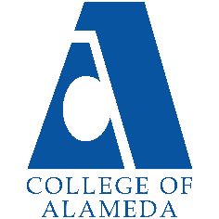
2025-26 Abbreviated Program Review (2 year)-
Anthropology

Program Overview
Please verify your program’s mission statement and program’s learning outcomes below and make any corrections necessary.
Mission Statement
[Update Mission Statement if needed]
The Anthropology programs and courses at College of Alameda offer students the opportunity to study humankind from biological, historic, prehistoric and cultural perspectives. Anthropology introduces students to ways to investigate and understand humanity in ways that are personally enriching and have practical application in their lives
Anthropology – AA-T Degree Program Learning Outcomes
- Explain core concepts of Anthropology, including biological, socio-cultural and archaeological aspects of the discipline.
- Demonstrate an understanding of the scientific methods (skills) used by contemporary anthropologists.
- Apply holistic perspective to discuss appreciation for the genetic and cultural diversity of humans in the past and present, around the world.

Anthropology – A.A. Degree Program Learning Outcomes
- Explain core concepts of Anthropology, including biological, socio-cultural and archaeological aspects of the discipline.
- Demonstrate an understanding of the scientific methods (skills) used by contemporary anthropologists.
- Apply holistic perspective to discuss appreciation for the genetic and cultural diversity of humans in the past and present, around the world.

List your program faculty and/or staff, and indicate whether they are full-time or part-time.
[Update list of personnel]
Jayne Smithson, full-time
Carlos Bazua Morales, part-time
Nicole Buyagawan, part-time
David Leitner, part-time
Karen Oeh, part-time
Iolani Sodhy-Gereben, part-time

Describe your current utilization of facilities, including labs and other space.
[Update facilities]
D-115 lab room: currently used as lecture room and lab room
CoA Library for research
Maker-Space (D-103?) for hands-on model-making

The Program Goals below are from your most recent Program Review or APU. If none are listed, please add your most recent program goals. Then, indicate the status of this goal, and which College and District goal your program goal aligns to. If your goal has been completed, please answer the follow up question regarding how you measured the achievement of this goal.
Program Goal | Engage students in lively discussions (in-class and online) about course materials and applications of course content in real-life situations
Status: In-Progress or Complete?  If complete, give a brief description of how you measured the goal completion. | Ongoing goal met every semester
Which college or district goal is aligned with your program goal? | CoA Goal 2: Provide quality educational and student support services that result in equitable student access to educational opportunities and success in earning a degree or certificate.  CoA Goal 5: Foster an inclusive and caring culture that thrives on diversity and promotes social justice and equity.  PCCD Goals Alignment: Advance Student Access, Equity, and Success; Develop and Manage Resources to Advance Our Mission

Program Goal | New Goal for 2024-2027: Keep Anthropology as a viable discipline at College of Alameda after full-time faculty member leaves for end-of service Banked Load Leave at the end of summer 2025 session, followed by retirement.
Status: In-Progress or Complete?  If complete, give a brief description of how you measured the goal completion. | Time will tell if this discipline will be supported by hiring a full-time instructor … or not. Goal completion will be measured by success or decline of Anthropology discipline at CoA without full-time faculty leadership.
Which college or district goal is aligned with your program goal? | Anthropology courses (particularly ANTHR 1, ANTHR 1L and ANTHR 3) are required courses for at least 30 programs at CoA. ANTHR 1 and ANTHR 1L fulfill the Biological Science requirement for CalGETC non-science major transfers to university (Cal State, UCs and private institutions). ANTHR 3 is required for nursing programs and other medical careers. In light of the above, college goals and district goals that are aligned with ANTHR include:  CoA Goal 2: Provide quality educational and student support services that result in equitable student access to educational opportunities and success in earning a degree or certificate.  CoA Goal 3: Leverage existing resources to maximize academic opportunities for all students and provide accessible and inclusive physical and virtual learning environments that promote equitable academic excellence.  PCCD Goals Alignment: Engage and Leverage Partners; Strengthen Accountability, Innovation, and Collaboration; Develop and Manage Resources to Advance Our Mission

Program Update – Enrollment Trends, Success Rates, and Degrees & Certificates
Discuss recent enrollment trends. District-wide enrollment trends are shown above for comparison.
ANTHR Enrollment
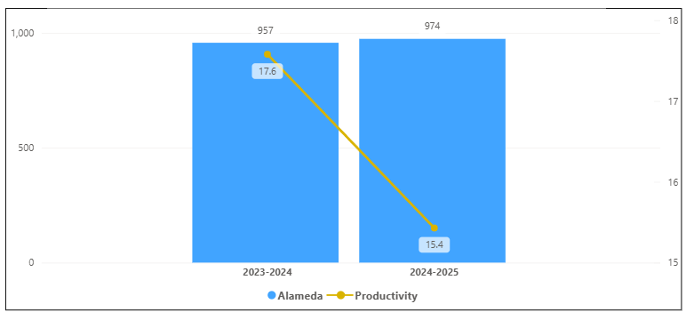
Overall Campus Enrollment
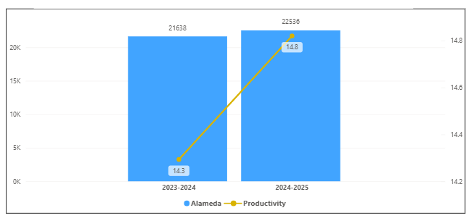

Enrollment for ANTHR has decreased in the last year. Its productivity has decreased by 2.2 and an increase of 17 enrollments. ANTHR percentage increase of 1.8% is smaller than the overall college percentage increase of 4.2 %.

[Enrollment trends discussion here i.e. any details of why the increase of Enrollment]

How is the course completion rate for your program or discipline compared to your college’s Institutional Set Standard for course completion (70% with stretch goal of 78%)? Also discuss the retention rate for your program or discipline, compared to the college average. Also discuss how program has done to improve course completion and retention rates. (Course completion rates are % of students who earned a grade of "C" or better).
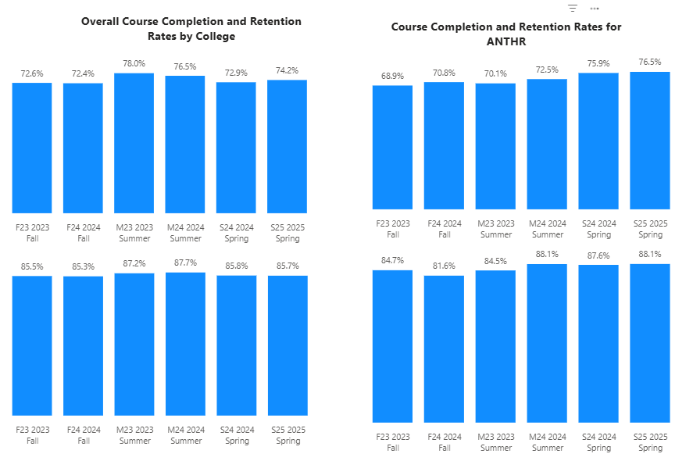

For ANTHR, all were below except Spring Semesters the college completion rates. All the terms were above the set standard of 70 % except Fall 2023 and None were above the stretch goal for completion rates. For retention, All but Spring Semesters and Summer 2024 were below the college average retention rate of 85%. Spring Semesters and Summer 2024 were above the College retention rate for that term.

[Efforts taken to improve success rates and retention rates go here]

Below data shows the number of degrees and certificates awarded by year, for the past two years.
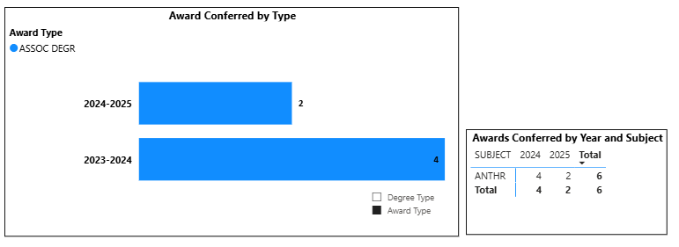
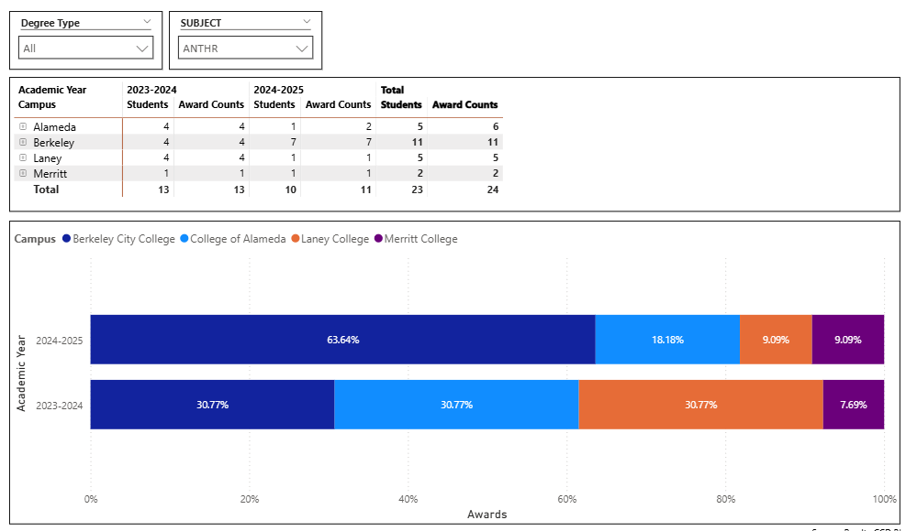
ANTHR had a decline of 2 degrees in the last year. There was overall decline in this award in the district. College of Alameda is still second top school in the district for this award for the last 2 years.

(Explain what you have been doing to help Degree and Certificates and Explain reasons for declines/increases)
The primary function of Anthropology courses in community colleges is to support transfer degrees and program completions in other disciplines by fulfilling the Biological Science requirements for non-science majors (ANTHR 1 and ANTHR 1L) and Cultural Studies requirements (ANTHR 3) for nursing and other medical careers.

Describe any significant changes in the recent years and discuss what the changes mean to your program.
[Update goes here]
Significant changes in the CoA Anthropology Department include:
-expansion of ANTHR 1 and ANTHR 1L class offerings in response to growing demand
-introduction of ANTHR 19 Sex and Gender class offering in response to community need for courses in equity and inclusion
-balanced, limited in-person classes offered on campus (one ANTHR 1 and ANTHR 1L hybrid section each) in response to students slowly returning partially to in-person campus opportunities at CoA.

Describe the department's progress on Student Learning Outcomes (SLOs) and/or Service Area Outcomes (SAOs) since the last Program Review/APU.
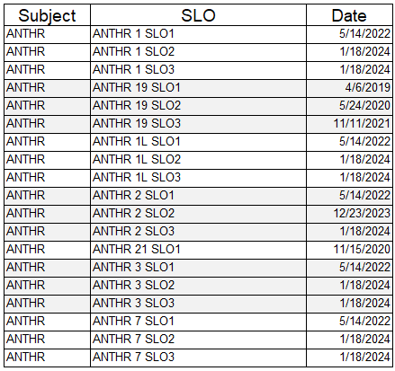
Last Submitted SLOs in 2024. Few SLOs are out of date ANTHR 19 and ANTHR 21.

[Describe what your plan to assess SLO and/ or SAO]

Describe the outcomes and accomplishments from previous year’s funded resource allocation request. If your program did not receive any allocations, leave the boxes blank.
Brief description of funded request | Source (any additional award outside your base allocation) | Total Award Amount | Outcome/Accomplishment

Prioritized Resource Requests Summary
In the boxes below, please add resource requests for your program. If there are no resources requested, leave the boxes blank.
Resource Category | Description/Justification | Full-Time Equivalent Percentage | Salary Grade (if applicable)
Personnel: Classified Staff

Personnel: Student Worker

Personnel: Part Time Faculty

Personnel: Full Time Faculty

Personnel: Full Time Faculty, future anticipated need

Resource Category | Description/Justification | Total Estimated Cost
Professional Development: Department wide PD needed

Professional Development: Personal/Individual PD needed

Prioritized Resource Requests Summary - Continued

Resource Category | Description/Justification | Total Estimated Cost
Supplies: Software

Supplies: Books, Magazines, and/or Periodicals

Supplies: Instructional Supplies

Supplies: Non-Instructional Supplies

Supplies: Library Collections

Resource Category | Description/Justification | Total Estimated Cost
Technology & Equipment: New

Technology & Equipment: Replacement

Prioritized Resource Requests Summary - Continued

Resource Category | Description/Justification | Total Estimated Cost
Facilities: Classrooms

Facilities: Offices

Facilities: Labs

Facilities: Other

Resource Category | Description/Justification | Total Estimated Cost
Library: Library materials

Library: Library collections

Resource Category | Description/Justification | Total Estimated Cost
OTHER

