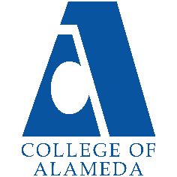
2025-26 Abbreviated Program Review (2 year)-
Auto Body & Paint

Program Overview
Please verify your program’s mission statement and program’s learning outcomes below and make any corrections necessary.
Mission Statement
[Update Mission Statement if needed]
The mission statement for the department of Auto Body & Paint is to ensure students get the most current training safely. We offer a 2-year program with certificates of completion and AS degrees in both fields, Auto Body and Auto Paint.

Auto Body – A.S. Degree Program Learning Outcomes
- Safely and effectively use hand tools and power tools and communicate the practices of occupational safety in the work environment.
- Accurately apply technical skills in the workplace based on hands-on knowledge of practices common within the industry.
- Understand parts of vehicles, vehicle construction and the language of the automotive trade.
- Apply scope of automotive principles to the creative components of automotive repair, restoration and customization.

Auto Body - Certificate of Achievement Program Learning Outcomes
- Apply critical thinking and problem solving skills in the process of diagnosing and repairing electrical and electronic systems, utilizing computer data bases and operating appropriate diagnostic equipment.
- Safely work with power and hand tools, welding equipment, and chemicals in an auto body repair shop.
- Apply critical thinking and problem solving skills in the process of following instructions and professional inter-personal communication with management and coworkers.
- Demonstrate competence and familiarity working with various metals, techniques, and equipment, including practicing all standard safety procedures.

Auto Paint – A.S. Degree Program Learning Outcomes
- Explain through essay and orally each of the undercoat categories and demonstrate application to substrates.
- Make necessary computation of VOC’s and log these computations into BAAQMD acceptable standards.
- Analyze and correct paint failures and problems.
- Dissemble, clean, test, and diagnose spray guns used under Sec. 8, Rule 45.

Auto Paint - Certificate of Achievement Program Learning Outcomes
- Evaluate various types of plastics repairs for auto collision repair.
- Appraise appropriate skills need for preparation of plastic welding and surface preparation.

List your program faculty and/or staff, and indicate whether they are full-time or part-time.
[Update list of personnel]
Peter Ha – Full-time Faculty

Describe your current utilization of facilities, including labs and other space.
[Update facilities]
Currently, lectures are on Zoom, pre-pandemic we’ve used B203 for lectures. Lectures includes; PowerPoint presentations, visuals via online video’s or footage taken from class. Written tests are also conducted in B203.

Lab takes place in B107. Depending on what class, (AutoB16,12,49,30,40) we would operate MIG welders, plastic welders, grinders, drills, sanding, materials application, frame straightening, automobile measuring, polishing of paints, machine sanding and other various pneumatic hand tools.

The Program Goals below are from your most recent Program Review or APU. If none are listed, please add your most recent program goals. Then, indicate the status of this goal, and which College and District goal your program goal aligns to. If your goal has been completed, please answer the follow up question regarding how you measured the achievement of this goal.
Program Goal | Complete and move into new building
Status: In-Progress or Complete?  If complete, give a brief description of how you measured the goal completion. | [Update on Progress]
Which college or district goal is aligned with your program goal? | College and district have agreed to move into the new building Summer of 2025

Program Goal | Need modern vehicles
Status: In-Progress or Complete?  If complete, give a brief description of how you measured the goal completion. | [Update on Progress]
Which college or district goal is aligned with your program goal? | ATECH at COA- they have modern cars

Program Update – Enrollment Trends, Success Rates, and Degrees & Certificates
Discuss recent enrollment trends. District-wide enrollment trends are shown above for comparison.
AUTOB Enrollment
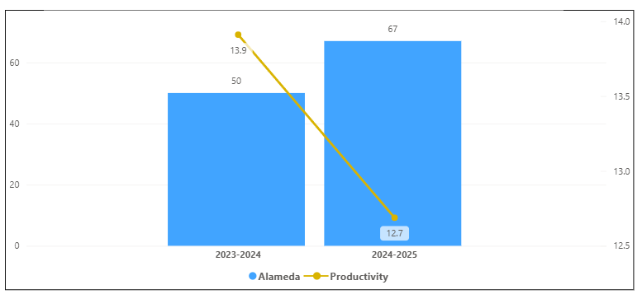
Overall Campus Enrollment
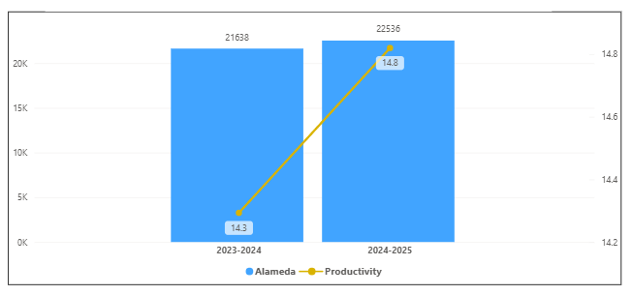

Enrollment for AUTOB has decreased in the last year. Its productivity has decreased by 1.2 and an increase of 17 enrollments. AUTOB percentage increase of 0.3% is smaller than the overall college percentage increase of 4.2 %.

[Enrollment trends discussion here i.e. any details of why the increase of Enrollment]

How is the course completion rate for your program or discipline compared to your college’s Institutional Set Standard for course completion (70% with stretch goal of 78%)? Also discuss the retention rate for your program or discipline, compared to the college average. Also discuss how program has done to improve course completion and retention rates. (Course completion rates are % of students who earned a grade of "C" or better).
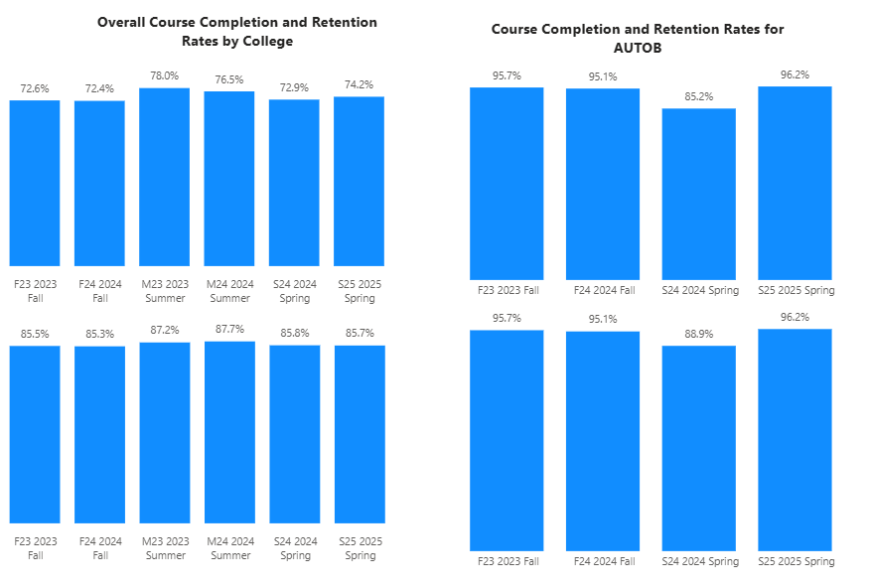

For AUTOB, all were above the college completion rates. All the terms were above the set standard of 70 % and all were above the stretch goal for completion rates. For retention, All terms were below the college average retention rate of 85%. All terms were above the College retention rate for that term.

[Efforts taken to improve success rates and retention rates go here]

Below data shows the number of degrees and certificates awarded by year, for the past two years.
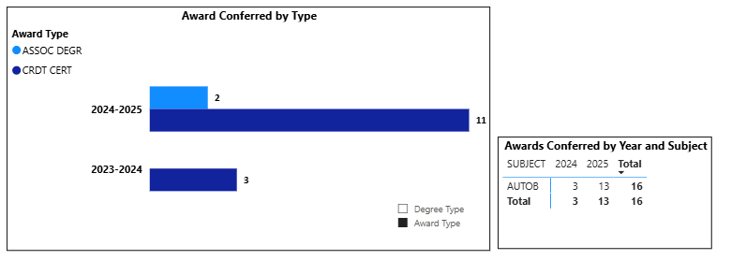
AUTOB had an increase of 2 degrees and 8 certificates in the last year. Overall increase of 10 awards given to students.

(Explain what you have been doing to help Degree and Certificates and Explain reasons for declines/increases)

Describe any significant changes in the recent years and discuss what the changes mean to your program.
[Update goes here]

Describe the department's progress on Student Learning Outcomes (SLOs) and/or Service Area Outcomes (SAOs) since the last Program Review/APU.
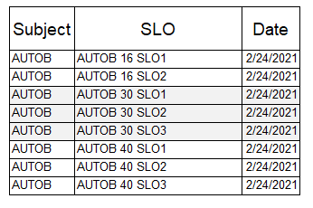
Last Submitted SLOs in 2021. Need new submissions of the SLOs for all courses.

[Describe what your plan to assess SLO and/ or SAO]

Describe the outcomes and accomplishments from previous year’s funded resource allocation request. If your program did not receive any allocations, leave the boxes blank.
Brief description of funded request | Source (any additional award outside your base allocation) | Total Award Amount | Outcome/Accomplishment

Prioritized Resource Requests Summary
In the boxes below, please add resource requests for your program. If there are no resources requested, leave the boxes blank.
Resource Category | Description/Justification | Full-Time Equivalent Percentage | Salary Grade (if applicable)
Personnel: Classified Staff

Personnel: Student Worker

Personnel: Part Time Faculty

Personnel: Full Time Faculty

Personnel: Full Time Faculty, future anticipated need

Resource Category | Description/Justification | Total Estimated Cost
Professional Development: Department wide PD needed

Professional Development: Personal/Individual PD needed

Prioritized Resource Requests Summary - Continued

Resource Category | Description/Justification | Total Estimated Cost
Supplies: Software

Supplies: Books, Magazines, and/or Periodicals

Supplies: Instructional Supplies

Supplies: Non-Instructional Supplies

Supplies: Library Collections

Resource Category | Description/Justification | Total Estimated Cost
Technology & Equipment: New

Technology & Equipment: Replacement

Prioritized Resource Requests Summary - Continued

Resource Category | Description/Justification | Total Estimated Cost
Facilities: Classrooms

Facilities: Offices

Facilities: Labs

Facilities: Other

Resource Category | Description/Justification | Total Estimated Cost
Library: Library materials

Library: Library collections

Resource Category | Description/Justification | Total Estimated Cost
OTHER

