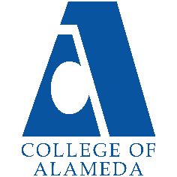
2025-26 Abbreviated Program Review (2 year)-
Kinesiology

Program Overview
Please verify your program’s mission statement and program’s learning outcomes below and make any corrections necessary.
Mission Statement
[Update Mission Statement if needed]
Mission Statement
The Mission of the College of Alameda Department of Kinesiology is to educate the whole person by teaching the benefits of life-long physical activities which improve health and quality of life, and academic courses which satisfy the requirements of transfer and further study in the field of kinesiology.

The courses offered in the Department of Kinesiology promote fitness, sport skill development, stress relief, and education in living a healthy lifestyle. It is our mission in the Department of Kinesiology to accommodate students of all ages, genders, ethnicities, and skill levels.
Kinesiology Program Learning Outcomes

Discipline Name – Kinesiology

The Program Learning Outcomes:
- Students acquire physical strength, control, and knowledge of their physical beings,
- Students acquire the self-confidence and the emotional by-products of physical fitness.
- Students develop a knowledge of the skills required for a physical activity

List your program faculty and/or staff, and indicate whether they are full-time or part-time.
[Update list of personnel]
Susanne Altenbach – part-time
Linda Dewrance – part-time

Describe your current utilization of facilities, including labs and other space.
[Update facilities]

The Kinesiology Department is housed in the “G” building at the main campus of the College of Alameda.
The following facilities are used:

G105 - Gymnasium
G111 - Dance Room
G214 – Strength Training Center
Track and Soccer Fields
Tennis Courts
Men’s and Women’s Locker rooms – 1st and 2nd floor of G building
Since the 1990s, the G building office buildings and storage facilities for Kinesiology have been renovated to house the Music department and Veteran’s services. Storage for Kinesiology is lacking.

The Program Goals below are from your most recent Program Review or APU. If none are listed, please add your most recent program goals. Then, indicate the status of this goal, and which College and District goal your program goal aligns to. If your goal has been completed, please answer the follow up question regarding how you measured the achievement of this goal.
Program Goal | Kinesiology department participation in the Early Alert Pilot program in order to proactively identify students who are most at risk of failing.
Status: In-Progress or Complete? If complete, give a brief description of how you measured the goal completion. | [Update Progress]
Which college or district goal is aligned with your program goal? | District Goal: Advance Student Access, Equity, and Success.
Program Goal | Hire 1 full-time faculty with a focus on program development and 1 part-time employee for specific activity classes.  Our last two retirees have not been replaced.  The FTEFs for Kinesiology need to be increased to accommodate the restoration and expansion of a robust program.
Status: In-Progress or Complete? If complete, give a brief description of how you measured the goal completion. | [Update Progress]
Which college or district goal is aligned with your program goal? | District Goal: Build Programs of Distinction.
Program Goal | Create a Kinesiology AA degree.
Status: In-Progress or Complete? If complete, give a brief description of how you measured the goal completion. | [Update Progress]
Which college or district goal is aligned with your program goal? | District Goal: Increase the number of Certificates and AA degrees offered by the College of Alameda.  Increase state funding as a result of the increase in Certificates and Degrees.

Program Update – Enrollment Trends, Success Rates, and Degrees & Certificates
Discuss recent enrollment trends. District-wide enrollment trends are shown above for comparison.
KIN Enrollment
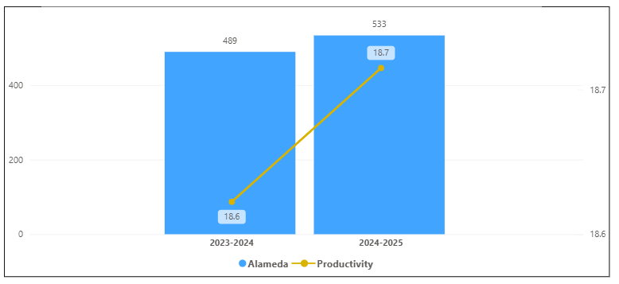
Overall Campus Enrollment
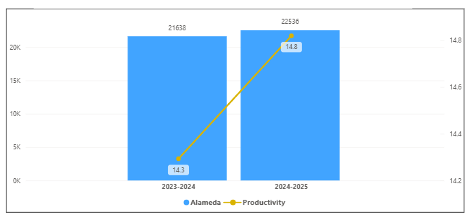

Enrollment for KIN has increased in the last year. Its productivity has increased by 0.1 and 44 enrollments. KIN percentage increase of 9.0% is bigger than the overall college percentage increase of 4.2 %.

[Enrollment trends discussion here i.e. any details of why the increase of Enrollment]

How is the course completion rate for your program or discipline compared to your college’s Institutional Set Standard for course completion (70% with stretch goal of 78%)? Also discuss the retention rate for your program or discipline, compared to the college average. Also discuss how program has done to improve course completion and retention rates. (Course completion rates are % of students who earned a grade of "C" or better).
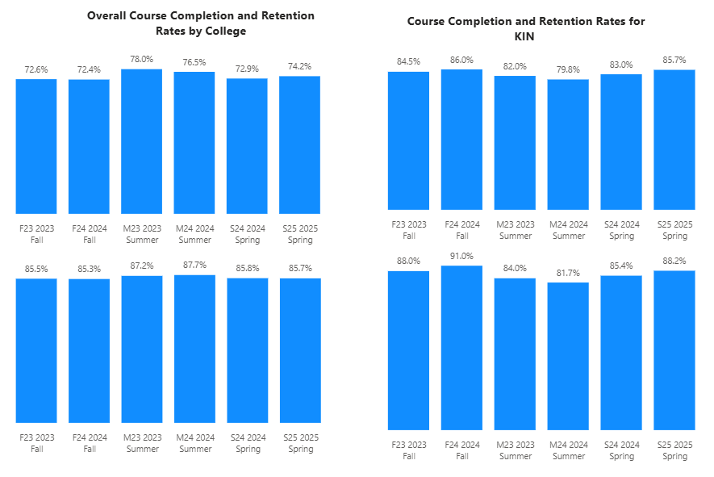

For KIN, all were above the college completion rates. All the terms were above the set standard of 70 % and All terms were above the stretch goal for completion rates. For retention, All but Summers were above the college average retention rate of 85%. Summers and Spring 2024 was below the College retention rate for that term.

[Efforts taken to improve success rates and retention rates go here]
Our success rate has been consistently high due to:

- Adequate personal attention to students in the in-person class mode.
- Adequate out-reach to students in our ONLINE classes.
- Reasonable but challenging class expectations.
- Developing a mutual respect between students and instructors.

Below data shows the number of degrees and certificates awarded by year, for the past two years.

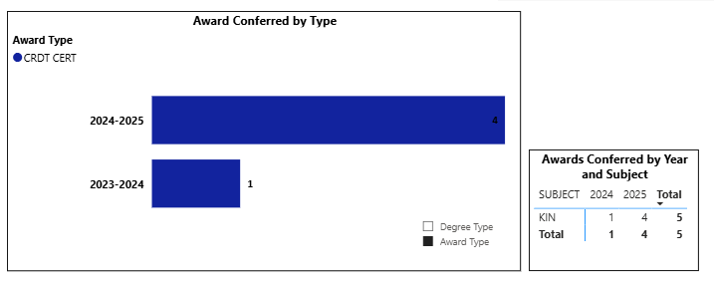

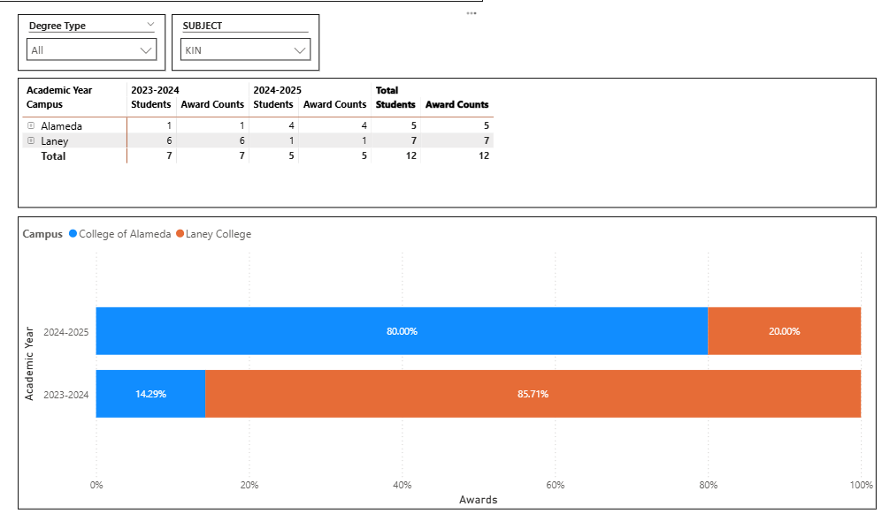

The certificates in KIN have increased by 3 certificates in the last year. College of Alameda was the top school for this award.

(Explain what you have been doing to help Degree and Certificates and Explain reasons for declines/increases)
Kinesiology has one certificate: “Athletic Trainer Aide.” A total of 4 certificates have been earned by students since 2023. The following measures should be taken to increase this number:

- The Kinesiology instructors need to advertise and promote this certificate more extensively.
- Create another Kinesiology certificate that is timely and will create more interest from students.
- The “AA” degree in Kinesiology should be created.

Describe any significant changes in the recent years and discuss what the changes mean to your program.
[Update goes here]

Describe the department's progress on Student Learning Outcomes (SLOs) and/or Service Area Outcomes (SAOs) since the last Program Review/APU.
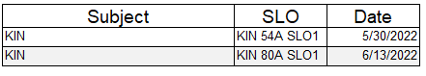
Above is the last submitted SLOs for each of the KIN Courses. Last Submitted SLOs were in 2022. Some SLOs have never been submitted.

[Describe what your plan to assess SLO and/ or SAO]

Describe the outcomes and accomplishments from previous year’s funded resource allocation request. If your program did not receive any allocations, leave the boxes blank.
Brief description of funded request | Source (any additional award outside your base allocation) | Total Award Amount | Outcome/Accomplishment

Prioritized Resource Requests Summary
In the boxes below, please add resource requests for your program. If there are no resources requested, leave the boxes blank.
Resource Category | Description/Justification | Full-Time Equivalent Percentage | Salary Grade (if applicable)
Personnel: Classified Staff

Personnel: Student Worker

Personnel: Part Time Faculty

Personnel: Full Time Faculty

Personnel: Full Time Faculty, future anticipated need

Resource Category | Description/Justification | Total Estimated Cost
Professional Development: Department wide PD needed

Professional Development: Personal/Individual PD needed

Prioritized Resource Requests Summary - Continued

Resource Category | Description/Justification | Total Estimated Cost
Supplies: Software

Supplies: Books, Magazines, and/or Periodicals

Supplies: Instructional Supplies

Supplies: Non-Instructional Supplies

Supplies: Library Collections

Resource Category | Description/Justification | Total Estimated Cost
Technology & Equipment: New

Technology & Equipment: Replacement

Prioritized Resource Requests Summary - Continued

Resource Category | Description/Justification | Total Estimated Cost
Facilities: Classrooms

Facilities: Offices

Facilities: Labs

Facilities: Other

Resource Category | Description/Justification | Total Estimated Cost
Library: Library materials

Library: Library collections

Resource Category | Description/Justification | Total Estimated Cost
OTHER

