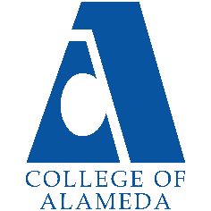
2025-26 Abbreviated Program Review (2 year)-
M/LAT

Program Overview
Please verify your program’s mission statement and program’s learning outcomes below and make any corrections necessary.
Mission Statement
[Update Mission Statement if needed]
Mission Statement
- Ethnic studies with an MLAT focus, is the interdisciplinary study of difference—chiefly race, ethnicity, and nation, but also sexuality, gender, and other such markings—and power, as expressed by the state, by civil society, and by individuals. It is the critical and interdisciplinary study of race, ethnicity, and indigeneity with a focus on the experiences and perspectives of people of color within and beyond the United States.

M/LAT Program Learning Outcomes
We are currently updating local AA degree.

List your program faculty and/or staff, and indicate whether they are full-time or part-time.
[Update list of personnel]
Araceli Quezada

Describe your current utilization of facilities, including labs and other space.
[Update facilities]

Due to the COVID-19 pandemic (campus closure), the department utilizes the
technological/virtual facilities available at COA and the PCCD. All our course offerings have been
distance education courses for the past academic year. Prior to this (and now) virtually the
department and students enrolled in courses utilized the campus computer labs (now software
available through the Peralta Portal), the college library, classrooms, and common space on
campus for observations, discussion, and study. Our program currently utilizes a considerable amount of web space like the CANVAS LMS, range of LTIs like Padlet, Flip Grid, Pronto, Voice
Thread, Confer Zoom, Turn-it-In, Honor Lock, Name Coach, and Ally to name a few. Beginning in Spring 2023, the Ethnic Studies Program plans to offer 50 percent of courses face-to-face and will once again utilize the campus space of classrooms, library, and computer labs, as well as common space for observations and discussion.

The Program Goals below are from your most recent Program Review or APU. If none are listed, please add your most recent program goals. Then, indicate the status of this goal, and which College and District goal your program goal aligns to. If your goal has been completed, please answer the follow up question regarding how you measured the achievement of this goal.
Program Goal | Define core concepts of Ethnic studies. (sociological theories, social structures, culture, social inequality and stratification,  race/ethnicity, gender, and globalization).  [Foundational knowledge in Ethnic studies]
Status: In-Progress or Complete?  If complete, give a brief description of how you measured the goal completion. | [Update Progress]
Which college or district goal is aligned with your program goal? | Aligned to COA ILOs:  (1) solve problems and make decision in life and work using  critical thinking, quantitative reasoning, community resources,  and civil engagement.  (2) Use technology and written and oral communication to  discover, develop, and relate critical ideas in multiple  environments.  (3) Exhibit aesthetic reflection to promote, participate and  contribute to human development, expression, creativity, and  curiosity.  (4) Engage in respectful interpersonal communications,  acknowledging ideas and values of diverse individuals that  represent different ethnic, racial, cultural, and gender  expressions.  (5) Accept personal, civic, social and environmental  responsibility in order to become a productive local and  global community member.

Program Goal | Aligned to COA ILOs:  (1) solve problems and make decision in life and work using  critical thinking, quantitative reasoning, community resources,  and civil engagement.  (2) Use technology and written and oral communication to  discover, develop, and relate critical ideas in multiple  environments.  (3) Exhibit aesthetic reflection to promote, participate and  contribute to human development, expression, creativity, and
Status: In-Progress or Complete?  If complete, give a brief description of how you measured the goal completion. | [Update Progress]
Which college or district goal is aligned with your program goal? | Aligned to COA ILOs:  (1) solve problems and make decision in life and work using  critical thinking, quantitative reasoning, community resources,  and civil engagement.  (2) Use technology and written and oral communication to  discover, develop, and relate critical ideas in multiple  environments.  (3) Exhibit aesthetic reflection to promote, participate and  contribute to human development, expression, creativity, and  curiosity.  (4) Engage in respectful interpersonal communications,  acknowledging ideas and values of diverse individuals that  represent different ethnic, racial, cultural, and gender  expressions.  (5) Accept personal, civic, social and environmental  responsibility in order to become a productive local and  global community member.

Program Goal | Successfully transfer to a four-year college/university with  robust multicultural training. [Personal Enrichment & Lifelong  Learning – Sociological Efficacy]
Status: In-Progress or Complete?  If complete, give a brief description of how you measured the goal completion. | [Update Progress]
Which college or district goal is aligned with your program goal? | Aligned to COA ILOs:  (1) solve problems and make decision in life and work using  critical thinking, quantitative reasoning, community resources,  and civil engagement.  (2) Use technology and written and oral communication to  discover, develop, and relate critical ideas in multiple  environments.  (3) Exhibit aesthetic reflection to promote, participate and  contribute to human development, expression, creativity, and  curiosity.  (4) Engage in respectful interpersonal communications,  acknowledging ideas and values of diverse individuals that  represent different ethnic, racial, cultural, and gender  expressions.  (5) Accept personal, civic, social and environmental  responsibility in order to become a productive local and  global community member.

Program Update – Enrollment Trends, Success Rates, and Degrees & Certificates
Discuss recent enrollment trends. District-wide enrollment trends are shown above for comparison.
M/LAT Enrollment
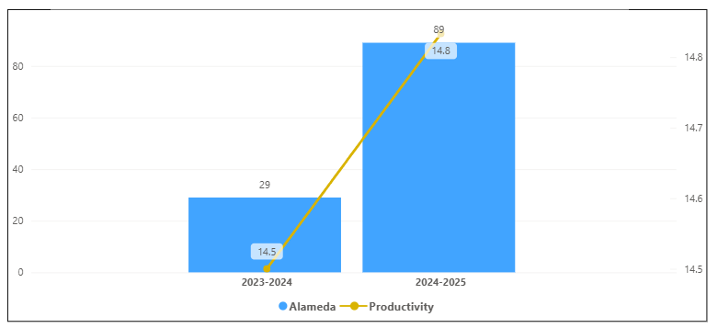
Overall Campus Enrollment
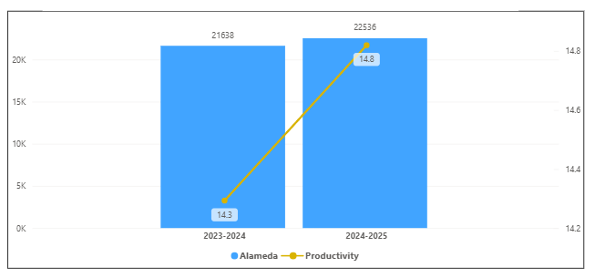

Enrollment for M/LAT has increased in the last year. Its productivity has increased by 0.3 and 60 enrollments. M/LAT percentage increase of 207% is bigger than the overall college percentage increase of 4.2 %.

[Enrollment trends discussion here i.e. any details of why the increase of Enrollment]

How is the course completion rate for your program or discipline compared to your college’s Institutional Set Standard for course completion (70% with stretch goal of 78%)? Also discuss the retention rate for your program or discipline, compared to the college average. Also discuss how program has done to improve course completion and retention rates. (Course completion rates are % of students who earned a grade of "C" or better).
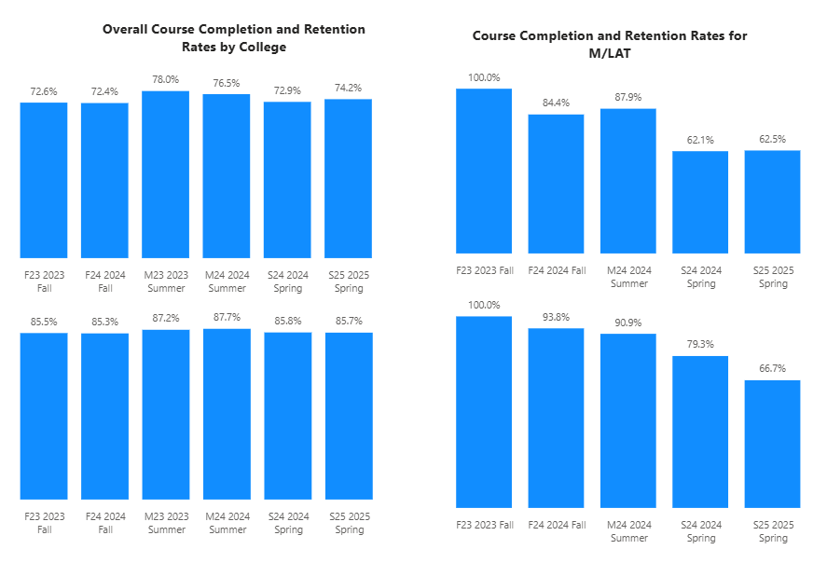

For KIN, all were above except Spring Semesters the college completion rates. All the terms were above the set standard of 70 % except Spring Semesters and All terms were above the stretch goal except the Spring Semesters for completion rates. For retention, All but Spring Semesters were above the college average retention rate of 85%. Spring Semesters were below the College retention rate for that term.

[Efforts taken to improve success rates and retention rates go here]
Our success rate has been consistently high due to:

- Adequate personal attention to students in the in-person class mode.
- Adequate out-reach to students in our ONLINE classes.
- Reasonable but challenging class expectations.
- Developing a mutual respect between students and instructors.

Below data shows the number of degrees and certificates awarded by year, for the past two years.
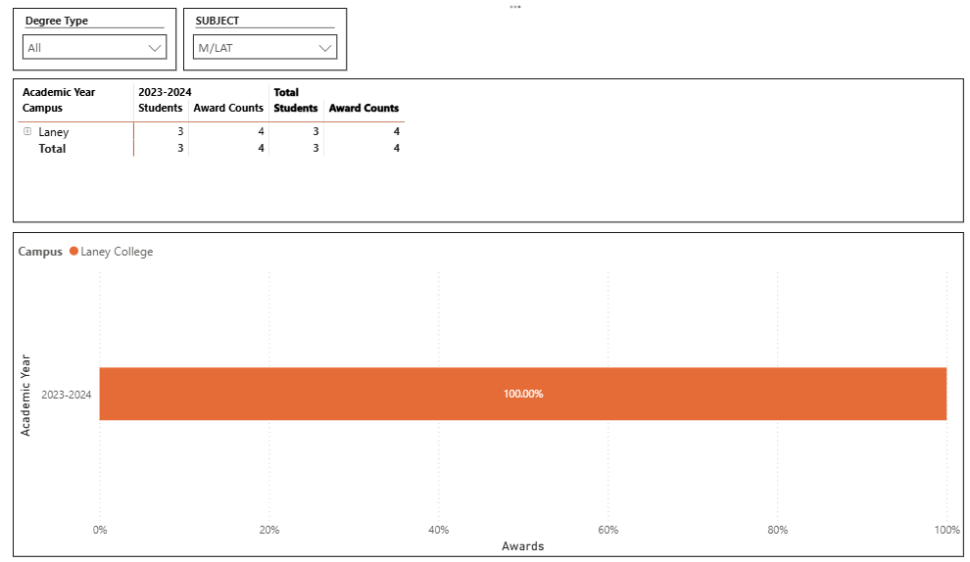
There is no degree for M/LAT at College of Alameda. There was only 4 degrees for M/LAT in the district in 2023-2024.

(Explain what you have been doing to help Degree and Certificates and Explain reasons for declines/increases)

Describe any significant changes in the recent years and discuss what the changes mean to your program.
[Update goes here]

Describe the department's progress on Student Learning Outcomes (SLOs) and/or Service Area Outcomes (SAOs) since the last Program Review/APU.

No SLOs have ever been submitted.

[Describe what your plan to assess SLO and/ or SAO]

Describe the outcomes and accomplishments from previous year’s funded resource allocation request. If your program did not receive any allocations, leave the boxes blank.
Brief description of funded request | Source (any additional award outside your base allocation) | Total Award Amount | Outcome/Accomplishment

Prioritized Resource Requests Summary
In the boxes below, please add resource requests for your program. If there are no resources requested, leave the boxes blank.
Resource Category | Description/Justification | Full-Time Equivalent Percentage | Salary Grade (if applicable)
Personnel: Classified Staff

Personnel: Student Worker

Personnel: Part Time Faculty

Personnel: Full Time Faculty

Personnel: Full Time Faculty, future anticipated need

Resource Category | Description/Justification | Total Estimated Cost
Professional Development: Department wide PD needed

Professional Development: Personal/Individual PD needed

Prioritized Resource Requests Summary - Continued

Resource Category | Description/Justification | Total Estimated Cost
Supplies: Software

Supplies: Books, Magazines, and/or Periodicals

Supplies: Instructional Supplies

Supplies: Non-Instructional Supplies

Supplies: Library Collections

Resource Category | Description/Justification | Total Estimated Cost
Technology & Equipment: New

Technology & Equipment: Replacement

Prioritized Resource Requests Summary - Continued

Resource Category | Description/Justification | Total Estimated Cost
Facilities: Classrooms

Facilities: Offices

Facilities: Labs

Facilities: Other

Resource Category | Description/Justification | Total Estimated Cost
Library: Library materials

Library: Library collections

Resource Category | Description/Justification | Total Estimated Cost
OTHER

