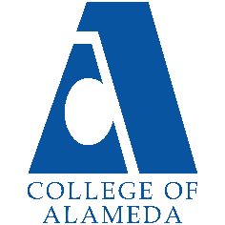
2025-26 Abbreviated Program Review (2 year)-
Political Science

Program Overview
Please verify your program’s mission statement and program’s learning outcomes below and make any corrections necessary.
Mission Statement
[Update Mission Statement if needed]
The mission of College of Alameda is to serve the educational needs of its diverse community by providing comprehensive and flexible programs and resources that empower students to achieve their goals.

The vision and mission of the “Politics” program/Department at College of Alameda: We envision our students as engaged persons, workers, and citizens enabled to lead in the creation of a world that is: Socially Just ,Environmentally and Economically sustainable, and Psychologically Fulfilling.

We aim to fulfill this vision in our mission of
1) offering Associate of Arts Degrees in Political Science and Certificates of Proficiency and
Achievement
2) programmatically emphasizing community engagement, future consciousness, and transformational leadership in creating social change. We aim to empower our students in building their capacity to effectively engage with the 21st Century Modern World

System as citizens, workers, and persons. An emphasis is placed on highlighting how politics is relevant to the lives of students as whole persons in their day-to-day world of lived and shared reality.

Overall, we fulfill this commitment by facilitating learning experiences for the people we serve in
1) The expansion of foundational knowledge of the socio-political world,
2) Increasing their proficiency with critical political thinking to be better able to engage their “knowledge in use” skills
3) Building their capacity for personal psycho-social political efficacy.

List your program faculty and/or staff, and indicate whether they are full-time or part-time.
[Update list of personnel]
- Robert J Brem f/t split assignment 60% in POSCI and 40% in PSYCH;
- POSCI Lead Faculty
- Judith Hurtado-Ortiz p/t
- Hasmik Geghamyan p/t 4. Rachel Antrobus p/t

Describe your current utilization of facilities, including labs and other space.
[Update facilities]
Our program is mostly virtual, (synchronous and asynchronous) and “dual enrollment” on site at Oakland high schools relative unremarkable success with actual “in-person” offerings thus far. With our f/t faculty member on permanent ADA accommodation to work 100% remotely (with no physical office on campus), we actually do not use any physical Peralta facilities. Dual enrollment format classes are in-person at the high schools (or on Zoom) in which we teach. Our p/t faculty do offer in-person classes and there has been some “mixed” success in this in Spring 2023, one Friday – one day only – full semester section is at 33 after second census. That was a surprise. So that type of class was a success. However, the other “inperson” section was a late start hybrid (one day in person) was almost cancelled; but got to 18 students, but 4 students contacted and said that they believed it was fully online and only 5 showed up to class, 2 others had severe disabilities which made coming not possible… the others we do not know their status. However, to make that class viable, we are forced to be extraordinarily flexible in how attendance is addressed. Students will be asked to review lecture presentations every week and write a reflection/summary as well as any questions they may have. Furthermore, these students will attend zoom meetings with the instructor every other week. Supplemental activities for students who cannot attend in person instruction will maintain the educational objectives while accommodating remote learning. This is a lot of extra effort for a p/t instructor. All of this underlines that in-person classes are not highly viable in our department. We have found (we asked) students are not highly motivated to come to COA when Laney and BCC have more convenient BART and parking access, and lack of strategic enrolment practices across district means there are so many options at sister colleges that we do not have any competitive advantage in attracting students.

The Program Goals below are from your most recent Program Review or APU. If none are listed, please add your most recent program goals. Then, indicate the status of this goal, and which College and District goal your program goal aligns to. If your goal has been completed, please answer the follow up question regarding how you measured the achievement of this goal.
[Update Goals from Program Review 2023-2024]
COA GOALS | PCCD GOALS | Progress on goal attainment | Explanation and Comments
A: Advance Student Access, Equity, and Success  COA – POSCI meets this goal with:  1) Innovative Learning Outcomes and Basic Skills integration efforts | A.1 Student Access: Increase enrollment for programs and course offerings in the essential areas of basic skills/ESOL, CTE and transfer to achieve the District target of 19,355 RES FTES.  A.2 Student Success: Increase students’ participation in SSSP eligible activities by 50%, with specific emphasis on expanding orientations, assessments, academic advising, and student educational plans. | Adequate and commensurable with other COA departments | Institutional challenges and key personnel issues slowed progress in the context of overly optimistic goals & timelines and social-economic

COA GOALS | PCCD GOALS | Progress on goal attainment | Explanation and Comments
2) Seeking to maintain program and courses offerings under continuing stressed times in which we operate.  3) We still aim to create CTE-POSCI stackable certificates. Even though we maintain our core law class, our withdrawal from CalLaw “pathway to Law” initiative (as being economically unviable at COA) means that the law track is only minimally viable due to our relationship with the Youth Law Academy (YLA). | A.3 Student Success: Using baseline data, increasing student engagement in activities such as student governance, student life activities, Student leadership development, service-learning programs, learning communities, student employment, etc.  A.4 Student Equity Planning: Address the achievement gap through fully developing and implementing the student success and equity plans at each campus. | Efforts are iterative and aimed at on-going improvement  Efforts are iterative and aimed at on-going improvement | National and local trends have made all our efforts in these areas problematic.  Project management plan and timeline extended.
B: Engage and Leverage Partners  COA – POSCI seeks to meet this goal with:  1) Our commitment to Dual Enrollment in our outreach efforts towards Area High Schools for recruitment (including LWA, Fremont, AUSD, OUSD, AIMS).  2) Outreach and partnerships with YLA at Centro Legal de la Raza – that is all that is left of our now defunct State Pathway to Law school partnership  3) In 2023 we are in continuing negotiations with Alameda Country and CSU EB to design a public administration training program | B.1 Partnerships: Develop a District-wide database that represents our current strategic partnerships and relationships.  B.2. Partnerships: Expand partnerships with K-12 institutions, community-based organizations, four-year institutions, local government, and regional industries and businesses. | Efforts are iterative and aimed at on-going improvement  We have shifted these efforts to the Alameda County / CSU partnership exclusively.  We are seeking to expand our Dual enrollment capacity to work with OUSD more effectively. | CSU East Bay is just as economically impacted as are we and their enrollments are very low. There are no growth opportunities there.  EXCEPT, if with AC, we can reinvigorate PA training initiative, and that holds some hope for stackable certificates and degree programs, and the (still elusive) CSU POSCI-MPA partnership. .
C: Build Programs of Distinction  COA – POSCI meets this goal with: In light of unfavorable socio-economic trends and institutional ligatures, we have scaled back all of our initiatives to be much more modest.  We now focus on core competencies and seeking continuous innovative learning facilitation models.  Continuation of “Building Programs of Distinction”  We have successfully launched our interdisciplinary certificate programs in Gender/Queer studies. We are now in our second round of scheduled sections of our course in that program in Spring 2024. It did attract sufficient enrollment to make.  We intend to open a new Emergency Management effort this coming year – aiming for Fall 2024.And we are working on a stackable Certificate PA program in partnership with Alameda County,  Though it is now quite moot, and no one is going to read this anyway, we had intended to expand other offerings in these areas, as this strategy is a path to a niche realm of success for COA-POSCI/CCUL. The Community Change and Urban Leadership Initiative was in itself a potentially world class program | C.1 Student Success: Develop a District-wide first year experience/student success program.  C.2 Student Success: Develop an innovative student success program at each college.  C.1 Student Success: Develop a District-wide first year experience/student success program.  C.2 Student Success: Develop an innovative student success program at each college. | Efforts are iterative and aimed at on-going improvement  Granting these efforts have yielded little progress over past decade; these efforts have been pulled back and are now much more modest  The new Emergency Management class has been created – we are seeking to break it up into fee-based segments,  We have shifted focus of CCUL to an AC partnership, to reinvigorate PA training initiative, and that holds some hope for stackable certificates and degree programs, and the (still elusive) CSU POSCI-MPA partnership. . | The Queer studies program will continue, as will we offer the courses, we have offered in the past, but these will be solely under the rubric of POSCI and not CCUL and Pathway to Law School as that last initiative has been cancelled.  We have shifted focus of CCUL to an AC partnership, to reinvigorate PA training initiative, and that holds some hope for stackable certificates and degree programs, and the (still elusive) CSU POSCI-MPA partnership.

COA GOALS | PCCD GOALS | Progress on goal attainment | Explanation and Comments
D: Strengthen Accountability, Innovation and Collaboration  COA – POSCI meets this goal with:  Our partnerships with community-based organizations and high schools offer this opportunity.  We do continue to work on our new integrated learning process assessment driven pedagogy model and are working with an Australian firm (Ziplet) in developing this further. Revised goal for readiness is Fall 2024. In this effort, we are working on a fully functional online CRL ideology / personality framework analysis tool which we need for all of our classes! | D.1 Service Leadership: Provide professional development opportunities for faculty, staff and administrators that lead to better service for our students and colleagues.  D.2 Institutional Leadership and Governance: Evaluate and update policies and administrative procedures and the PBIM participatory governance structure. | Efforts are iterative and aimed at on-going improvement  Ziplet development work toward integration into Canvas is slower than desirable… we are still working on it and then there is the online CRL ideology / personality framework analysis tool which we need for all of our classes! Development has been painfully slow due to need for professional help which costs money we do not yet have…. | Other than partnering initiatives with Ziplet, Centro Legal de la Raza, and two high schools,  Work on the online CRL ideology / personality framework analysis tool which we need for all of our classes is painfully slow due to need for professional help which costs money we do not yet have….

Program Update – Enrollment Trends, Success Rates, and Degrees & Certificates
Discuss recent enrollment trends. District-wide enrollment trends are shown above for comparison.
AUTOB Enrollment
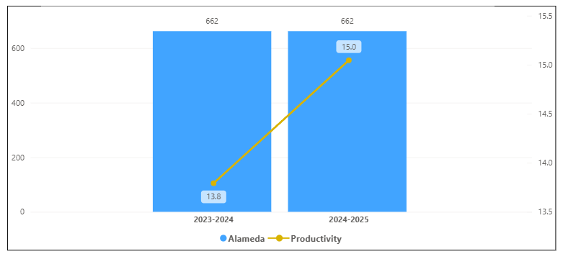
Overall Campus Enrollment
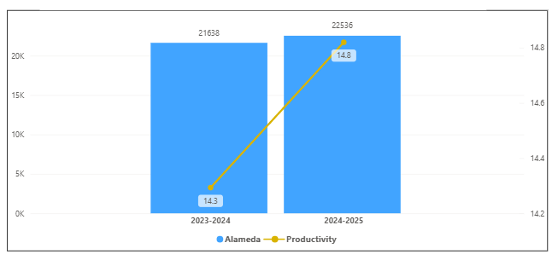

Enrollment for POSCI has increased in the last year. Its productivity has increased by 1.2 and same enrollments. POSCI percentage increase of 0% of enrollment is smaller than the overall college enrollment percentage increase of 4.2 %.

[Enrollment trends discussion here i.e. any details of why the increase of Enrollment]

How is the course completion rate for your program or discipline compared to your college’s Institutional Set Standard for course completion (70% with stretch goal of 78%)? Also discuss the retention rate for your program or discipline, compared to the college average. Also discuss how program has done to improve course completion and retention rates. (Course completion rates are % of students who earned a grade of "C" or better).
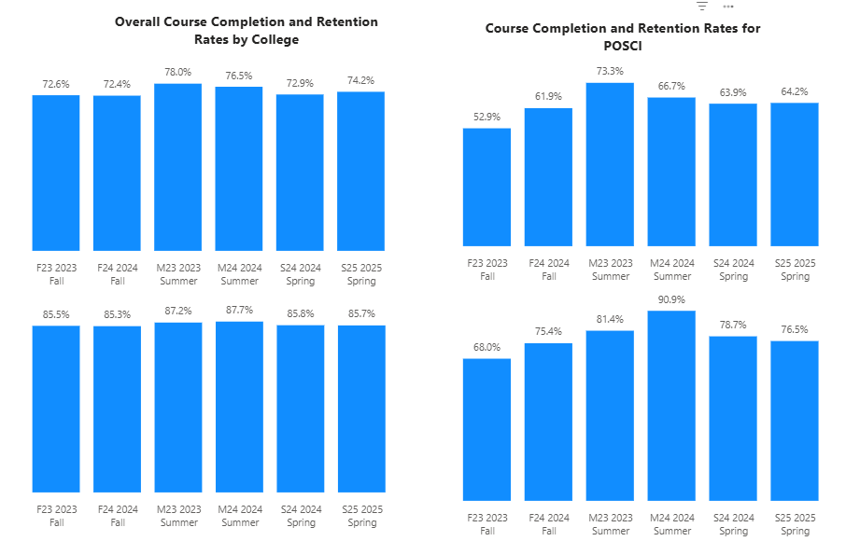

For POSCI, all were below the college completion rates. All the terms were below except Summer 2023 the set standard of 70 % and all were below the stretch goal for completion rates. For retention, all terms were below except Summer 2024, the college average retention rate of 85%. All terms were below except Summer 2024, the College retention rate for that term.

[Efforts taken to improve success rates and retention rates go here]

Below data shows the number of degrees and certificates awarded by year, for the past two years.
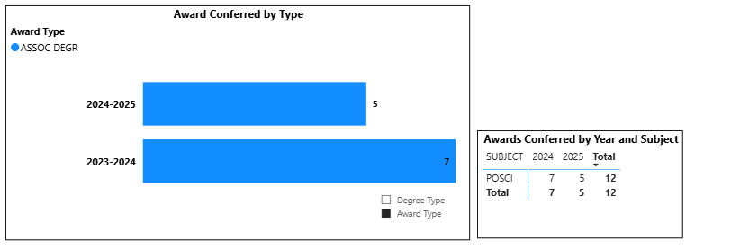
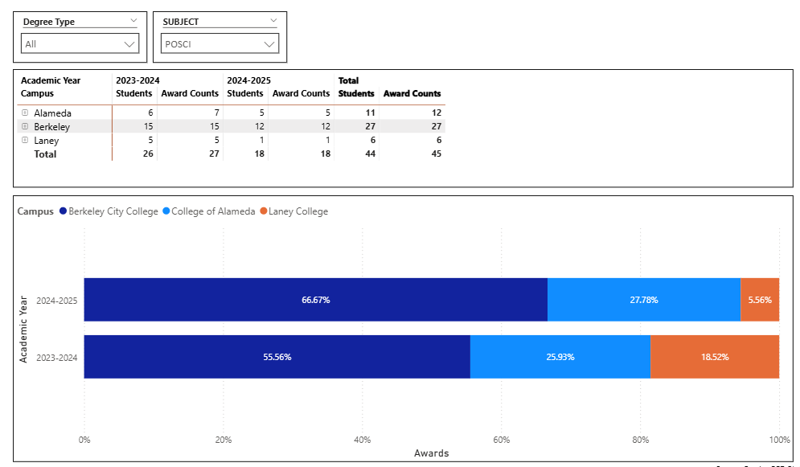
POSCI had a decrease of 2 degrees. There was a decline in all political science awards through the district for 2024-2025. We are the second top college with political science degrees awarded.

(Explain what you have been doing to help Degree and Certificates and Explain reasons for declines/increases)

Describe any significant changes in the recent years and discuss what the changes mean to your program.
[Update goes here]

Describe the department's progress on Student Learning Outcomes (SLOs) and/or Service Area Outcomes (SAOs) since the last Program Review/APU.
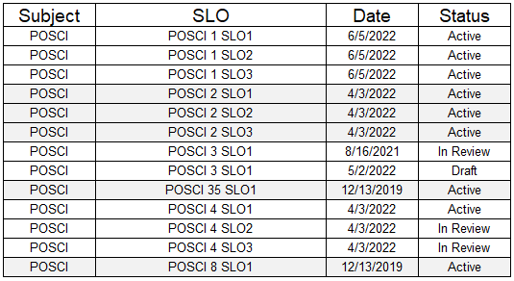
Last Submitted SLOs in 2022. Need new submissions of the SLOs for some courses.

[Describe what your plan to assess SLO and/ or SAO]

Describe the outcomes and accomplishments from previous year’s funded resource allocation request. If your program did not receive any allocations, leave the boxes blank.
Brief description of funded request | Source (any additional award outside your base allocation) | Total Award Amount | Outcome/Accomplishment

Prioritized Resource Requests Summary
In the boxes below, please add resource requests for your program. If there are no resources requested, leave the boxes blank.
Resource Category | Description/Justification | Full-Time Equivalent Percentage | Salary Grade (if applicable)
Personnel: Classified Staff

Personnel: Student Worker

Personnel: Part Time Faculty

Personnel: Full Time Faculty

Personnel: Full Time Faculty, future anticipated need

Resource Category | Description/Justification | Total Estimated Cost
Professional Development: Department wide PD needed

Professional Development: Personal/Individual PD needed

Prioritized Resource Requests Summary - Continued

Resource Category | Description/Justification | Total Estimated Cost
Supplies: Software

Supplies: Books, Magazines, and/or Periodicals

Supplies: Instructional Supplies

Supplies: Non-Instructional Supplies

Supplies: Library Collections

Resource Category | Description/Justification | Total Estimated Cost
Technology & Equipment: New

Technology & Equipment: Replacement

Prioritized Resource Requests Summary - Continued

Resource Category | Description/Justification | Total Estimated Cost
Facilities: Classrooms

Facilities: Offices

Facilities: Labs

Facilities: Other

Resource Category | Description/Justification | Total Estimated Cost
Library: Library materials

Library: Library collections

Resource Category | Description/Justification | Total Estimated Cost
OTHER

