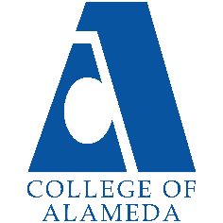
College of Alameda
2025-2026 Abbreviated Program Review (2 Years) – Athletics

Program Overview
Please provide your program’s mission statement and program’s learning outcomes
The Athletic programs at the College of Alameda are committed to excellence in academics and athletics. We believe that competition, conducted according to the rules, good sportsmanship and honor, both on and off the site of competition, can bring out the best in the student-athlete. We strive to win, to achieve and to excel, but we believe that each individual student-athlete striving to do their best is the heart, spirit and purpose of competition. College of Alameda will provide the environment, facilities, support and opportunities for academic and athletic excellence

List your program faculty and/or staff.
[Update list of personnel goes here]
Ramaundo Vaughn- Director of Athletics (part time) 4th yr
Justin Hoover- Head Women’s Volleyball Coach (part time) 1st yr
Gary Payton- Head Men’s Basketball Coach (part time) 1st yr

Describe your current utilization of facilities, including labs and other space.
[Update list goes here]
At present, the athletics teams at COA utilize the gymnasium for all practices. We would like to be able to utilize the weight room for strength and conditioning. The mens basketball team at times utilize the Umoja space for small meetings. A dedicated space for athletics teams to meet for study halls, etc. would greatly enhance our ability to engage with our student athletes, both basketball and volleyball.

List your program goals from your most recent Program Review or APU. Then, provide an update on the status of the goal. Has your program achieved the goal? Have any of your goals been revised or are any still in progress? Lastly, make sure to discuss which College or District goal your program goal aligns to.
If no program goals exist or if this is your first program review, work to create 2-3 goals and align them with a college or District goal.
Program Goal | Assist student athletes to identify and achieve their personal, educational and athletic goals.
Status: In-Progress or Complete? | [Update Progress]
Which college or district goal is aligned with your program goal? | Aligns to District Goal: Advance Student Access, Equity, and Success  Aligns to College Goal: Strengthen Data-driven / informed decision making

Program Goal | Provide counseling and other supportive services to enable students to select appropriate goals and to receive assistance in realizing those goals.
Status: In-Progress or Complete? | [Update Progress]
Which college or district goal is aligned with your program goal? | Aligns to District Goal: Advance Student Access, Equity, and Success  Aligns to College Goal: Increase access to college programs/coursework through collaboration with other PCCD colleges in redesigning college schedules & offerings

Program Goal | .
Status: In-Progress or Complete?
Which college or district goal is aligned with your program goal?

Program Update
Course Completion Rates and Retention Rates

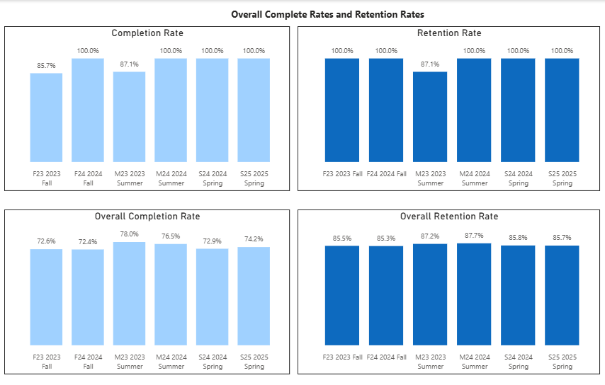
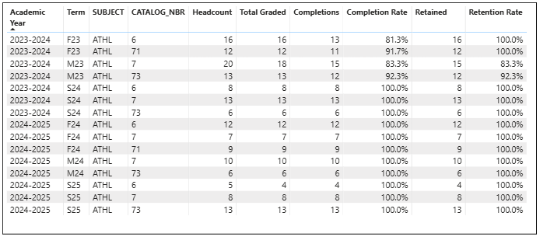

Student Group Completion Rates and Retention Rates
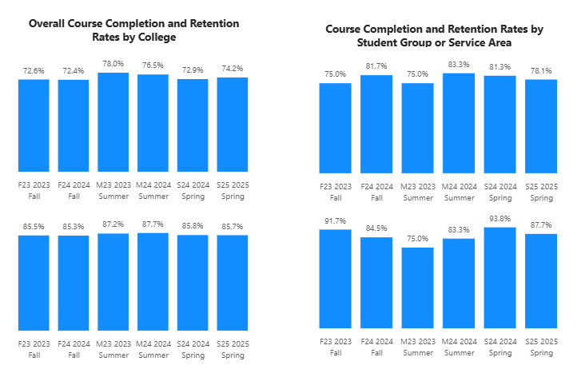

Course Completion and Retention Rates
For the Athletics Courses, Completion and Retention Rates by Term for the last two years are higher than the Overall College Completion and Retention Rates. Also, the Completion rate for Athletics is higher than the stretch goal of the set standards of 78% for all terms in the last two years. Now when looking at the athletics student group completion rates, we only have one summer that is below the college overall completion rate. All the completion rates of the athletics student group are higher than the set standard of 70%. For Retention Rates, Summer is only where the overall campus is higher than the athletics student group retention.

(Explain what you have been doing to help with Completion Rates and Retention Rates and Explain reasons for declines/increases)

Course Enrollment
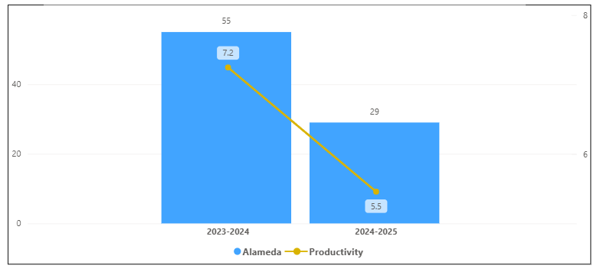
Overall College Enrollment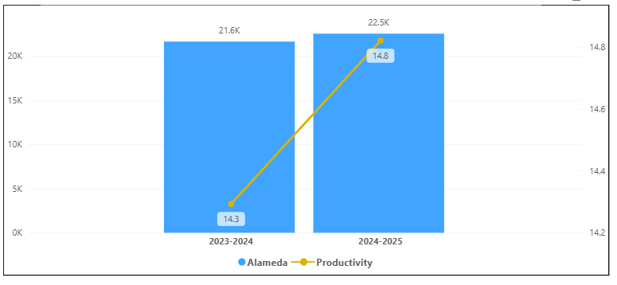

Student Group Enrollment
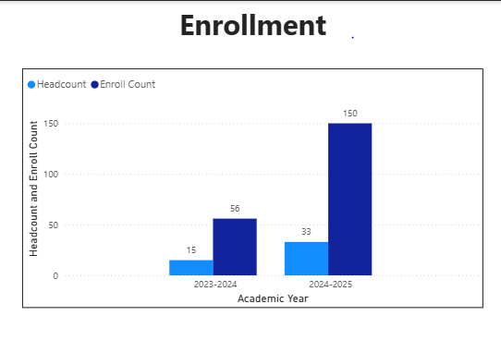

Enrollment Trends
For Athletics Courses, Enrollment and Headcounts have decreased in the last year. It had a -47% decrease in their enrollment where the overall campus had a 4.2% increase. For the Student Group Athletics, Enrollment and Headcount have increased.

(Explain what you have been doing to help Enrollments and Explain reasons for declines/increases)

Student Group Certifications and Degrees
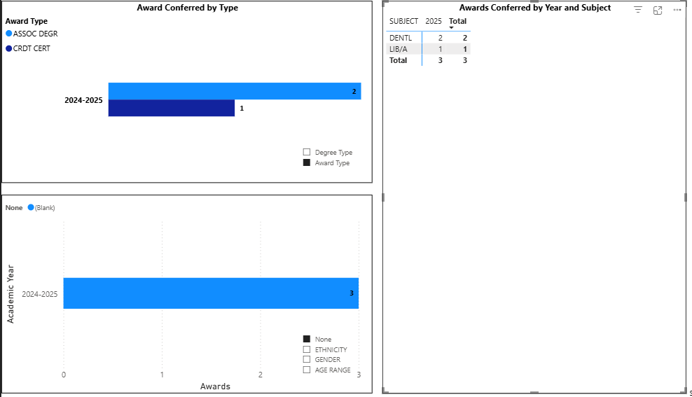
There are zero Degrees and Certifications for Athletics for Subject
Degrees and Certificates
There have been no degrees and certificates for the athletics program for the last 2 years. In the Student Athletics Group, two degrees and one certificate have been awarded to students in the student athletics group.

(Explain what you have been doing to help Degree and Certificates and Explain reasons for declines/increases)

Consider whether performance gaps exist for disproportionality impacted (DI) students. Focus upon the most recent 2 years and/or the years since your last comprehensive program review. Cite data points to support your reflection. Describe any significant changes and discuss what the changes mean to your program.
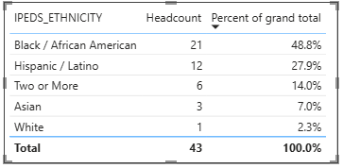
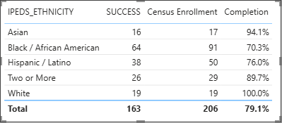
Student Athletics Group

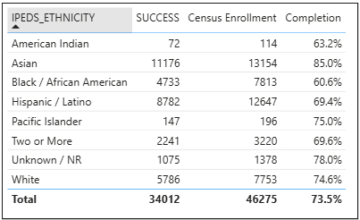
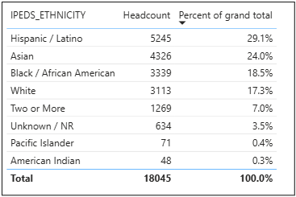
Overall Population

In the Student Athletics Group, we see that African Americans are the biggest DI group support at a higher percent than the overall population. Also, their success rate is 70.3%, which is higher than the overall group on the college and higher than the set standards. But it is still the lowest success rate in the athletics group. Hispanic the second largest group in the student athletics group completion is higher than the completion rates of the overall college and Hispanic group. There are missing di groups from the athletics student group.

[Explain Equity Gaps and If there were changes in the program]

Describe the department's progress on Student Learning Outcomes (SLOs) and/or Service Area Outcomes (SAOs) since the last Program Review/APU.
[Describe what you are going to do to assess SLO and/ or SAO]

Last Submitted SAO was Spring 2020.

SAO 1: Monitor student-athletes and coaches’ ability to demonstrate acquired interpersonal skills that will increase their ability to work with others, effectively communicate, and develop support for each other.

SAO 2: Track the matriculation rate for all student-athletes (during the academic year of 2019-2020) who met their athletic eligibility at College of Alameda.

Last Submitted SLO Fall 2021 ATHL 6
SLO 1 Analyze a game situation and devise solutions as to individual and team strategy and tactics and their application to advance offensive and defensive systems of play.

Last Submitted SLO Summer 2018 ATHL 73
SLO 1: Comprehend, analyze and execute fundamental volleyball skills and strategies. instructor will observe and evaluate student performance in drills and simulated situations reflecting most aspects of volleyball.

Describe the outcomes and accomplishments from previous year’s funded resource allocation request. If your program did not receive any allocations, leave the boxes blank.
Brief description of funded request | Source (any additional award outside your base allocation) | Total Award Amount | Outcome/Accomplishment

Prioritized Resource Requests Summary
In the boxes below, please add resource requests for your program. If there are no resources requested, leave the boxes blank.
Resource Category | Description/Justification | Total Estimated Cost
Personnel: Classified Staff

Personnel: Student Worker

Personnel: Part Time Faculty
Personnel: Full Time Faculty

Resource Category | Description/Justification | Total Estimated Cost
Professional Development: Department wide PD needed
Professional Development: Personal/Individual PD needed
Supplies: Software

Supplies: Books, Magazines, and/or Periodicals

Supplies: Instructional Supplies

Supplies: Non-Instructional Supplies

Supplies: Library Collections

Technology & Equipment

Library: Library materials/collections

Facilities: Classrooms/Labs

Facilities: Offices

Other

