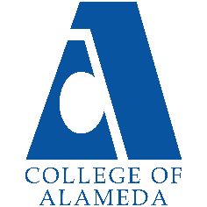
College of Alameda
2025-26 Program Review Template – Adult Education

Lead Author:
[Your Name Here]

Program Overview
Provide your service area’s mission statement. If your service area does not have a mission statement, what is your timeline for creating a mission statement?
[Your Mission Here]
The mission of the Adult Transitions Department at the College of Alameda is to collaborate with Adult Schools and Community Based Organizations to enable adults (18+) to advance education, obtain employment, and improve wages.

List your program faculty and/or staff.
[List of personnel goes here]
1.0 FTE Program Manager

List the essential functions of your department, program or unit and provide a description of how the unit aligns with the college mission.
[Your Essential Functions Here]
The essential functions of the department that aligns with the college mission are: - That we are responsible for providing a smooth transition for students from adult schools, local community-based organizations, and re-entry clients to academic programs and services at College of Alameda. - We work with other departments such as Welcome Center, EOPS, Financial Aid, DSPS, Counseling, to provide adult students additional support as they enroll in services to help them be successful. - Works to demystify fear and challenges of the enrollment processes for students, such as asylum pending students, concurrently enrolled students, ESOL students, and others who may feel intimidated by the admissions process.

List your program goals from your most recent Program Review or APU (Annual Program Update). Then, provide an update on the status of the goal. Has your program achieved the goal? Have any of your goals been revised or are any still in progress? Lastly, make sure to discuss which College or District goal your program goal aligns with.
If no program goals exist or if this is your first program review, create 2-3 goals and align them with a college or District goal.
Program Goal | Increase the number of concurrent enrollment students from adult schools.
Status: In-Progress or Complete? | [Update Progress]
Which college or district goal is aligned with your program goal? | • Increase retention and persistence rates  • Increase community & educational partnerships  • Advance COA (College of Alameda) teaching and learning

Program Goal
Status: In-Progress or Complete?
Which college or district goal is aligned with your program goal?

Program Goal
Status: In-Progress or Complete?
Which college or district goal is aligned with your program goal?

Student Enrolled Adult Education Last 4 Years
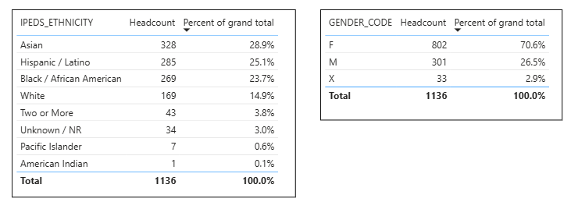
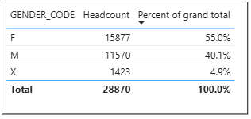
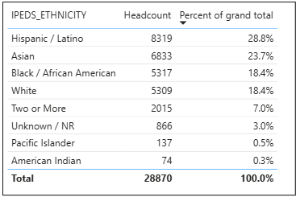
Overall Last 4 Years

Student Group Adult Education Last 4 Years
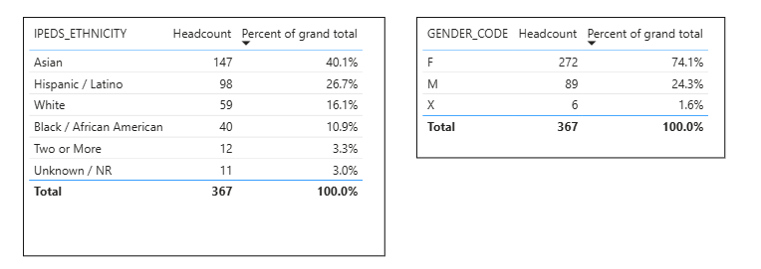

Do the students served by your service area differ from the College's overall student population? If so, elaborate on how the service area is identifying and addressing the needs of the student population.
Yes, the adult student population is different from the college’s overall population. The Adult Education is a higher percentage of women compared to the overall population of women. It is 74.1 % women compared to the 55% of the overall population. Also, the biggest group in Adult Education is Asian. Whereas Hispanic is the biggest population in the overall population.

[Students’ Demographics discussion goes here]

Which groups of students are underrepresented among those who received services, particularly by race/ethnicity and gender?
Black/African American are the third biggest group in our overall population and the adult education enrolled at college of alameda. However, it the student group for college of alameda Black/African Americans are forth and have a small percentage. We have none American Indians and Pacific Islanders in the Adult Education for College of Alameda Group.

[Students’ Demographics discussion goes here]

Describe how external factors such as advisory board recommendations, federal or state mandates, changing demographics, and/or COVID-19 have impacted the support services your program or administrative unit provides.
How has your program addressed these changes or challenges to ensure students are supported and can continue to work towards meeting their educational goals?
[Changes and Challenges discussion goes here]

Data Analysis
Enrolled Adult Education in COA
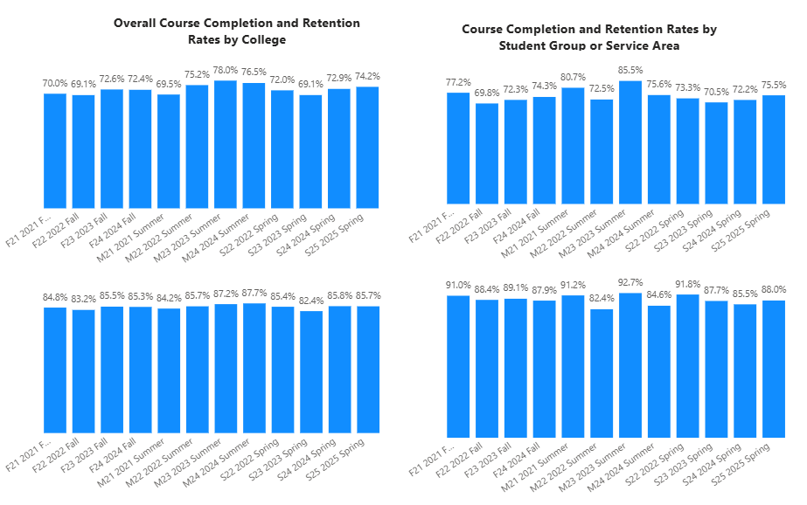
Adult Education Student Group
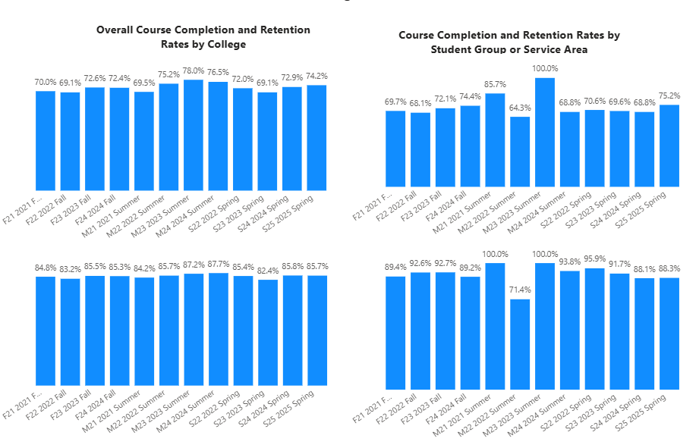

How does the course completion rate for your program compare to your college's College-Set Standard for course completion of 70% and the stretch goal of 78%?

For the Adult Education Students who are enrolled at College Alameda, it shows that their completion rates are all above the set standard expect for Fall 2022. Fall 2022 was however super close to 70%. Overall Adult Education Students are doing well in our courses. However, COA Adult Education Student Group only 6 out of the 12 were above the set standard. Both groups had only two semester that they were above the stretch goal which were both summer courses, Summer 2023 and Summer 2021.

[College Completion Rates discussion here: how will transfer center increase student completion rate]

On average the course retention rate (number of students are retained in the course) for College of Alameda has been 85% for the past three years. Examine the course retention rates for your program over the last three years. How does your program course retention rate compare to the college?
For the Adult Education Students who are enrolled at College Alameda, it shows that their retention rates are all above the set standard expect for Summer 2022 and Summer 2024. Overall Adult Education Students are doing well in our courses. COA Adult Education Student Group all but one were above the average retention rate. Only Summer 2022 had a low retention rate for the COA Adult Education. COA Retention Rates were higher than the overall Adult Education Group but had lower completion rates.

[College Retention Rates discussion here: how will transfer center increase student retention rate]

Equity
College of Alameda continues to focus on access, equity, and success. The goal is to create an inclusive environment where all students can thrive and meet their education and career goals. As pertaining student equity data from Student Equity Plan 2022-2025, how could your program help increase the number of students reaching each of these metrics.
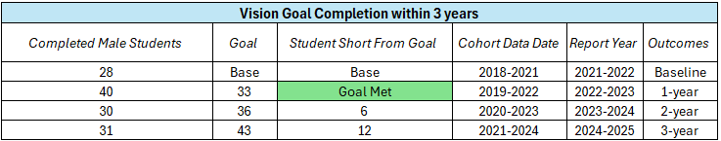
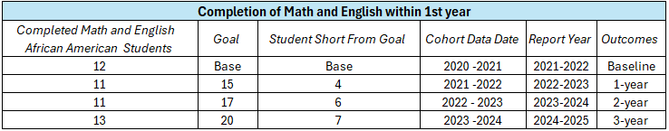
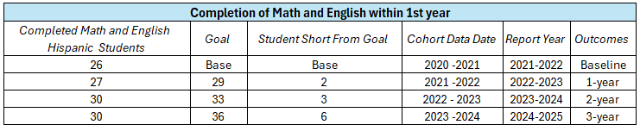
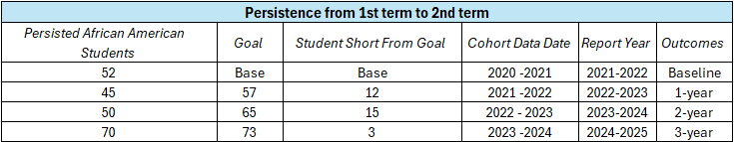
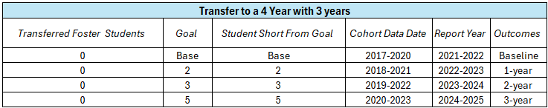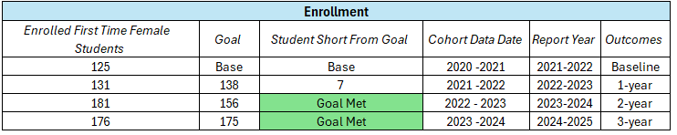
Adult Education Enrolled Students
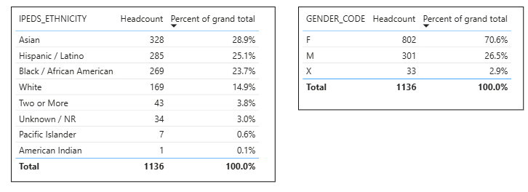
Adult Education Student Group

Discuss how your program has worked to address these equity gaps. Incorporate examples of your program data where applicable.
Adult Education has a large majority of women in their student groups. This could have led to a bigger female enrollment in the last couple years which led to us meeting our goals for female enrollment. If we keep up the enrollment for adult education this trend will keep adding to this metric. This is a strategy for many colleges to increase their enrollment numbers through Adult Education.

Second for Hispanics being their second biggest group adult education students should be taking English and math in their first year here. This would help the metric for completion math and English in their first year, which we were only 6 students away from meeting that goal last year. With completion of Math and English in their first year, the students are more likely to get awards and transfer leading to more outcomes.

[Further Equity discussion here]

Student Learning Outcomes Assessment
List of your Service Area Outcomes (SAOs) and/or Student Learning Outcomes (SLOs)
[Please list updated SAOs]

Last Assessed Spring 2022
SAO 1: Current completion rate to increase to 75%. 68%

Last Assessed Spring 2023
SAO 1: The goal was for 50% of the students to be enrolled from fall to spring (persistence). 42.8%

Last Assessed Spring 2021
SAO 3: Service area outcome was to maintain online services for adult education students and retain at least 50% of students from Fall 2020 to Spring 2021. 72.35%

Please provide a high-level summary and your program’s interpretation of your SAO/SLO findings over the past year.
It has been 2 Years since last SAO was assessed.
[Please discuss assessments of SAOs in the last 4 years]

What were the most important things your department learned from assessment? Did implementation of your action plans result in better student learning?
[Please respond with plan on how to assess the SAOs in the future]

Degrees & Certificates Conferred
Increasing the number of students who complete a certificate or degree is a shared goal across CoA’s Ed Master Plan Goals, PCCD (Peralta Community College District) Goals, the Chancellor’s Office Vision for Success, the Student-Centered Funding Formula, and Guided Pathways.
How can your program contribute to increasing the number of certificates and degrees awarded over the next three years?
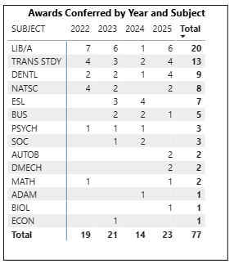

The number of degrees and certificates the adult education student has been getting has gone up and down. However, this last year has gone up to the higher in the last 4 years at 23 degrees and certificates. I noticed this year there is more CTE programs on the list of degrees.

[Awards Discussion on the increases and decreases. How can we keep increasing this number?]

Engagement
How has your department participated in college wide efforts such as committees, presentations, and departmental activities?
[Update Engagement Discussion]
We participate in all student service enrollment and outreach activities; attend campus Student Equity and Achievement committee, Student Services weekly meetings, meets with ESOL faculty, and other departments as collaborations arise.

How has your department engaged in community activities, partnerships and/or collaborations?
[Update Collaborations Discussion]
Many of our partners are off site so we participate in -outreach activities facilitated by partners with tabling or presenting information on our program - attending other community outreach events - setting up partnerships with CBO’s to host classes off site - meet with adult schools, CBOs, reentry clients off site to provide enrollment/registration transition services

Prioritized Resource Requests Summary
In the boxes below, please add resource requests for your program. If there are no resources requested, leave the boxes blank.
Resource Category | Description/Justification | Total Estimated Cost
Personnel: Classified Staff
Personnel: Student Worker
Personnel: Part Time Faculty
Personnel: Full Time Faculty

Resource Category | Description/Justification | Total Estimated Cost
Professional Development: Department wide PD (Professional Development) needed
Professional Development: Personal/Individual PD needed
Supplies: Software
Supplies: Books, Magazines, and/or Periodicals
Supplies: Instructional
Supplies: Non-Instructional
Supplies: Library Collections
Technology & Equipment
Library materials/collections
Facilities: Classrooms/Labs
Facilities: Offices
Other

