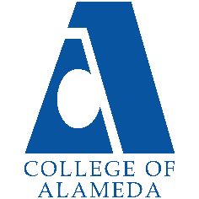
College of Alameda
2025-26 Program Review Template – Articulation

Lead Author:
Vinh Phan

Program Overview
Provide your service area’s mission statement. If your service area does not have a mission statement, what is your timeline for creating a mission statement?
[Update Mission Here]
The mission of the Articulation Program at College of Alameda is to assist students transferring to four-year colleges and universities by establishing articulation agreements regarding those courses that will transfer as lower-division requirements, including specific courses that will meet general education, course-to-course, major preparation requirements, and updating annual AA/AS General Education Requirements. By enhancing student’s ability to transfer to four-year colleges and universities, the Articulation Program supports the College in meeting its mission: “to serve the educational needs of its diverse community by providing comprehensive and flexible programs and resources that empower students to achieve their goals.”

List your program faculty and/or staff.
[List of personnel goes here]
Vinh Phan

List the essential functions of your department, program or unit and provide a description of how the unit aligns with the college mission.
[Your Essential Functions Here]
Articulation refers specifically to the process of developing a formal, written agreement that identifies courses (or sequences of courses) on a “sending” campus (COA) that are comparable to, or acceptable in lieu of, specific course requirements at a “receiving” campus (CSU/UC/Private institutions). Successful completion of an articulated course assures the student and the faculty that the student has taken the appropriate course, received the necessary instruction and preparation, and that similar outcomes can be assured. In short, the articulation process enables the student to progress to the next level of instruction at the receiving institution. College of Alameda’s Articulation Officer initiates and maintains general education and major articulation agreements, so students can transfer as seamlessly as possible. Without articulation agreements, there would be no “roadmaps” for COA students and faculty to navigate the often complicated transfer process. As a result, articulation is the foundation of the vital transfer function that eases students’ transition between segments of higher education. Without creating new or updating existing “roadmaps” or articulation agreements, COA students would encounter more obstacles in the transfer process. Therefore, Student Retention and Success are, in part, based on the establishment and maintenance of articulation agreements as facilitated by COA’s Articulation Officer (A.O.). College of Alameda’s Articulation Officer also serves as the ASSIST Manager and maintains College of Alameda lower division courses which are electronically entered into the ASSIST database. This on-line database is used to submit courses for basic maintenance of COA’s transferable courses as well as submitting College of Alameda courses for UCTCA, CSU-GE Breadth, and IGETC approval.

List your program goals from your most recent Program Review or APU (Annual Program Update). Then, provide an update on the status of the goal. Has your program achieved the goal? Have any of your goals been revised or are any still in progress? Lastly, make sure to discuss which College or District goal your program goal aligns with.
If no program goals exist or if this is your first program review, create 2-3 goals and align them with a college or District goal.
Program Goal | All COA established Articulation Agreements with UCs and CSUs will be accessible on the web at www.assist.org for all students, faculty, and the public
Status: In-Progress or Complete? | Update Progress
Which college or district goal is aligned with your program goal? | Which Goals?

Program Goal | Students will have access to updated General Education Advising sheets which will indicate all articulated courses for transfer to UC, CSU and private institutions
Status: In-Progress or Complete? | Update Progress
Which college or district goal is aligned with your program goal? | Which Goals?

Program Goal | Increase Articulation Proposals and subsequently Articulation Agreements with UCs, CSUs, CA Private/Independent Colleges and Universities, and Out-of-State College and Universities starting with local primary feeder schools
Status: In-Progress or Complete? | Update Progress
Which college or district goal is aligned with your program goal? | Which Goals?

Program Goal | Conduct workshops, training, and individual sessions with faculty regarding curriculum related topics
Status: In-Progress or Complete? | Update Progress
Which college or district goal is aligned with your program goal? | Which Goals?

Demographics

Articulation Last 4 Years
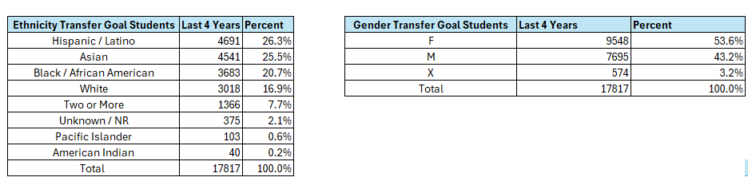

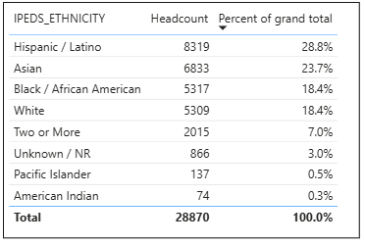
Overall Last 4 Years
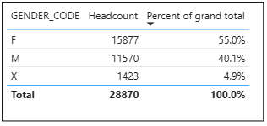

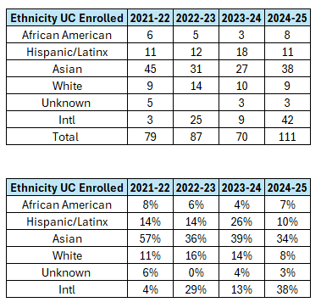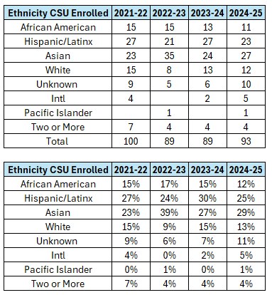
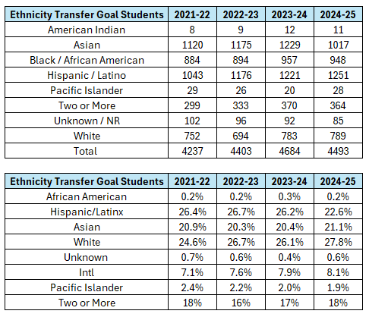

Do the students served by your service area differ from the College's overall student population? If so, elaborate on how the service area is identifying and addressing the needs of the student population.
No, the students whose education goal is to transfer are not that differed from the college’s overall student population. Overall, most of our students are taking articulated and transferable courses at College of Alameda. There is a bigger percent of men compared to the overall college percent who are taking transferable courses. However, Students that are completing the transfer process are different then our overall population. Asian are the largest group who is transferring to CSU and UC which is not our largest population on our campus.

[Students’ Demographics discussion goes here]

Which groups of students are underrepresented among those who received services, particularly by race/ethnicity and gender?
There is none Pacific Islander or American Indian transferring to UC. There is no American Indians transferring to a CSU. However, there are students who in this demographic at College of Alameda whose education goal is to transfer.

[Students’ Demographics discussion goes here]

Describe how external factors such as advisory board recommendations, federal or state mandates, changing demographics, and/or COVID-19 has impacted the support services your program or administrative unit provides.
How has your program addressed these changes or challenges to ensure students are supported and can continue to work towards meeting their educational goals?
[Changes and Challenges discussion goes here]

Data Analysis
Articulation in COA
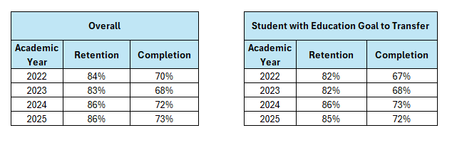

How does the course completion rate for your program compare to your college's College-Set Standard for course completion of 70% and the stretch goal of 78%?

With Students that have the goal to transfer to a 4 Year University completion rates with below for each annual year except 2023-2024. For the set standard of 70% all semesters were above this standard except 2021-2022 and 2022-2023. So, it is great we are now above the set standard for our transfer students.
[College Completion Rates discussion here: how will transfer center increase student completion rate]

On average the course retention rate (number of students are retained in the course) for College of Alameda has been 85% for the past four years. Examine the course retention rates for your program over the last four years. How does your program course retention rate compare to the college?
With Students that have the education goal to transfer to a 4 Year University retention rates were below for each of the annual years except 2023-2024. For the College of Alameda average of 85% for the retention rate, all semesters were above except 2021-2022 and 2022-2023. So, it is getting above the average for the last two years. So, the last two years we have been doing better in the retention for the students with education goals to transfer.

[College Retention Rates discussion here: how will transfer center increase student retention rate]

Equity
College of Alameda continues to focus on access, equity, and success. The goal is to create an inclusive environment where all students can thrive and meet their education and career goals. As pertaining to student equity data from Student Equity Plan 2022-2025, how could your program help increase the number of students reaching each of these metrics.
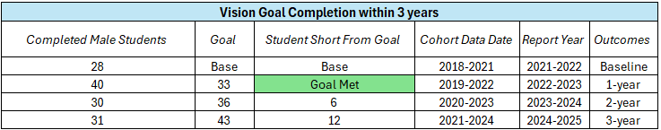
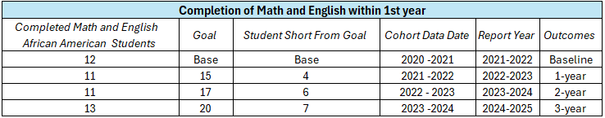
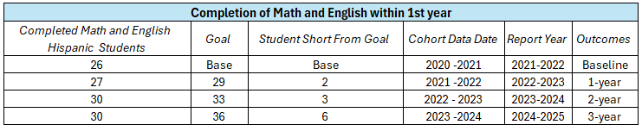
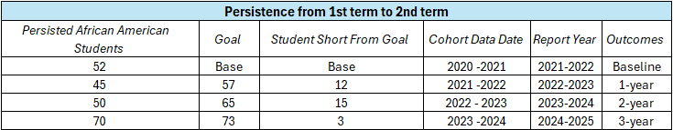
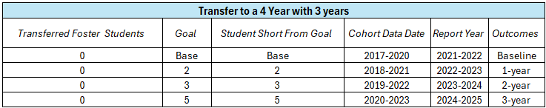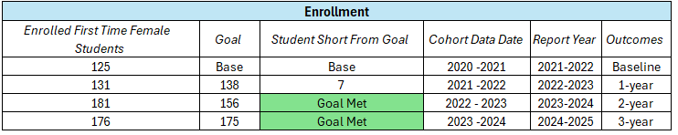
Articulation Last 4 Years
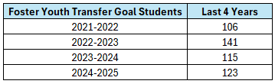
Discuss how your program has worked to address these equity gaps. Incorporate examples of your program data where applicable.
Students whose Education Goal is to transfer have a higher percent of males then overall population. This would apply to the Goal Completion for Males. So, we could get transfer students to not only get the transfer outcome but their awards as well to help reach this metric. Also, for the persistence and completion of math and English should be tracked by Student Education Plans that are given to males with their counseling appointment which would lead to the completion of these to goal metrics. Also, for the transfer goal in SEA Plan COA could not get any foster youth to transfer to a 4-year university. Looking at number of foster youth students who have education goals to transfer we see that is a definite group we could work on to get more transfers and pathways to help them transfer.

[Further Equity discussion here]

Student Learning Outcomes Assessment
List of your Service Area Outcomes (SAOs) and/or Student Learning Outcomes (SLOs)
SOA 1: All COA established
Articulation Agreements
with UCs and CSUs will be
accessible on the web at
www.assist.org for all
students, faculty, and the
public.
SOA 2: Students will have
access to updated General
Education Advising sheets
which will indicate all
articulated courses for
transfer to UC, CSU and
private institutions
[Please list any other SAOs]

Please provide a high-level summary and your program’s interpretation of your SAO/SLO findings over the past year.
Articulation has not assessed SAOs completed for this SAO assessment cycle.
[Please discuss assessments of SAOs in the last 4 years]

What were the most important things your department learned from assessment? Did implementation of your action plans result in better student learning?
[Please respond with plan on how to assess the SAOs in the future]

Degrees & Certificates Conferred
Increasing the number of students who complete a certificate or degree is a shared goal across CoA’s Ed Master Plan Goals, PCCD (Peralta Community College District) Goals, the Chancellor’s Office Vision for Success, the Student-Centered Funding Formula, and Guided Pathways.
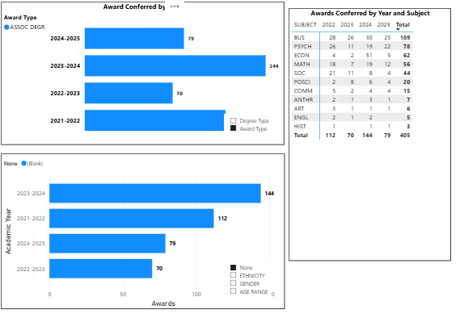
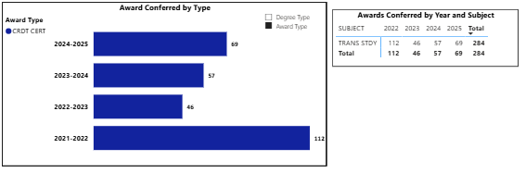
How can your program contribute to increasing the number of certificates and degrees awarded over the next three years?
For AD-T, College of Alameda higher year was 2023-2024. We had a slight decline in 2024-2025. For IGETC College of Alameda had a big decline in 2022-2023 but has been slowly increasing the past three years.

[Awards Discussion on the increases and decreases. How can we keep increasing this number?]

Engagement
How has your department participated in college wide efforts such as committees, presentations, and departmental activities?
[Engagement Discussion]
Institutional Engagement
College of Alameda’s AO is a member on the following committees:
• Council on Instruction, Planning and Development (CIPD)
• College of Alameda Curriculum Committee
• GE Subcommittee • Catalog Committee
• Distance Education Subcommittee
• Student Services Committee

How has your department engaged in community activities, partnerships and/or collaborations?
[Collaborations Discussion]
Community Engagement
The AO has engaged in initial talks to develop high school articulation agreements with Alameda Unified School District.
As a member of the Counseling Department, the A.O has been involved in the follow:
• High School Outreach
• “Fab Friday” (Welcome Day for New Students)
• Graduation
• Classroom Presentations
• ADT Workshops
• Time Management Workshops
• Study Skills Workshops

Prioritized Resource Requests Summary
In the boxes below, please add resource requests for your program. If there are no resources requested, leave the boxes blank.
Resource Category | Description/Justification | Total Estimated Cost
Personnel: Classified Staff
Personnel: Student Worker
Personnel: Part Time Faculty
Personnel: Full Time Faculty

Resource Category | Description/Justification | Total Estimated Cost
Professional Development: Department wide PD (Professional Development) needed
Professional Development: Personal/Individual PD needed
Supplies: Software
Supplies: Books, Magazines, and/or Periodicals
Supplies: Instructional
Supplies: Non-Instructional
Supplies: Library Collections
Technology & Equipment
Library materials/collections
Facilities: Classrooms/Labs
Facilities: Offices
Other

