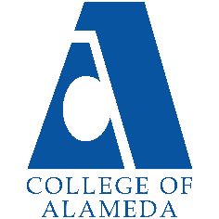
College of Alameda
2025-26 Program Review Template – MESA

Lead Author:
Ann Gonzalez, MESA Director

Program Overview
Provide your service area’s mission statement. If your service area does not have a mission statement, what is your timeline for creating a mission statement?
[Update Mission Here]
MESA Program at College of Alameda offers academic support and career exploration for STEM majors planning to transfer to four-year colleges. We offer academic counseling, priority registration, tutoring, speakers from STEM industries, conferences, and college campus visits as well as information on the transfer process, financial aid, and internships.

List your program faculty and/or staff.
[List of personnel goes here]
Ann Gonzalez, MESA Director
Cynthia Haro, MESA Counselor

List the essential functions of your department, program or unit and provide a description of how the unit aligns with the college mission.
[Your Essential Functions Here]
The MESA Program requires that each college accomplish seven of the thirteen programs
components (see details below) in the first year of MESA. The primary strategic goal for this
academic year is to accomplish those seven components.
Details
The seven required MESA components for the first year are:
1. Hire an Administrator
2. Create a Student Center
3. Offer Academic Excellence Workshops (AEW) and/or other High Effective Practices
4. Offer Academic Counseling
5. Offer MESA Orientations
6. Offer Student Support Services
7. Conduct Student Outreach and Recruitment

List your program goals from your most recent Program Review or APU (Annual Program Update). Then, provide an update on the status of the goal. Has your program achieved the goal? Have any of your goals been revised or are any still in progress? Lastly, make sure to discuss which College or District goal your program goal aligns with.
If no program goals exist or if this is your first program review, create 2-3 goals and align them with a college or District goal.
Program Goal | New Goals
Status: In-Progress or Complete?
Which college or district goal is aligned with your program goal?

Program Goal | New Goals
Status: In-Progress or Complete?
Which college or district goal is aligned with your program goal?

Program Goal | New Goals
Status: In-Progress or Complete?
Which college or district goal is aligned with your program goal?

MESA Last 4 Years
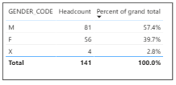
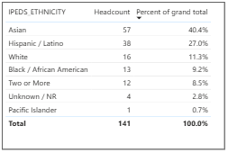

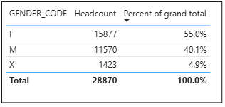
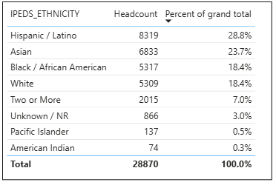
Overall Last 4 Years

Do the students served by your service area differ from the College's overall student population? If so, elaborate on how the service area is identifying and addressing the needs of the student population.
Yes, the MESA served students that differed from the college’s overall student population. The MESA’s populations by percent serviced more Asian ethnicities than the overall population. MESA served less Black/ African than what the college population has. Also, MESA served more men than the college overall population.

[Students’ Demographics discussion goes here]

STEM Students Demographics Last 4 Years
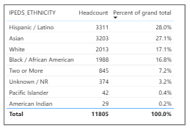
Which groups of students are underrepresented among those who received services, particularly by race/ethnicity and gender?
There is less Black/African Americans in MESA compared to the STEM Black/African American who are enrolled in this college for the last 4 years.

[Students’ Demographics discussion goes here]

Describe how external factors such as advisory board recommendations, federal or state mandates, changing demographics, and/or COVID-19 has impacted the support services your program or administrative unit provides.
How has your program addressed these changes or challenges to ensure students are supported and can continue to work towards meeting their educational goals?
[Changes and Challenges discussion goes here]

Data Analysis
MESA in COA
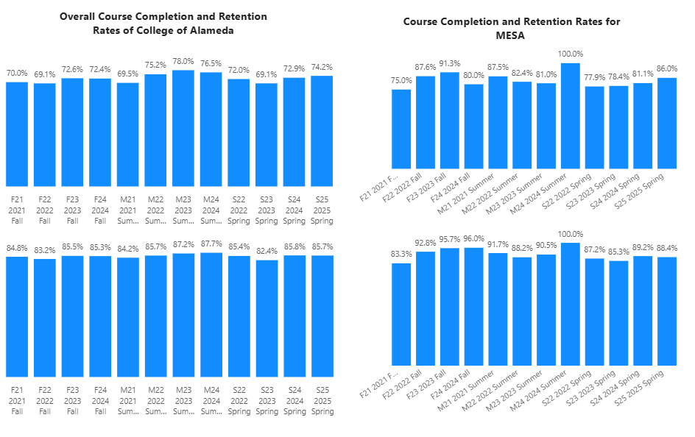

How does the course completion rate for your program compare to your college's College-Set Standard for course completion of 70% and the stretch goal of 78%?

The course completion for MESA Students is above the College of Alameda’s completion rate for that term. MESA Students is also above the set standard and stretch goals of 70% for the completion rate for all terms. All terms except for Fall 2021 and Spring 2022, the Stretch Goal was met.

[College Completion Rates discussion here: how will transfer center increase student completion rate]

On average the course retention rate (number of students are retained in the course) for College of Alameda has been 85% for the past four years. Examine the course retention rates for your program over the last four years. How does your program course retention rate compare to the college?
For retention, MESA Students are above the College of Alameda’s retention for that term except Fall 2021. MESA Students are above the average of 85% for retention rate for all terms except Fall 2021.

[College Retention Rates discussion here: how will transfer center increase student retention rate]

Equity
College of Alameda continues to focus on access, equity, and success. The goal is to create an inclusive environment where all students can thrive and meet their education and career goals. As pertaining to student equity data from Student Equity Plan 2022-2025, how could your program help increase the number of students reaching each of these metrics.
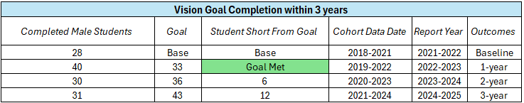
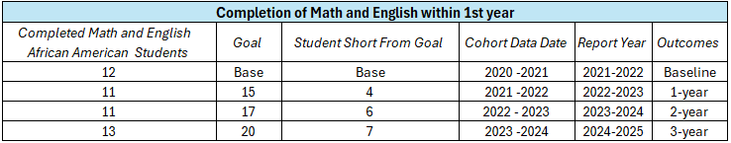
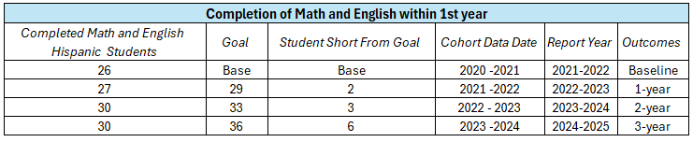
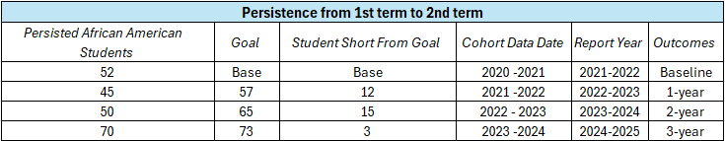
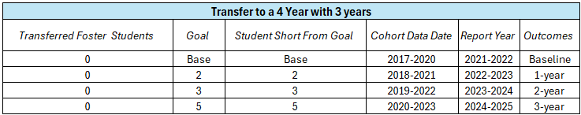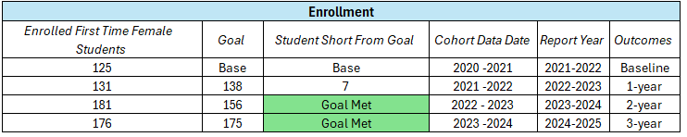
MESA Last 4 Years

Discuss how your program has worked to address these equity gaps. Incorporate examples of your program data where applicable.
With most of the MESA Students being males, this would apply to the Goal Completion for Males. With number of males in the group we could make sure they are getting awards and completing within the 3 years which would lead the completion goal to be met in SEP. Also, for the persistence and completion of math and English should be tracked by Student Education Plans that are given to males with their counseling appointment which would lead to the completion of these to goal metrics. There is less Black African American in our MESA student group this could be something to investigate to get the numbers higher. So, MESA could help with the Black/African American goals of Completion of Math and English and Persistence.

[Further Equity discussion here]

Student Learning Outcomes Assessment
List of your Service Area Outcomes (SAOs) and/or Student Learning Outcomes (SLOs)
[Please list any other SAOs]

Please provide a high-level summary and your program’s interpretation of your SAO/SLO findings over the past year.
MESA has no assessed SLOs completed for this SAO assessment cycle.
[Please discuss assessments of SAOs in the last 4 years]

What were the most important things your department learned from assessment? Did implementation of your action plans result in better student learning?
[Please respond with plan on how to assess the SAOs in the future]

Degrees & Certificates Conferred
Increasing the number of students who complete a certificate or degree is a shared goal across CoA’s Ed Master Plan Goals, PCCD (Peralta Community College District) Goals, the Chancellor’s Office Vision for Success, the Student-Centered Funding Formula, and Guided Pathways.
How can your program contribute to increasing the number of certificates and degrees awarded over the next three years?
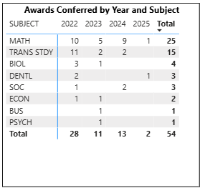

The number of veterans from the student group has decreased in the number of degrees and certificates they are getting. MESA just restarted program in Spring 2025. So, it is why there is a big difference between the number of degrees earned by MESA Students.

[Awards Discussion on the increases and decreases. How can we keep increasing this number?]

Engagement
How has your department participated in college wide efforts such as committees, presentations, and departmental activities?
[Engagement Discussion]

How has your department engaged in community activities, partnerships and/or collaborations?
[Collaborations Discussion]

Prioritized Resource Requests Summary
In the boxes below, please add resource requests for your program. If there are no resources requested, leave the boxes blank.
Resource Category | Description/Justification | Total Estimated Cost
Personnel: Classified Staff
Personnel: Student Worker
Personnel: Part Time Faculty
Personnel: Full Time Faculty

Resource Category | Description/Justification | Total Estimated Cost
Professional Development: Department wide PD (Professional Development) needed
Professional Development: Personal/Individual PD needed
Supplies: Software
Supplies: Books, Magazines, and/or Periodicals
Supplies: Instructional
Supplies: Non-Instructional
Supplies: Library Collections
Technology & Equipment
Library materials/collections
Facilities: Classrooms/Labs
Facilities: Offices
Other

