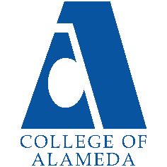
College of Alameda
2025-26 Program Review Template – Veterans

Lead Author:
[Your Name Here]

Program Overview
Provide your service area’s mission statement. If your service area does not have a mission statement, what is your timeline for creating a mission statement?
[Your Mission Here]
The Veterans Resource Center Program provides Resources, supportive services & assistance to veterans and their eligible Family members in their pursuit towards a degree or certificate. Services provided to veterans and eligible family members are: Academic / career counseling, tutorial assistance, referral services on/off campus, job search, housing, Mental health and Wellness as well as food services.

List your program faculty and/or staff.
[List of personnel goes here]
Jamar Mears – Veterans Counselor
La Shawn Brumfield – Coordinator/SCO

List the essential functions of your department, program or unit and provide a description of how the unit aligns with the college mission.
[Your Essential Functions Here]
Function - Alignment w/ College Mission
Counseling - Counseling provides healthy dialogue between student and counselor, which produces an education plan that will guide the student to accomplishing their educational goal. Certify - By certifying veterans & dependents enrollment, this action provides monies to student that cover the bare and educational necessities for students to complete their program/degree. Resources & Referrals - The services provided by the VRC empowers student by providing educational necessities and assist in the students maintaining their mental & physical well-being

List your program goals from your most recent Program Review or APU (Annual Program Update). Then, provide an update on the status of the goal. Has your program achieved the goal? Have any of your goals been revised or are any still in progress? Lastly, make sure to discuss which College or District goal your program goal aligns with.
If no program goals exist or if this is your first program review, create 2-3 goals and align them with a college or District goal.
Program Goal
Status: In-Progress or Complete?
Which college or district goal is aligned with your program goal?

Program Goal
Status: In-Progress or Complete?
Which college or district goal is aligned with your program goal?

Program Goal
Status: In-Progress or Complete?
Which college or district goal is aligned with your program goal?

Program Goal
Status: In-Progress or Complete?
Which college or district goal is aligned with your program goal?

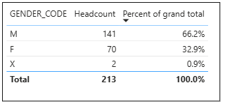
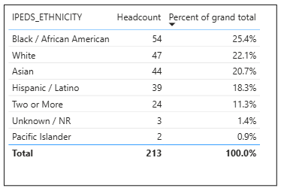
Student Veterans Last 4 Years

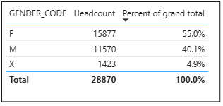
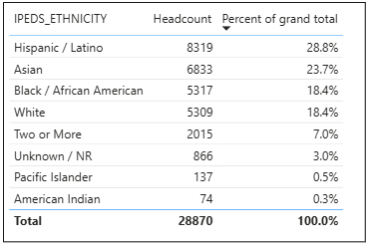
Overall Last 4 Years

Alameda Student Veterans Last 4 Years
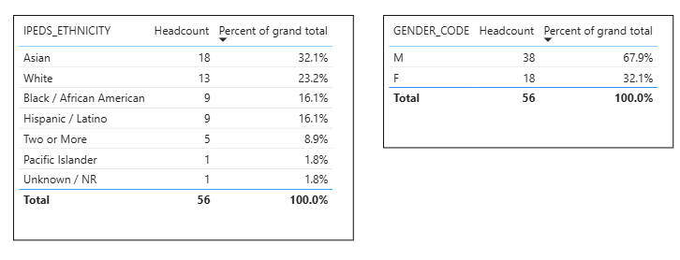

Do the students served by your service area differ from the College's overall student population? If so, elaborate on how the service area is identifying and addressing the needs of the student population.
Yes, the Veterans served a student that differed from the college’s overall student population. The veterans’ populations by percent serviced more Black/African Americans and White’s ethnicities than the overall population. The veteran center served more Asian and Whiter compared to the Veterans which consisted of more Black/African Americans. Also, the veterans center served more men than the college overall population.

[Students’ Demographics discussion goes here]

Which groups of students are underrepresented among those who received services, particularly by race/ethnicity and gender?
There is less Hispanic and Black/African Americans in the veteran student group compared to the veterans who are enrolled in this college for the last 4 years.

[Students’ Demographics discussion goes here]

Describe how external factors such as advisory board recommendations, federal or state mandates, changing demographics, and/or COVID-19 has impacted the support services your program or administrative unit provides.
How has your program addressed these changes or challenges to ensure students are supported and can continue to work towards meeting their educational goals?
[Changes and Challenges discussion goes here]

Data Analysis
Enrolled Veterans in COA
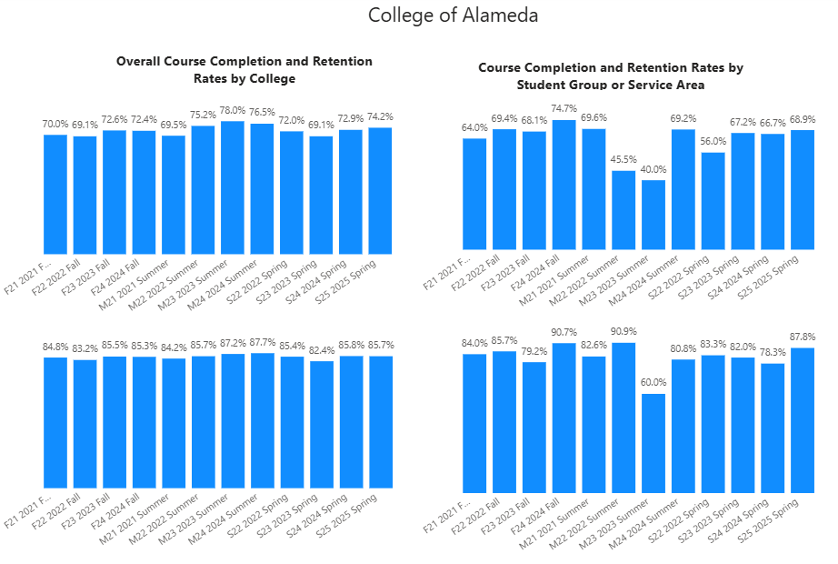
AVET Student Group
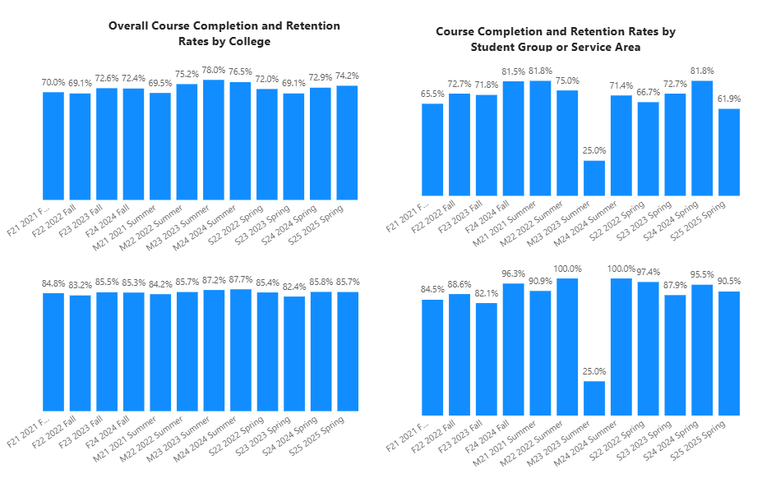

How does the course completion rate for your program compare to your college's College-Set Standard for course completion of 70% and the stretch goal of 78%?

There was one semester where the completion rate was below the set standard, and it was Fall 2024. All other semester the completion rate was below the set standard for the veteran enrolled in COA. However, Veterans Student Group 4 of the semester was below the set standard, especially Summer 2023.

[College Completion Rates discussion here: how will transfer center increase student completion rate]

On average the course retention rate (number of students are retained in the course) for College of Alameda has been 85% for the past three years. Examine the course retention rates for your program over the last three years. How does your program course retention rate compare to the college?
The students who were served in the Transfer Center have smaller rate of retention compared to the overall population of the campus 8 of 12 of the semesters. There were 4 semesters out of the 12 that were above the average of 85% for retention rate. Two of the four are Fall Semesters which had higher retention rates. For the Veteran Student Group, 3 out of the 4 semesters were below the average retention rate. So, the Alameda veterans’ group had better retention than the veterans enrolled at college of Alameda.

[College Retention Rates discussion here: how will transfer center increase student retention rate]

Equity
College of Alameda continues to focus on access, equity, and success. The goal is to create an inclusive environment where all students can thrive and meet their education and career goals. As pertaining student equity data from Student Equity Plan 2022-2025, how could your program help increase the number of students reaching each of these metrics.
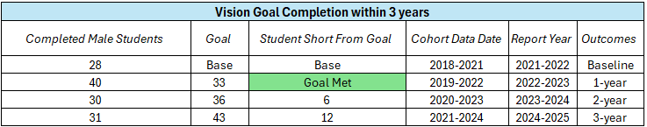
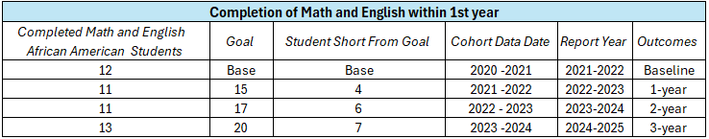
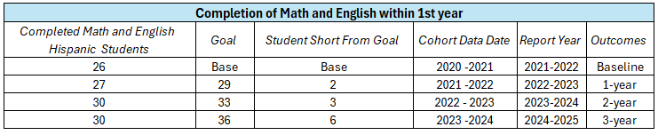
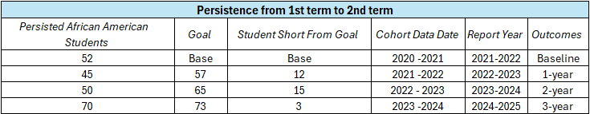
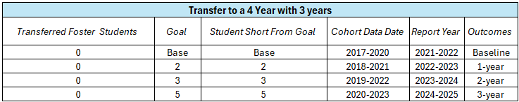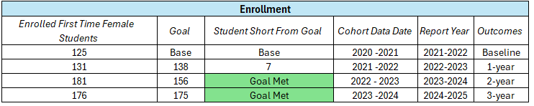
Veterans
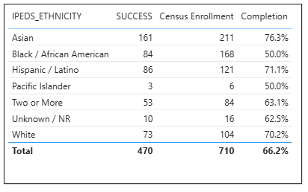

AVET Student Group

Discuss how your program has worked to address these equity gaps. Incorporate examples of your program data where applicable.
With most of the student veterans’ group being males and Black/African American, this would apply to the Goal Completion for Males and Black/African American Persistence and Completion of English and Math. WE should see if we could get more Black/African American Veterans to join our student group for college of alameda. With number of males in the group we could make sure they are getting awards and completing within the 3 years which would lead the completion goal to be met in SEP. Also, for the persistence and completion of math and English should be tracked by Student Education Plans that are given to veterans with their counseling appointment which would lead to the completion of these to goal metrics. So, because the equity gaps in the SEP are seen in the veteran’s community this is a great place to cover some ground in these goals.

[Further Equity discussion here]

Student Learning Outcomes Assessment
List your Service Area Outcomes (SAOs) and/or Student Learning Outcomes (SLOs)
[Please list any other SAOs]

Last Assessed Spring 2019
SAO 1: Students will have a defined educational goal by the second semester of their enrollment measured by the number of updated Ed Plans 56.3%

Last Assessed Spring 2020
SAO 2: Students will understand how to access their Educational Benefits as measured by the number of students who are certified by the 4th week of school 0%

Please provide a high-level summary and your program’s interpretation of your SAO/SLO findings over the past year.
SAO 1 and 2 have not been assessed since Spring 2020 and other SAO have not been assessed at all.
[Please discuss assessments of SAOs in the last 4 years]

What were the most important things your department learned from assessment? Did implementation of your action plans result in better student learning?
[Please respond with plan on how to assess the SAOs in the future]

Degrees & Certificates Conferred
Increasing the number of students who complete a certificate or degree is a shared goal across CoA’s Ed Master Plan Goals, PCCD (Peralta Community College District) Goals, the Chancellor’s Office Vision for Success, the Student-Centered Funding Formula, and Guided Pathways.
How can your program contribute to increasing the number of certificates and degrees awarded over the next three years?
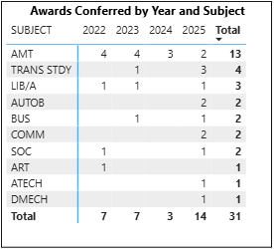

The number of veterans from the student group has increased in the number of degrees and certificates they are getting. 2025 was the first year with double digits for degrees and certificates awards to veteran’s student group.

[Awards Discussion on the increases and decreases. How can we keep increasing this number?]

Engagement
How has your department participated in college wide efforts such as committees, presentations, and departmental activities?
[Engagement Discussion]

How has your department engaged in community activities, partnerships and/or collaborations?
[Collaborations Discussion]
The VRC has partner or collaborated with outside organization such as : Oakland Veterans Center, Swords to Plowshares, Disable American Veteran’s Department (DAV).

Prioritized Resource Requests Summary
In the boxes below, please add resource requests for your program. If there are no resources requested, leave the boxes blank.
Resource Category | Description/Justification | Total Estimated Cost
Personnel: Classified Staff
Personnel: Student Worker
Personnel: Part Time Faculty
Personnel: Full Time Faculty

Resource Category | Description/Justification | Total Estimated Cost
Professional Development: Department wide PD (Professional Development) needed
Professional Development: Personal/Individual PD needed
Supplies: Software
Supplies: Books, Magazines, and/or Periodicals
Supplies: Instructional
Supplies: Non-Instructional
Supplies: Library Collections
Technology & Equipment
Library materials/collections
Facilities: Classrooms/Labs
Facilities: Offices
Other

